ANOVAs pro Gui

por Francisko de Moraes Rezende, [francisko.rezende@gmail.com](mailto:francisko.rezende@gmail.com), 2020-03-26

# carregando os pacotes ---------------------------------------------------  
  
lista_de_pacotes <- c("tidyverse",  
 "readxl",  
 "here",  
 "lme4",  
 "janitor",  
 "ggbeeswarm",  
 "broom",  
 "tufte",  
 "ggthemes",  
 "ggpol")  
  
  
pacotes_novos <-  
 lista_de_pacotes[!(lista_de_pacotes %in% installed.packages()[, "Package"])]  
if (length(pacotes_novos))  
 install.packages(pacotes_novos)  
  
  
library(tidyverse)  
library(readxl)  
library(here)  
library(lme4)  
library(janitor)  
library(ggbeeswarm)  
library(broom)  
library(ggthemes)  
library(ggpol)

# Carregando os dados

# ANOVA ui

## Código

ui_m1 <- lm(ui ~ sp * face, data = ui)  
  
anova(ui_m1)  
  
ui_m2 <- update(ui_m1, . ~ . -sp:face)  
  
anova(ui_m2) %>%   
 rename(`P value` = `Pr(>F)`)

## Tabela ANOVA ui

anova(ui_m2) %>%   
 rename(`P value` = `Pr(>F)`) %>%   
 knitr::kable(digits = 3)

|  |  |  |  |  |  |
| --- | --- | --- | --- | --- | --- |
|  | Df | Sum Sq | Mean Sq | F value | P value |
| sp | 1 | 1.082 | 1.082 | 238.52 | 0.000 |
| face | 1 | 0.000 | 0.000 | 0.07 | 0.798 |
| Residuals | 9 | 0.041 | 0.005 | NA | NA |

## Gráfico

Os dois gráficos abaixo tem as mesmas informções, escolha o que mais lhe agradar.

ui %>%   
 ggplot(aes(x = sp, y = ui)) +  
 geom_boxplot() +  
 geom_quasirandom(groupOnX = T,  
 alpha = .5) +  
 theme_classic() +  
 theme(axis.line.x = element_blank(),  
 text = element_text(size = 12))

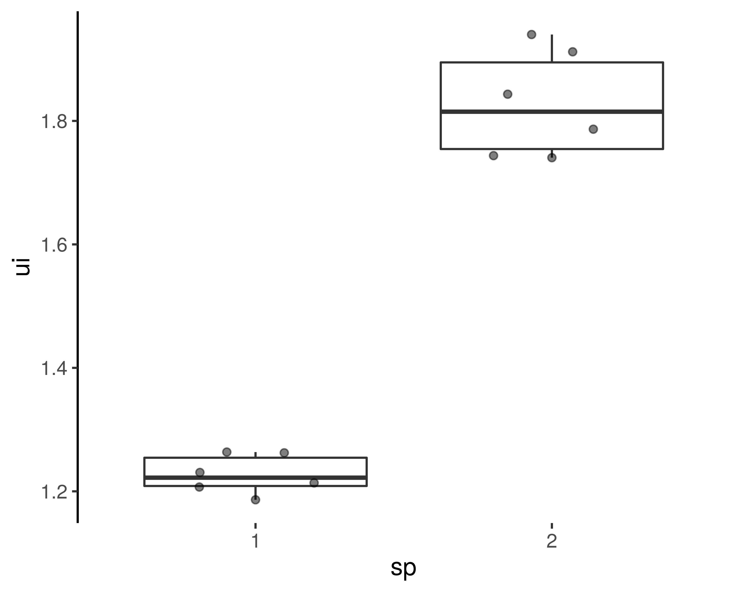

ui %>%   
 ggplot(aes(x = sp, y = ui)) +  
 geom_boxjitter(jitter.height = 0) +  
 theme_classic() +  
 theme(axis.line.x = element_blank(),  
 text = element_text(size = 12))

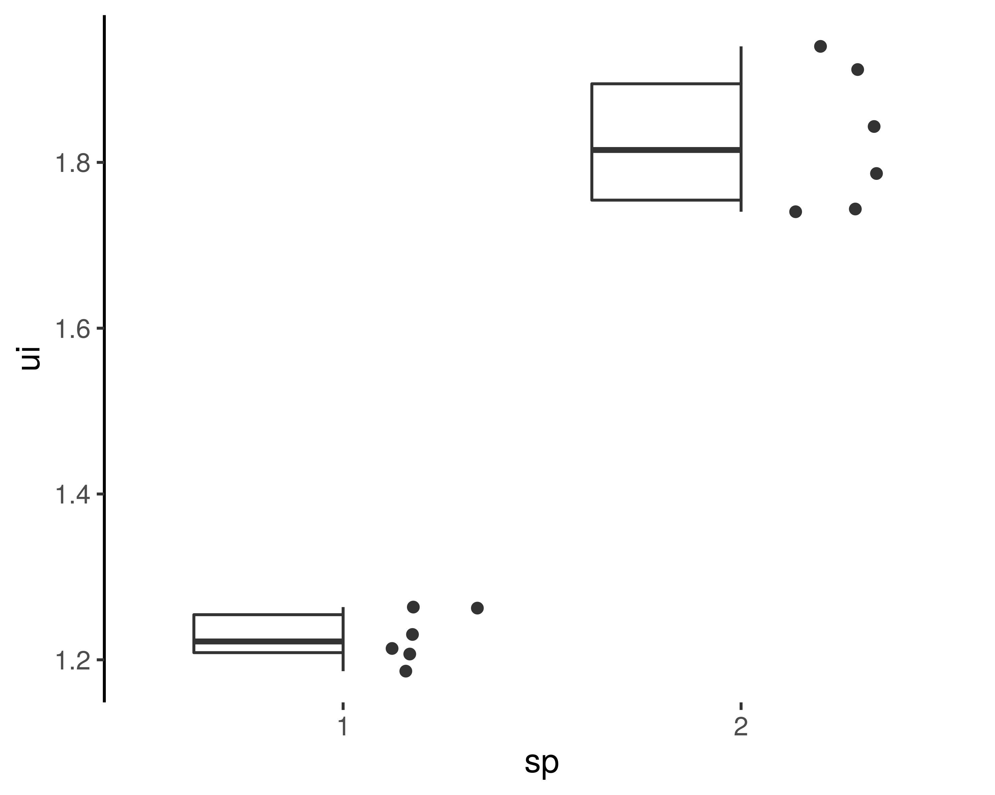

# ANOVA angle

## Código

angle_m1 <- lm(angle ~ sp*face, data = angle)  
  
anova(angle_m1)  
  
angle_m2 <- update(angle_m1, . ~ . - sp:face)  
  
anova(angle_m1, angle_m2)  
  
anova(angle_m2)

## Tabela

|  |  |  |  |  |  |
| --- | --- | --- | --- | --- | --- |
|  | Df | Sum Sq | Mean Sq | F value | P value |
| sp | 1 | 11803.277 | 11803.28 | 586.646 | 0.000 |
| face | 1 | 17.280 | 17.28 | 0.859 | 0.378 |
| Residuals | 9 | 181.079 | 20.12 | NA | NA |

## Gráfico

Os dois gráficos abaixo tem as mesmas informções, escolha o que mais lhe agradar.

angle %>%   
 ggplot(aes(x = sp, y = angle)) +  
 geom_boxplot() +  
 geom_quasirandom(groupOnX = T,  
 alpha = .5) +  
 theme_classic() +  
 theme(axis.line.x = element_blank(),  
 text = element_text(size = 12))

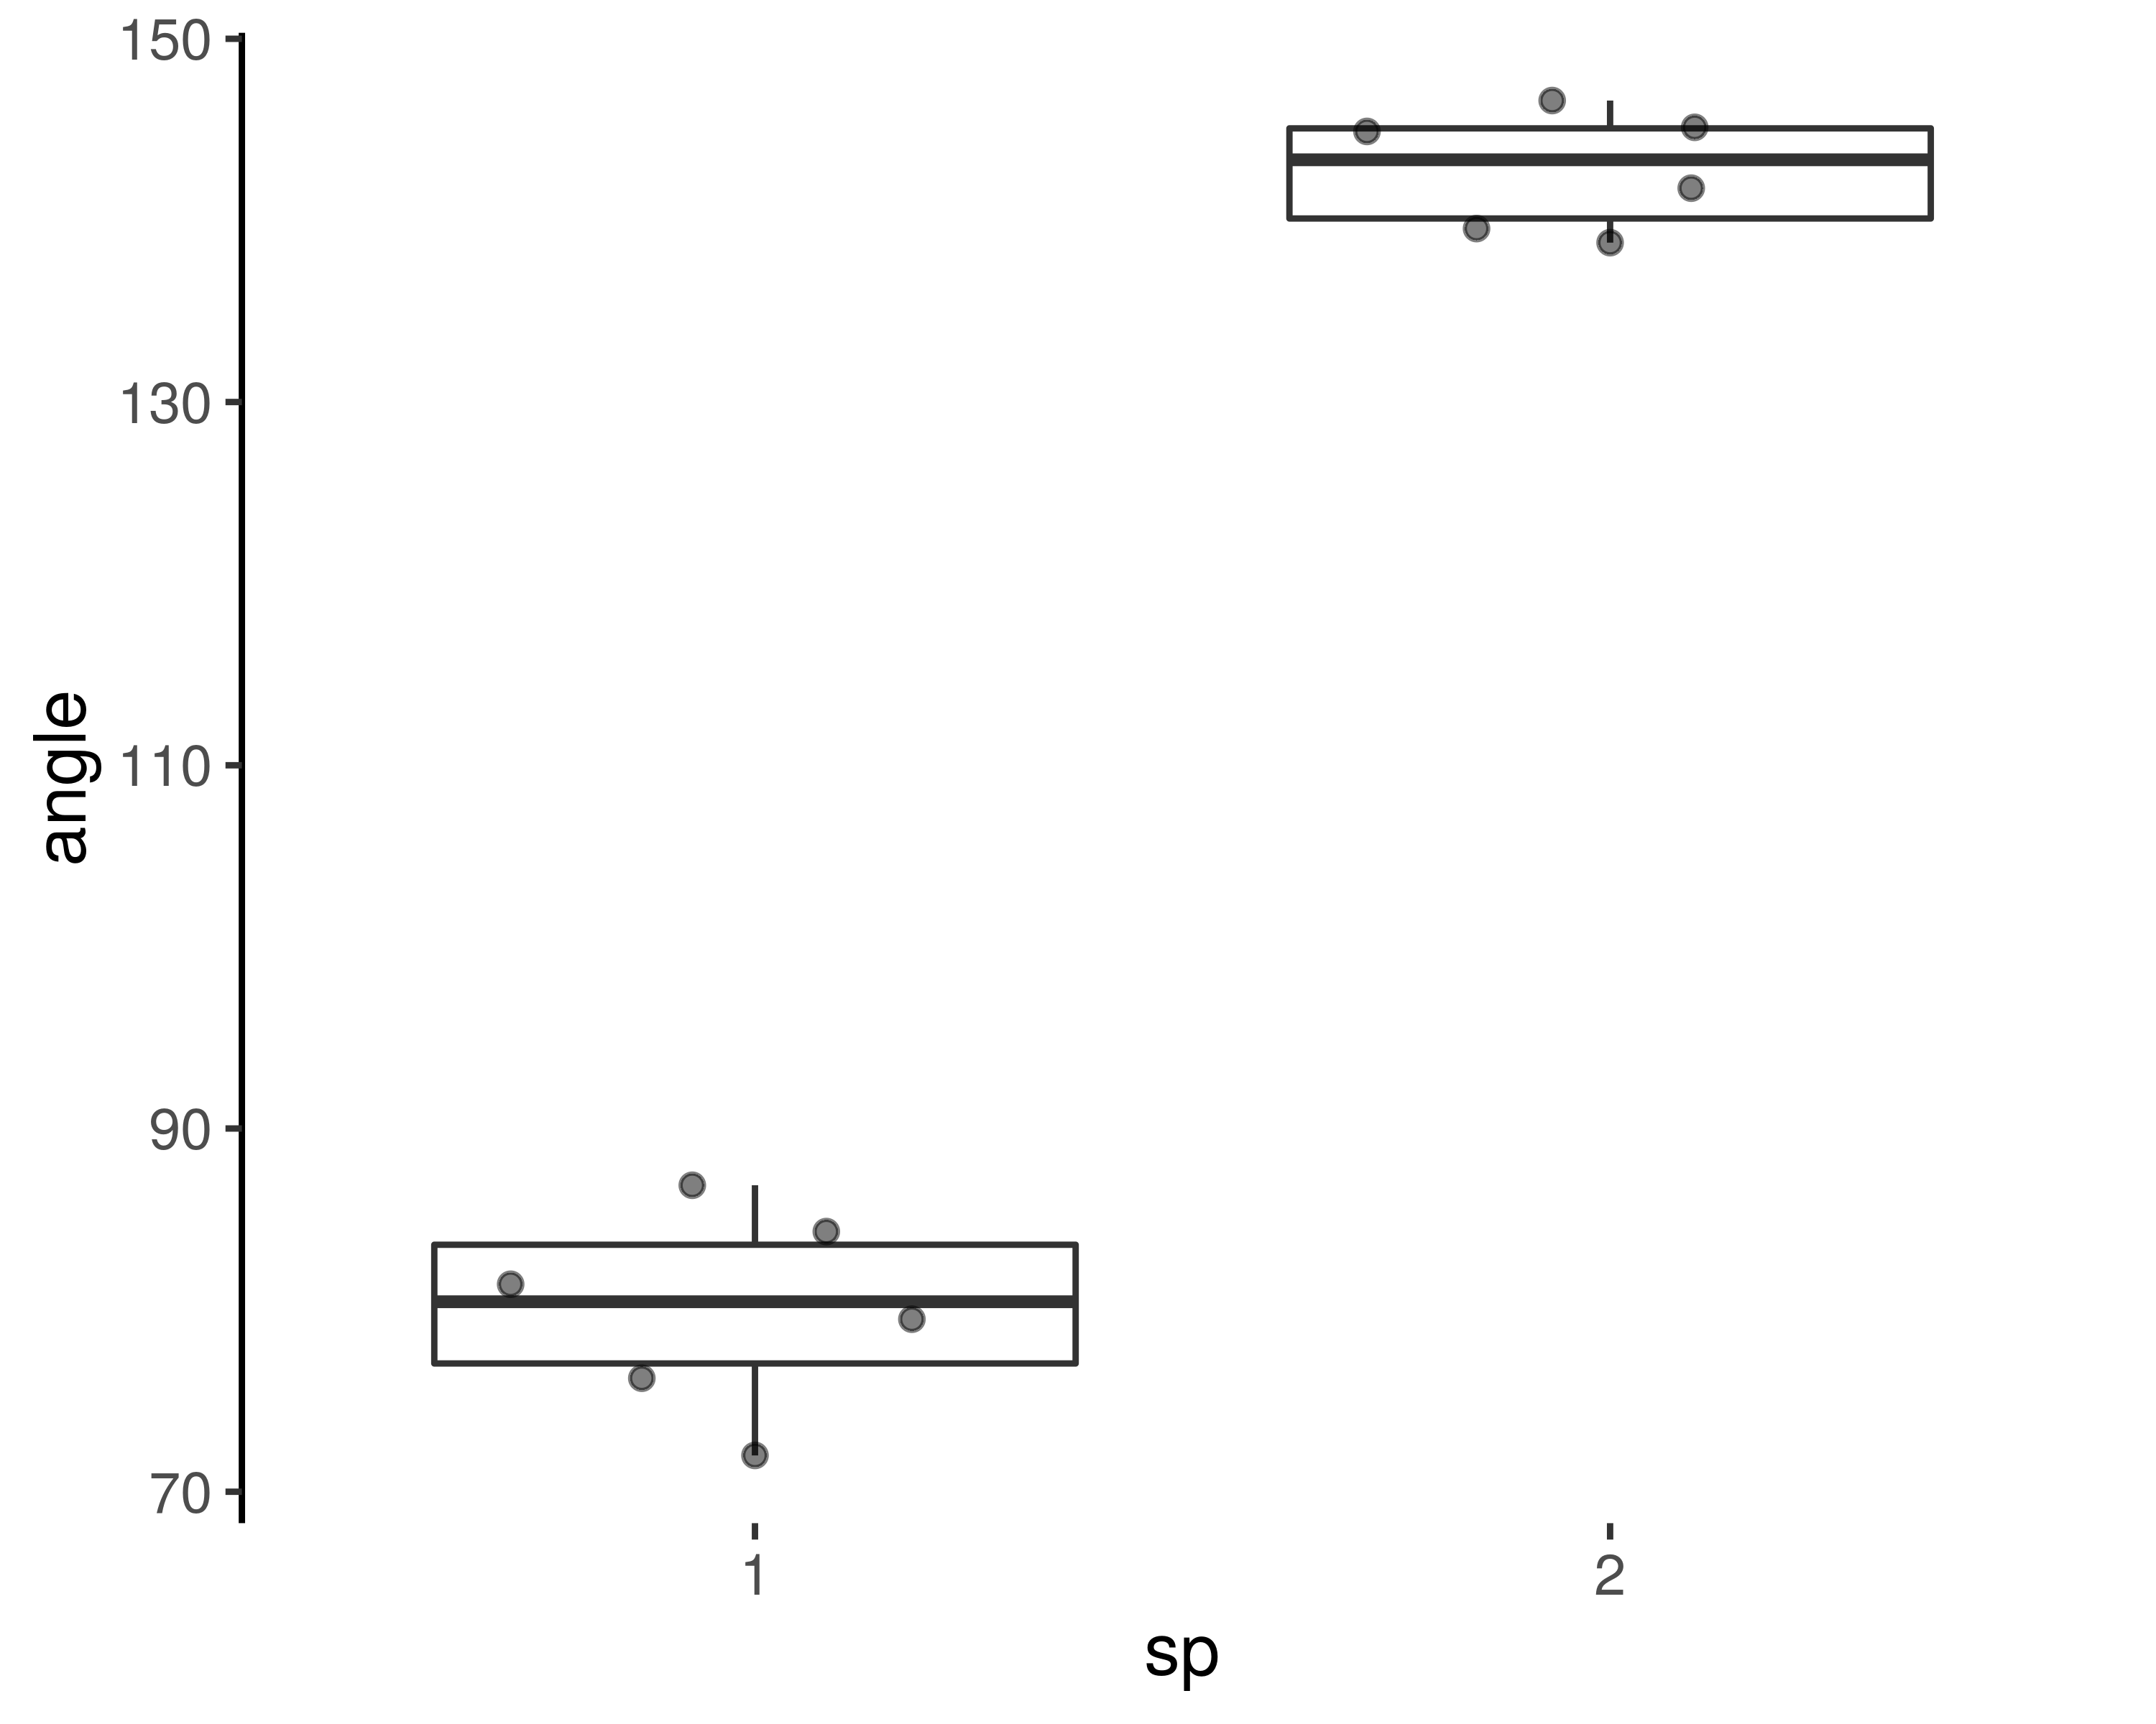

angle %>%   
 ggplot(aes(x = sp, y = angle)) +  
 geom_boxjitter(jitter.height = 0) +  
 theme_classic() +  
 theme(axis.line.x = element_blank(),  
 text = element_text(size = 12))

