ANOVAs pro Gui

por Francisko de Moraes Rezende, [francisko.rezende@gmail.com](mailto:francisko.rezende@gmail.com), 2020-03-26

# carregando os pacotes ---------------------------------------------------  
  
lista_de_pacotes <- c("tidyverse",  
 "readxl",  
 "here",  
 "lme4",  
 "janitor",  
 "ggbeeswarm",  
 "broom",  
 "tufte",  
 "ggthemes",  
 "ggpol")  
  
  
pacotes_novos <-  
 lista_de_pacotes[!(lista_de_pacotes %in% installed.packages()[, "Package"])]  
if (length(pacotes_novos))  
 install.packages(pacotes_novos)  
  
  
library(tidyverse)  
library(readxl)  
library(here)  
library(lme4)  
library(janitor)  
library(ggbeeswarm)  
library(broom)  
library(ggthemes)  
library(ggpol)

# Carregando os dados

micro <-  
 read_xls(here("dados","Stat-microrrugosidade.xls")) %>%   
 clean_names() %>%   
 mutate_at(.vars = vars(sp:rep), .funs = ~ factor(.))  
  
micro_m1 <- lm(sq ~ sp*face, data = micro)  
  
anova(micro_m1)

## Analysis of Variance Table  
##   
## Response: sq  
## Df Sum Sq Mean Sq F value Pr(>F)   
## sp 1 158961 158961 92.4622 1.136e-05 ***  
## face 1 1046 1046 0.6083 0.4579   
## sp:face 1 4941 4941 2.8741 0.1285   
## Residuals 8 13754 1719   
## ---  
## Signif. codes: 0 '***' 0.001 '**' 0.01 '*' 0.05 '.' 0.1 ' ' 1

micro_m2 <- update(micro_m1, . ~ . - sp:face)  
  
anova(micro_m2)

## Analysis of Variance Table  
##   
## Response: sq  
## Df Sum Sq Mean Sq F value Pr(>F)   
## sp 1 158961 158961 76.5266 1.077e-05 ***  
## face 1 1046 1046 0.5034 0.496   
## Residuals 9 18695 2077   
## ---  
## Signif. codes: 0 '***' 0.001 '**' 0.01 '*' 0.05 '.' 0.1 ' ' 1

anova(micro_m1)

## Analysis of Variance Table  
##   
## Response: sq  
## Df Sum Sq Mean Sq F value Pr(>F)   
## sp 1 158961 158961 92.4622 1.136e-05 ***  
## face 1 1046 1046 0.6083 0.4579   
## sp:face 1 4941 4941 2.8741 0.1285   
## Residuals 8 13754 1719   
## ---  
## Signif. codes: 0 '***' 0.001 '**' 0.01 '*' 0.05 '.' 0.1 ' ' 1

TukeyHSD(aov(micro_m1))

## Tukey multiple comparisons of means  
## 95% family-wise confidence level  
##   
## Fit: aov(formula = micro_m1)  
##   
## $sp  
## diff lwr upr p adj  
## 2-1 230.189 174.986 285.3919 1.14e-05  
##   
## $face  
## diff lwr upr p adj  
## 2-1 -18.6703 -73.87328 36.53267 0.4578902  
##   
## $`sp:face`  
## diff lwr upr p adj  
## 2:1-1:1 270.77301 162.35873 379.18728 0.0002015  
## 1:2-1:1 21.91374 -86.50054 130.32802 0.9135876  
## 2:2-1:1 211.51866 103.10438 319.93294 0.0011122  
## 1:2-2:1 -248.85927 -357.27355 -140.44499 0.0003659  
## 2:2-2:1 -59.25434 -167.66862 49.15993 0.3607959  
## 2:2-1:2 189.60492 81.19064 298.01920 0.0022748

macro <- read_xls(here("dados", "Stat-macrorrugosidade.xls")) %>%   
 clean_names() %>%   
 mutate_at(.vars = vars(sp:rep), .funs = ~ factor(.))  
  
# macro_m1 <- lm()

# ANOVA ui

## Média e desvio padrão

ui %>%   
 group_by(sp, face) %>%   
 summarise(avg_ui = mean(ui),  
 sd_ui = sd(ui)) %>%   
 knitr::kable(digits = 4)

|  |  |  |  |
| --- | --- | --- | --- |
| sp | face | avg_ui | sd_ui |
| 1 | 1 | 1.2522 | 0.0187 |
| 1 | 2 | 1.2023 | 0.0143 |
| 2 | 1 | 1.8130 | 0.0888 |
| 2 | 2 | 1.8423 | 0.0981 |

## Código

ui_m1 <- lm(ui ~ sp * face, data = ui)  
  
anova(ui_m1)  
  
(TukeyHSD(aov(ui_m1)))  
  
# ui_m2 <- update(ui_m1, . ~ . -sp:face)  
#   
# anova(ui_m2) %>%   
# rename(`P value` = `Pr(>F)`)

## Tabela ANOVA ui

anova(ui_m1) %>%   
 rename(`P value` = `Pr(>F)`) %>%   
 knitr::kable(digits = 3)

|  |  |  |  |  |  |
| --- | --- | --- | --- | --- | --- |
|  | Df | Sum Sq | Mean Sq | F value | P value |
| sp | 1 | 1.082 | 1.082 | 239.627 | 0.000 |
| face | 1 | 0.000 | 0.000 | 0.070 | 0.798 |
| sp:face | 1 | 0.005 | 0.005 | 1.042 | 0.337 |
| Residuals | 8 | 0.036 | 0.005 | NA | NA |

## Gráfico

Os dois gráficos abaixo tem as mesmas informações, escolha o que mais lhe agradar.

ui %>%   
 ggplot(aes(x = sp, y = ui)) +  
 geom_boxplot() +  
 geom_quasirandom(groupOnX = T,  
 alpha = .5) +  
 theme_classic() +  
 theme(axis.line.x = element_blank(),  
 text = element_text(size = 12))

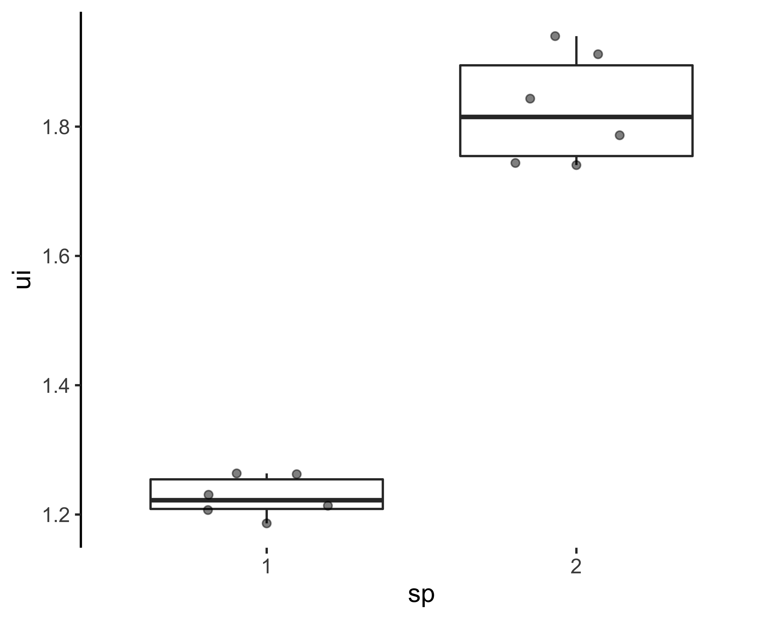

ui %>%   
 ggplot(aes(x = sp, y = ui)) +  
 geom_boxjitter(jitter.height = 0) +  
 theme_classic() +  
 theme(axis.line.x = element_blank(),  
 text = element_text(size = 12))

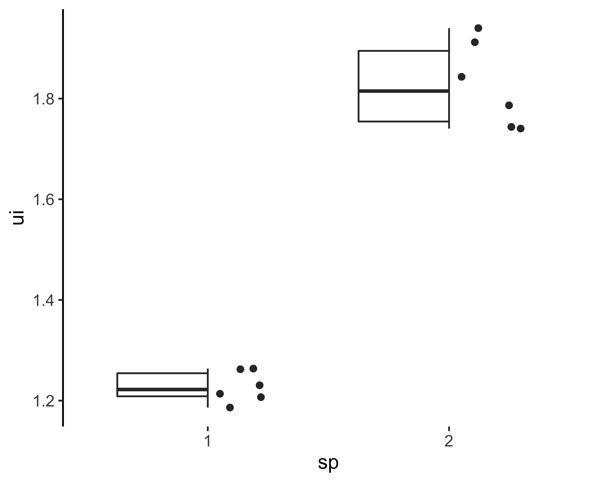

## Tukey

# ANOVA angle

## Média e desvio padrão

angle %>%   
 group_by(sp, face) %>%   
 summarise(avg = mean(angle),  
 sd = sd(angle)) %>%   
 knitr::kable(digits = 4)

|  |  |  |  |
| --- | --- | --- | --- |
| sp | face | avg | sd |
| 1 | 1 | 78.375 | 7.6618 |
| 1 | 2 | 81.750 | 2.4289 |
| 2 | 1 | 142.075 | 2.6876 |
| 2 | 2 | 143.500 | 4.1579 |

## Código

angle_m1 <- lm(angle ~ sp*face, data = angle)  
  
anova(angle_m1)  
  
(TukeyHSD(aov(angle_m1)))  
  
# angle_m2 <- update(angle_m1, . ~ . - sp:face)  
#   
# anova(angle_m1, angle_m2)  
#   
# anova(angle_m2)

## Tabela

|  |  |  |  |  |  |
| --- | --- | --- | --- | --- | --- |
|  | Df | Sum Sq | Mean Sq | F value | P value |
| sp | 1 | 11803.277 | 11803.277 | 529.807 | 0.000 |
| face | 1 | 17.280 | 17.280 | 0.776 | 0.404 |
| sp:face | 1 | 2.852 | 2.852 | 0.128 | 0.730 |
| Residuals | 8 | 178.227 | 22.278 | NA | NA |

## Gráfico

Os dois gráficos abaixo tem as mesmas informções, escolha o que mais lhe agradar.

angle %>%   
 ggplot(aes(x = sp, y = angle)) +  
 geom_boxplot() +  
 geom_quasirandom(groupOnX = T,  
 alpha = .5) +  
 theme_classic() +  
 theme(axis.line.x = element_blank(),  
 text = element_text(size = 12))

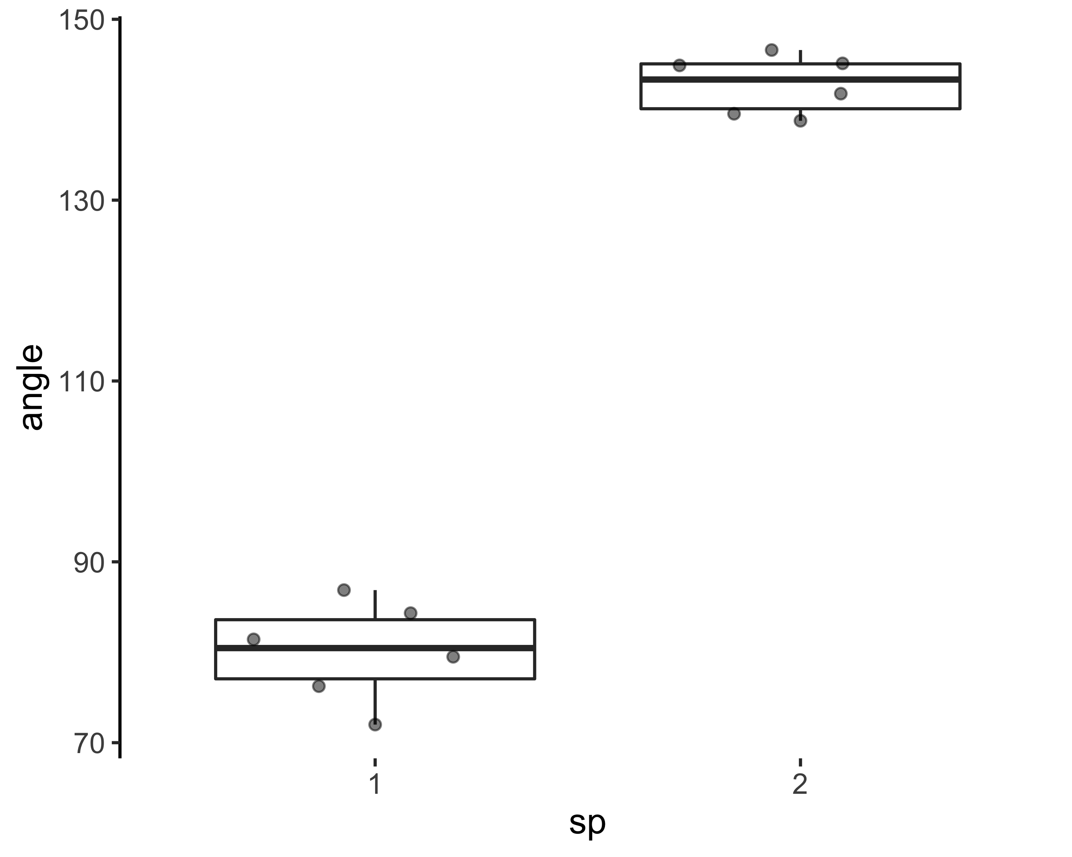

angle %>%   
 ggplot(aes(x = sp, y = angle, color = face)) +  
 geom_boxjitter(jitter.height = 0) +  
 theme_classic() +  
 theme(axis.line.x = element_blank(),  
 text = element_text(size = 12))



 