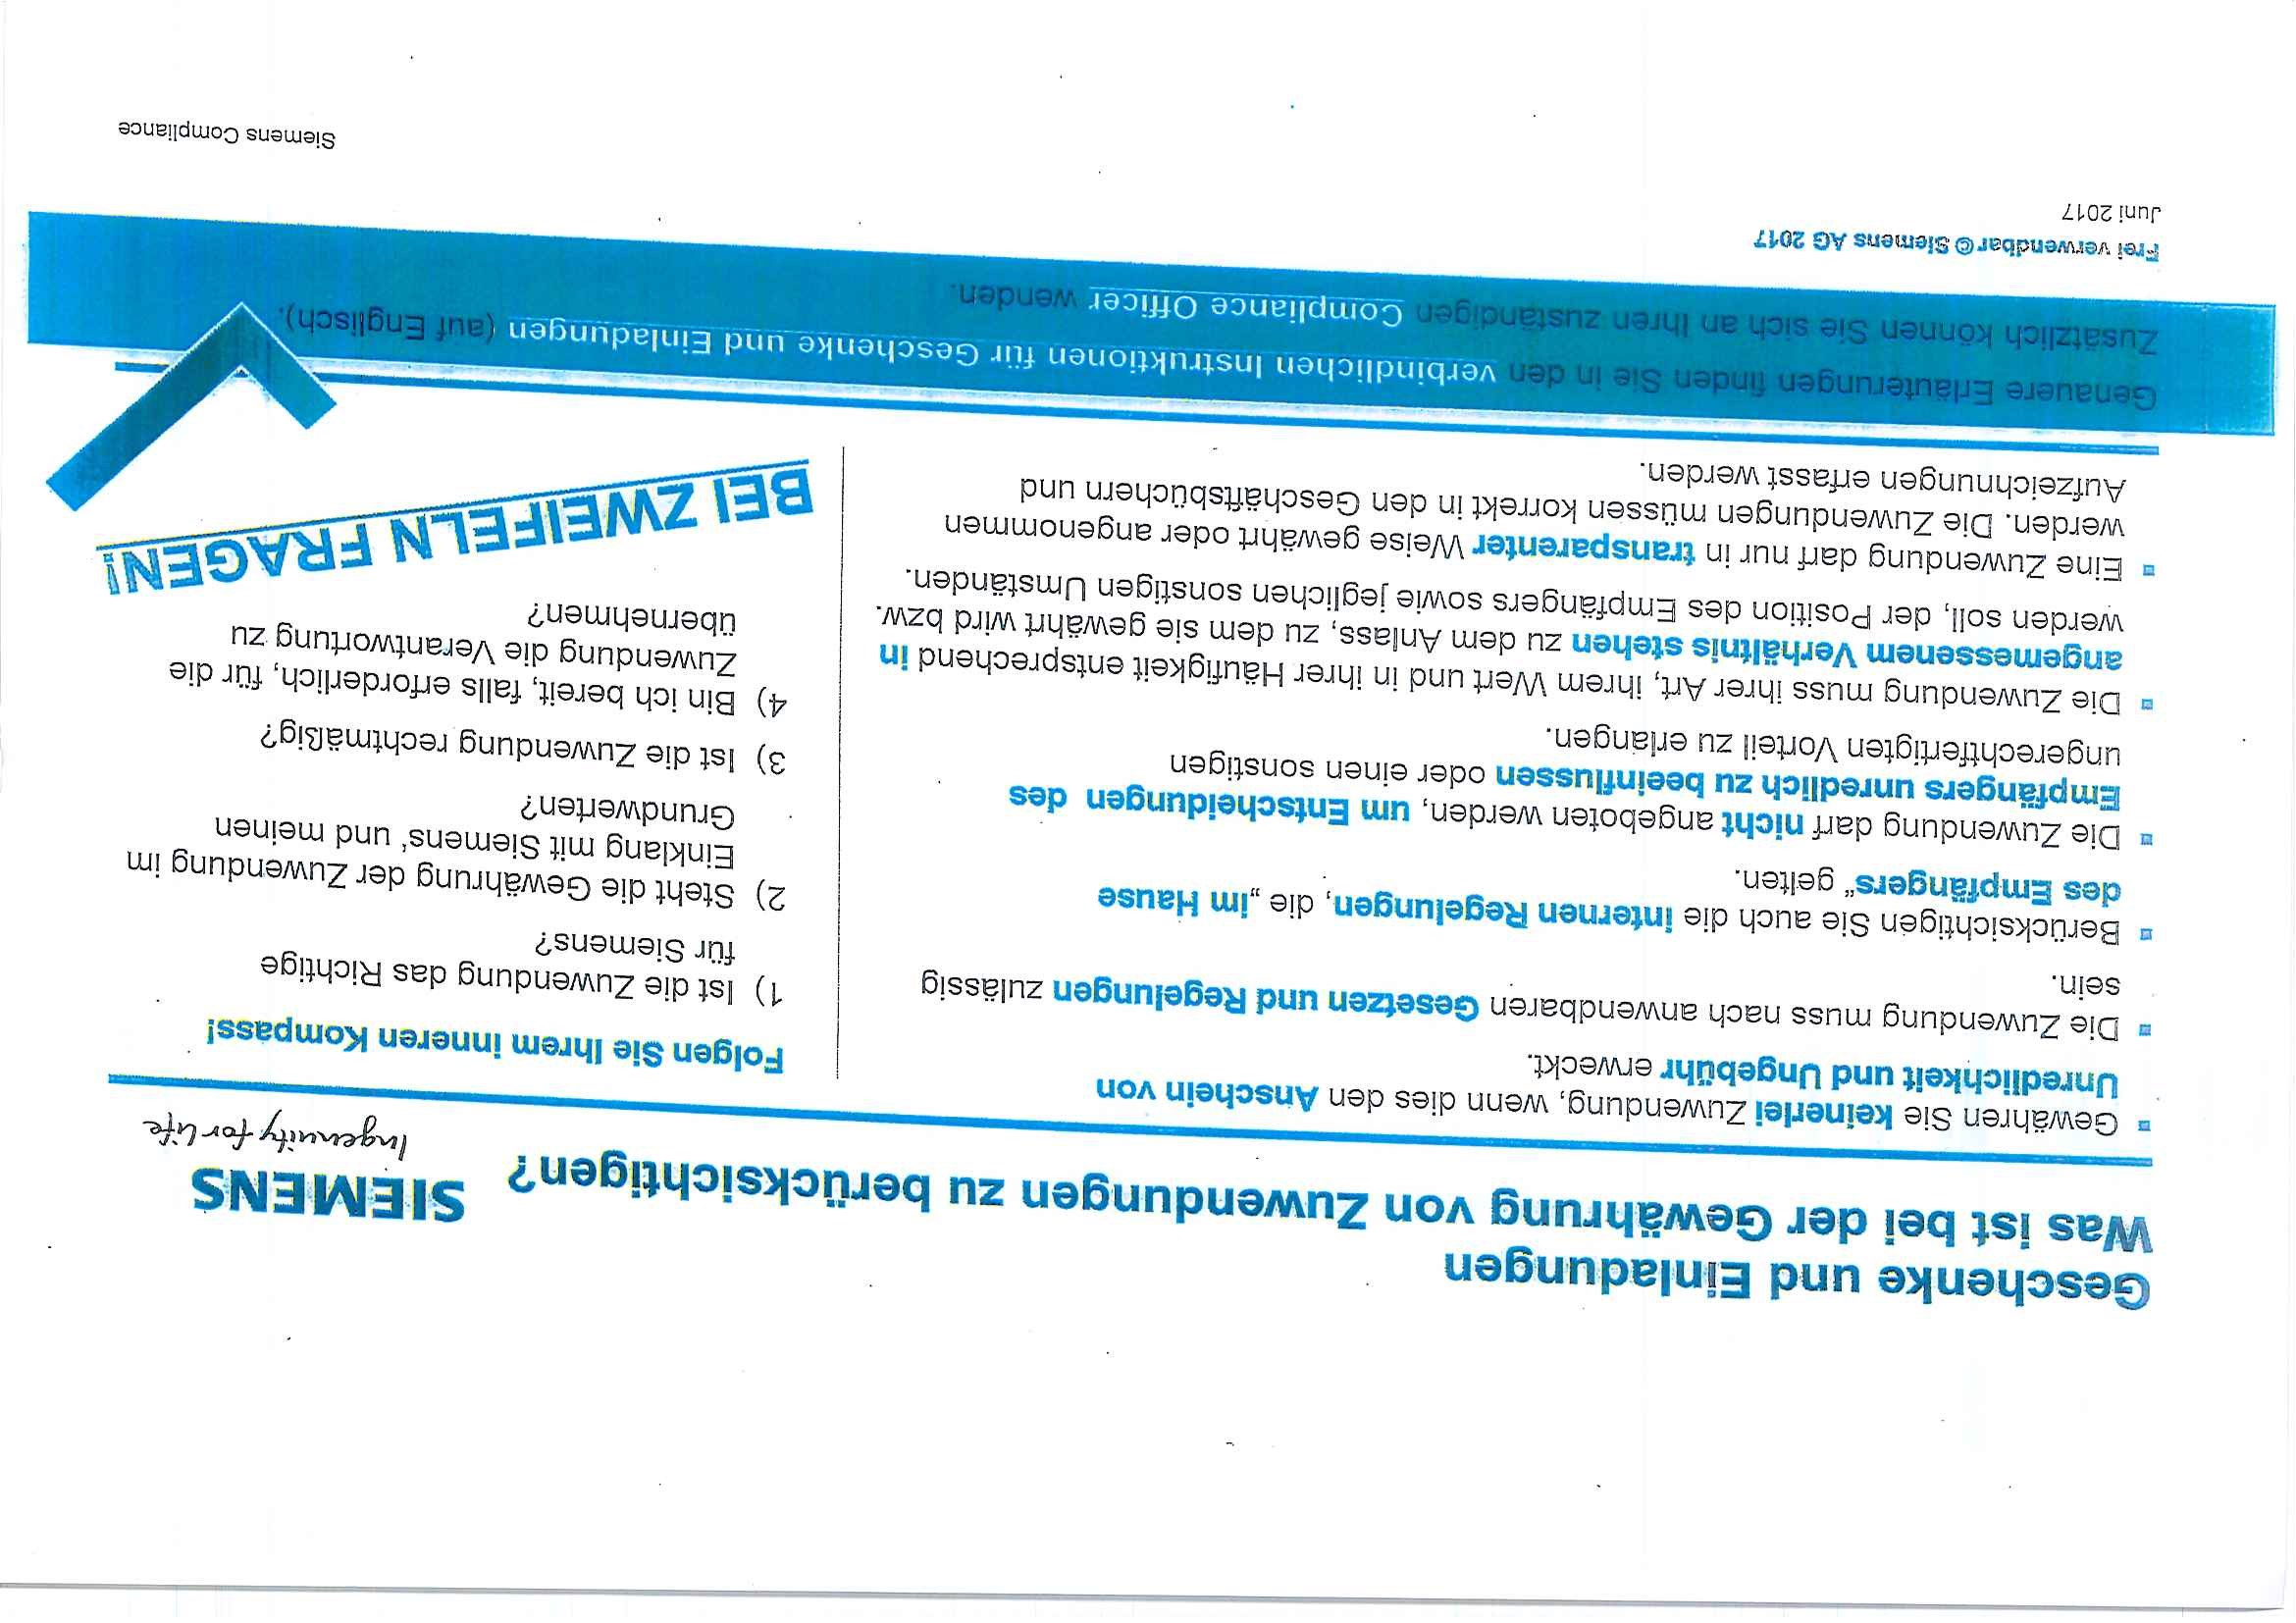
Created by unlicensed version of PDF Focus .Net 7.7.7.24!
The unlicensed version inserts "trial" into random places.
This text will disappear after purchasing the license.

