COMP229 — Web Application Development
Mid-Term Test
Fran's Campus Lost & Found REST API
REST API Test Evidence — Postman & MongoDB Compass
Francis Torres
Student ID: 301530008
Project: COMP229-MidTerm-301530008
https://github.com/francismtorres/COMP229-MidTerm-301530008
October 23, 2026

Contents
Overview & Environment 3
Server start-up log (connected to MongoDB, listening on 8080) 3
How the tests are organised 3
Status codes implemented 3
Test Results Summary 4
Evidence: updating or deleting another user's item is rejected 6
Screenshots 7
1. Server running on port 8080 7
2. Authentication (provided signup / signin / JWT) 7
3. Create items — POST /api/items (Bearer) 11
MongoDB evidence — Create items 15
4. Read items — GET (public and Bearer) 17
5. Update items — PUT /api/items/:id (Bearer, owner only) 23
MongoDB evidence — Update items 27
6. Delete items — DELETE (Bearer, owner only) 28
MongoDB evidence — Delete items 32

Overview & Environment
This document records the testing of Fran's Campus Lost & Found REST API, built on the provided starter project (Node.js, Express, MongoDB, Mongoose, TypeScript). Signup/signin and the JWT middleware were provided; the Item model validation, HTTP input validation, the seven item controllers and the item routes were implemented for this test.
Every request was sent from Postman against the running server, and the resulting data changes were verified in MongoDB Compass. Two users were created so that the owner-only rules could be tested: Francis Torres (owner) and Alex Other (a second user who tries to change Fran's items).
Item | Value
Node.js | v24.21.0
Framework | Express 4 + TypeScript (ESM), Mongoose 8
Database | MongoDB 8.3 Community, local (mongodb://127.0.0.1:27017/comp229_midterm_fran)
Port | 8080 (PORT=8080 in .env)
Run command | npm install → npm run build → npm start (or npm run dev)
REST client | Postman 12 — collection: postman/Fran-LostFound.postman_collection.json
DB viewer | MongoDB Compass 1.53
Source code | https://github.com/francismtorres/COMP229-MidTerm-301530008

Server start-up log (connected to MongoDB, listening on 8080)
> comp229-midterm-301530008@2.0.0 start
> node dist/server.js
[db] Connected to MongoDB: comp229_midterm_fran
[server] Listening on http://localhost:8080 (development)

How the tests are organised
The Postman collection is split into folders that are run top to bottom. Signin requests save the JWT into collection variables ({{franToken}}, {{alexToken}}), and create requests save the new item ids ({{franItemId}}, {{franItem2Id}}). Every request has Postman test scripts that assert the expected status code; the whole collection was also run with Newman (Postman's command-line runner): 44 requests, 56 assertions, 0 failures.

Status codes implemented
Situation | Status | Example (figure)
Successful GET / PUT / DELETE | 200 | Fig. 22, 33, 47
Successful create | 201 | Fig. 14
Invalid body, invalid filter, malformed id or JSON | 400 | Fig. 11, 26, 28, 13
Missing / invalid JWT | 401 | Fig. 9, 10
Not the item owner | 403 | Fig. 34, 43
Item not found | 404 | Fig. 29, 48
Duplicate title (unique field) | 409 | Fig. 16, 39

Test Results Summary
Every row below matches a screenshot later in this document. "Actual" is the status shown in the Postman response pane of that screenshot.
Fig. | Method | URL | Scenario | Status | Result
1 | GET | / | API root confirms the server is up on port 8080 and personalised for Fran | 200 OK | Pass
2 | POST | /api/auth/signup | Sign up user #1 (Francis Torres) and receive a JWT | 201 Created | Pass
3 | POST | /api/auth/signup | Sign up again with the same email | 409 Conflict | Pass
4 | POST | /api/auth/signin | Sign in with a wrong password | 401 Unauthorized | Pass
5 | POST | /api/auth/signin | Sign in Fran; the test script stores the token in {{franToken}} | 200 OK | Pass
6 | POST | /api/auth/signup | Sign up user #2 (Alex Other), used to prove ownership rules | 201 Created | Pass
7 | POST | /api/auth/signin | Sign in Alex; token stored in {{alexToken}} | 200 OK | Pass
8 | GET | /api/auth/me | Bearer token resolves to the signed-in user | 200 OK | Pass
9 | POST | /api/items | Create without an Authorization header | 401 Unauthorized | Pass
10 | POST | /api/items | Create with a forged token ("Bearer not.a.real.token"; Postman masks the literal value as a vault variable) | 401 Unauthorized | Pass
11 | POST | /api/items | Only a title is sent; every missing required field is reported | 400 Bad Request | Pass
12 | POST | /api/items | Invalid type, category and a future date are rejected | 400 Bad Request | Pass
13 | POST | /api/items | Malformed JSON body | 400 Bad Request | Pass
14 | POST | /api/items | Fran creates "Black Jansport Backpack"; owner is set from the JWT and status defaults to Open | 201 Created | Pass
15 | POST | /api/items | Fran creates "White AirPods Pro Case" | 201 Created | Pass
16 | POST | /api/items | Duplicate title in different case ("black jansport backpack") is rejected; title is the unique field | 409 Conflict | Pass
17 | POST | /api/items | Alex creates "Web Application Development Textbook" | 201 Created | Pass
22 | GET | /api/items | List all items (public); test asserts 3 items | 200 OK | Pass
23 | GET | /api/items?type=Found | Filter by type; every result is Found | 200 OK | Pass
24 | GET | /api/items?category=Electronics | Filter by category | 200 OK | Pass
25 | GET | /api/items?type=Found&category=Books | Combined filters; exactly 1 match | 200 OK | Pass
26 | GET | /api/items?type=Stolen | Unknown filter value | 400 Bad Request | Pass
27 | GET | /api/items/{{franItemId}} | Get a single item by id (public, owner populated) | 200 OK | Pass
28 | GET | /api/items/not-a-valid-id | Malformed ObjectId | 400 Bad Request | Pass
29 | GET | /api/items/64b000000000000000000000 | Valid ObjectId that does not exist | 404 Not Found | Pass
30 | GET | /api/items/mine | Fran's items only (Bearer {{franToken}}) | 200 OK | Pass
31 | GET | /api/items/mine | Postman Test Results: "Only Fran's 2 items" PASSED (Alex's item is excluded) | 200 OK | Pass
32 | GET | /api/items/mine | Protected route without a token | 401 Unauthorized | Pass
33 | PUT | /api/items/{{franItemId}} | Owner (Fran) marks the backpack Returned and changes its location | 200 OK | Pass
34 | PUT | /api/items/{{franItemId}} | OWNERSHIP: Alex tries to rename Fran's item to "Hijacked by Alex" — rejected | 403 Forbidden | Pass
35 | PUT | /api/items/{{franItemId}} | Same request, Headers tab: it is sent with Alex's token (Bearer {{alexToken}}) | 403 Forbidden | Pass
36 | PUT | /api/items/{{franItemId}} | Update without a token | 401 Unauthorized | Pass
37 | PUT | /api/items/{{franItemId}} | Invalid status and an attempt to overwrite owner | 400 Bad Request | Pass
38 | PUT | /api/items/{{franItemId}} | Empty body {} | 400 Bad Request | Pass
39 | PUT | /api/items/{{franItem2Id}} | Rename to a title already used by another item | 409 Conflict | Pass
40 | PUT | /api/items/12345 | Malformed ObjectId | 400 Bad Request | Pass
41 | PUT | /api/items/64b000000000000000000000 | Item does not exist | 404 Not Found | Pass
43 | DELETE | /api/items/{{franItemId}} | OWNERSHIP: Alex tries to delete Fran's item (Bearer {{alexToken}}) — rejected | 403 Forbidden | Pass
44 | DELETE | /api/items/{{franItemId}} | Delete without a token | 401 Unauthorized | Pass
45 | DELETE | /api/items/abc | Malformed ObjectId | 400 Bad Request | Pass
46 | DELETE | /api/items/64b000000000000000000000 | Item does not exist | 404 Not Found | Pass
47 | DELETE | /api/items/{{franItemId}} | Owner (Fran) deletes the backpack | 200 OK | Pass
48 | GET | /api/items/{{franItemId}} | The deleted item is gone | 404 Not Found | Pass
49 | DELETE | /api/items/mine | Delete all of Fran's items; deletedCount = 1 (the AirPods) | 200 OK | Pass
50 | GET | /api/items/mine | Fran now has no items: [] | 200 OK | Pass
51 | GET | /api/items | Alex's item is unaffected by Fran's DELETE /mine | 200 OK | Pass

Evidence: updating or deleting another user's item is rejected
The items were created by Francis Torres. Signed in as Alex Other, the same requests were sent with Alex's JWT. The API compares item.owner with the user id taken from the verified token, and returns 403 Forbidden before touching the document:
• Fig. 34 & 35: PUT by Alex → 403 "Forbidden: you can only update your own items".
• Fig. 43: DELETE by Alex → 403 "Forbidden: you can only delete your own items".
• Fig. 42: MongoDB still shows the original title, so the rejected update changed nothing.
• Fig. 51 & 52: Fran's DELETE /api/items/mine removed only Fran's items; Alex's item remains.

Screenshots

1. Server running on port 8080
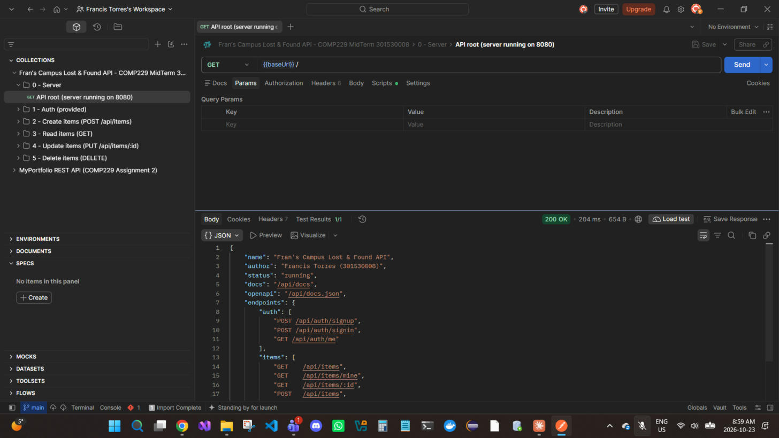
Figure 1 — GET / — API root confirms the server is up on port 8080 and personalised for Fran → 200 OK

2. Authentication (provided signup / signin / JWT)
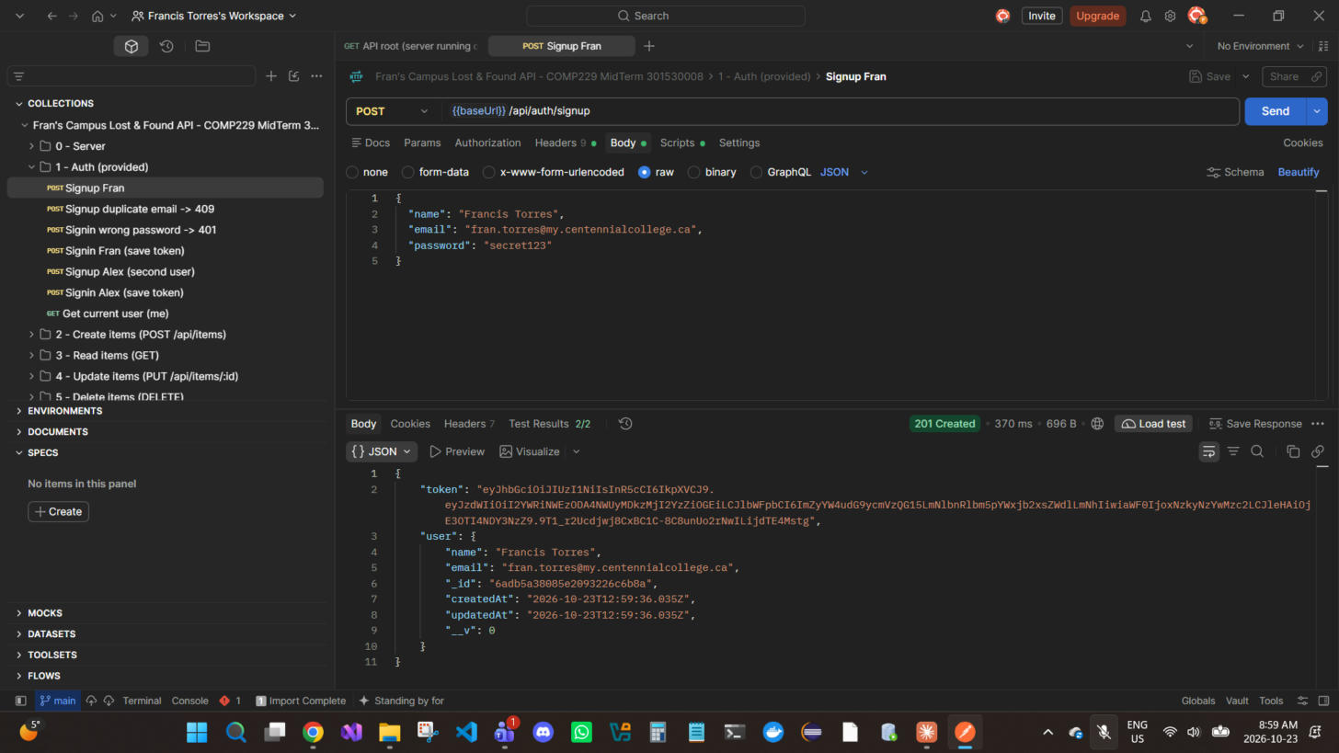
Figure 2 — POST /api/auth/signup — Sign up user #1 (Francis Torres) and receive a JWT → 201 Created
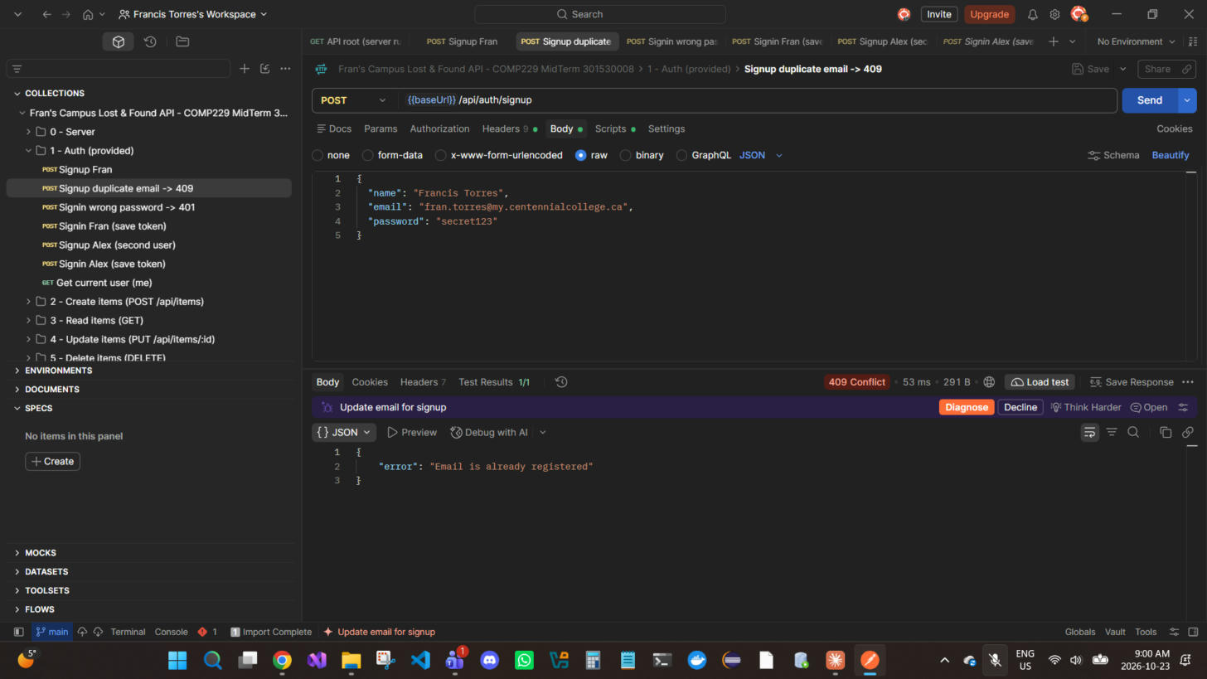
Figure 3 — POST /api/auth/signup — Sign up again with the same email → 409 Conflict
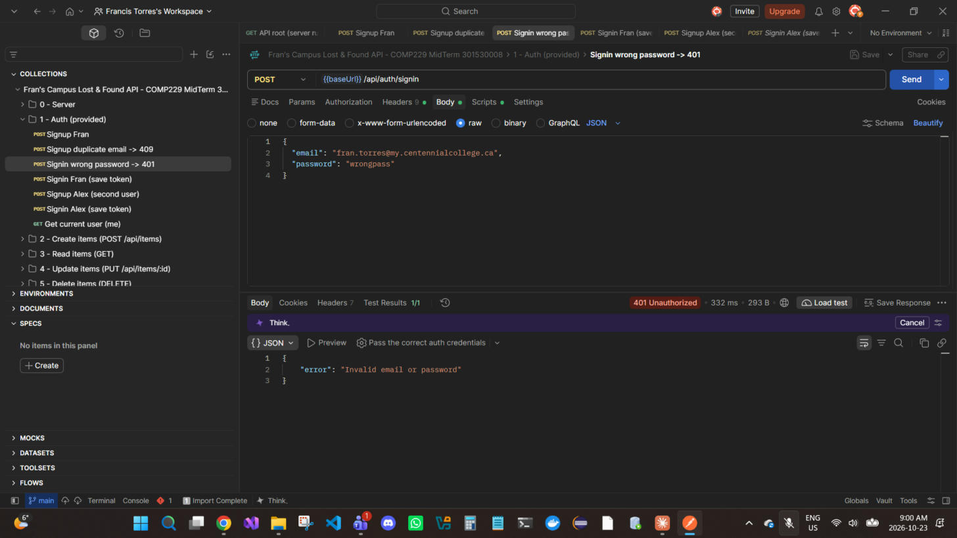
Figure 4 — POST /api/auth/signin — Sign in with a wrong password → 401 Unauthorized
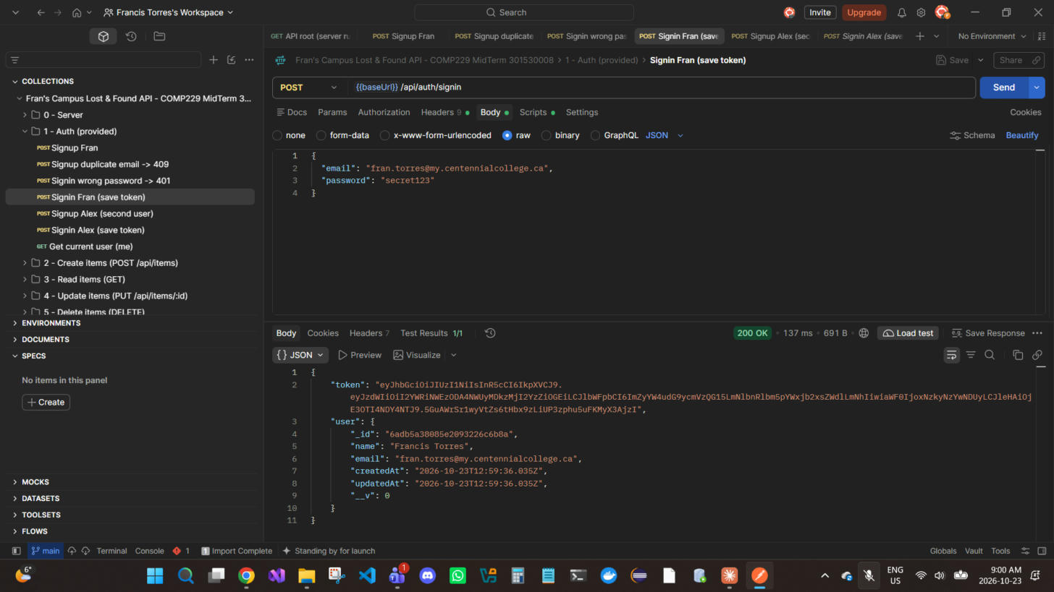
Figure 5 — POST /api/auth/signin — Sign in Fran; the test script stores the token in {{franToken}} → 200 OK
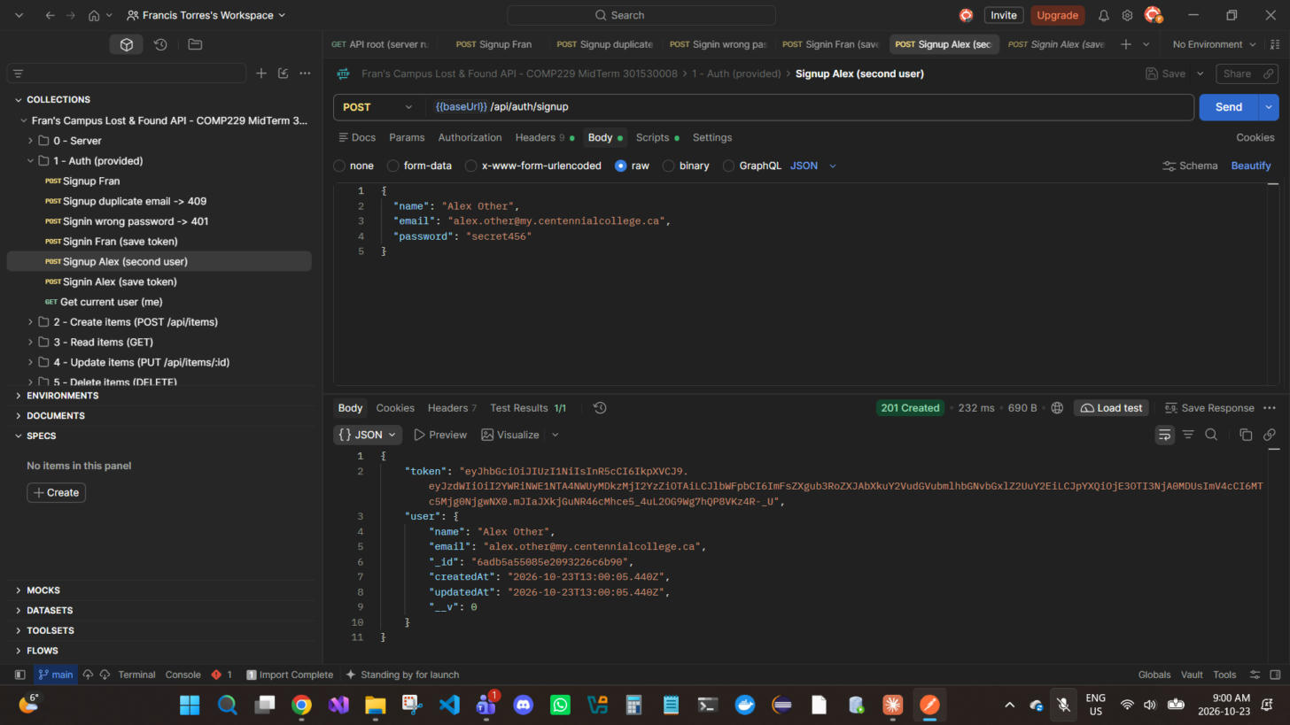
Figure 6 — POST /api/auth/signup — Sign up user #2 (Alex Other), used to prove ownership rules → 201 Created
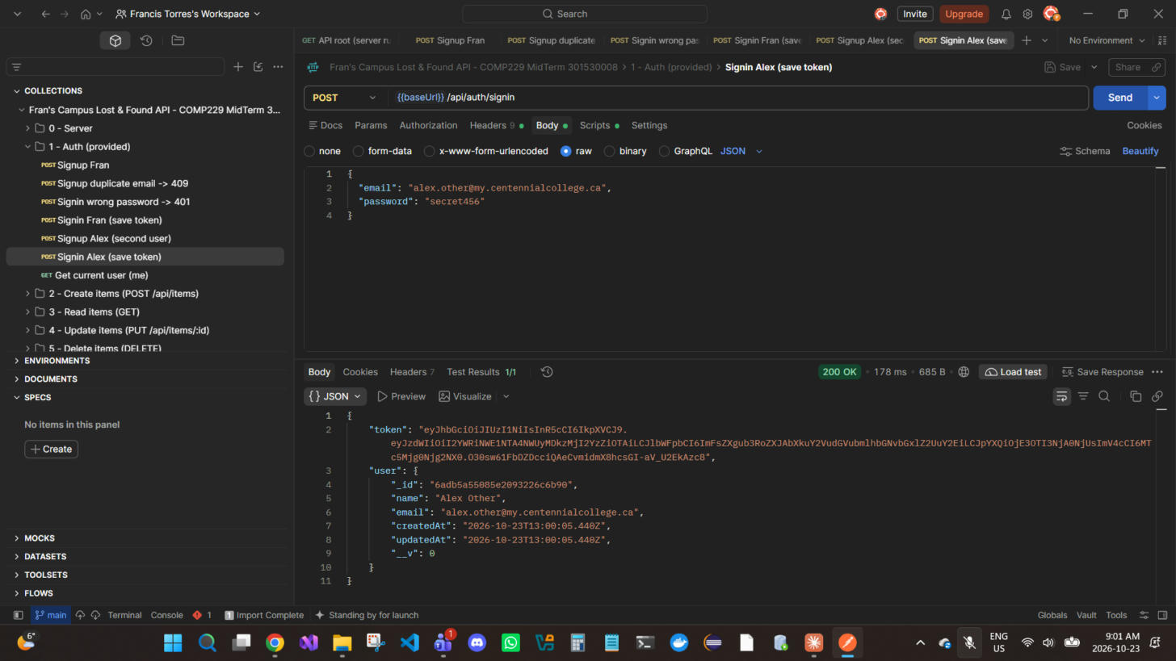
Figure 7 — POST /api/auth/signin — Sign in Alex; token stored in {{alexToken}} → 200 OK
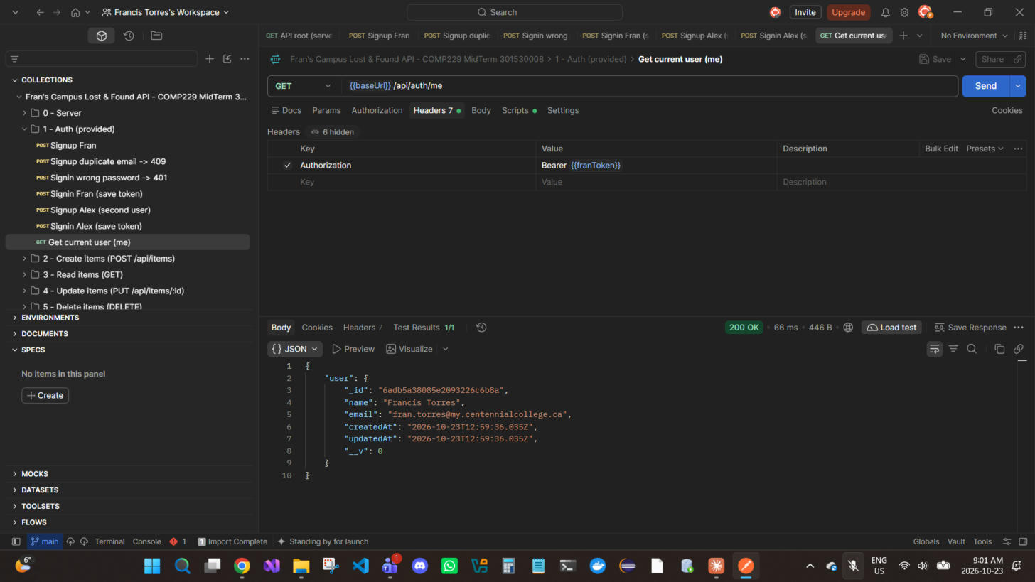
Figure 8 — GET /api/auth/me — Bearer token resolves to the signed-in user → 200 OK

3. Create items — POST /api/items (Bearer)
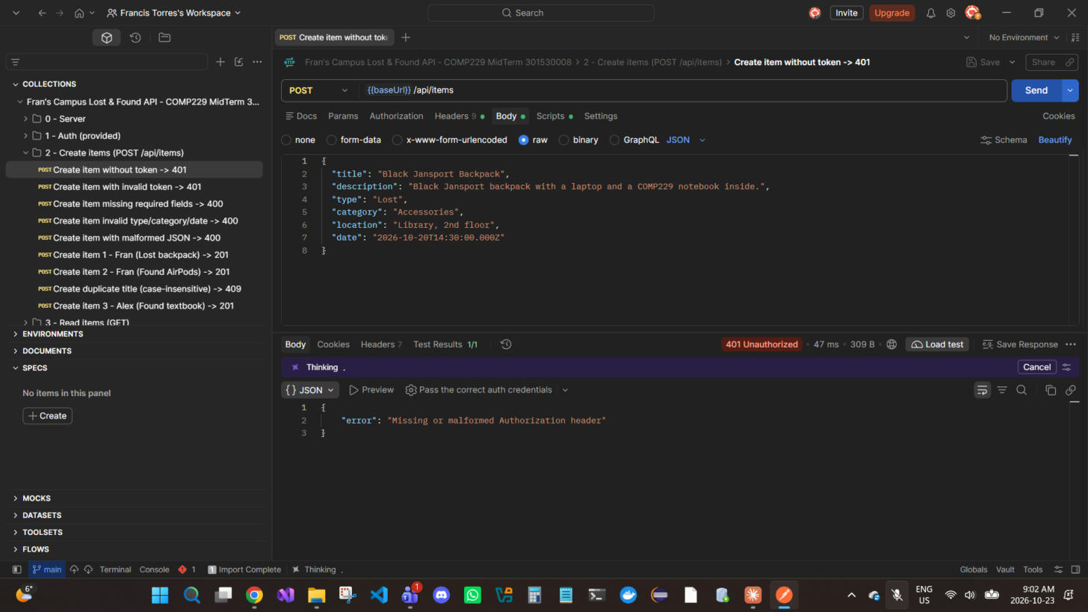
Figure 9 — POST /api/items — Create without an Authorization header → 401 Unauthorized
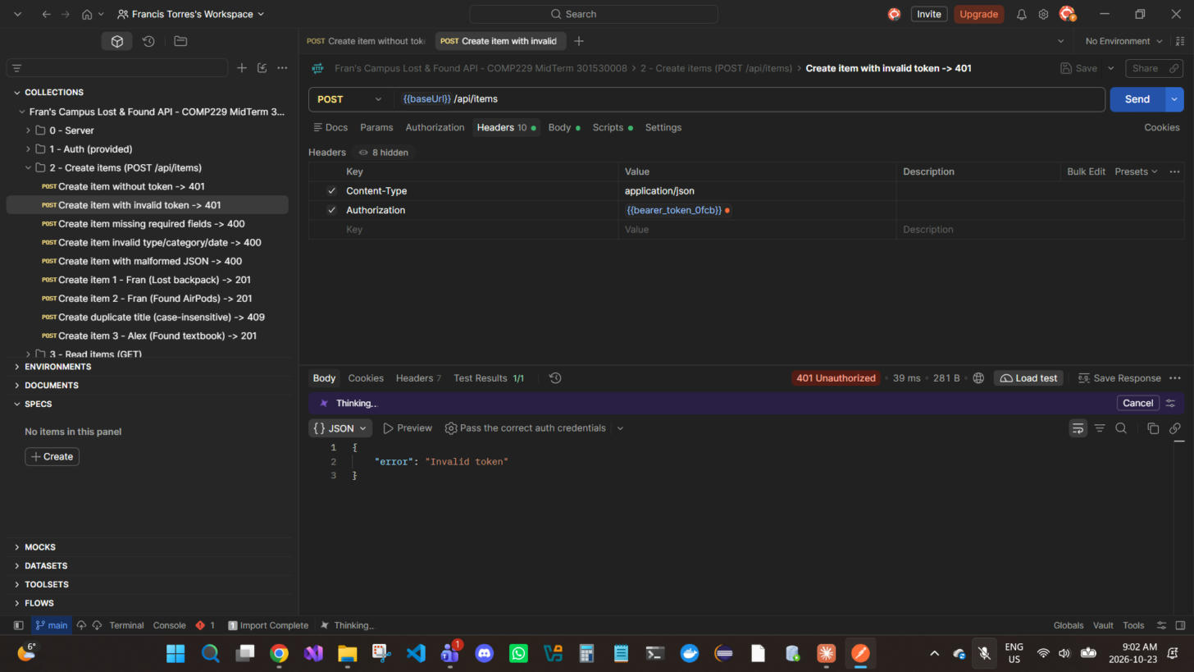
Figure 10 — POST /api/items — Create with a forged token ("Bearer not.a.real.token"; Postman masks the literal value as a vault variable) → 401 Unauthorized
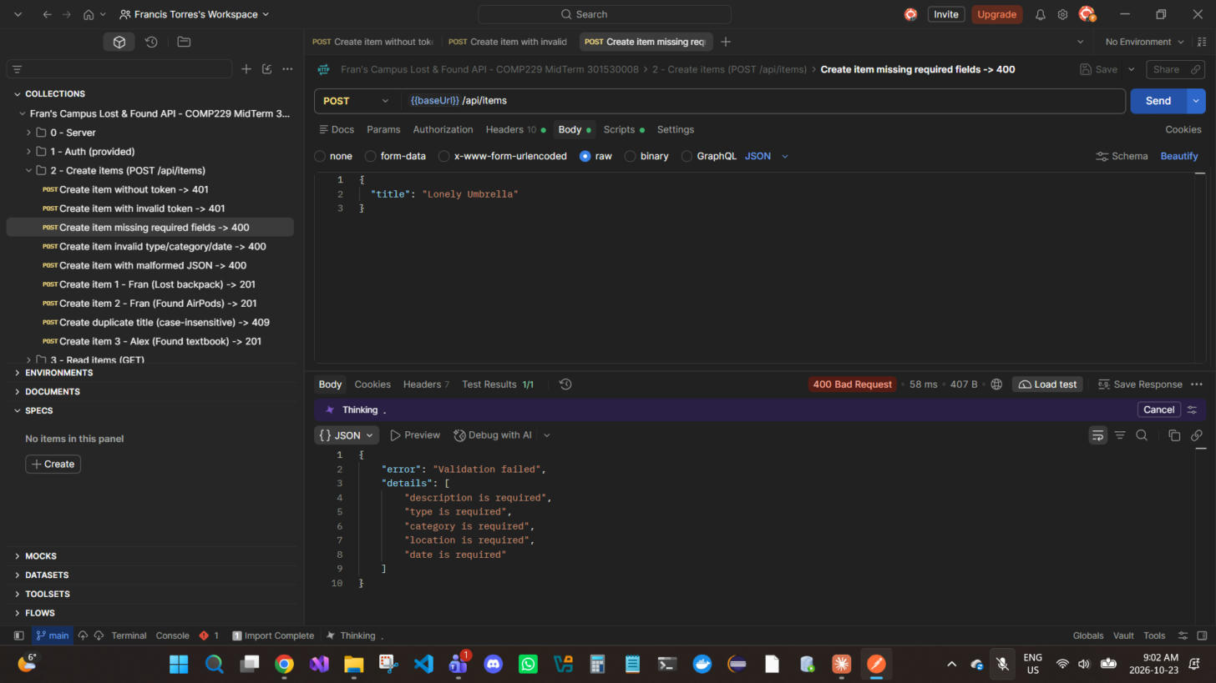
Figure 11 — POST /api/items — Only a title is sent; every missing required field is reported → 400 Bad Request
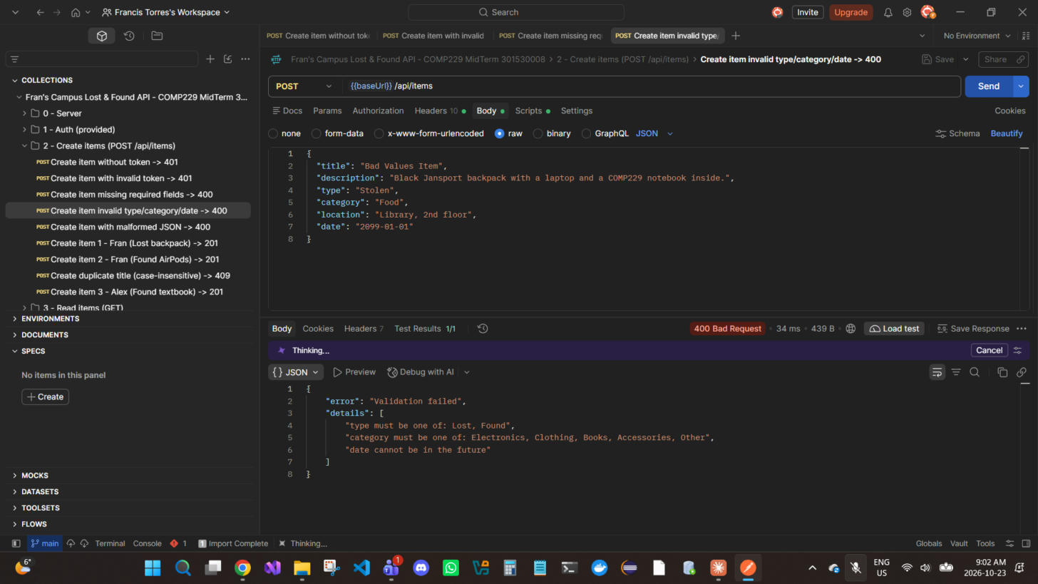
Figure 12 — POST /api/items — Invalid type, category and a future date are rejected → 400 Bad Request
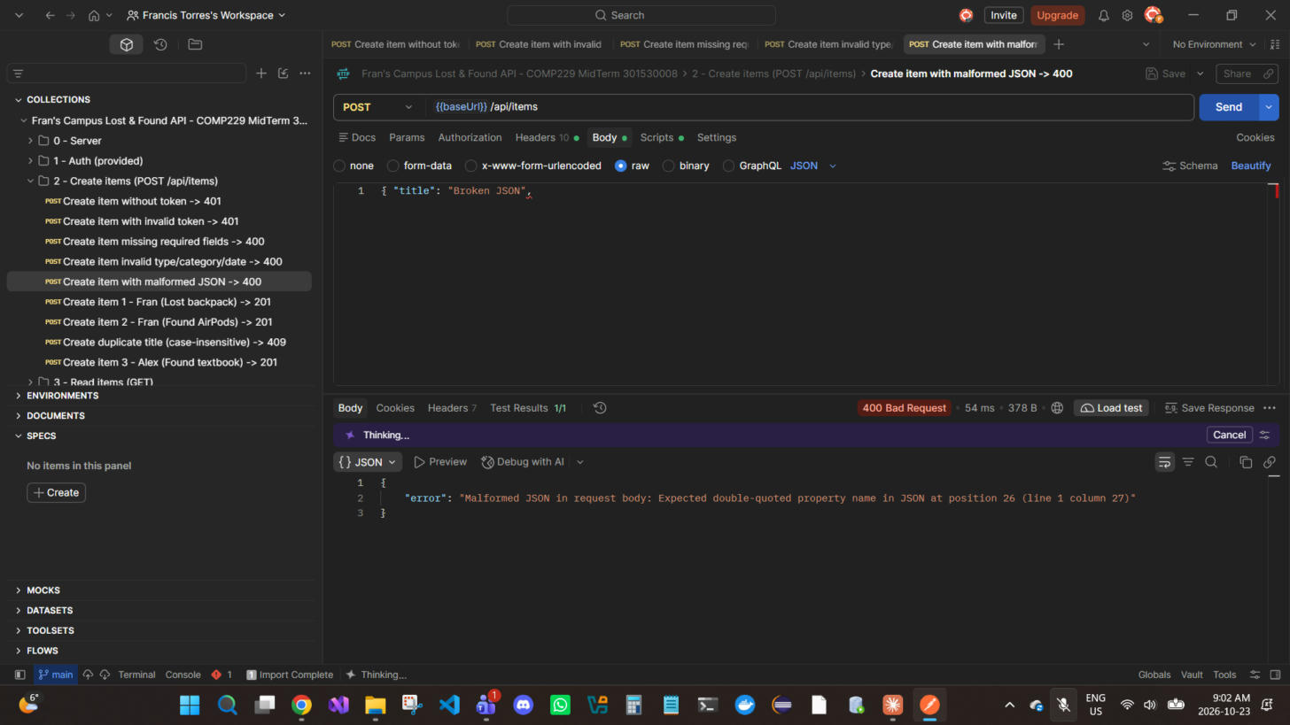
Figure 13 — POST /api/items — Malformed JSON body → 400 Bad Request
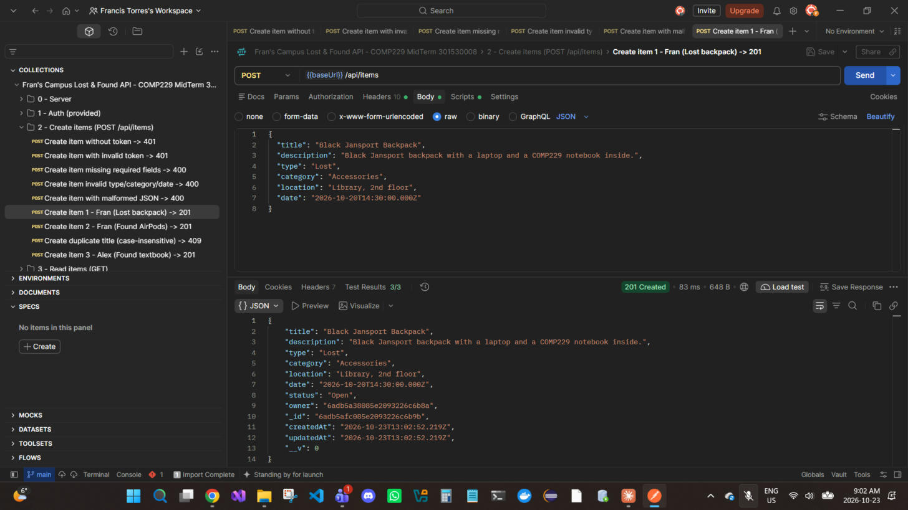
Figure 14 — POST /api/items — Fran creates "Black Jansport Backpack"; owner is set from the JWT and status defaults to Open → 201 Created
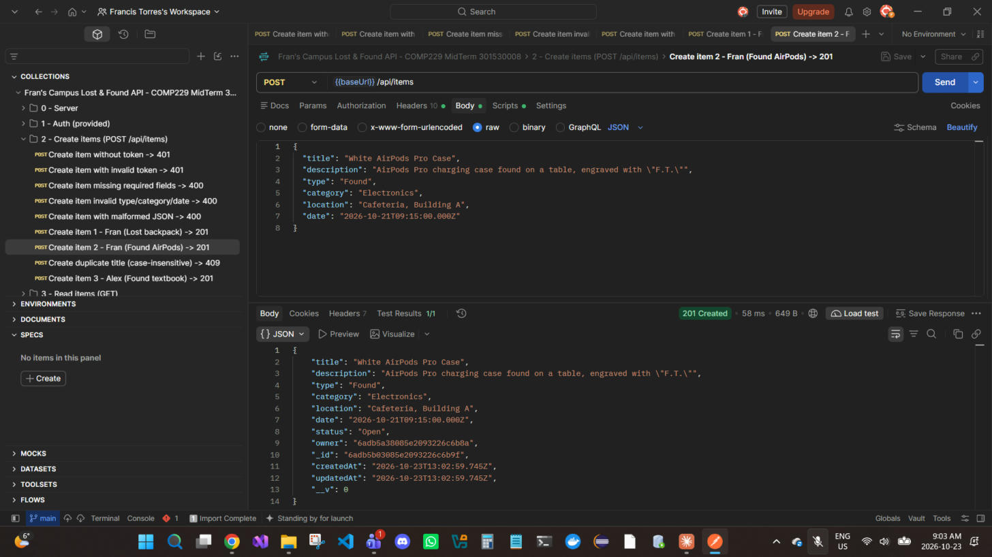
Figure 15 — POST /api/items — Fran creates "White AirPods Pro Case" → 201 Created
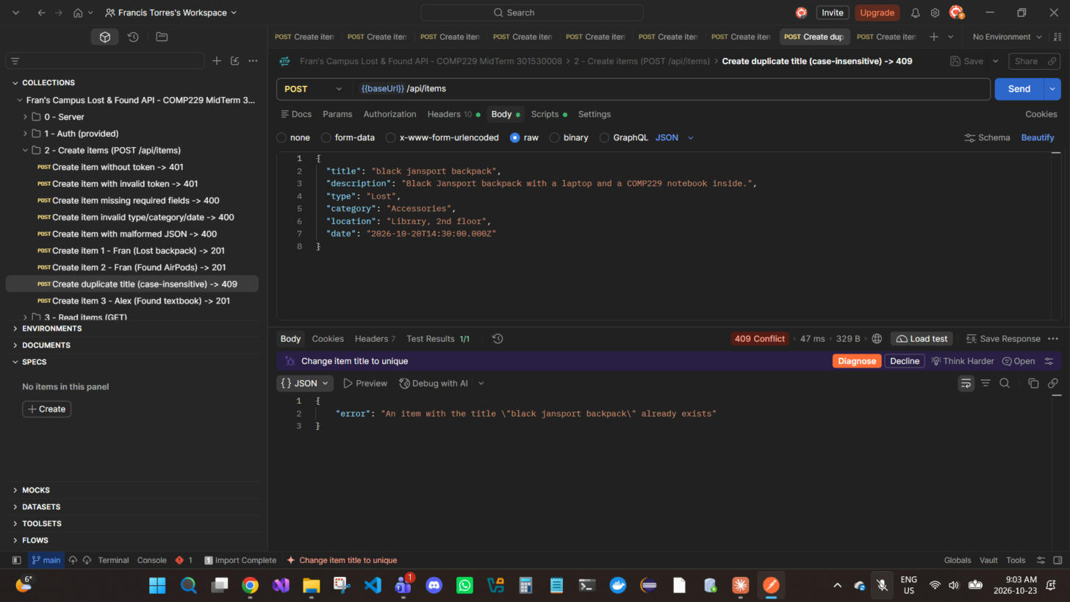
Figure 16 — POST /api/items — Duplicate title in different case ("black jansport backpack") is rejected; title is the unique field → 409 Conflict
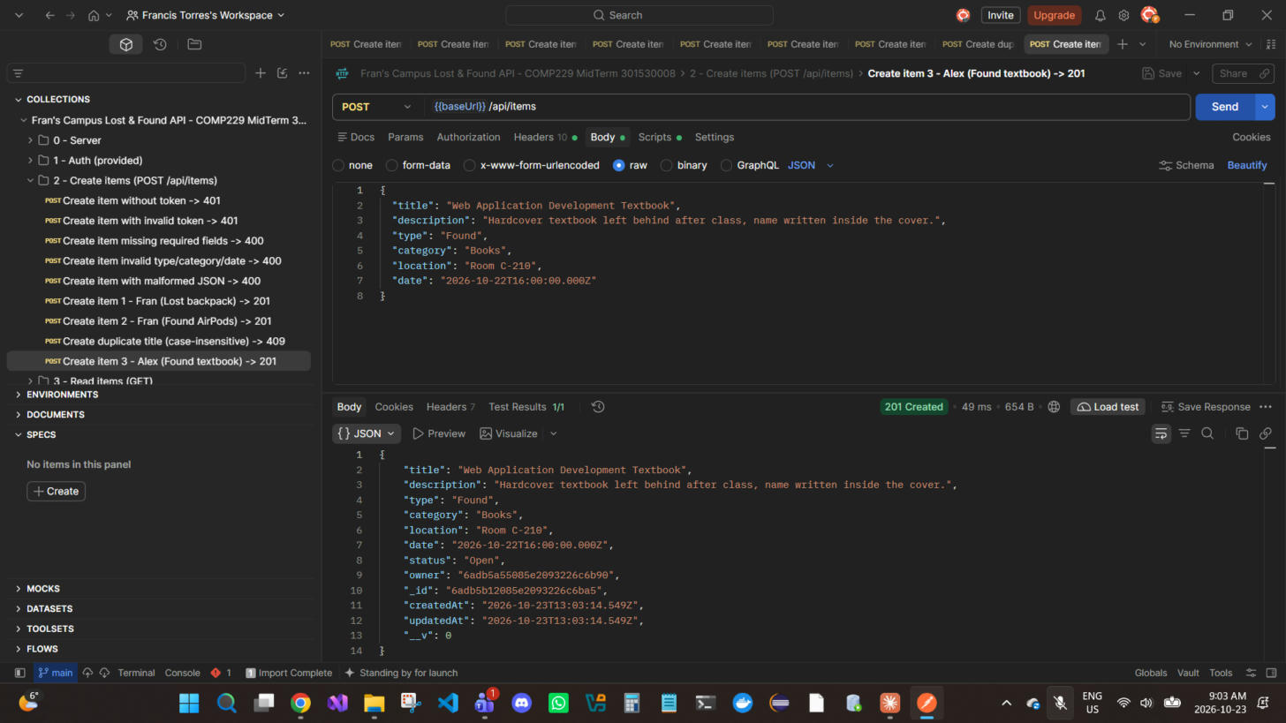
Figure 17 — POST /api/items — Alex creates "Web Application Development Textbook" → 201 Created

MongoDB evidence — Create items
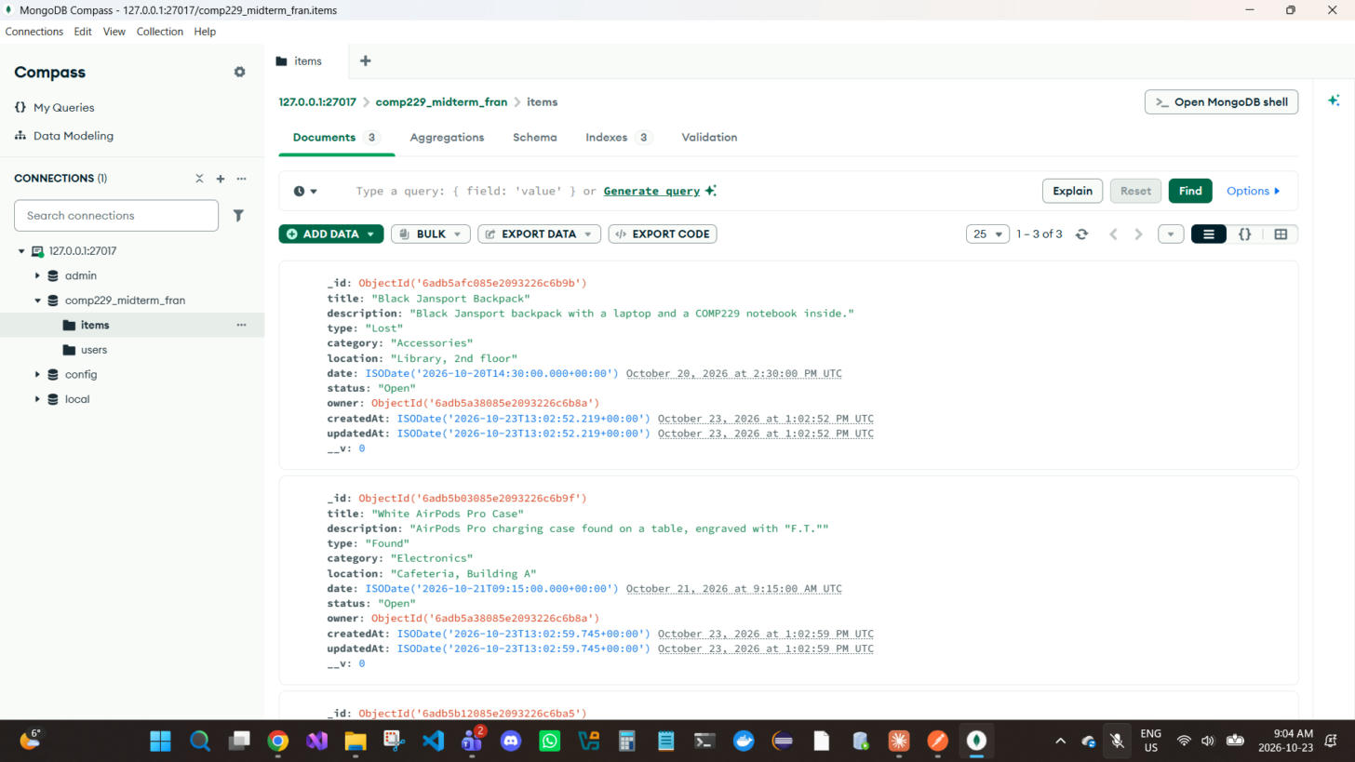
Figure 18 — MongoDB Compass: comp229_midterm_fran.items now holds the 3 created documents (1–3 of 3) with owner ObjectIds and timestamps.
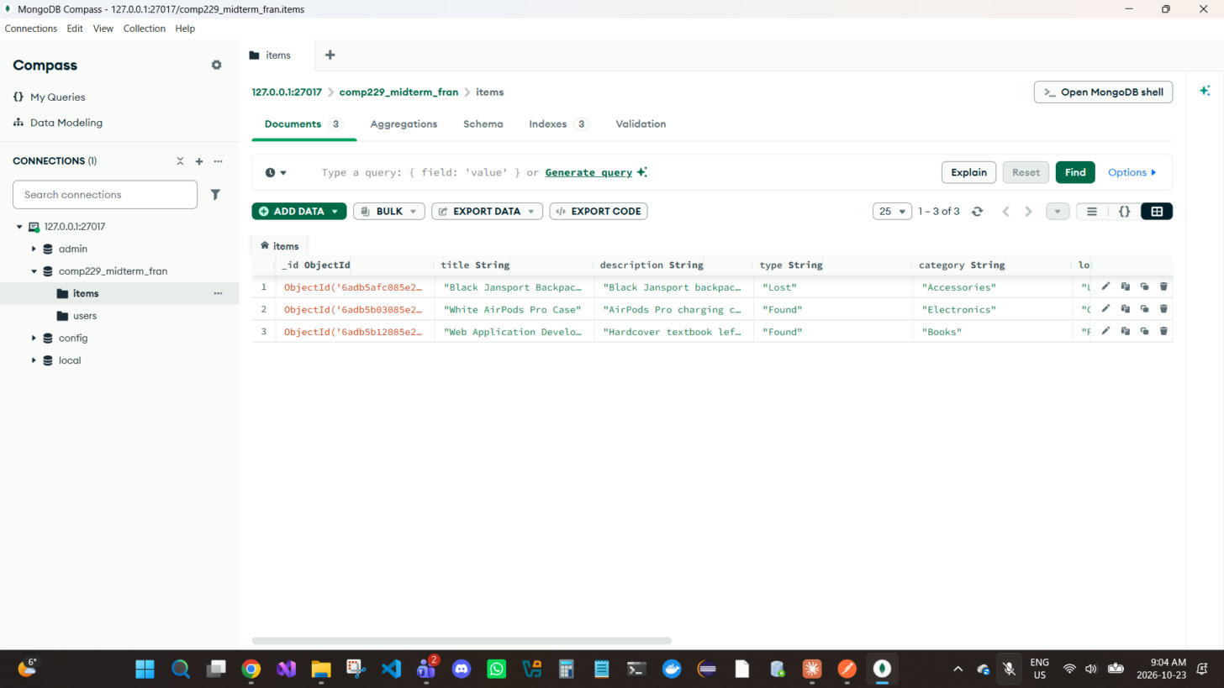
Figure 19 — MongoDB Compass table view of the same 3 documents.
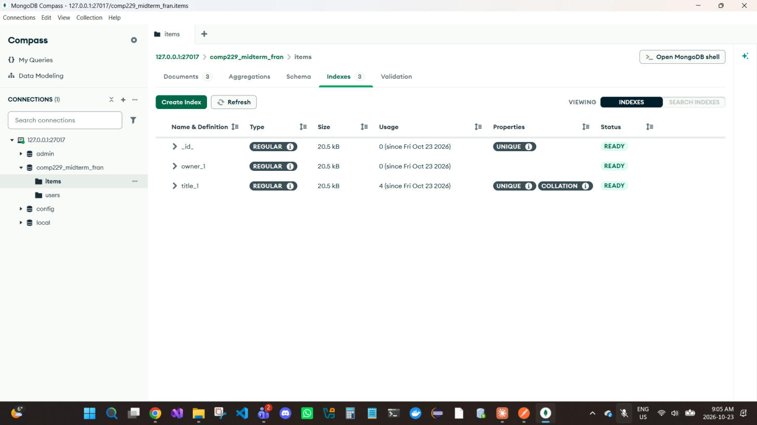
Figure 20 — Indexes tab: title_1 is UNIQUE with a case-insensitive COLLATION (prevents duplicate items); owner_1 speeds up /mine queries.
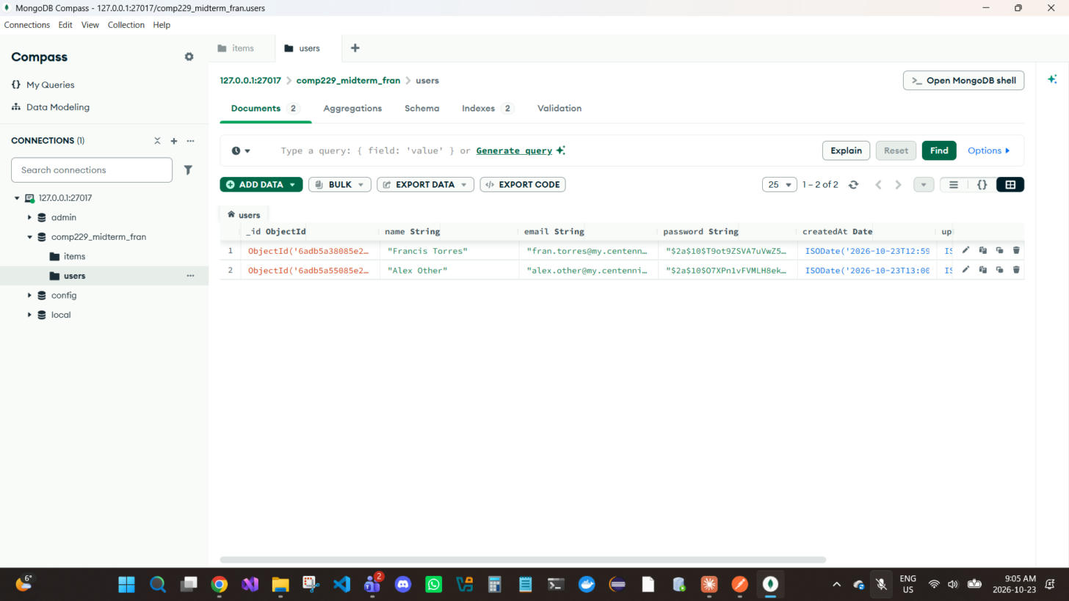
Figure 21 — users collection: both test users, with bcrypt-hashed passwords ($2a$10$...), never plain text.

4. Read items — GET (public and Bearer)
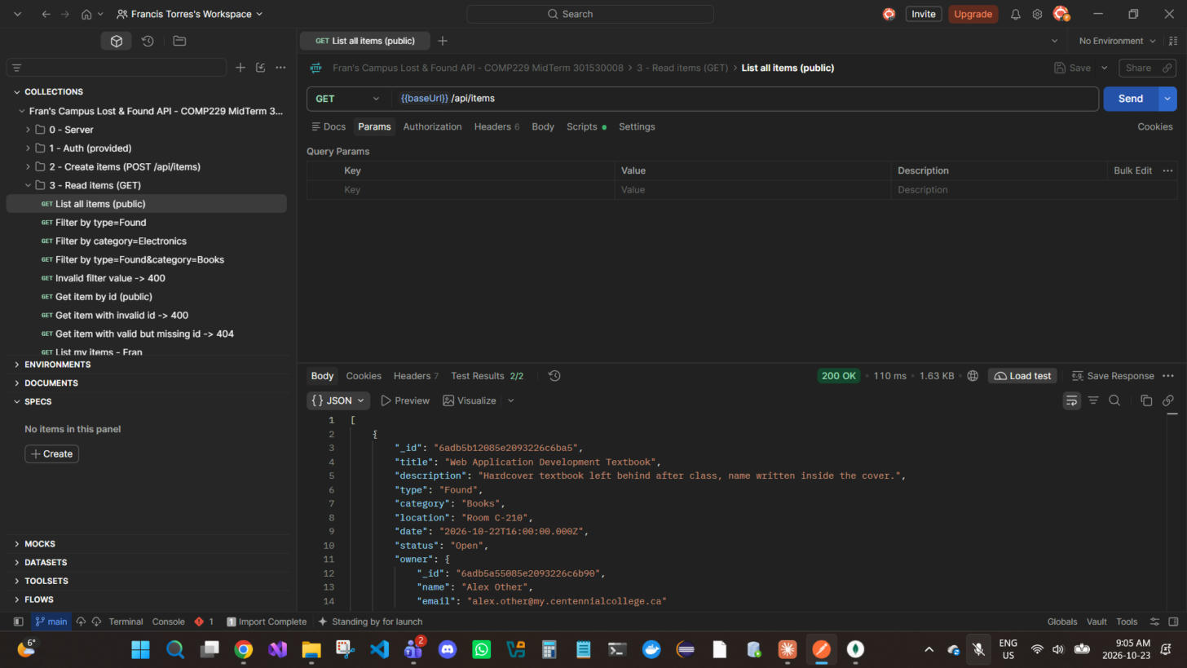
Figure 22 — GET /api/items — List all items (public); test asserts 3 items → 200 OK
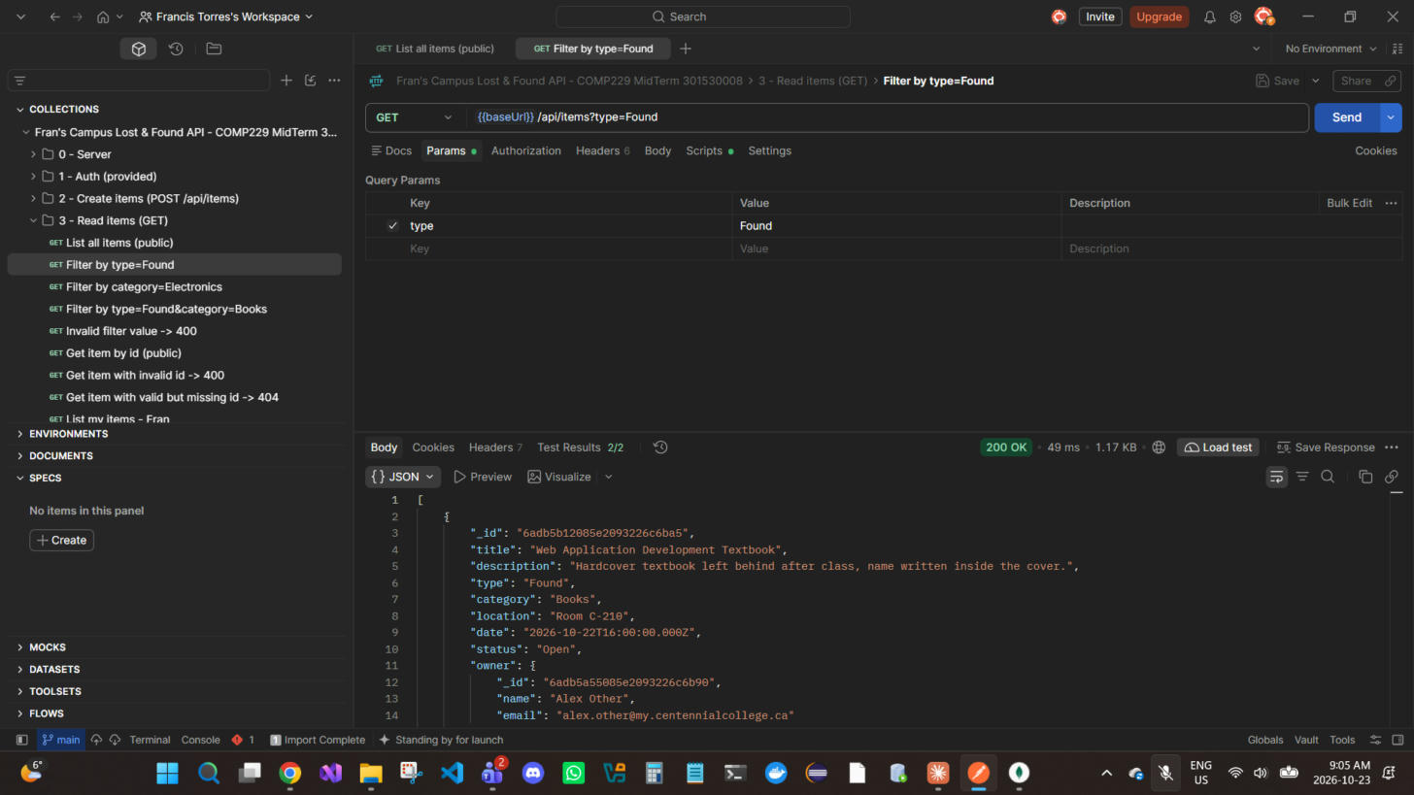
Figure 23 — GET /api/items?type=Found — Filter by type; every result is Found → 200 OK
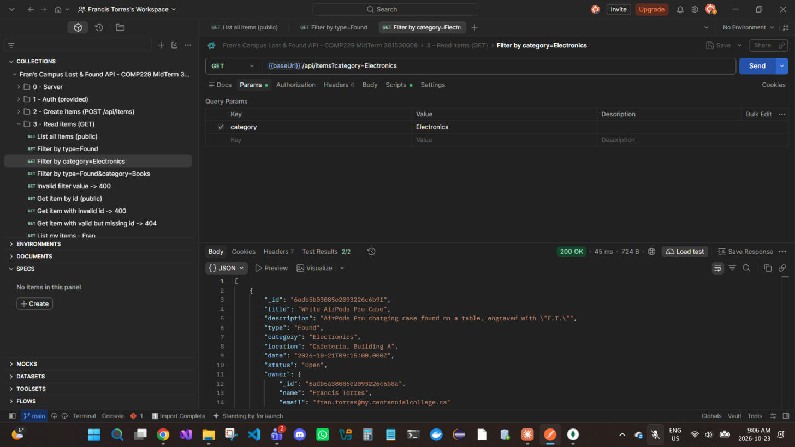
Figure 24 — GET /api/items?category=Electronics — Filter by category → 200 OK
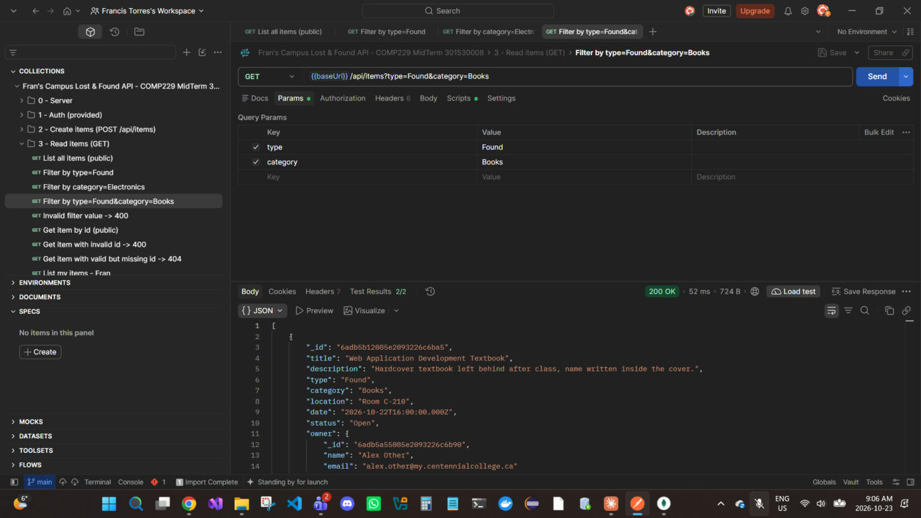
Figure 25 — GET /api/items?type=Found&category=Books — Combined filters; exactly 1 match → 200 OK
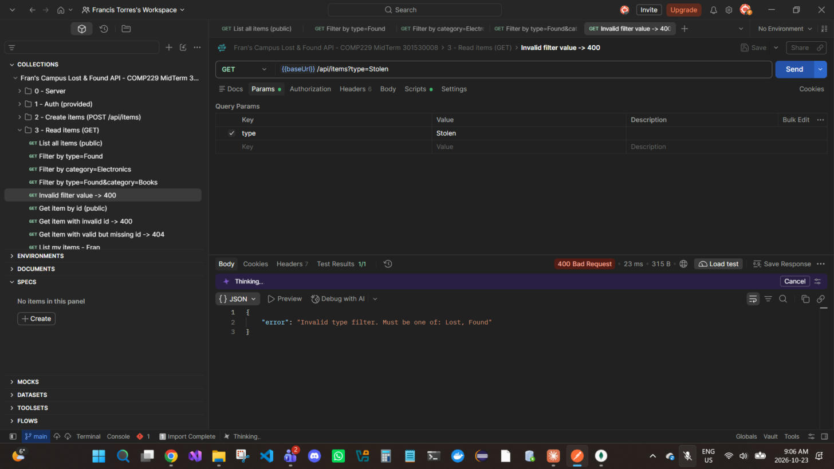
Figure 26 — GET /api/items?type=Stolen — Unknown filter value → 400 Bad Request
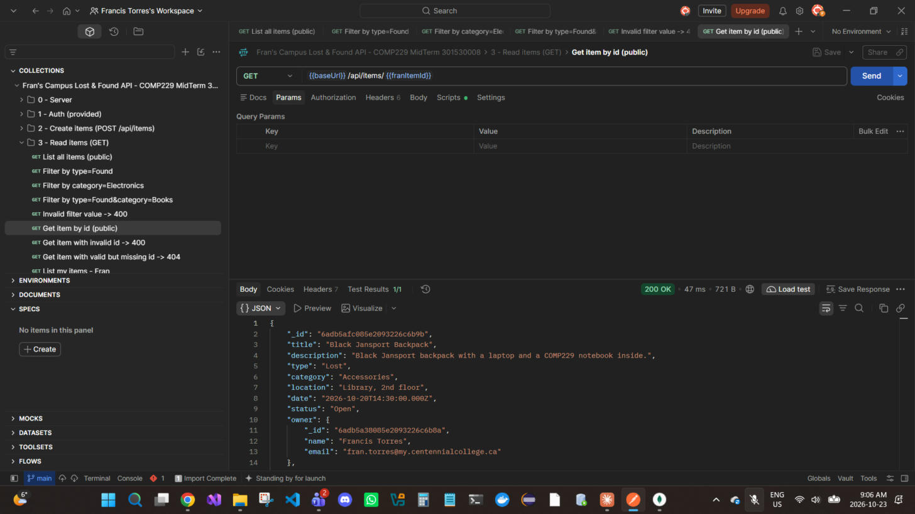
Figure 27 — GET /api/items/{{franItemId}} — Get a single item by id (public, owner populated) → 200 OK
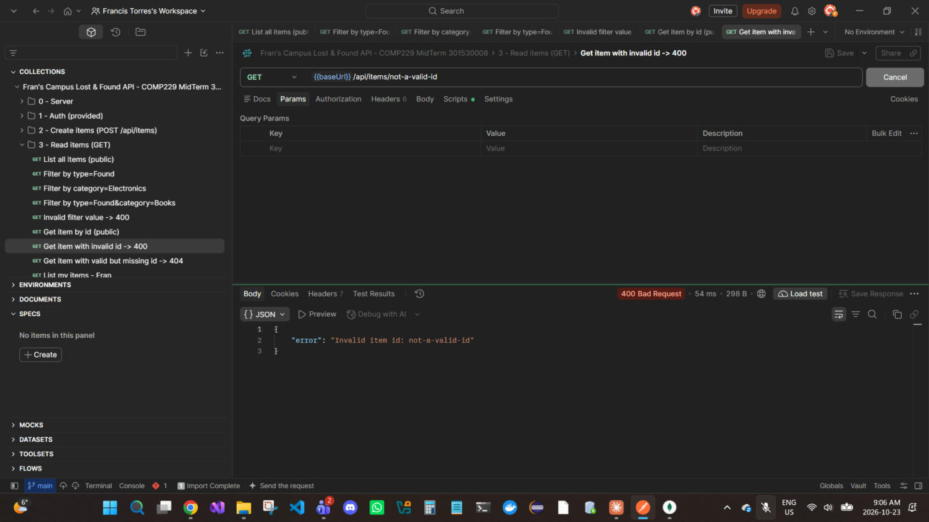
Figure 28 — GET /api/items/not-a-valid-id — Malformed ObjectId → 400 Bad Request
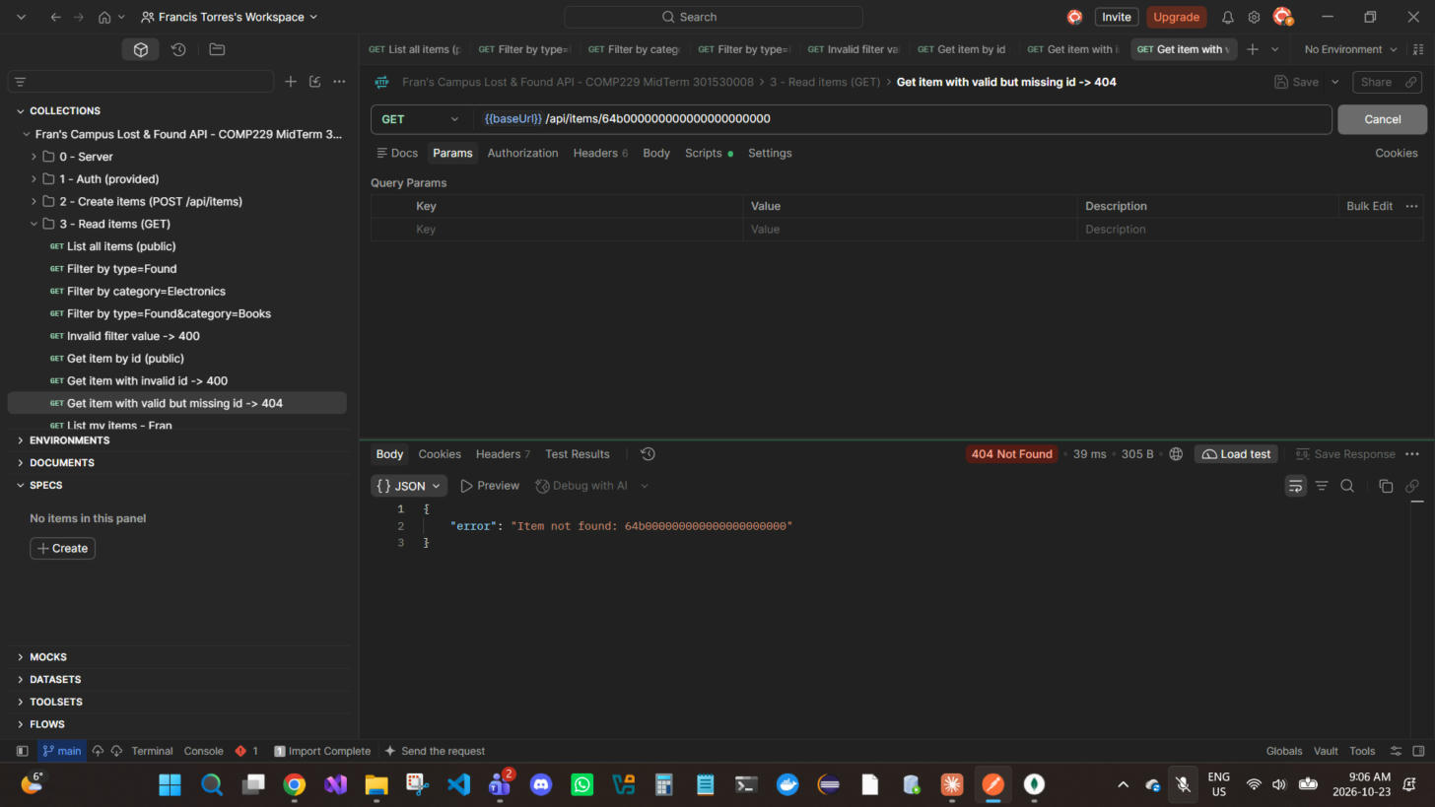
Figure 29 — GET /api/items/64b000000000000000000000 — Valid ObjectId that does not exist → 404 Not Found
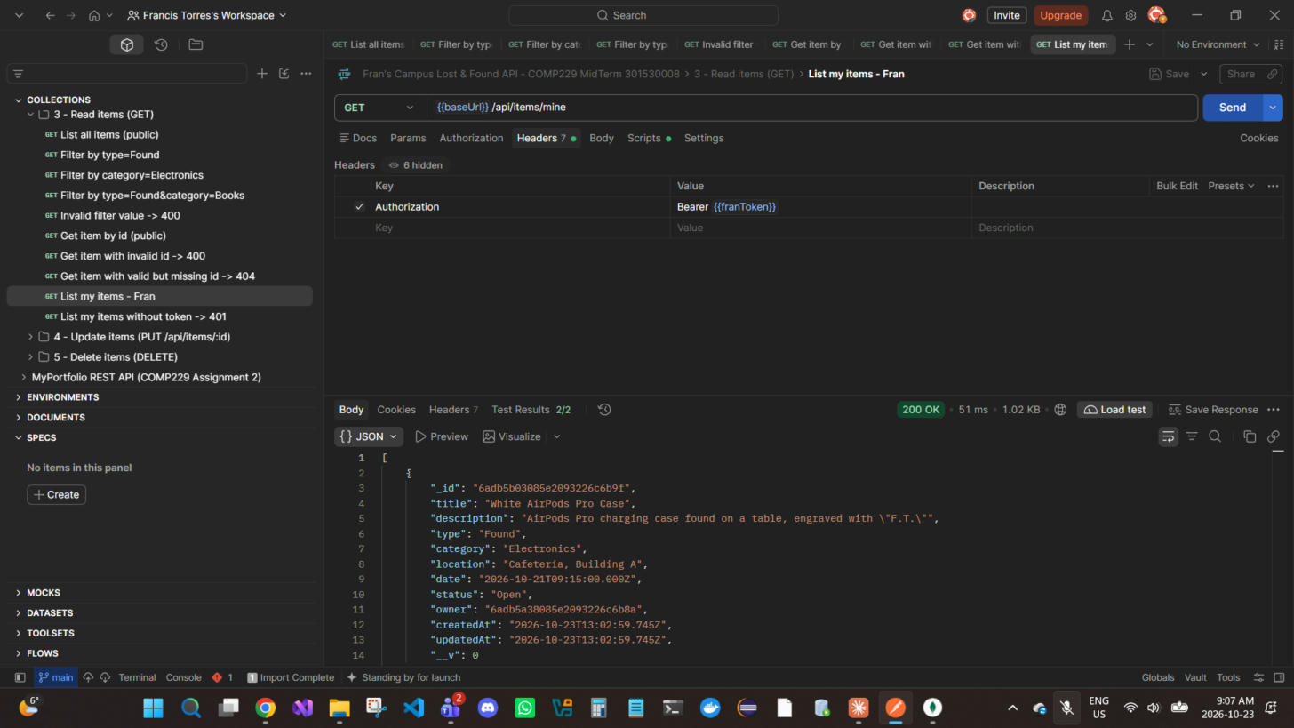
Figure 30 — GET /api/items/mine — Fran's items only (Bearer {{franToken}}) → 200 OK
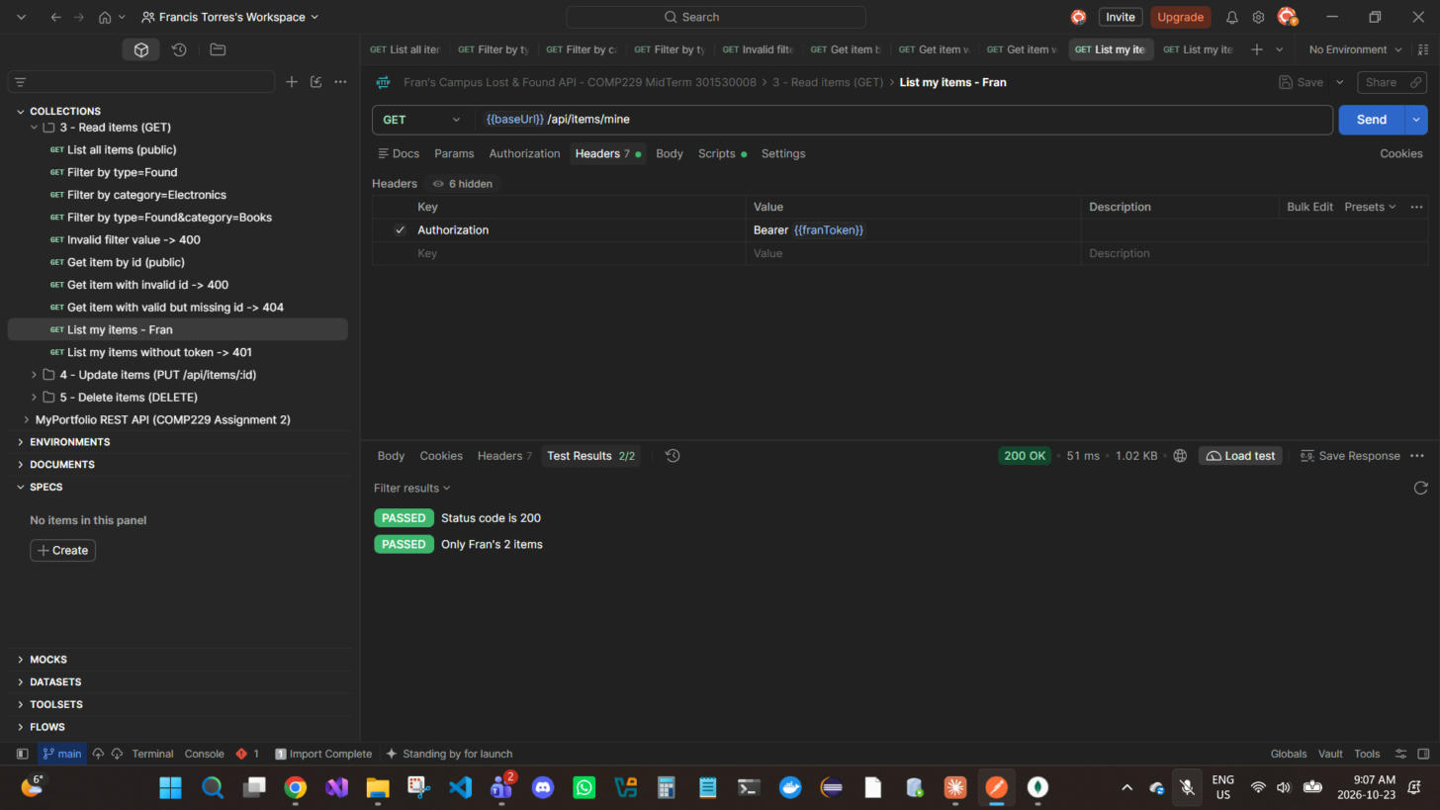
Figure 31 — GET /api/items/mine — Postman Test Results: "Only Fran's 2 items" PASSED (Alex's item is excluded) → 200 OK
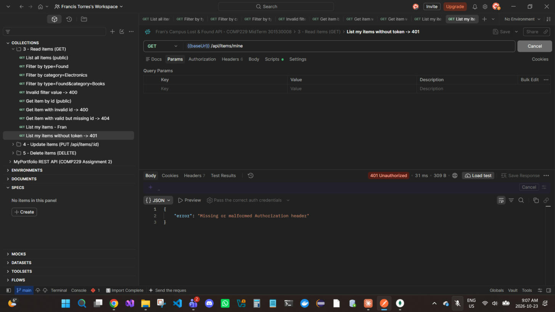
Figure 32 — GET /api/items/mine — Protected route without a token → 401 Unauthorized

5. Update items — PUT /api/items/:id (Bearer, owner only)
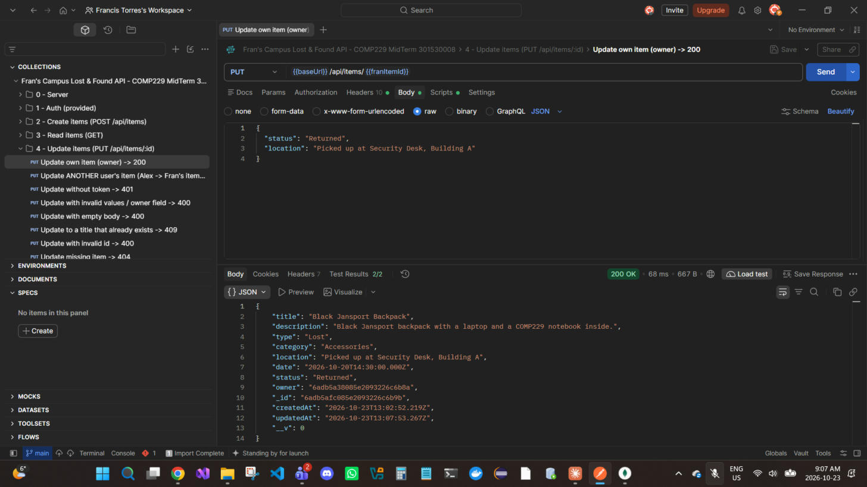
Figure 33 — PUT /api/items/{{franItemId}} — Owner (Fran) marks the backpack Returned and changes its location → 200 OK
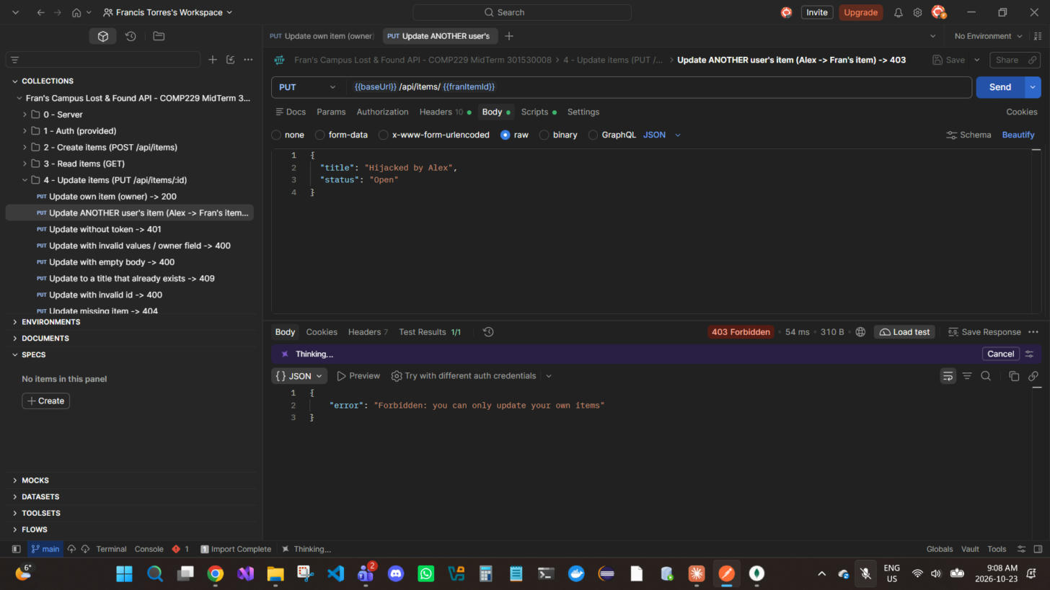
Figure 34 — PUT /api/items/{{franItemId}} — OWNERSHIP: Alex tries to rename Fran's item to "Hijacked by Alex" — rejected → 403 Forbidden
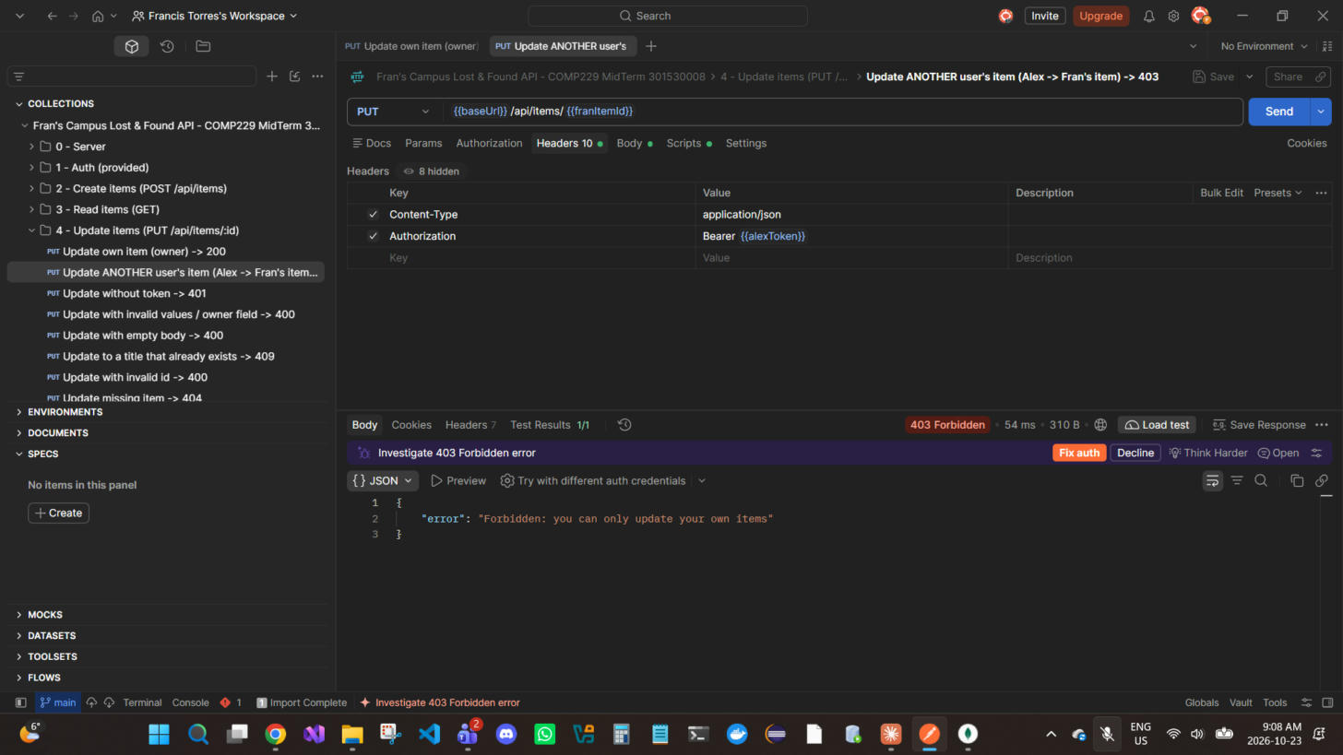
Figure 35 — PUT /api/items/{{franItemId}} — Same request, Headers tab: it is sent with Alex's token (Bearer {{alexToken}}) → 403 Forbidden
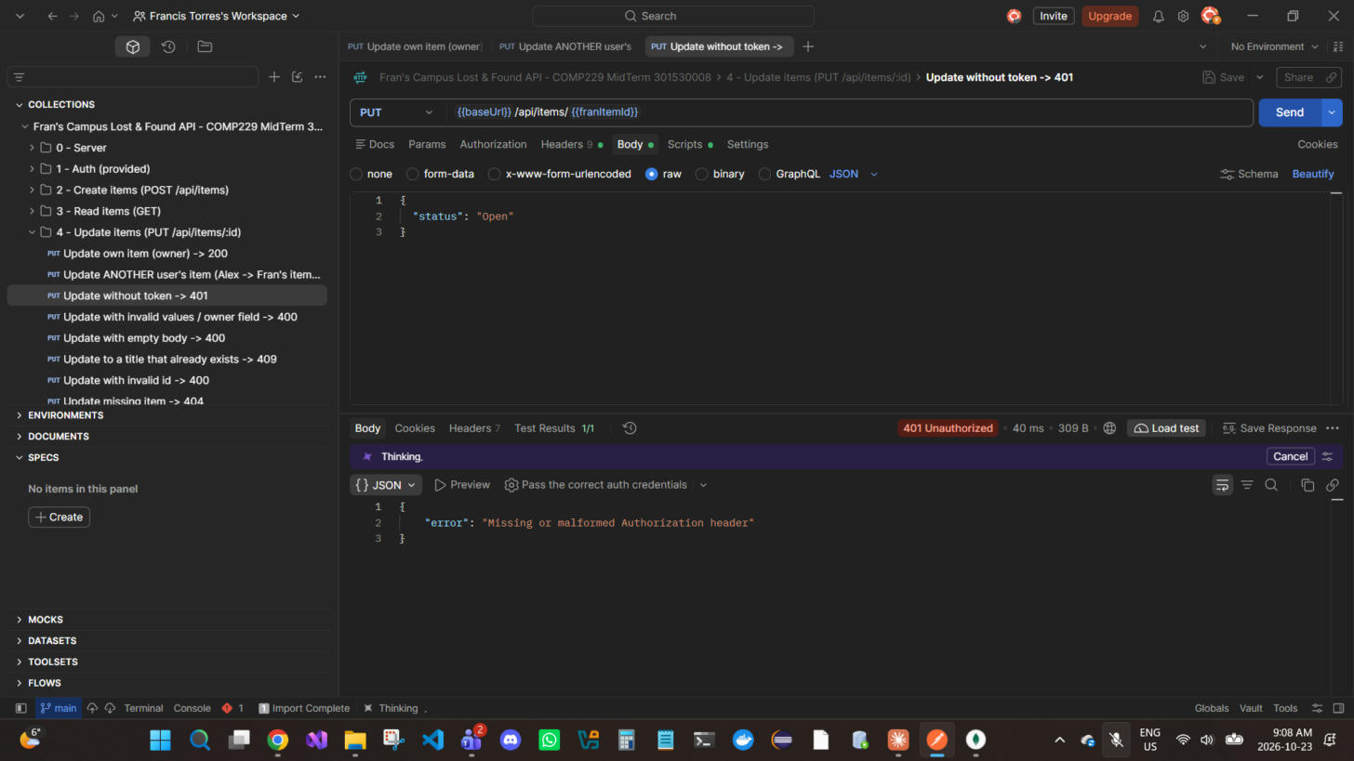
Figure 36 — PUT /api/items/{{franItemId}} — Update without a token → 401 Unauthorized
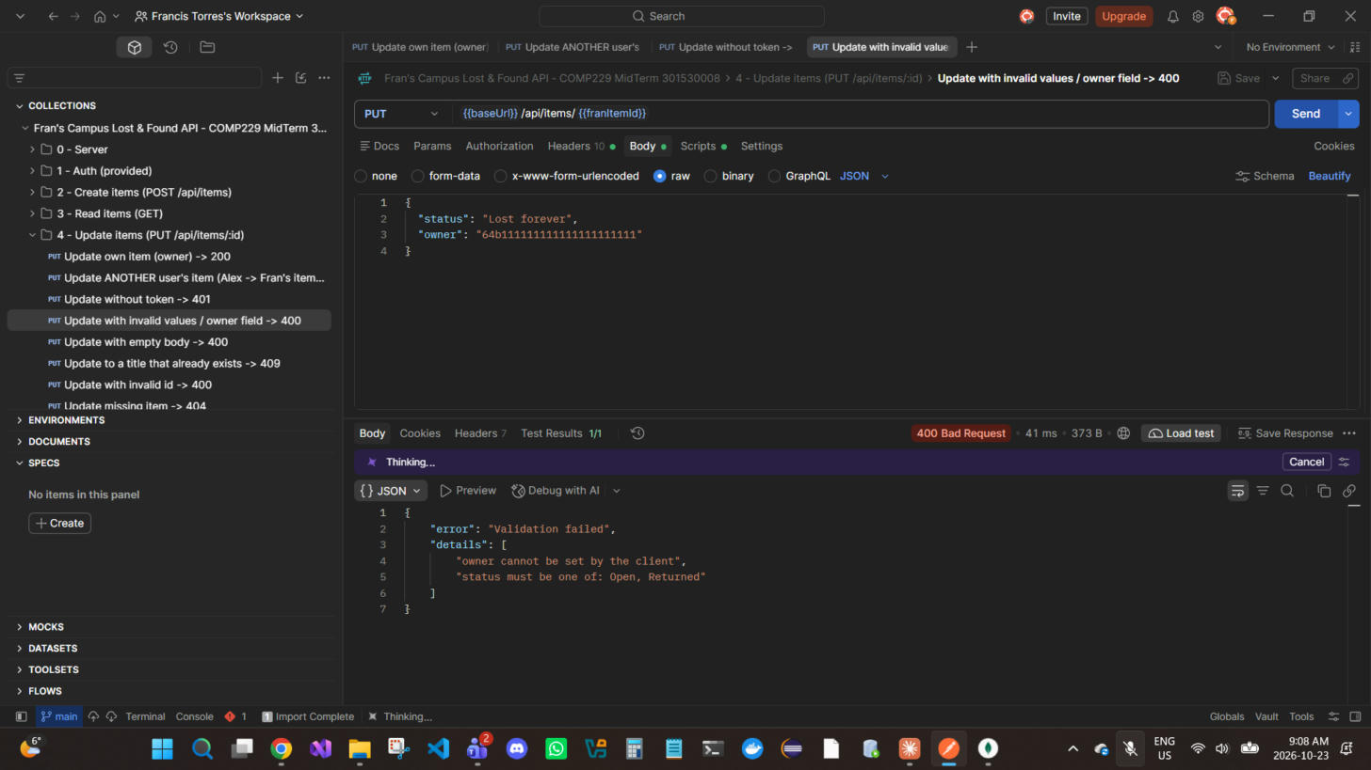
Figure 37 — PUT /api/items/{{franItemId}} — Invalid status and an attempt to overwrite owner → 400 Bad Request
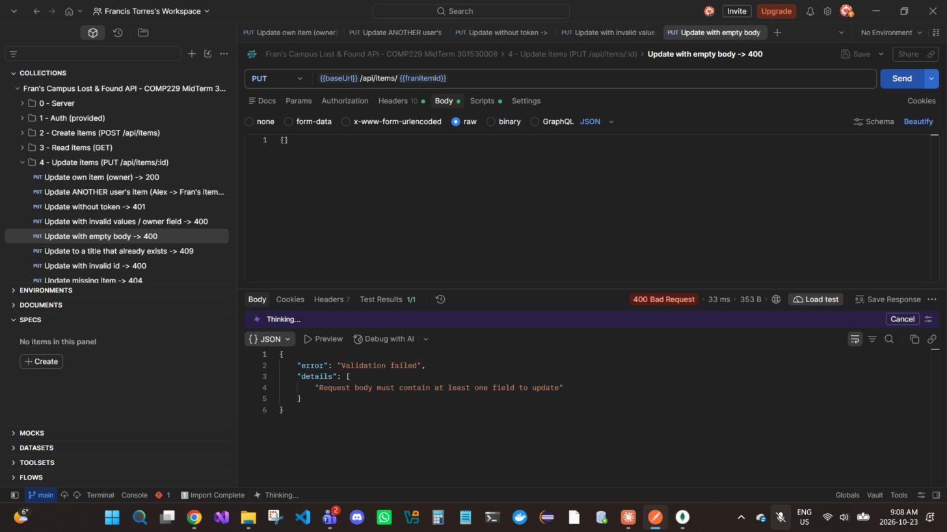
Figure 38 — PUT /api/items/{{franItemId}} — Empty body {} → 400 Bad Request
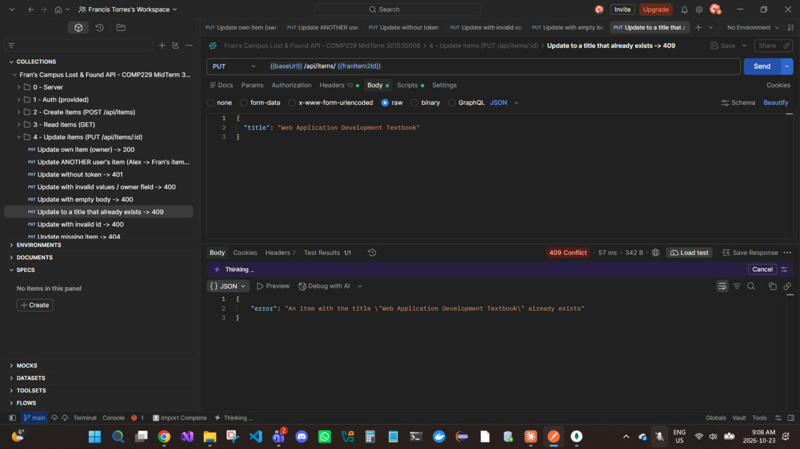
Figure 39 — PUT /api/items/{{franItem2Id}} — Rename to a title already used by another item → 409 Conflict
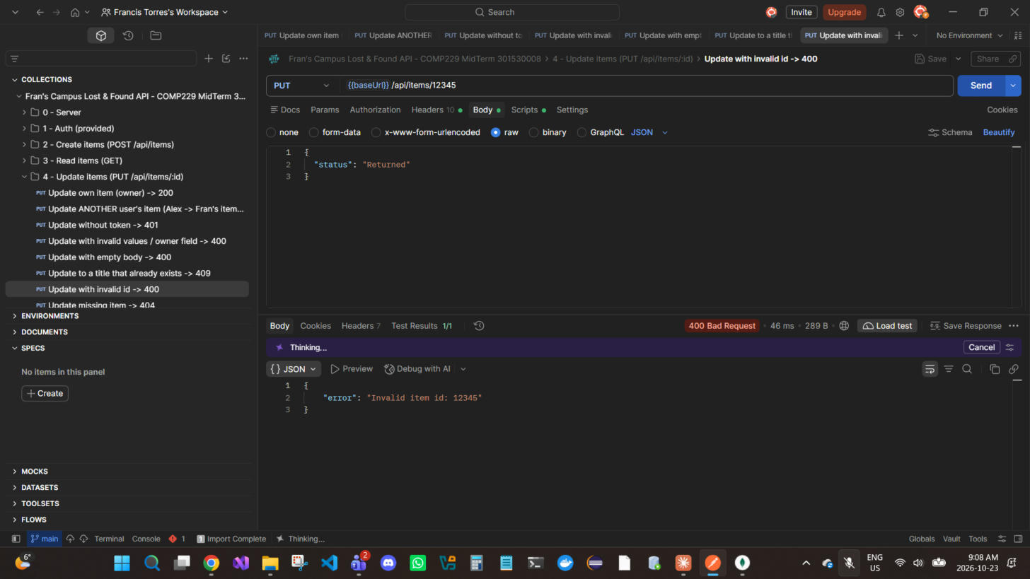
Figure 40 — PUT /api/items/12345 — Malformed ObjectId → 400 Bad Request
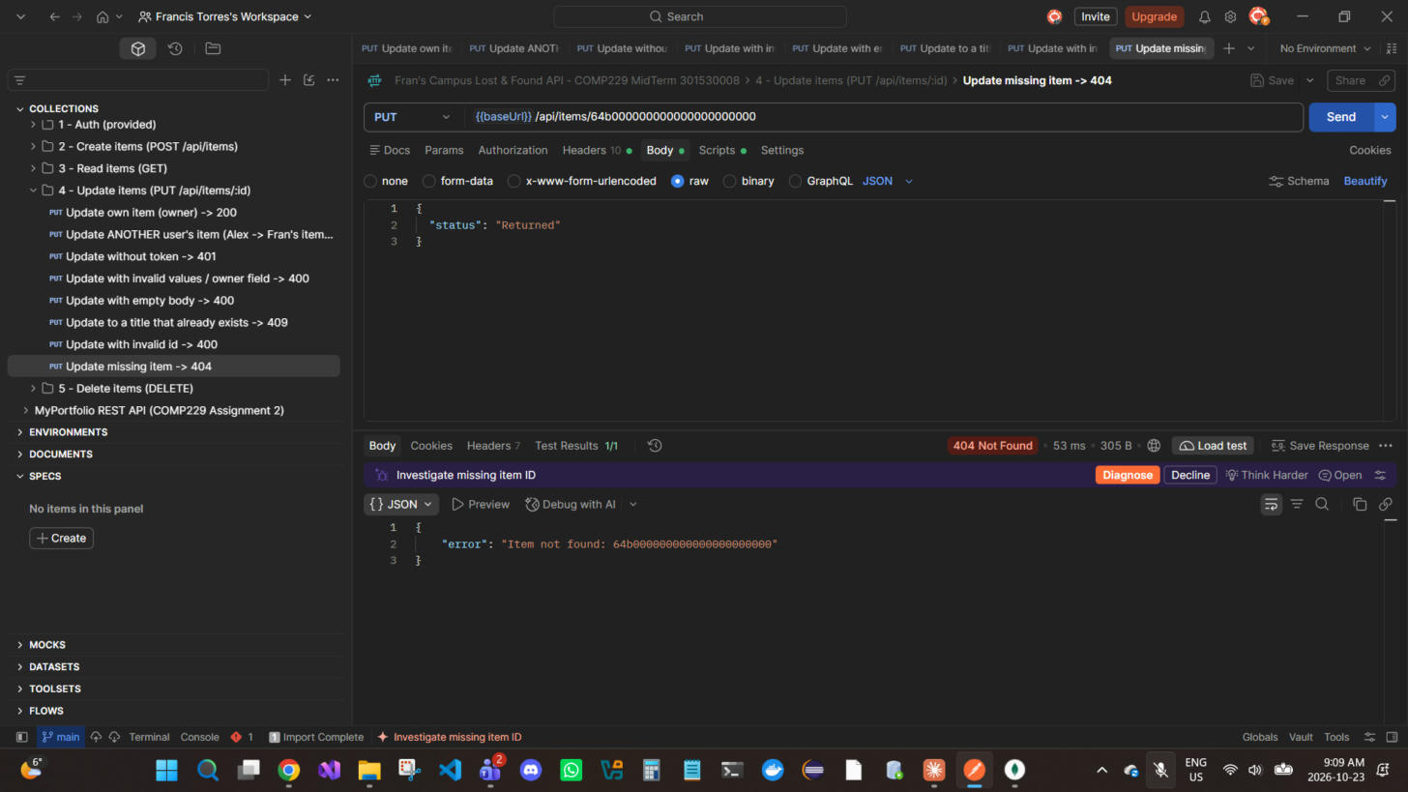
Figure 41 — PUT /api/items/64b000000000000000000000 — Item does not exist → 404 Not Found

MongoDB evidence — Update items
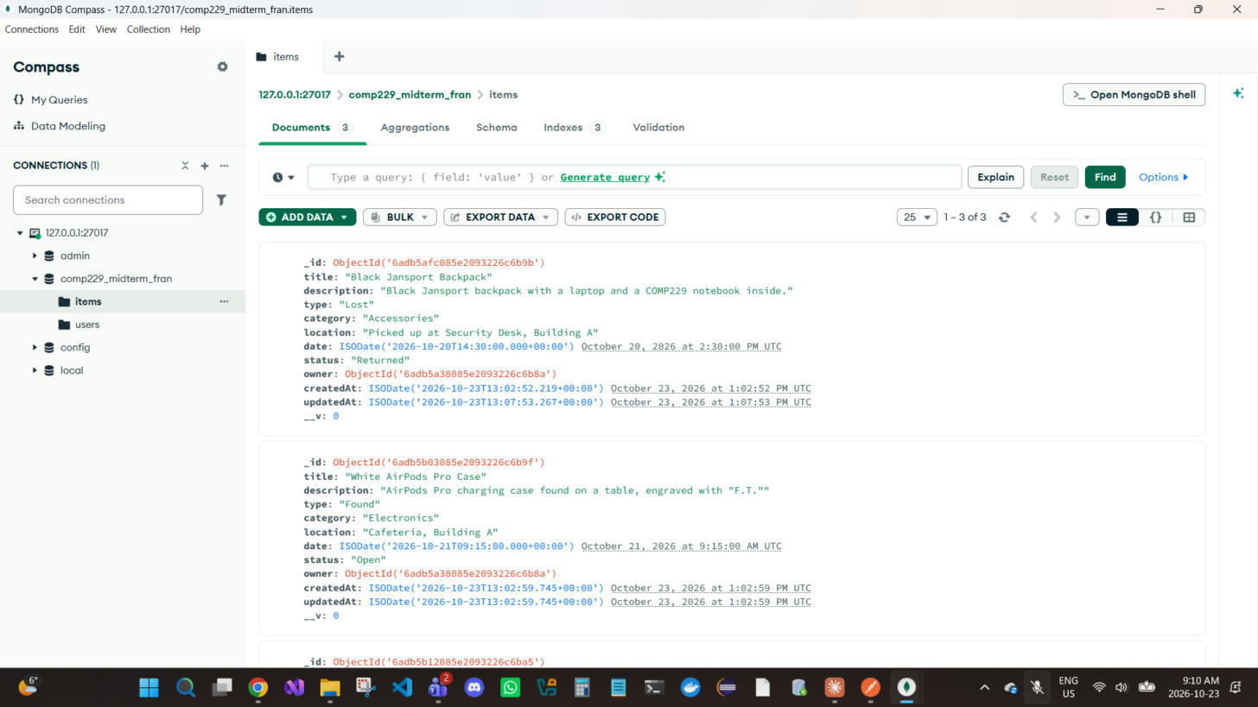
Figure 42 — MongoDB Compass after the updates: the backpack now has status "Returned", location "Picked up at Security Desk, Building A" and a newer updatedAt (1:07:53 PM vs createdAt 1:02:52 PM). Its title is still "Black Jansport Backpack", proving Alex's 403 update never reached the database.

6. Delete items — DELETE (Bearer, owner only)
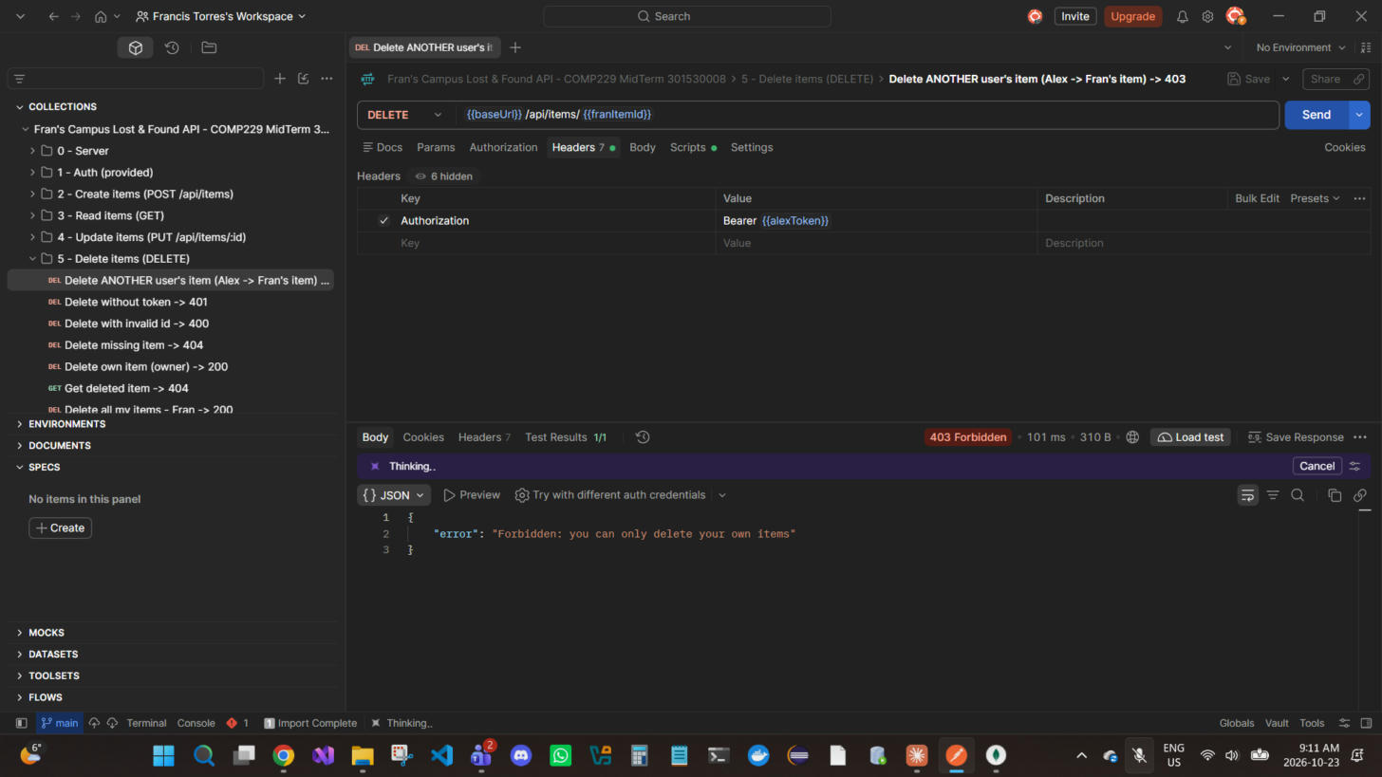
Figure 43 — DELETE /api/items/{{franItemId}} — OWNERSHIP: Alex tries to delete Fran's item (Bearer {{alexToken}}) — rejected → 403 Forbidden
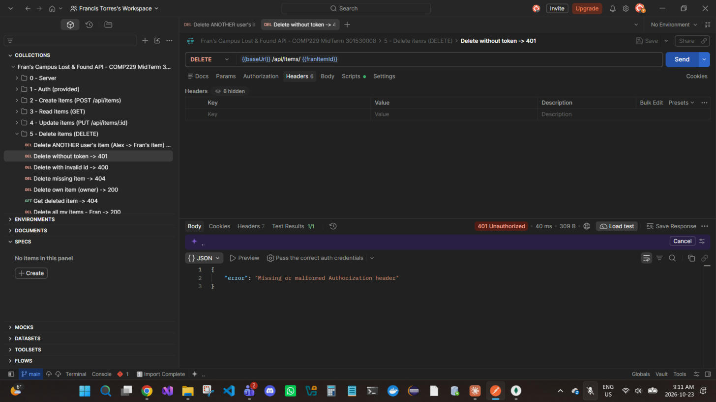
Figure 44 — DELETE /api/items/{{franItemId}} — Delete without a token → 401 Unauthorized
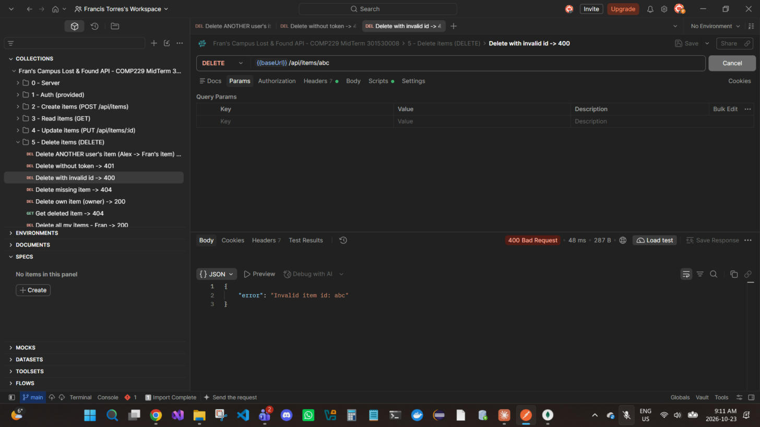
Figure 45 — DELETE /api/items/abc — Malformed ObjectId → 400 Bad Request
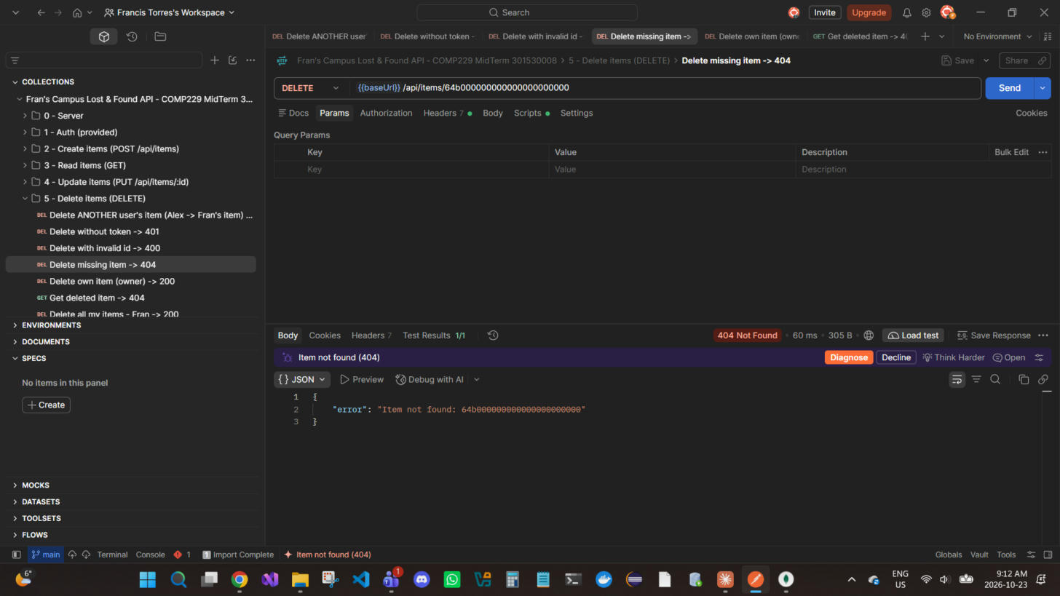
Figure 46 — DELETE /api/items/64b000000000000000000000 — Item does not exist → 404 Not Found
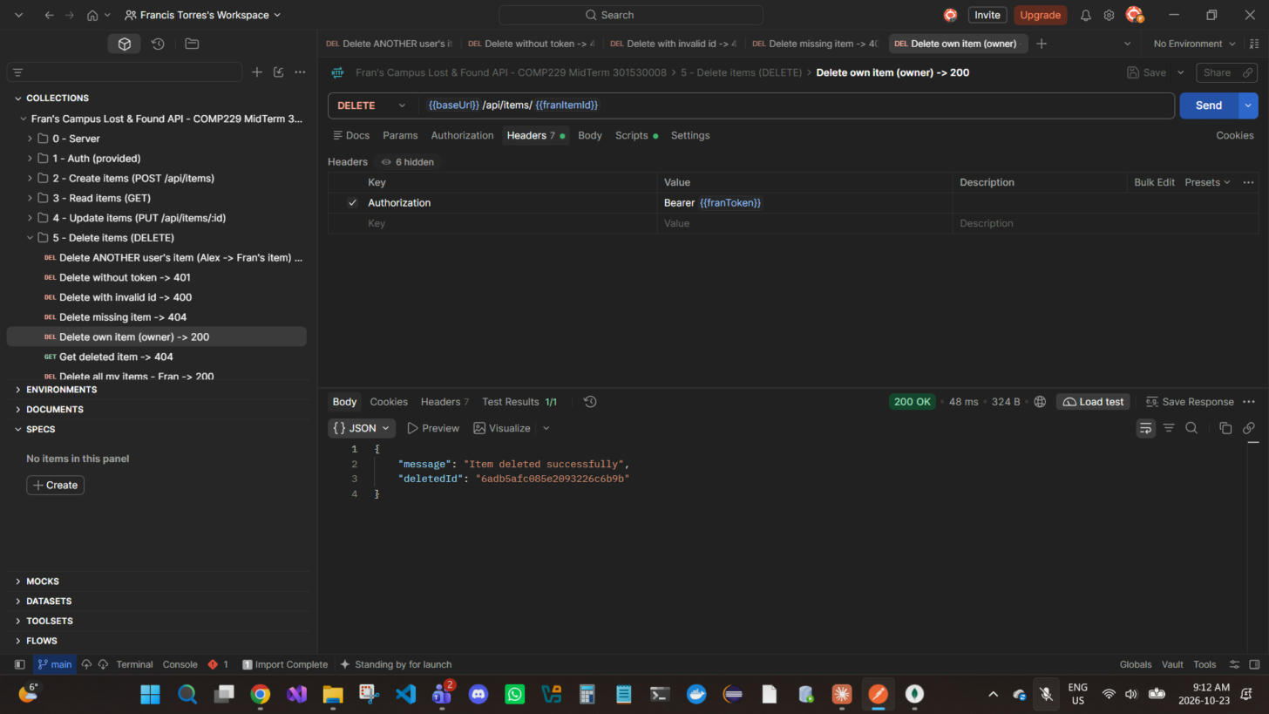
Figure 47 — DELETE /api/items/{{franItemId}} — Owner (Fran) deletes the backpack → 200 OK
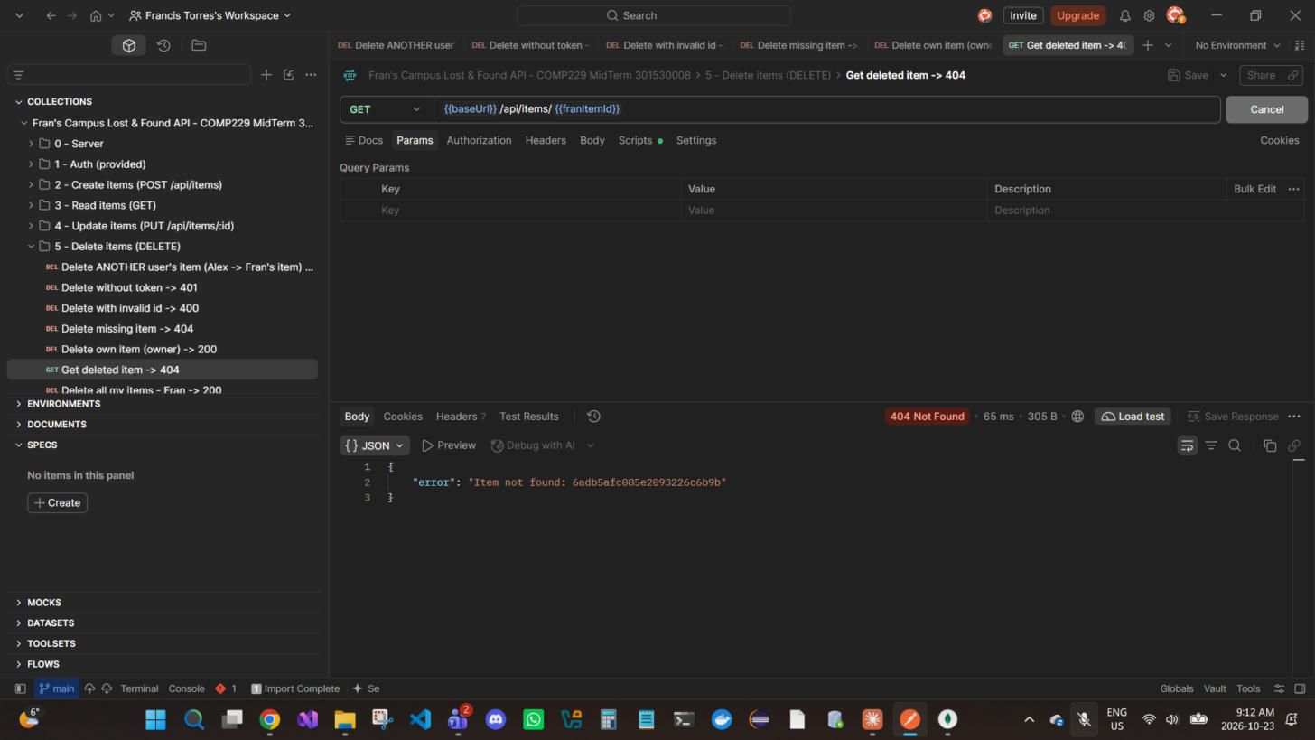
Figure 48 — GET /api/items/{{franItemId}} — The deleted item is gone → 404 Not Found
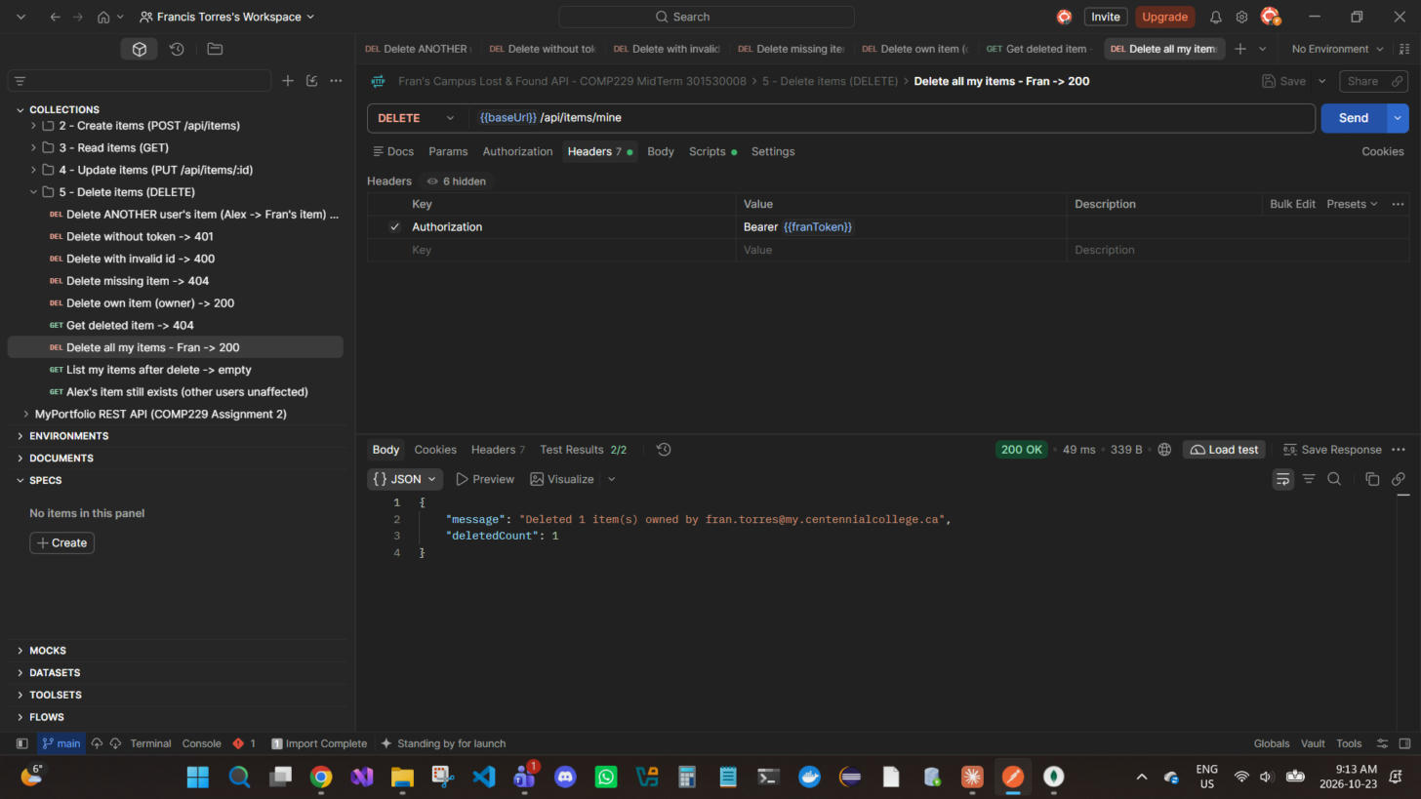
Figure 49 — DELETE /api/items/mine — Delete all of Fran's items; deletedCount = 1 (the AirPods) → 200 OK
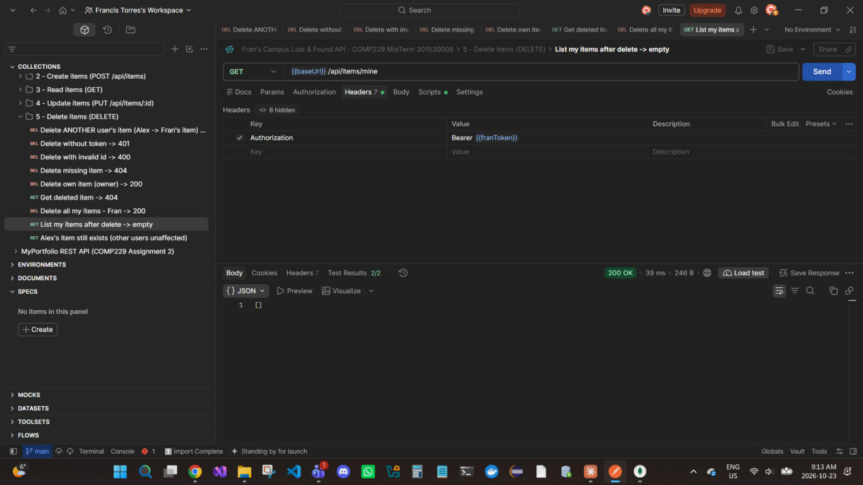
Figure 50 — GET /api/items/mine — Fran now has no items: [] → 200 OK
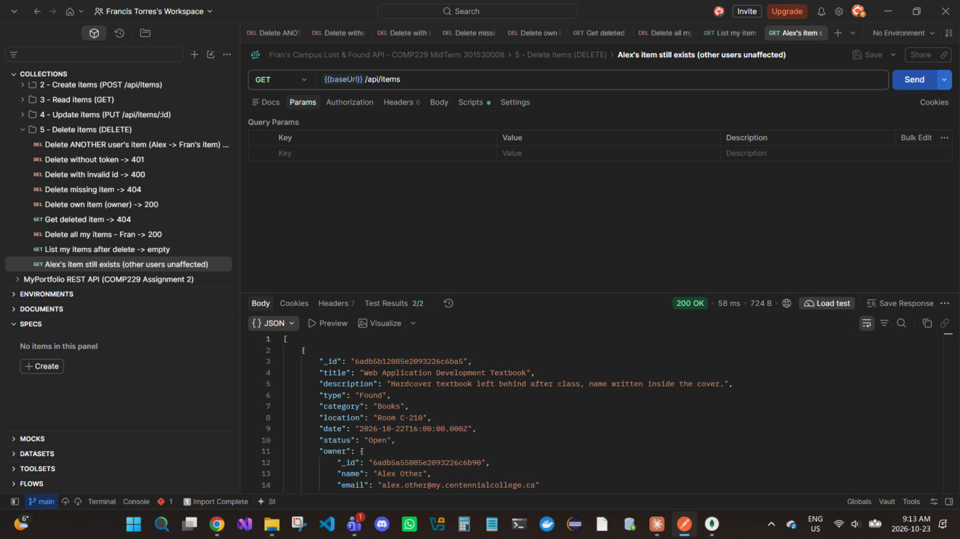
Figure 51 — GET /api/items — Alex's item is unaffected by Fran's DELETE /mine → 200 OK

MongoDB evidence — Delete items
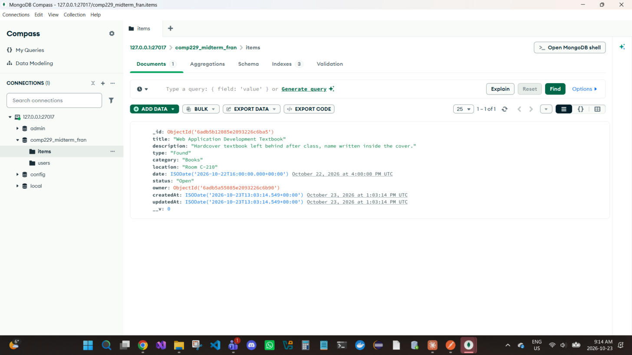
Figure 52 — MongoDB Compass after the deletes: items shows 1 of 1 — only Alex's textbook remains. Fran's two items were removed from the database.

