*Student Directory*

Team 09

Project Lead: Gregory Billings

Team Members: Gregory Billings, Francis Poirier

# Project Description:

Software as a service student directory package beta of the standard package, this would be of interest to any tutoring service, school district or post-secondary education. The project at completion will have a basic GUI setup that allows for the addition of classes, professor/student interaction, Administration system modifying all of the values of other users, registration of classes and grading system all interacting with a backend database. Produced as a byproduct of main development was reviews we received during check in times and an azure database setup for continued use. For the completion of the project, the key requirements were as follows: developing database infrastructure, designing an intuitive GUI, developing backend processing, and proper testing of the application.

# Process Model:

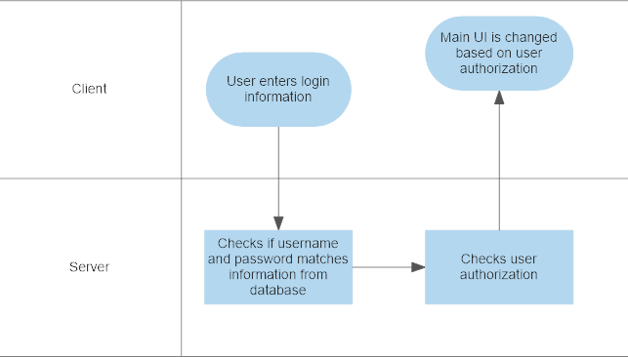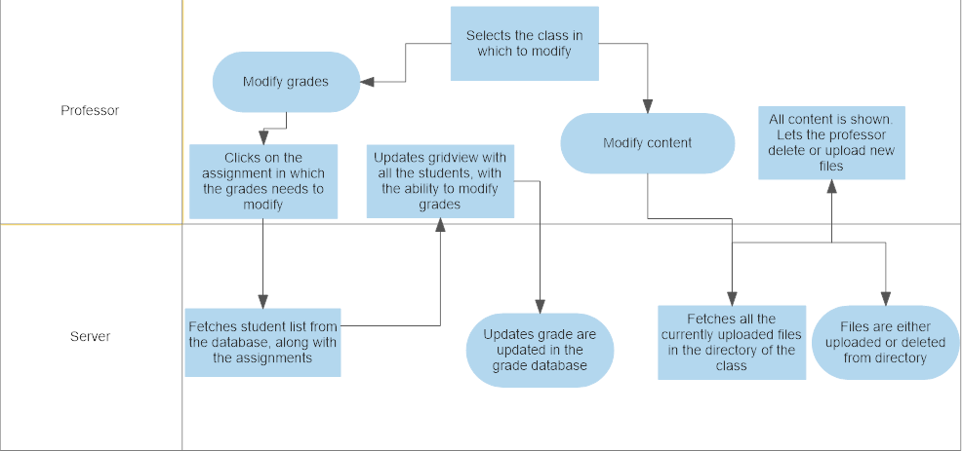

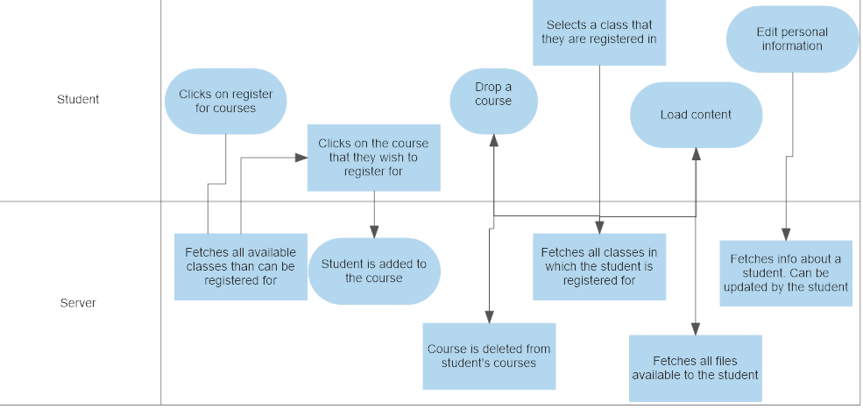

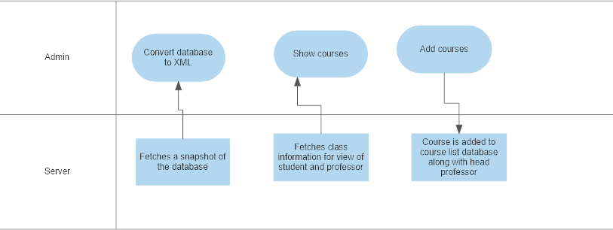

# Database Model:

<https://www.lucidchart.com/invitations/accept/c242a653-1e07-41f3-8311-0bb3a399eebd>

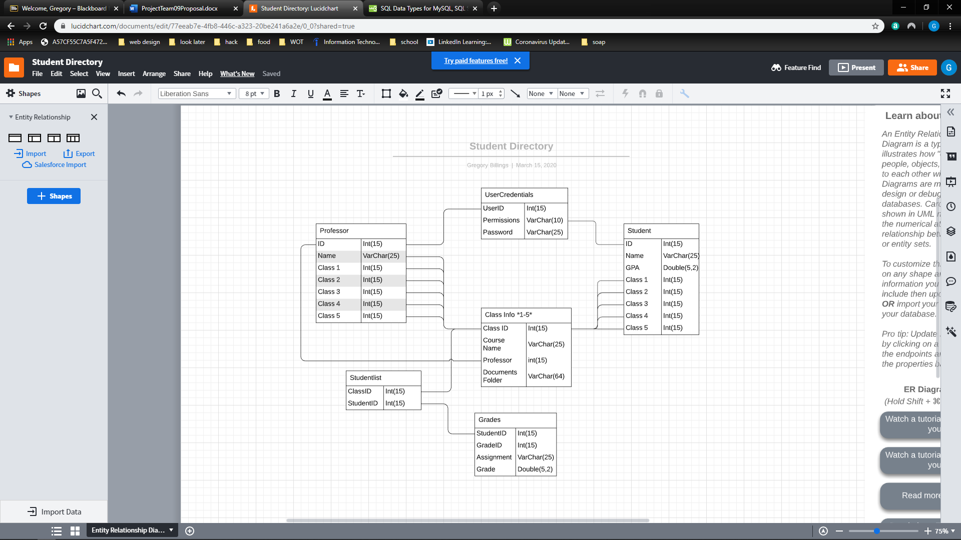

# User Interface:

1. Login screen – Username and password authentication. Will lead to main screen based on user permissions. For ease of access for grading and since this is a beta version, login logic can be bypassed by writing “admin”, “professor” or “student” in the user Id input to get to associated forms.
2. Students -
   1. Register for a course – May select through an available course list from a grid view. If the student has more than 5 courses, then they will not be allowed to register for more courses. Once a course has been selected, a register for course button will appear. This will add the student to the class list, adding a row to the grades table for the class. If the student has less than 5 classes, the remaining classes will be left null.
   2. Drop a course – Will load current registered courses in a gridview with the option to delete a course.
   3. Show grades – Student selects a registered course from a gridview. This will load all the assignments and midterms on the clicked course that has been publicly shown to student. May look at the assignment/midterm breakdown if it has multiple sections (example: midterm – multiple choice, essay).
   4. Show content – Student select a registered course from a gridview. This will load all the current publicly available files of the clicked course (from file directory linked to professor)
   5. Edit personal information – Will load the profile of a student to edit phone number, email, etc.
3. Professors -
   1. Course Information – Controls are a data grid view, drop-down list and two buttons. All controls are always displayed, the data grid view is an updated display of course information based on the last selected item in the drop-down list. The first button on this UI has the professor go to the grade's modification screen, and the second button brings the professor to a content modification screen.
   2. Modify Grades – Allows the professor to select a specific assignment. This will load a student list for that class in which grades can be modified and saves for the specific assignment.
   3. Modify content – Lists current content uploaded to the directory. This gives an option to either delete already uploaded content and upload new content.
4. Admin
   1. Main screen – This form has 5 main controls:
   2. Show course – Shows exactly the searched class from the perspective of the student or teacher with full permissions to edit from both perspectives (logging will be a stretch goal to make sure this power isn't abused with no accountability.)
   3. Add Courses- This screen will show multiple TextBox entries and a Button that allow the user to add new courses to the database. The TextBoxes will be an entry for Course ID, Course Name and Professor of class. If the user tries to add a course without all of these filled an error is thrown.(stretch goal turn this into a modify courses, so that only course ID and course name are required and professor can be changed later, along with being able to delete unneeded courses.

# Timeline:

<https://github.com/francispoi93/Team09Project/commits/master>

