*Student Directory*

Team 09

Project Lead: Gregory Billings

Team Members: Gregory Billings, Francis Poirier

# Project Description:

Software as a service student directory package beta of the standard package, this would be of interest to any tutoring service, school district or post-secondary education. The project at completion will have a basic GUI setup that allows for the addition of classes, professor/student interaction, Administration system modifying all of the values of other users, registration of classes and grading system all interacting with a backend database. Produced as a byproduct of main development was reviews we received during check in times and an azure database setup for continued use. For the completion of the project, the key requirements were as follows: developing database infrastructure, designing an intuitive GUI, developing backend processing, and proper testing of the application.

# Process Model:

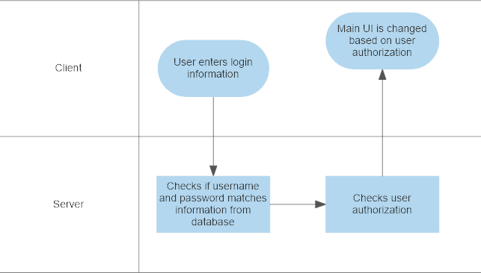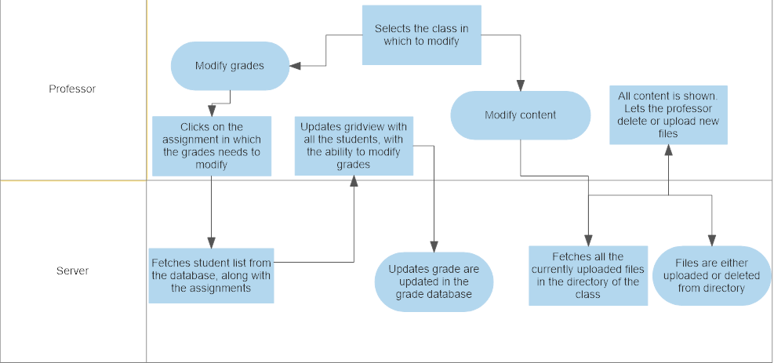

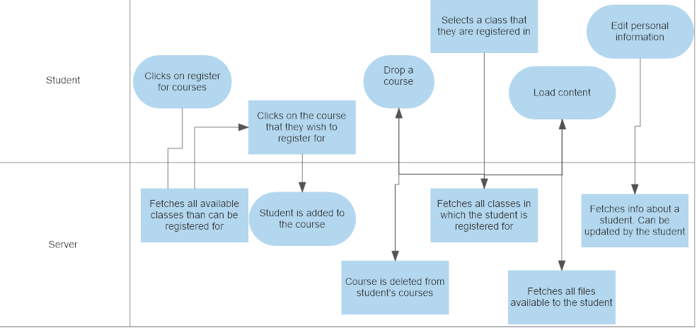

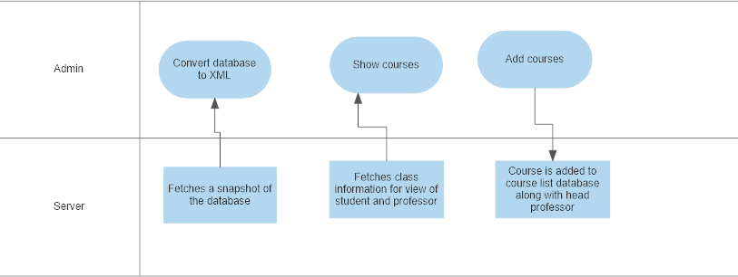

# Database Model:

<https://www.lucidchart.com/invitations/accept/c242a653-1e07-41f3-8311-0bb3a399eebd>

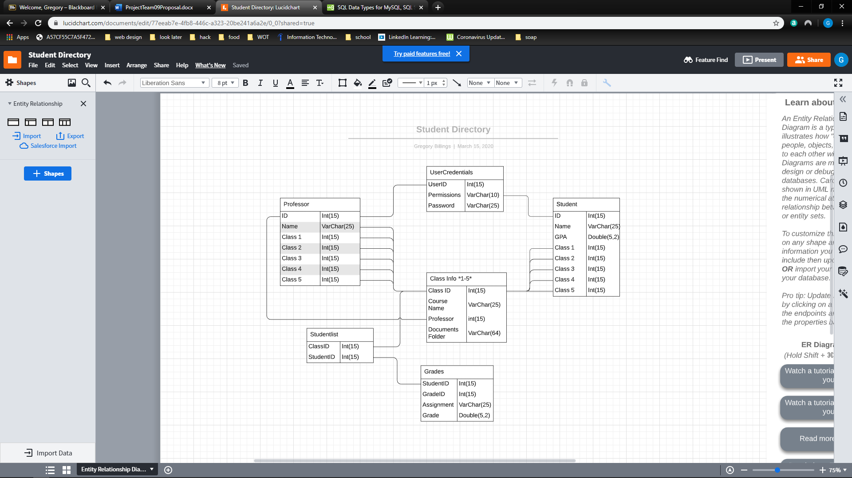

# User Interface:

1. Login screen – Username and password authentication. Will lead to main screen based on user permissions. For ease of access for grading and since this is a beta version, login logic can be bypassed by writing “admin”, “professor” or “student” in the user Id input to get to associated forms.
2. Students -
   1. Register Course Button
      1. Registers user for the course selected in the courses view
   2. Courses Grid View
      1. Shows a list of current courses that are available for the user to register
   3. Registered Grid View
      1. Shows all of the courses the user is registered in
   4. Drop a course
      1. Will load current registered courses in a gridview with the option to delete a course.
   5. Show grades
      1. Student selects a registered course from a gridview. This will load all the assignments and midterms on the clicked course that has been publicly shown to student. May look at the assignment/midterm breakdown if it has multiple sections (example: midterm – multiple choice, essay).
   6. Show content
      1. Student select a registered course from a gridview. This will load all the current publicly available files of the clicked course (from file directory linked to professor)
   7. Edit personal information
      1. Will load the profile of a student to edit phone number, email, etc.
3. Professors -
   1. Course Information – Controls are a data grid view, drop-down list and two buttons. All controls are always displayed, the data grid view is an updated display of course information based on the last selected item in the drop-down list. The first button on this UI has the professor go to the grade's modification screen, and the second button brings the professor to a content modification screen.
   2. Modify Grades – Allows the professor to select a specific assignment. This will load a student list for that class in which grades can be modified and saves for the specific assignment.
   3. Modify content – Lists current content uploaded to the directory. This gives an option to either delete already uploaded content and upload new content.
4. Admin
   1. Main screen – This form has 5 main controls:
      1. User View Search
         1. Input is userID that generates a form when the button is pressed.
      2. Report Open Button
         1. Opens the report screen
      3. Add Course Button
         1. Opens the Course add form
      4. Add/Modify User Button
         1. Opens the Add/Modify user form
      5. Backup to XML
         1. Backs up what is in the context Database to XML
   2. Add Modify
      1. Admin Display
         1. Displays a list of current admins and information
         2. Can delete selections
      2. Student Display
         1. Displays a list of current students and their information
         2. Can delete selections
      3. Professor Display
         1. Displays a list of current Professors
         2. Can delete sections
      4. Add User Button
         1. Adds a user to the database based on the form generated
      5. Modify User
         1. Modifies the currently selected user based on the form generated
   3. Add User
      1. Radio Button Selector
         1. Selects what type of user you are adding based on the radio button selection and enables or disables inputs
      2. Text box inputs
         1. First name and last name inputs for all users, Classes for Professors and Students
      3. Add button
         1. Adds a user to the database based on all other controls on the form.
   4. Modify User
      1. Fills the appropriate forms text boxes with current user information to be changed with the Modify button in form.
   5. Add Course
      1. Text Box Inputs
         1. Inputs for various attributes of course class
      2. Add course
         1. Gathers info from the inputs and creates a new course and adds it to the database.
   6. Reports

# Timeline:

<https://github.com/francispoi93/Team09Project/commits/master>

