NAME  Tanjusay, Francis C. |  | DATE  February 4, 2017 | SCORE
SCHEDULE  10:00 - 12:50 | SCORE |  | SCORE

LABORATORY EXERCISES
RECURSION

OBJECTIVES:
- Understand recursion and its parts
- Use recursion to solve programming problems

PROCEDURE:
- Encode the C++ program below.
- Save as rec1.cpp,and rec2.cpp, respectively.
- Compile and run the program by pressing Ctrl + F9.
- For each syntax or logical error encountered in the given program, do the following:
- Correct the error
- Recompile the program
- Repeat step 4 until no errors are encountered in the program.
- Illustrate the output of the modified program.

Program No. 1

#include <iostream>
Output:

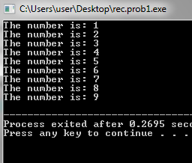

using namespace std;

void numberFunction(int i) {
cout << "The number is: " << i << endl;
i++;
if(i<10) {
numberFunction(i );
}
}

int main() {

int i = 1;
numberFunction(i);

return 0;
}

Program No. 2

#include <iostream>
using namespace std;

int factorial(int);

int main() {
int n;
cout<<"Enter a number to find factorial: ";
cin>>n;
cout<<"Factorial of "<<n<<" = "<<factorial(n);
return 0;
}
Output:

int factorial(int n) {
if (n>1) {
return n*factorial(n-1);
}
else {
return 1;
}
}

Supplementary Problem

- A recursive function that sums up the 10 integers in an array.

Program:

#include <iostream>
#include<iomanip>
using namespace std;

Addition(int array[ ], int x){
int total = 0;
if(x == 0){
return array[0];
}
else{
total = array[x] + Addition(array, x-1);
return total;
}
}
int main(){
int array[] = {1, 2, 3, 4, 5, 6, 7, 8, 9, 10};
int total;
total = Addition(array, 9);
cout<<"The SUM of the 10 integers is: "<<total;
return 0;
}

Output:

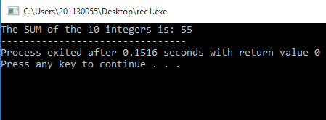

- A recursive function to produce the Fibonacci number for a given index in the series.
Use the function int fibonacci(int n)

Program:

#include <iostream>
using namespace std;

int Fibonacci(int v) {

if(v < 2 ){
return v;
}
else{
return Fibonacci(v - 1) + Fibonacci(v - 2);
}
}
int main() {
int num = 0;
cout << "Enter Number: ";
cin >> num;
cout << "Fibonacci number is: " << Fibonacci(num) << endl;
return 0;
}

Output:

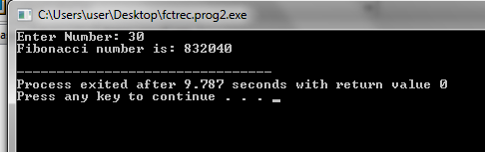

- A recursive function which raises its first parameter to the power of its second parameter.
Use the function int power(int number, int power)

Program:

#include <iostream>
#include<iomanip>

using namespace std;
int Power(double number, int power){
int total = 1;
if(power == 1){
return number;
}
else if(power == 0 ) {
return total;
}
else{
total = number * Power(number, power-1);
return total;
}
}

int main() {
int power, ans;
double num;
cout<<"Enter number: ";
cin>>num;
cout<<"Enter Exponent: ";
cin>>power;
ans = Power(num, power);
cout<<"The answer is: "<<ans;
return 0;
}

Output:
