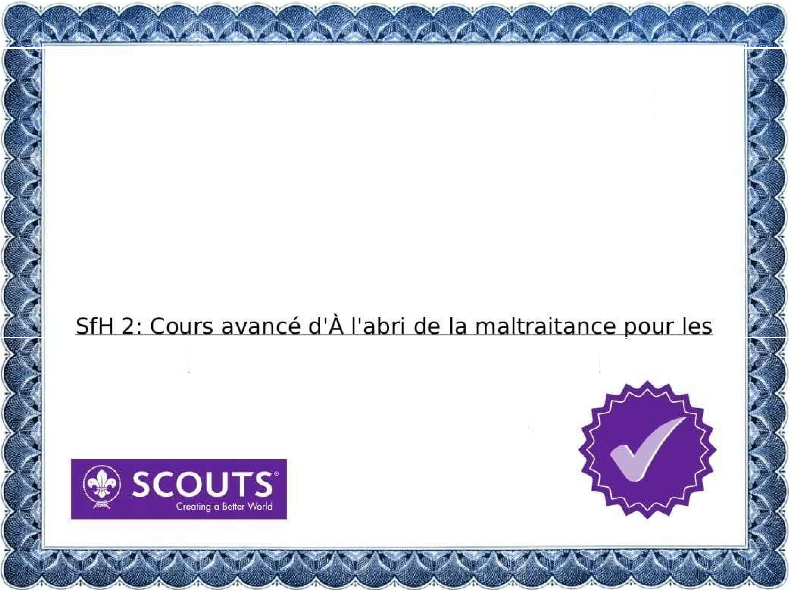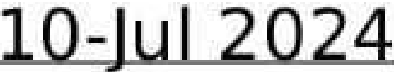

Certificate of Completion

This hereby certifies that:

assemene mardochee

has completed the course

bén,évo,l,es et le personnel d,e J'OMMS

Certificate Numbsr: :n4283-85281449-4673·176