School of Digital Media and Infocomm Technology (DMIT)

ST0281 Mobile Applications

Practical 2

**Installation and Testing the Android SDK and emulator**

|  |
| --- |
| Objectives:  After completing this lab, you will be able to:   * Install the Android Studio * Configure the Android Studio * Configure and test the Android Emulator |

1. **Installing the Android Studio**

Follow the instructions from this link to download the installer for the Android Studio:

<https://developer.android.com/studio/index.html>

1. **The Android Studio**

The following doc link will give you a better insight of the Android Studio:

<https://developer.android.com/studio/intro/index.html>

1. **Testing the Android emulator**

You have installed the necessary Android developer tools and platforms. From the Android Studio and AVD Manager, you will be able to create Android emulators that relates to particular versions of the Android OS.

Step 1:

Launch the Android Studio



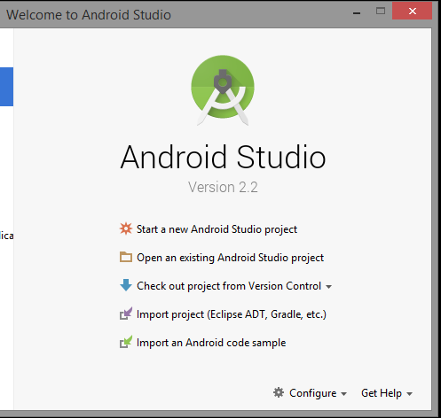

Step 2:

Select -> Start a new Android Studio project

Step 3:

Application name: HelloWorld

Company Domain: sg.com.mapp

Select Next.

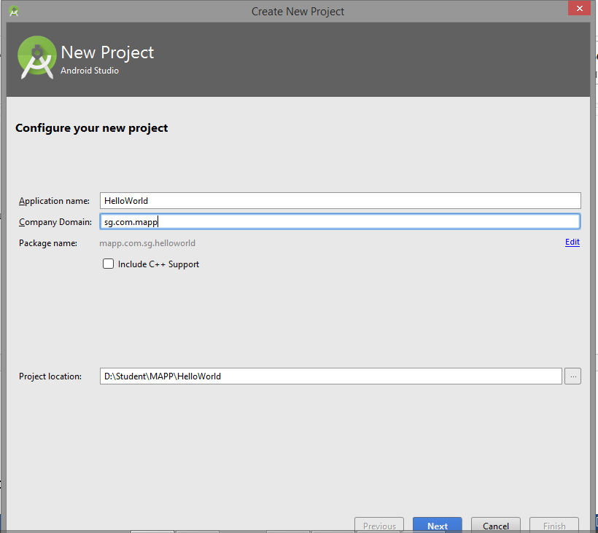

Step 4:

Phone and Tablet ->

Minimum SDK: API 16: Android 4.1 (Jelly Bean)

Select Next.

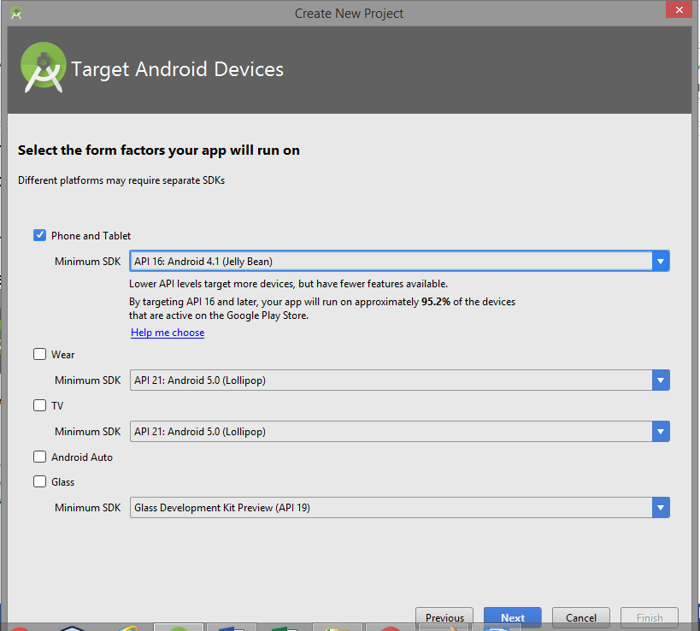

Step 5:

Select Empty Activity

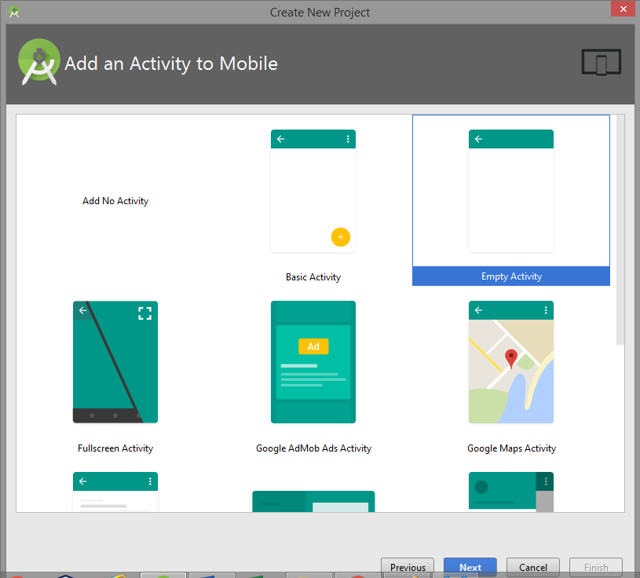

Step 6:

Activity Name: MainActivity

Layout Name: activity_main

Select Finish

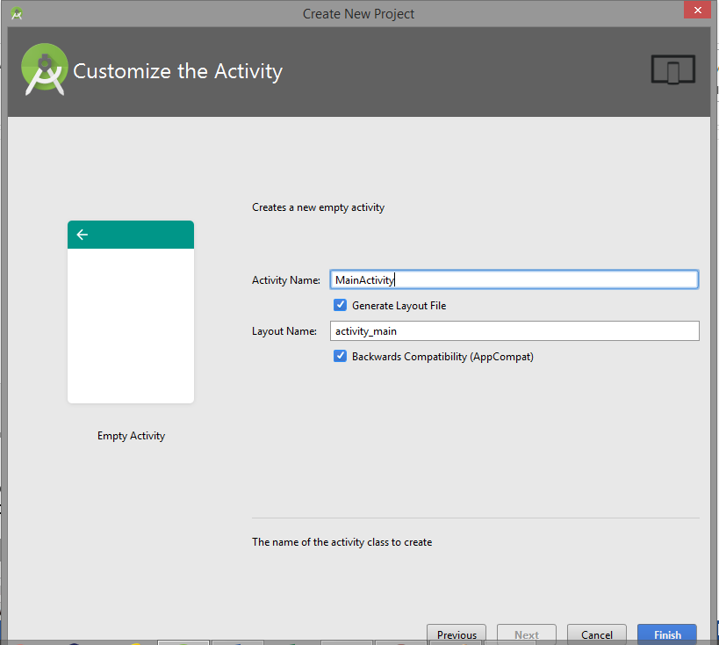

Select 7:

From the Android Studio, select Virtual Devices and follow the instructions to create an Android Virtual Device (AVD).

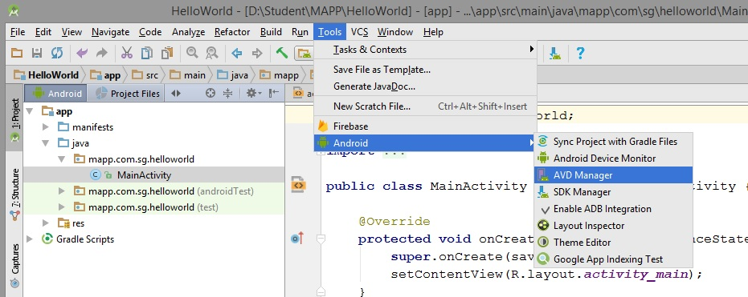

Step 8:

Select Create Virtual Device

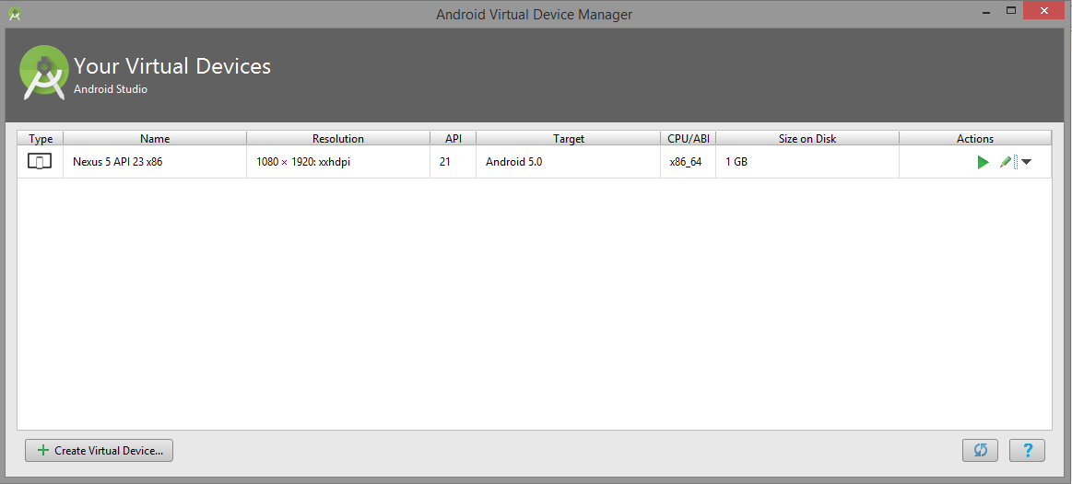

Step 9:

Select Nexus 5 (Size 4.95”) Resolution: 1080 X 1920

Select Next

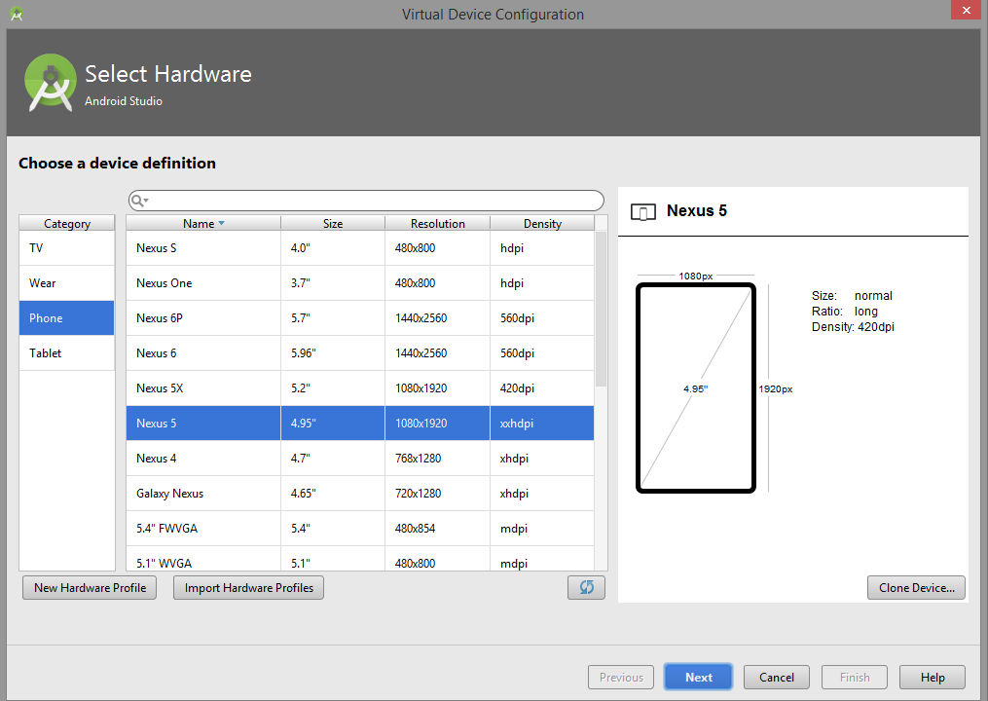

Step 10:

Use the default: Marshmallow (API Level 23 x86_64)

Note: If not available select Download the library.

Select Next.

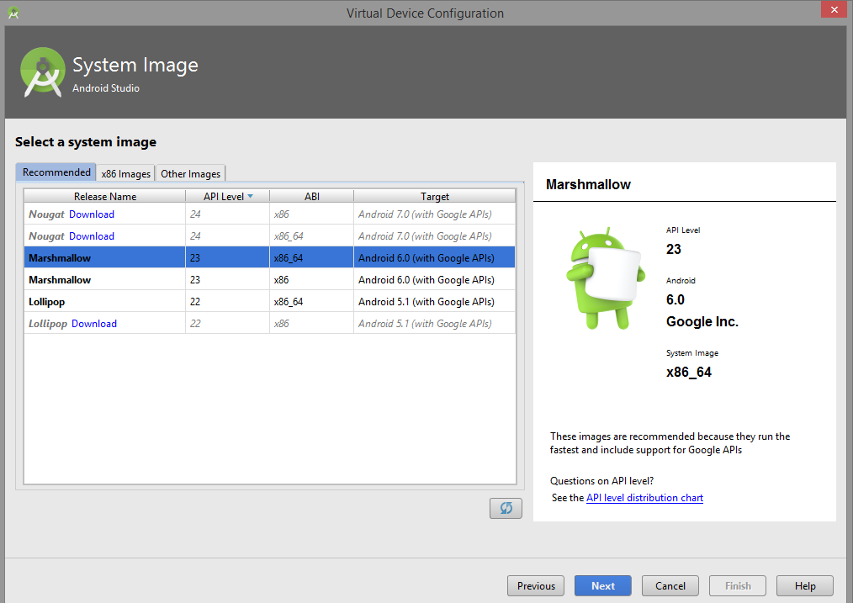

Step 11:

AVD Name: My AVD Devices

Select Finish

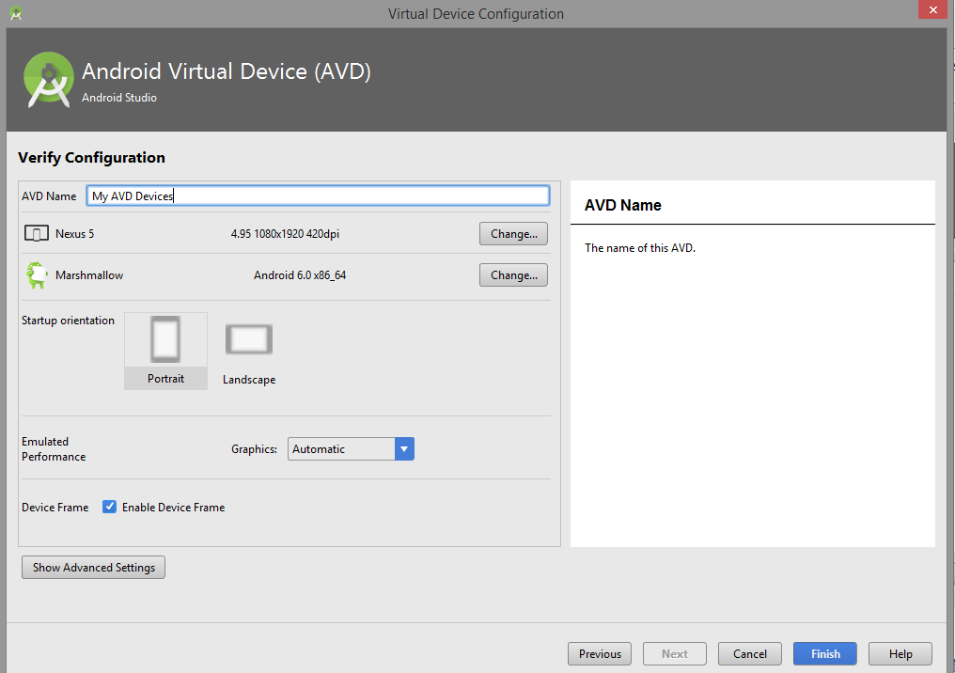

Step 12:

At the Action column -> click on the Run

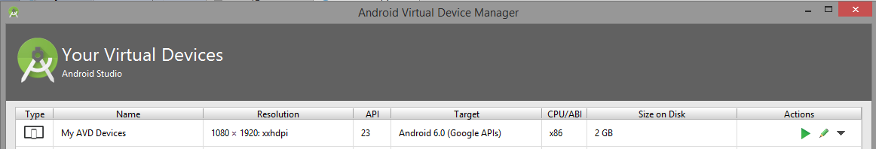

Step 13:

The Android Emulator is ready for use.

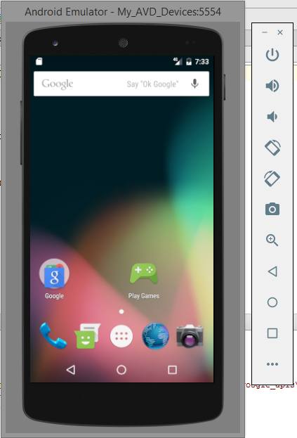

Start the emulator you have created. Depending on your machine speed and RAM available, it may take a minute or two for the emulator to come on. Browse around the emulator to be familiar with it and try out the following key presses:

Resources:

<https://developer.android.com/studio/run/emulator.html>

<http://developer.android.com/tools/help/emulator.html>

Step 14:

Click on the play button to Run the HelloWorld Application

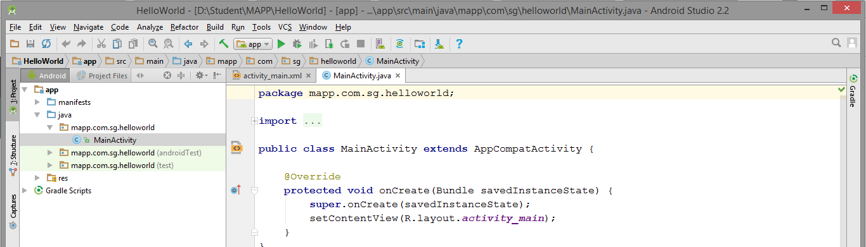

Step 15:

Select My AVD Devices

Click OK

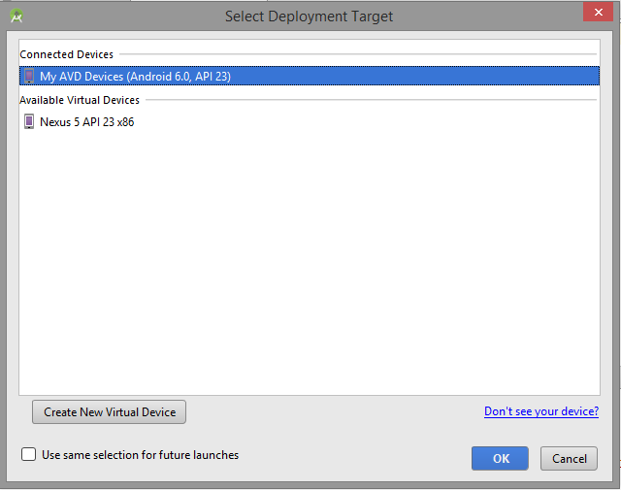

Step 16:

The HelloWorld apk will be launched in the Android Emulator.

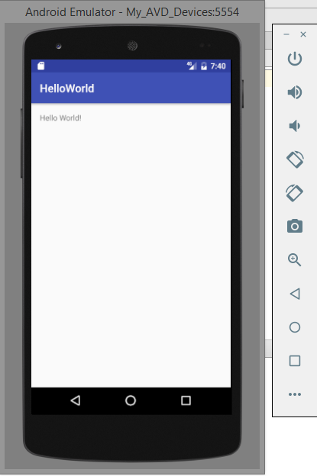

-- End of Practical 2 --