School of Digital Media and Infocomm Technology (DMIT)

ST0281 Mobile Applications

Practical 5

|  |
| --- |
| Objectives:  After completing this lab, you will be able to:   * Program an activity * Understand the Activity Life Cycle in Android Application Development. * Program the user interface of an activity using XML and change the layout of the user interface |

**1. Create a new Android project, name AndroidActivity.**

Step 1: Start a new Project.

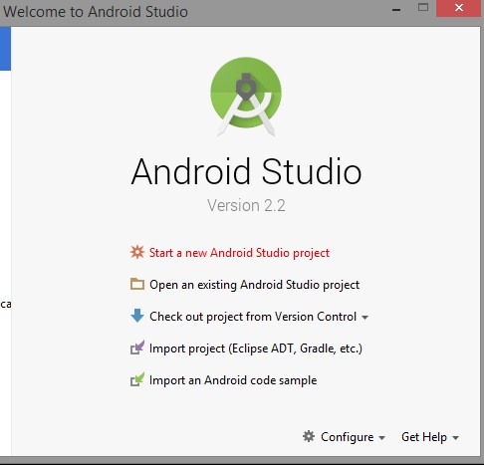

Step 2:

Application name: AndroidActivity

Company Domain: sg.com.mapp (optional)

Package name: mapp.com.sg.androidactivity

Click Next.

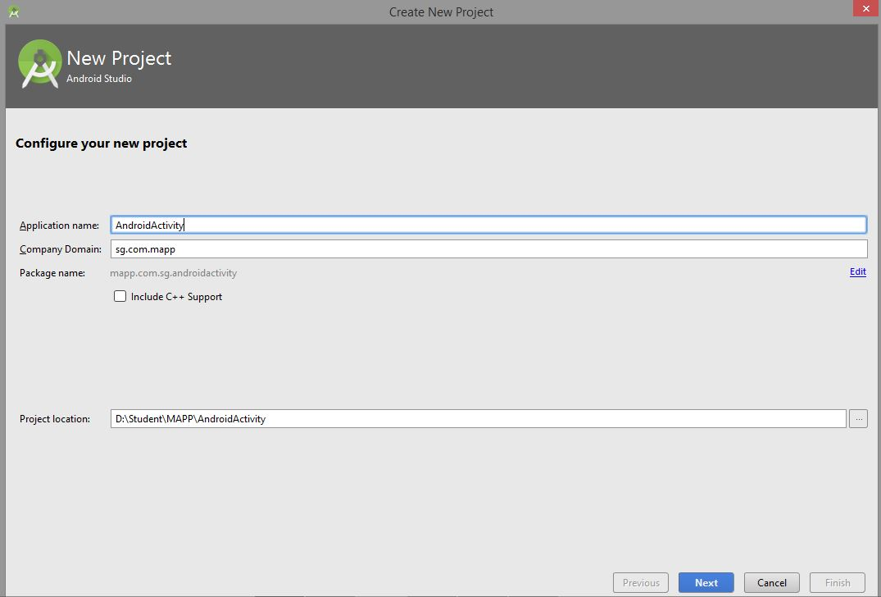

Step 3:

Minimum SDK: API 16: Android 4.1 (Jelly Bean)

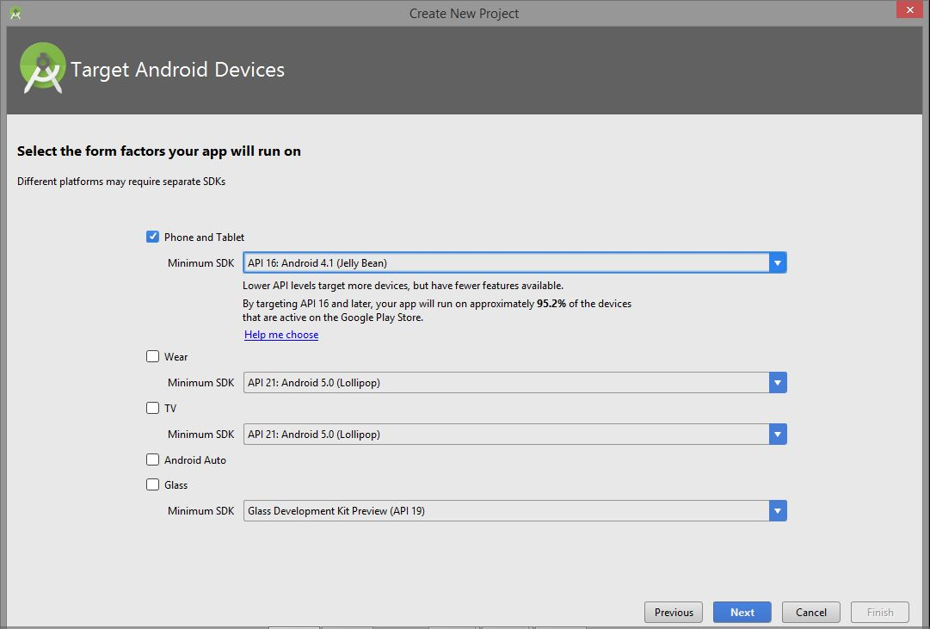

Note: The Lower API levels target more devices, but fewer features available.

Step 4:

Select Empty Activity

Click Next.

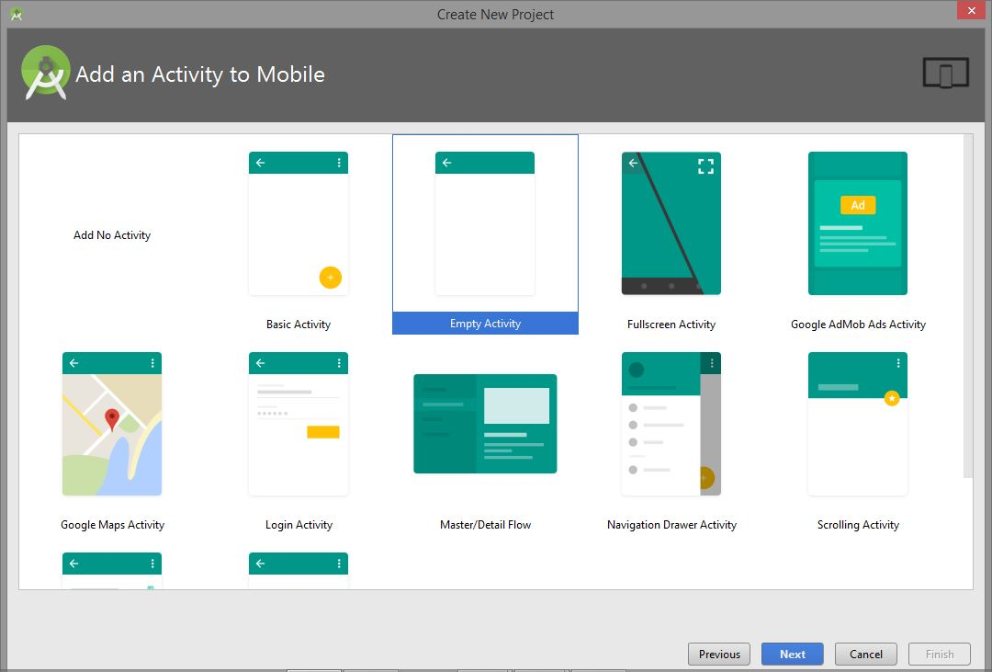

Step 5:

Activity Name: MainActivity

Layout Name: activity_main

Click Finish.

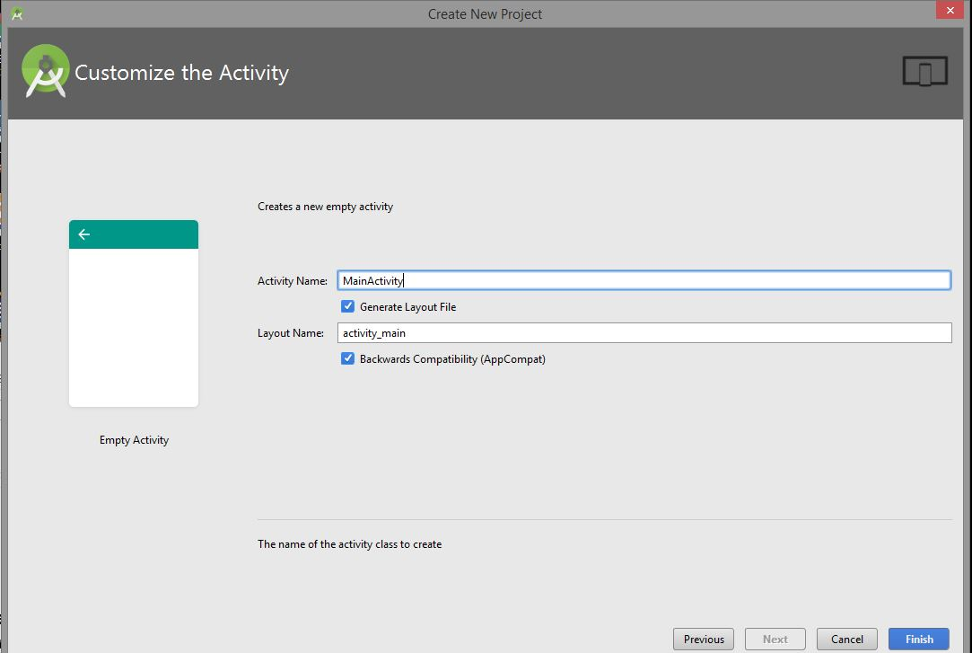

Note: This process of creating new project will be used throughout the MAPP practical lesson.

2. Create the User Interface for each activity.

Step 1:

Change the Text to “Android Activity In Action!”

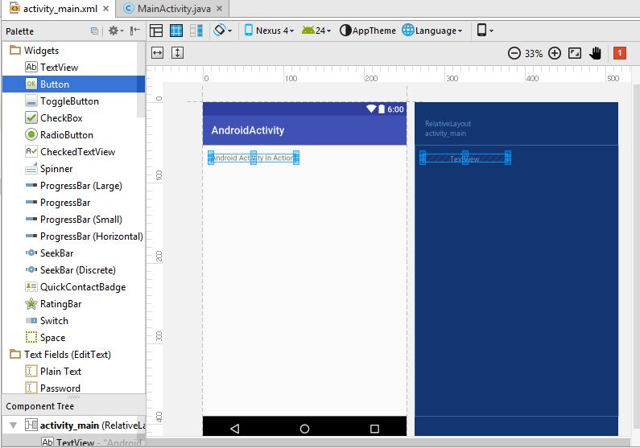

Step 2:

Add 3 buttons into the activity_main.xml.

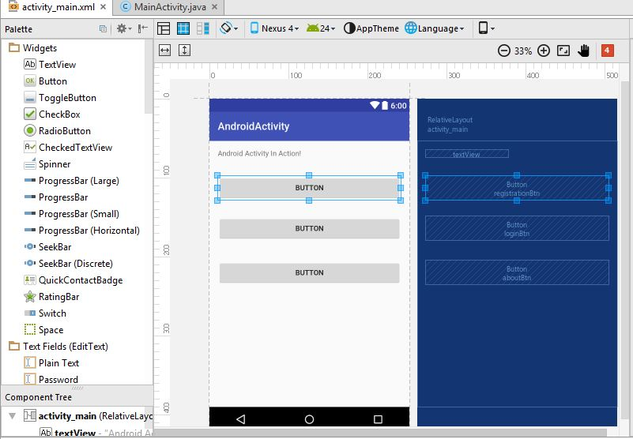

The activity_main.xml files will be as such.

|  |
| --- |
| <?xml version="1.0" encoding="utf-8"?>  <RelativeLayout xmlns:android="http://schemas.android.com/apk/res/android"  xmlns:tools="http://schemas.android.com/tools"  android:id="@+id/activity_main"  android:layout_width="match_parent"  android:layout_height="match_parent"  android:paddingBottom="@dimen/activity_vertical_margin"  android:paddingLeft="@dimen/activity_horizontal_margin"  android:paddingRight="@dimen/activity_horizontal_margin"  android:paddingTop="@dimen/activity_vertical_margin"  tools:context="mapp.com.sg.androidactivity.MainActivity">  <TextView  android:layout_width="wrap_content"  android:layout_height="wrap_content"  android:id="@+id/textInfo"  android:text="Android Activity In Action!" />  <Button  android:text="Registration"  android:layout_width="wrap_content"  android:layout_height="wrap_content"  android:layout_below="@+id/textInfo"  android:layout_alignParentLeft="true"  android:layout_alignParentStart="true"  android:layout_marginTop="34dp"  android:id="@+id/registrationBtn"  android:layout_alignParentRight="true"  android:layout_alignParentEnd="true" />  <Button  android:text="Login"  android:layout_width="wrap_content"  android:layout_height="wrap_content"  android:layout_below="@+id/registrationBtn"  android:layout_alignParentLeft="true"  android:layout_alignParentStart="true"  android:layout_marginTop="30dp"  android:id="@+id/loginBtn"  android:layout_alignParentRight="true"  android:layout_alignParentEnd="true" />  <Button  android:text="About"  android:layout_width="wrap_content"  android:layout_height="wrap_content"  android:layout_below="@+id/loginBtn"  android:layout_alignParentLeft="true"  android:layout_alignParentStart="true"  android:layout_marginTop="37dp"  android:id="@+id/aboutBtn"  android:layout_alignParentRight="true"  android:layout_alignParentEnd="true" />  </RelativeLayout> |

**3. Coding the MainActivity.java**

Step 1:

Add the following code into the MainActivity.java.

|  |
| --- |
| package mapp.com.sg.androidactivity;  import android.support.v7.app.AppCompatActivity;  import android.os.Bundle;  import android.util.Log;  public class MainActivity extends AppCompatActivity {  String msg = "Android : ";  @Override  protected void onCreate(Bundle savedInstanceState) {  super.onCreate(savedInstanceState);  setContentView(R.layout.activity_main);  }  **// Add the following code**  /** Called when the activity is about to become visible. */  @Override  protected void onStart() {  super.onStart();  Log.d(msg, "The onStart() event");  }  /** Called when the activity has become visible. */  @Override  protected void onResume() {  super.onResume();  Log.d(msg, "The onResume() event");  }  /** Called when another activity is taking focus. */  @Override  protected void onPause() {  super.onPause();  Log.d(msg, "The onPause() event");  }  /** Called when the activity is no longer visible. */  @Override  protected void onStop() {  super.onStop();  Log.d(msg, "The onStop() event");  }  /** Called just before the activity is destroyed. */  @Override  public void onDestroy() {  super.onDestroy();  Log.d(msg, "The onDestroy() event");  }  **// End of Adding the code**  } |

Note: The Log. will be highlighted in red. Use Alt-Enter to import the android.ultil.log

import android.util.Log;

**4. Understand the Activity LifeCycle.**

Run the **AndroidActivity** android application in android emulator or the android phone.

The AndroidActivity application will be as shown.

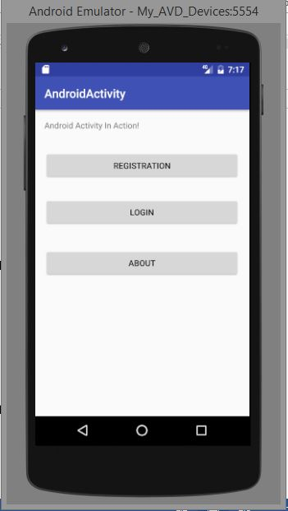

View the logcat by selecting Android Monitor.

Observe the activity using the logcat.

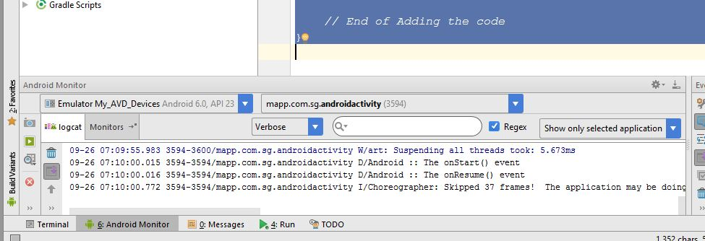

Observe the application output by doing the following:

* Run the application.
* Click on the Home button
* Recent Applications
* Back Button.

**5. Tasks**

Use the screen capture tools (Snipping Tools) to capture the each of the above output.

Take note of the observation.

**Activity Life Cycle**

