School of Digital Media and Infocomm Technology (DMIT)

ST0281 Mobile Applications

Practical 6

|  |
| --- |
| Objectives:  After completing this lab, you will be able to:   * Implement the About button * Program an activity as the response to user clicking on the About button |

In this practical, you will implement the About button so that when the user clicks on it or taps on it, it will show some text that describes the application.

This is a continuation of Practical 5. Hence, launch Android Studio and open the project that you have created in Practical 5.

Follow the following steps:

**Define a layout using xml declaration in res/layout, called *about.xml*.**

Step 1: Right click on the res/layout and select Layout resource file.

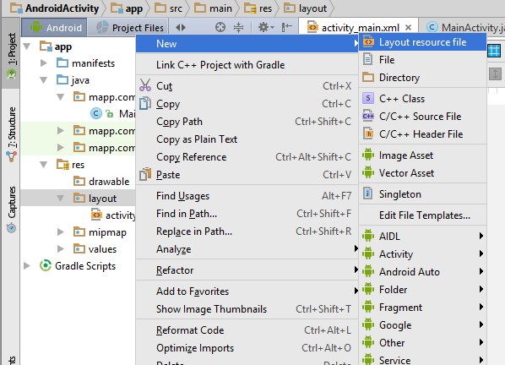

Step 2: Filename: about.xml.

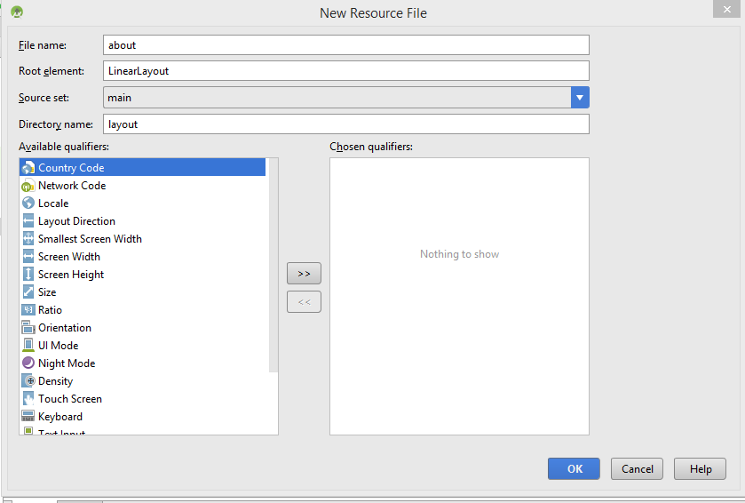

Step 3:

Modify the about.xml files as shown.

|  |
| --- |
| <?xml version="1.0" encoding="utf-8"?>  <LinearLayout xmlns:android="http://schemas.android.com/apk/res/android"  android:orientation="vertical" android:layout_width="match_parent"  android:layout_height="match_parent">  <TextView  android:id="@+id/about_content"  android:text="@string/about_text"  android:layout_width="wrap_content"  android:layout_height="wrap_content" />  </LinearLayout> |

Insert the following into the strings.xml

|  |
| --- |
| <resources>  <string name="app_name">AndroidActivity</string>  <string name="about_title">About the Application</string>  <string name="about_text">This is my first Mobile Application. Developer: XXX </string>  </resources> |

**Create a class file called About.java.**

Step 1:

Right click on the mapp.com.sg.androidactivity->New->Java Class

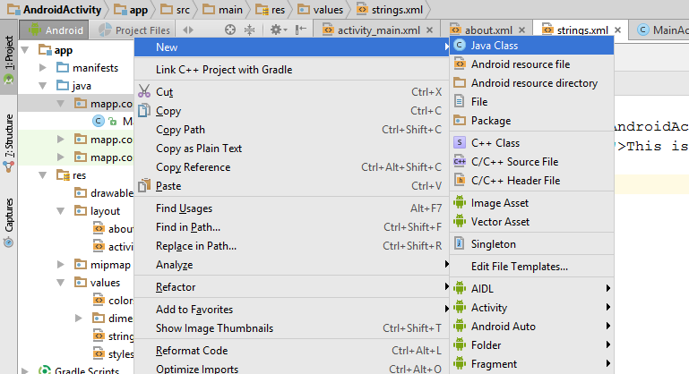

Step 2:

Name: About.java

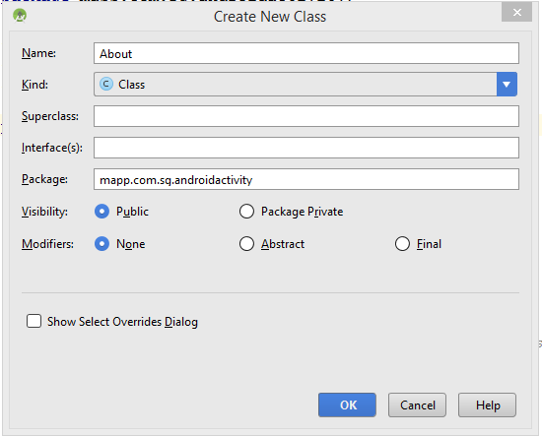

Step 3:

Modify the About.java code as shown.

|  |
| --- |
| package mapp.com.sg.androidactivity;  import android.app.Activity;  import android.os.Bundle;  /**  * Created by s38092 on 3/10/2016.  */  public class About extends AppCompatActivity {  @Override  protected void onCreate(Bundle savedInstanceState){  super.onCreate(savedInstanceState);  setContentView(R.layout.about);  }  } |

In order to enable the button, the MainActivity.java have to implements the OnClickListener interface.

Step 1:

You may need to click on the lightbulb to implement the onClick method.

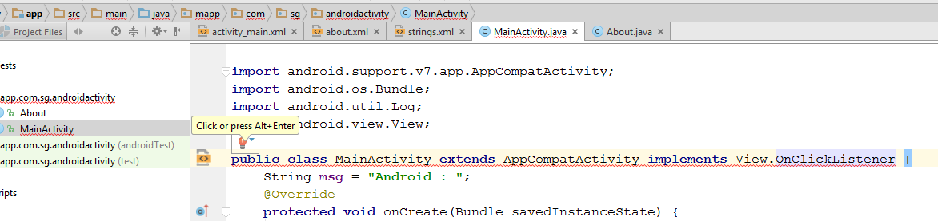

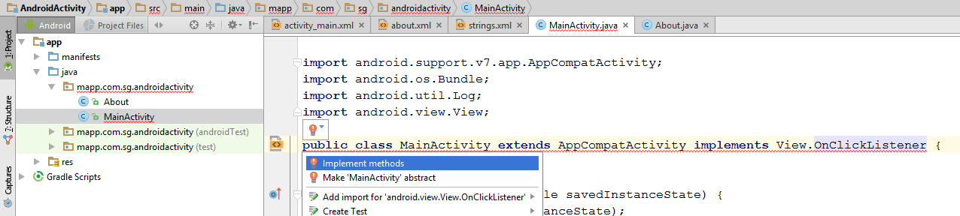

Click OK to implement the onClick method.

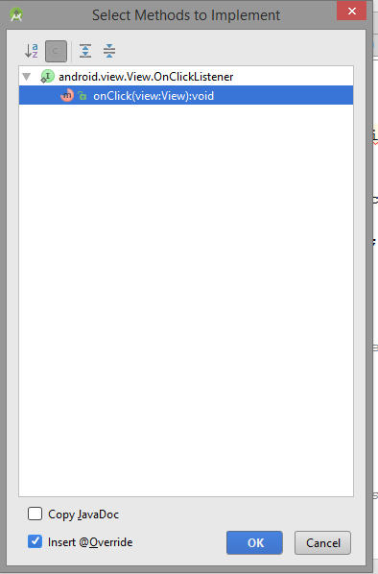

Enter the following code into the MainActivity.java.

|  |
| --- |
| package mapp.com.sg.androidactivity;  import android.content.Intent;  import android.support.v7.app.AppCompatActivity;  import android.os.Bundle;  import android.util.Log;  import android.view.View;  public class MainActivity extends AppCompatActivity implements View.OnClickListener {  String msg = "Android : ";  @Override  protected void onCreate(Bundle savedInstanceState) {  super.onCreate(savedInstanceState);  setContentView(R.layout.activity_main);  }  /** Called when the activity is about to become visible. */  @Override  protected void onStart() {  super.onStart();  Log.d(msg, "The onStart() event");  }  /** Called when the activity has become visible. */  @Override  protected void onResume() {  super.onResume();  Log.d(msg, "The onResume() event");  }  /** Called when another activity is taking focus. */  @Override  protected void onPause() {  super.onPause();  Log.d(msg, "The onPause() event");  }  /** Called when the activity is no longer visible. */  @Override  protected void onStop() {  super.onStop();  Log.d(msg, "The onStop() event");  }  /** Called just before the activity is destroyed. */  @Override  public void onDestroy() {  super.onDestroy();  Log.d(msg, "The onDestroy() event");  }  @Override  public void onClick(View view) {  switch (view.getId()) {  case R.id.aboutBtn:  Intent i = new Intent(this, About.class);  startActivity(i);  break;  }  }  } |

Modify the activity_main.xml to include the onClick.

|  |
| --- |
| <?xml version="1.0" encoding="utf-8"?>  <RelativeLayout xmlns:android="http://schemas.android.com/apk/res/android"  xmlns:tools="http://schemas.android.com/tools"  android:id="@+id/activity_main"  android:layout_width="match_parent"  android:layout_height="match_parent"  android:paddingBottom="@dimen/activity_vertical_margin"  android:paddingLeft="@dimen/activity_horizontal_margin"  android:paddingRight="@dimen/activity_horizontal_margin"  android:paddingTop="@dimen/activity_vertical_margin"  tools:context="mapp.com.sg.androidactivity.MainActivity">  <TextView  android:layout_width="wrap_content"  android:layout_height="wrap_content"  android:id="@+id/textInfo"  android:text="Android Activity In Action!" />  <Button  android:text="Registration"  android:layout_width="wrap_content"  android:layout_height="wrap_content"  android:layout_below="@+id/textInfo"  android:layout_alignParentLeft="true"  android:layout_alignParentStart="true"  android:layout_marginTop="34dp"  android:id="@+id/registrationBtn"  android:layout_alignParentRight="true"  android:layout_alignParentEnd="true" />  <Button  android:text="Login"  android:layout_width="wrap_content"  android:layout_height="wrap_content"  android:layout_below="@+id/registrationBtn"  android:layout_alignParentLeft="true"  android:layout_alignParentStart="true"  android:layout_marginTop="30dp"  android:id="@+id/loginBtn"  android:layout_alignParentRight="true"  android:layout_alignParentEnd="true" />  <Button  android:text="About"  android:layout_width="wrap_content"  android:layout_height="wrap_content"  android:layout_below="@+id/loginBtn"  android:layout_alignParentLeft="true"  android:layout_alignParentStart="true"  android:layout_marginTop="37dp"  android:id="@+id/aboutBtn"  android:onClick="onClick" 🡨--------------Insert the OnClick  android:layout_alignParentRight="true"  android:layout_alignParentEnd="true" />  </RelativeLayout> |

**Add the activity in the Android Manifest file.**

|  |
| --- |
| <?xml version="1.0" encoding="utf-8"?>  <manifest xmlns:android="http://schemas.android.com/apk/res/android"  package="mapp.com.sg.androidactivity">  <application  android:allowBackup="true"  android:icon="@mipmap/ic_launcher"  android:label="@string/app_name"  android:supportsRtl="true"  android:theme="@style/AppTheme">  <activity android:name=".MainActivity">  <intent-filter>  <action android:name="android.intent.action.MAIN" />  <category android:name="android.intent.category.LAUNCHER" />  </intent-filter>  </activity>  <activity android:name=".About"  android:theme="@style/AppTheme"  android:label="@string/about_title">  </activity>  </application>  </manifest> |

Save all the files and run the project as an Android application. You should see the following being displayed when you click on the About button:

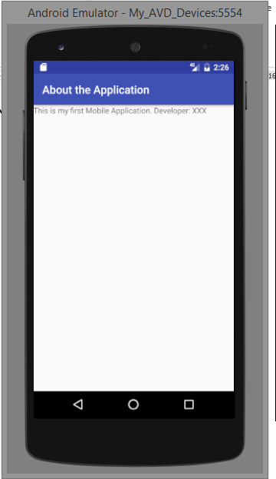

**Intent**

An Intent is an object that provides runtime binding between separate components (such as two activities). The Intent represents an app’s "intent to do something." You can use intents for a wide variety of tasks.

-- End of Practical 6 --