School of Digital Media and Infocomm Technology (DMIT)

ST0281 Mobile Applications

Practical 7

|  |
| --- |
| Objectives:  After completing this lab, you will be able to:   * Implement the Registration button * Program an activity as the response to user clicking on the Registration button |

In this practical, you will implement the Registration button so that when the user clicks on it or taps on it, it will show the registration page.

This is a continuation of Practical 6. Hence, launch Android Studio and open the project that you have created in Practical 5.

You are required to use the knowledge learnt in Practical 6 to complete Practical 7.

The requirement to create the Registration function is as follow:

* Define a layout using xml declaration in res/layout, called registration.xml.
* Create a class file called Registration.java.
* Modify the code in the MainActivity.java to trigger the Intent for the Registration.class.
* Modify the activity_main.xml to include the onClick tags.
* Add the registration activity in the Android Manifest file.

The layout for the activity_main.xml is as follow:

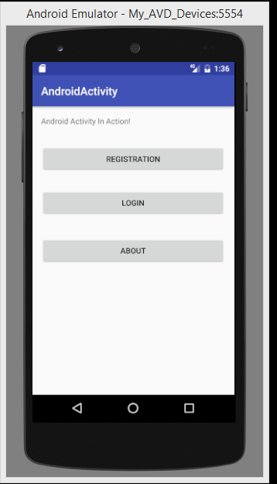

When user tab on the Registration button, it will trigger the Intent for the registration.class

The layout of the registration.xml.

TextView

android:text="Name"

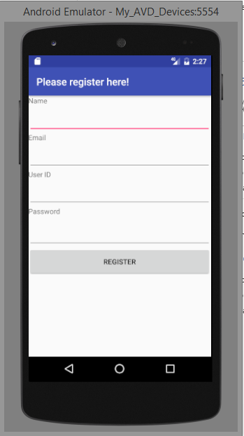

Button

android:text="Register"

android:id="@+id/btnRegistered"

EditText

android:inputType="textPassword"android:id="@+id/txtPassword"

EditText

android:text=""

android:id="@+id/txtUserID"

EditText

android:text=""

android:id="@+id/txtEmail"

EditText

android:text=""

android:id="@+id/txtName"

TextView

android:text="Password"

TextView

android:text="Email"

TextView

android:text="UserID"