School of Digital Media and Infocomm Technology (DMIT)
ST0281 Mobile Applications
Practical 10

Objectives:

After completing this lab, you will be able to:

- Implement SharedPreferences
- Program an Activity that uses getPreferences()
- Program an Activity to demonstrate saving information to a text file.

In this practical, you will create a new Android project to implement SharedPreferences. You will see the difference between not implementing SharedPreferences and implementing SharedPreferences where information being keyed in is “retained” or saved.

The shared preferences can be used by other application components. But if you do not need to share the preferences with other components and want to have activities private preferences, you can do that with the help of getPreferences() method of the activity. The getPreference method uses the getSharedPreferences() method with the name of the activity class for the preference file name

Follow the steps below:
Step 1:
Create a new project called MyData.
Note: Refer to Practical 5 on the step to create a new project.
1. Application name: MyData  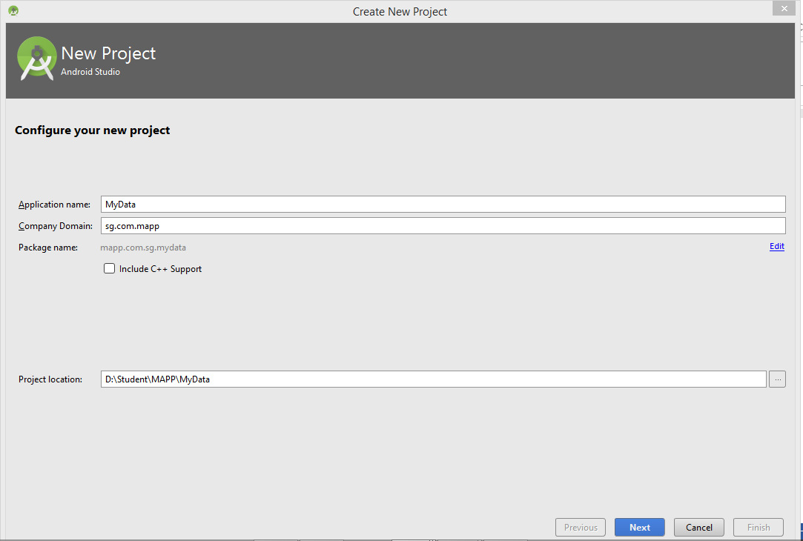 | 2.  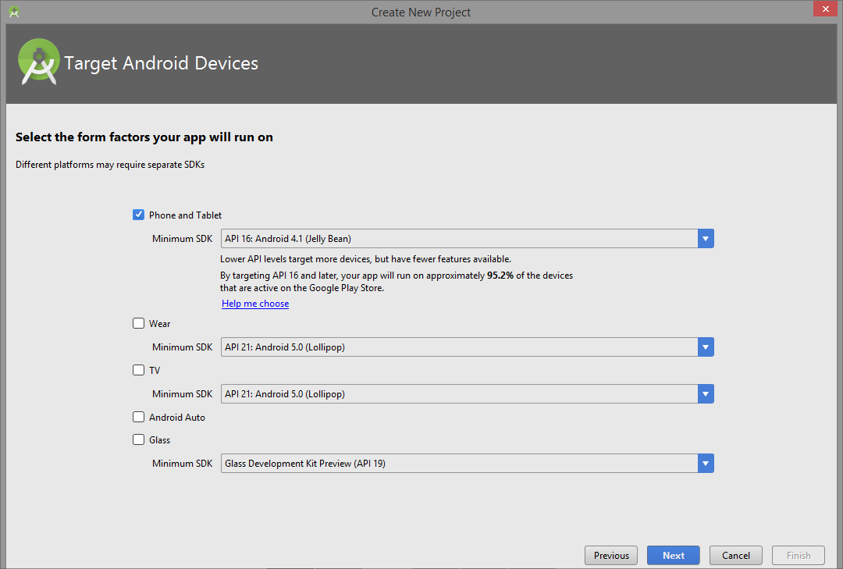
3. Empty Activity  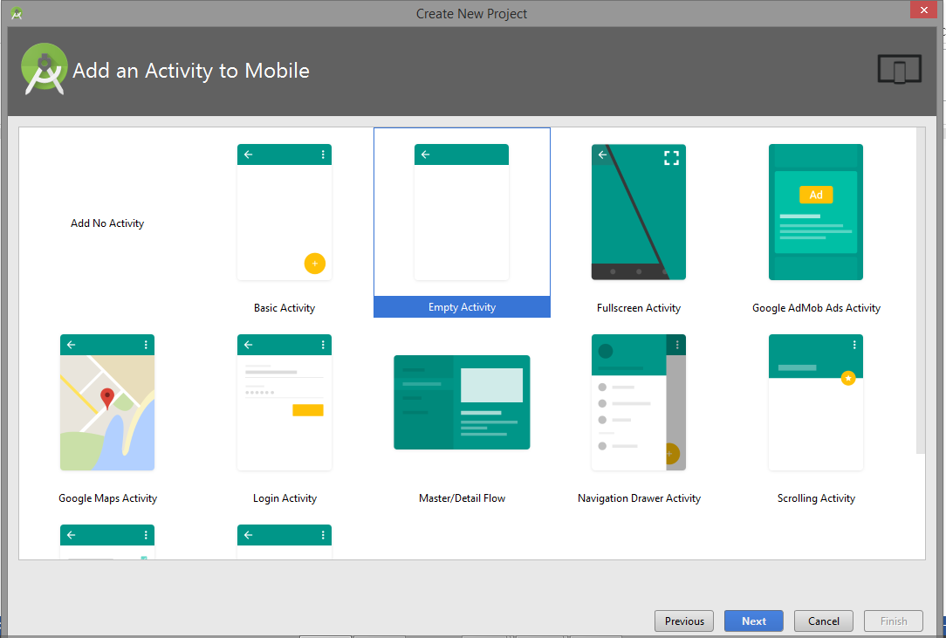 | 4. Activity Name:MainActivity  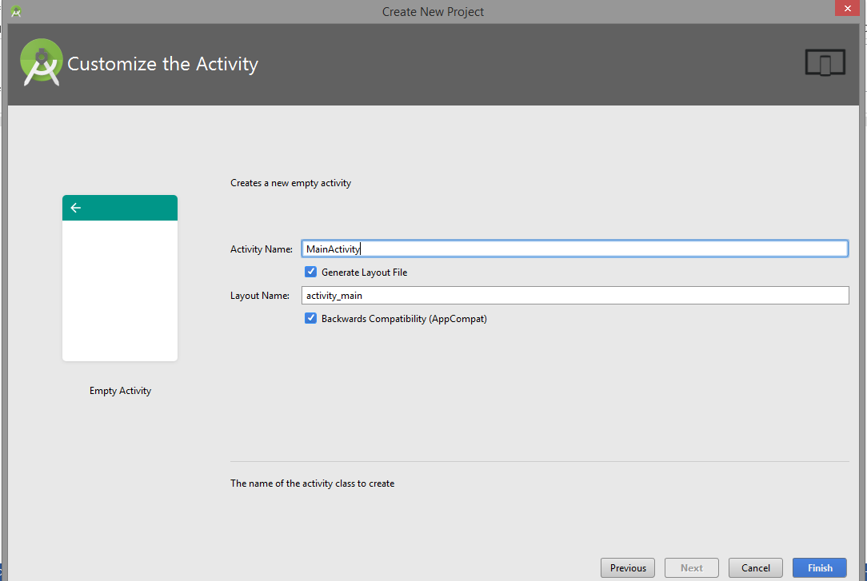

Step 2:
Modify the activity_main.xml as shown below:

<?xml version="1.0" encoding="utf-8"?>
<RelativeLayout xmlns:android="http://schemas.android.com/apk/res/android"
xmlns:tools="http://schemas.android.com/tools"
android:id="@+id/activity_main"
android:layout_width="match_parent"
android:layout_height="match_parent"
android:paddingBottom="@dimen/activity_vertical_margin"
android:paddingLeft="@dimen/activity_horizontal_margin"
android:paddingRight="@dimen/activity_horizontal_margin"
android:paddingTop="@dimen/activity_vertical_margin"
tools:context="mapp.com.sg.mydata.MainActivity">

<TextView
android:layout_width="wrap_content"
android:layout_height="wrap_content"
android:text="Welcome to MyData Storage" />

<EditText
android:layout_width="wrap_content"
android:layout_height="wrap_content"
android:inputType="textPersonName"
android:ems="10"
android:id="@+id/txtUserID"
android:layout_marginTop="27dp"
android:layout_below="@+id/textView"
android:layout_alignParentRight="true"
android:layout_alignParentEnd="true" />

<TextView
android:text="User ID"
android:layout_width="wrap_content"
android:layout_height="wrap_content"
android:id="@+id/textView2"
android:textSize="14sp"
android:layout_alignTop="@+id/txtUserID"
android:layout_alignParentLeft="true"
android:layout_alignParentStart="true" />

<TextView
android:text="Password"
android:layout_width="wrap_content"
android:layout_height="wrap_content"
android:layout_below="@+id/txtUserID"
android:layout_alignParentLeft="true"
android:layout_alignParentStart="true"
android:layout_marginTop="30dp"
android:id="@+id/textView3" />

<EditText
android:layout_width="wrap_content"
android:layout_height="wrap_content"
android:inputType="textPassword"
android:ems="10"
android:layout_below="@+id/txtUserID"
android:layout_alignParentRight="true"
android:layout_alignParentEnd="true"
android:layout_marginTop="16dp"
android:id="@+id/txtPw" />

<Button
android:text="Login"
android:layout_width="wrap_content"
android:layout_height="wrap_content"
android:layout_below="@+id/txtPw"
android:layout_alignParentLeft="true"
android:layout_alignParentStart="true"
android:layout_marginTop="34dp"
android:id="@+id/btnLogin" />

<Button
android:text="Create New Account"
android:layout_width="wrap_content"
android:layout_height="wrap_content"
android:layout_marginTop="81dp"
android:id="@+id/btnNewUser"
android:layout_below="@+id/btnLogin"
android:layout_alignParentRight="true"
android:layout_alignParentEnd="true"
android:layout_alignParentLeft="true"
android:layout_alignParentStart="true" />

<Button
android:text="Foget Password"
android:layout_width="wrap_content"
android:layout_height="wrap_content"
android:layout_below="@+id/btnNewUser"
android:layout_alignParentLeft="true"
android:layout_alignParentStart="true"
android:layout_marginTop="19dp"
android:id="@+id/btnForgetPw"
android:layout_alignParentRight="true"
android:layout_alignParentEnd="true" />
</RelativeLayout>

The user interface will display as follow:

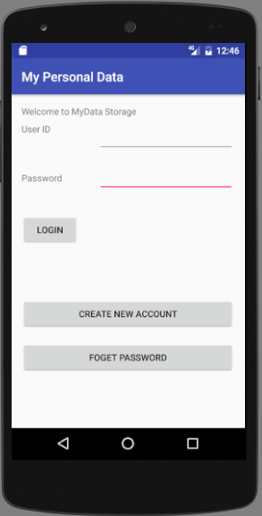

Step 3:
Run the project.
Enter the following:
User ID: p172219
Password: password

Click on the login.

When done press the Back button (triangle symbol) to go to the Home screen.
Now click the “My Personal Data” app, the text you typed disappear.
In order to store data so that it can be recall later, SharedPreferences are required to store the data and recall for again.

Share Preferences

Step 4:
Modify the MainActivity.java as shown below:

package mapp.com.sg.mydata;

import android.content.Context;
import android.content.SharedPreferences;
import android.support.v7.app.AppCompatActivity;
import android.os.Bundle;
import android.view.View;
import android.widget.Button;
import android.widget.EditText;

import java.util.prefs.Preferences;

public class MainActivity extends AppCompatActivity implements View.OnClickListener {

SharedPreferences prefs;
EditText edUName, edPw;
Button bLogin;
public static final String MyPREFERNCES = "MyPrefs";
public static final String UName = "unameKey";
public static final String Upw = "upwKey";

@Override
protected void onCreate(Bundle savedInstanceState) {
super.onCreate(savedInstanceState);
setContentView(R.layout.activity_main);

edUName = (EditText)findViewById(R.id.txtUserID);
edPw = (EditText)findViewById(R.id.txtPw);
bLogin = (Button)findViewById(R.id.btnLogin);

// Load the preferences
prefs = getSharedPreferences(MyPREFERNCES, MODE_PRIVATE);
String gUID = prefs.getString(UName,"");
String gPw = prefs.getString(Upw,"");

// Set the EditText view to the various saved values
// Place the data into the respective EditText
edUName.setText(gUID);
edPw.setText(gPw);
}

@Override
public void onPause(){
super.onPause();

edUName = (EditText)findViewById(R.id.txtUserID);
edPw = (EditText)findViewById(R.id.txtPw);
bLogin = (Button)findViewById(R.id.btnLogin);

prefs = getSharedPreferences(MyPREFERNCES, MODE_PRIVATE);

// Get the text from the EditText field
String uID = edUName.getText().toString();
String uPw = edPw.getText().toString();

SharedPreferences.Editor editor = prefs.edit();

// Store into the SharedPreferences
editor.putString(UName,uID);
editor.putString(Upw,uPw);
editor.commit();

}

@Override
public void onClick(View view) {
edUName = (EditText)findViewById(R.id.txtUserID);
edPw = (EditText)findViewById(R.id.txtPw);
bLogin = (Button)findViewById(R.id.btnLogin);

prefs = getSharedPreferences(MyPREFERNCES, MODE_PRIVATE);

// Get the text from the EditText field
String uID = edUName.getText().toString();
String uPw = edPw.getText().toString();

SharedPreferences.Editor editor = prefs.edit();

// Store into the SharedPreferences
editor.putString(UName,uID);
editor.putString(Upw,uPw);
editor.commit();
}
}

Step 5:
Saved All Files
Run the Application.

Step 6:
Key in the User ID and password in the respective field, click on the submit button.
Click the Home button.
Go back to the application, is the User ID and password still available.

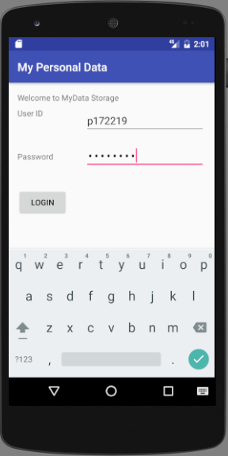

Next, close the application completely (kill the app).

Now run the Application, state the observation on the User ID and password.

-- End of Practical 10 --

