School of Digital Media and Infocomm Technology (DMIT)
ST0281 Mobile Applications
Practical 11

Objectives:

After completing this lab, you will be able to:

- Implement the passing of information from one Activity to another using Intents
- Create an Alert dialog
- Set the properties of an Alert dialog.

In this practical, you will learn to pass data from one Activity to another Activity using an Intent object. The second Activity will display what the first Activity passed to it.

If the user does not key in anything before tapping a button to navigate to the second Activity, an Alert Dialog will be shown. Take note of how the Alert Dialog is created and set up and how it is being shown and dismissed.

This is a continuation of Practical 11. Hence, launch Android Studio and open the project that you have created in Practical 11 (MyData project).

Follow the steps below:
Step 1:
Create 2 new Empty Activity.

Right Click app->New-Activity->Empty Activity  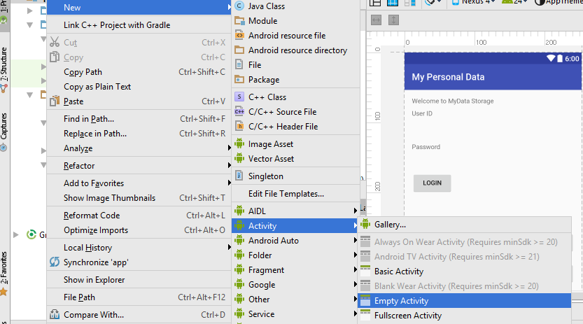 | Activity Name: NewAccountActivity  Click Finish.  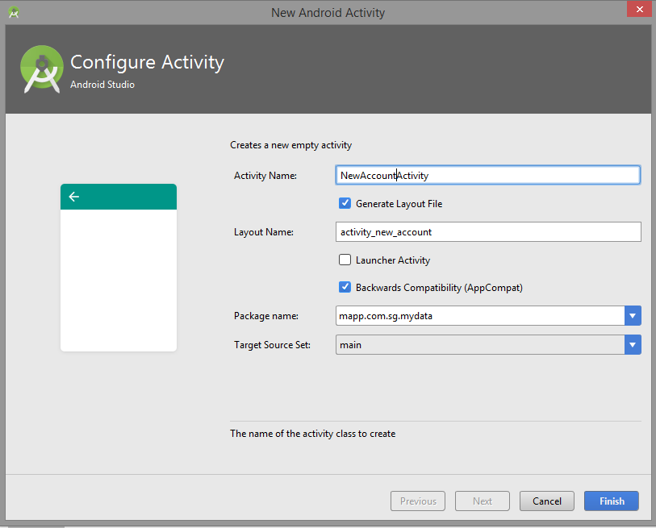

Right Click app->New-Activity->Empty Activity | Activity Name: ConfirmRegistrationActivity  Click Finish.  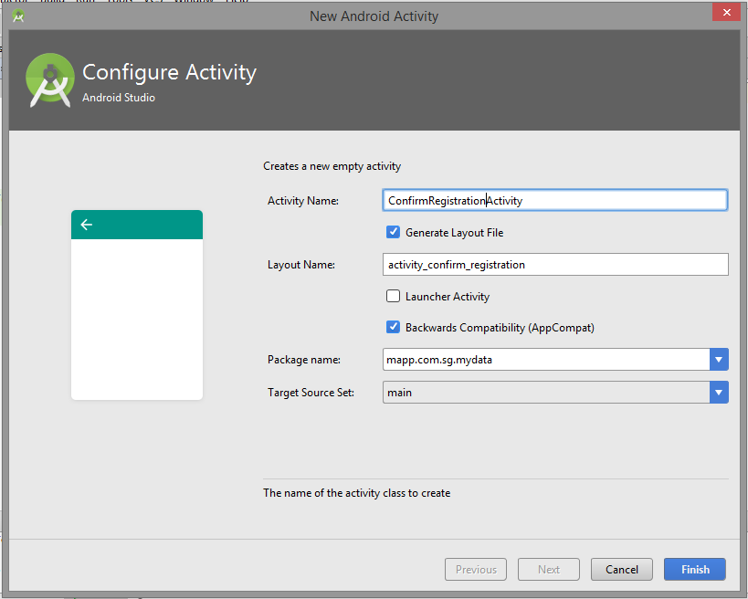

Step 2:
Modify the MainActivity.java
To start the NewAccountActivity intent.
@Override
public void onClick(View view) {
edUName = (EditText)findViewById(R.id.txtUserID);
edPw = (EditText)findViewById(R.id.txtPw);
bLogin = (Button)findViewById(R.id.btnLogin);

prefs = getSharedPreferences(MyPREFERNCES, MODE_PRIVATE);

// Get the text from the EditText field
String uID = edUName.getText().toString();
String uPw = edPw.getText().toString();

SharedPreferences.Editor editor = prefs.edit();

// Store into the SharedPreferences
editor.putString(UName,uID);
editor.putString(Upw,uPw);
editor.commit();

// Button Click AddOn
switch (view.getId()){ < --------- Insert the following code
case R.id.btnNewUser:
Intent i = new Intent(this, NewAccountActivity.class);
startActivity(i);
break;
}
// End of Button Click

}

Step 3:
Modify the activity_new_account.xml.

<?xml version="1.0" encoding="utf-8"?>
<RelativeLayout xmlns:android="http://schemas.android.com/apk/res/android"
xmlns:tools="http://schemas.android.com/tools"
android:id="@+id/activity_new_account"
android:layout_width="match_parent"
android:layout_height="match_parent"
android:paddingBottom="@dimen/activity_vertical_margin"
android:paddingLeft="@dimen/activity_horizontal_margin"
android:paddingRight="@dimen/activity_horizontal_margin"
android:paddingTop="@dimen/activity_vertical_margin"
tools:context="mapp.com.sg.mydata.NewAccountActivity">

<TextView
android:text="First Name"
android:layout_width="wrap_content"
android:layout_height="wrap_content"
android:layout_alignParentTop="true"
android:layout_alignParentLeft="true"
android:layout_alignParentStart="true"
android:id="@+id/textView4" />

<Button
android:text="registeration"
android:layout_width="wrap_content"
android:layout_height="wrap_content"
android:layout_marginTop="23dp"
android:id="@+id/btnRegister"
android:onClick="onClick"
android:layout_below="@+id/txtPassword"
android:layout_alignParentLeft="true"
android:layout_alignParentStart="true" />

<TextView
android:text="Mobile Number"
android:layout_width="wrap_content"
android:layout_height="wrap_content"
android:id="@+id/textView9"
android:layout_alignBaseline="@+id/txtTelNo"
android:layout_alignBottom="@+id/txtTelNo"
android:layout_alignParentLeft="true"
android:layout_alignParentStart="true" />

<EditText
android:layout_width="wrap_content"
android:layout_height="wrap_content"
android:inputType="textPassword"
android:ems="10"
android:id="@+id/txtPassword"
android:layout_marginTop="32dp"
android:layout_below="@+id/txtUsrName"
android:layout_alignParentRight="true"
android:layout_alignParentEnd="true" />

<TextView
android:text="User Name"
android:layout_width="wrap_content"
android:layout_height="wrap_content"
android:id="@+id/textView7"
android:layout_marginTop="23dp"
android:layout_below="@+id/txtTelNo"
android:layout_alignParentLeft="true"
android:layout_alignParentStart="true" />

<TextView
android:text="Password"
android:layout_width="wrap_content"
android:layout_height="wrap_content"
android:id="@+id/textView8"
android:layout_alignTop="@+id/txtPassword"
android:layout_alignParentLeft="true"
android:layout_alignParentStart="true" />

<EditText
android:layout_width="wrap_content"
android:layout_height="wrap_content"
android:inputType="textPersonName"
android:ems="10"
android:id="@+id/txtUsrName"
android:layout_alignTop="@+id/textView7"
android:layout_alignParentRight="true"
android:layout_alignParentEnd="true" />

<TextView
android:text="Email"
android:layout_width="wrap_content"
android:layout_height="wrap_content"
android:id="@+id/textView6"
android:layout_alignParentLeft="true"
android:layout_alignParentStart="true"
android:layout_alignTop="@+id/txtEmail" />

<EditText
android:layout_width="wrap_content"
android:layout_height="wrap_content"
android:inputType="textPersonName"
android:ems="10"
android:id="@+id/txtFName"
android:layout_alignParentTop="true"
android:layout_alignParentRight="true"
android:layout_alignParentEnd="true" />

<EditText
android:layout_width="wrap_content"
android:layout_height="wrap_content"
android:inputType="textPersonName"
android:ems="10"
android:layout_below="@+id/txtFName"
android:layout_alignLeft="@+id/txtEmail"
android:layout_alignStart="@+id/txtEmail"
android:layout_marginTop="19dp"
android:id="@+id/txtLName" />

<TextView
android:text="LastName"
android:layout_width="wrap_content"
android:layout_height="wrap_content"
android:id="@+id/textView5"
android:layout_alignTop="@+id/txtLName"
android:layout_alignParentLeft="true"
android:layout_alignParentStart="true" />

<EditText
android:layout_width="wrap_content"
android:layout_height="wrap_content"
android:ems="10"
android:id="@+id/txtTelNo"
android:layout_marginTop="16dp"
android:layout_below="@+id/txtEmail"
android:layout_alignParentRight="true"
android:layout_alignParentEnd="true"
android:inputType="text" />

<EditText
android:layout_width="wrap_content"
android:layout_height="wrap_content"
android:inputType="textPersonName"
android:ems="10"
android:id="@+id/txtEmail"
android:layout_below="@+id/txtLName"
android:layout_alignParentRight="true"
android:layout_alignParentEnd="true"
android:layout_marginTop="14dp" />
</RelativeLayout>

The user interface should display as follow:

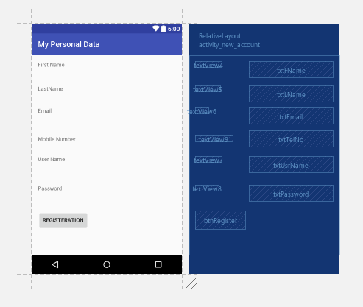

Step 4:
Modify the activity_confirm_registration.xml.

<?xml version="1.0" encoding="utf-8"?>
<RelativeLayout xmlns:android="http://schemas.android.com/apk/res/android"
xmlns:tools="http://schemas.android.com/tools"
android:id="@+id/activity_confirm_registration"
android:layout_width="match_parent"
android:layout_height="match_parent"
android:paddingBottom="@dimen/activity_vertical_margin"
android:paddingLeft="@dimen/activity_horizontal_margin"
android:paddingRight="@dimen/activity_horizontal_margin"
android:paddingTop="@dimen/activity_vertical_margin"
tools:context="mapp.com.sg.mydata.ConfirmRegistrationActivity">

<TextView
android:text="TextView"
android:layout_width="wrap_content"
android:layout_height="wrap_content"
android:layout_below="@+id/txtRow3"
android:layout_alignParentLeft="true"
android:layout_alignParentStart="true"
android:layout_marginTop="24dp"
android:id="@+id/txtRow4" />

<TextView
android:text="TextView"
android:layout_width="wrap_content"
android:layout_height="wrap_content"
android:layout_below="@+id/txtRow4"
android:layout_alignParentLeft="true"
android:layout_alignParentStart="true"
android:layout_marginTop="27dp"
android:id="@+id/txtRow5" />

<TextView
android:text="TextView"
android:layout_width="wrap_content"
android:layout_height="wrap_content"
android:layout_below="@+id/txtRow5"
android:layout_alignParentLeft="true"
android:layout_alignParentStart="true"
android:layout_marginTop="25dp"
android:id="@+id/txtRow6" />

<TextView
android:text="Please confirm your registration."
android:layout_width="wrap_content"
android:layout_height="wrap_content"
android:layout_alignParentTop="true"
android:layout_alignParentLeft="true"
android:layout_alignParentStart="true"
android:id="@+id/textView13" />

<Button
android:text="Confirmed"
android:layout_width="wrap_content"
android:layout_height="wrap_content"
android:layout_below="@+id/txtRow6"
android:layout_alignParentLeft="true"
android:layout_alignParentStart="true"
android:layout_marginTop="24dp"
android:id="@+id/btnConfirm1"
android:onClick="onClick"/>

<TextView
android:text="TextView"
android:layout_width="wrap_content"
android:layout_height="wrap_content"
android:id="@+id/txtRow3"
android:layout_marginTop="24dp"
android:layout_below="@+id/txtRow1"
android:layout_alignParentLeft="true"
android:layout_alignParentStart="true" />

<TextView
android:text="TextView"
android:layout_width="wrap_content"
android:layout_height="wrap_content"
android:id="@+id/txtRow1"
android:layout_below="@+id/txtRow2"
android:layout_alignParentLeft="true"
android:layout_alignParentStart="true"
android:layout_marginTop="20dp" />

<TextView
android:text="TextView"
android:layout_width="wrap_content"
android:layout_height="wrap_content"
android:layout_marginTop="15dp"
android:id="@+id/txtRow2"
android:layout_below="@+id/textView13"
android:layout_alignParentLeft="true"
android:layout_alignParentStart="true" />
</RelativeLayout>

The user interface should display as follow:
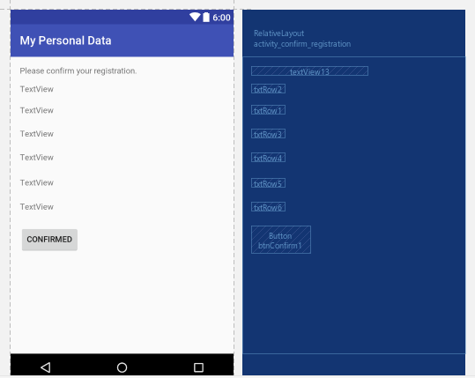

Step 5:
Modify the NewAccountActivity.java.

package mapp.com.sg.mydata;

import android.content.Intent;
import android.support.v7.app.AppCompatActivity;
import android.os.Bundle;
import android.view.View;
import android.widget.EditText;

public class NewAccountActivity extends AppCompatActivity implements View.OnClickListener {

private String pFName, pLName, pEmail, pUId, pPW,pMobileNo;
private EditText edFName, edLName, edEmail, edUID, edPW, edMobileNo;

@Override
protected void onCreate(Bundle savedInstanceState) {
super.onCreate(savedInstanceState);
setContentView(R.layout.activity_new_account);

edFName = (EditText) findViewById(R.id.txtFName);
edLName = (EditText) findViewById(R.id.txtLName);
edEmail = (EditText) findViewById(R.id.txtEmail);
edMobileNo = (EditText) findViewById(R.id.txtTelNo);
edUID = (EditText) findViewById(R.id.txtUsrName);
edPW = (EditText) findViewById(R.id.txtPassword);

}
@Override
public void onClick(View view) {
// Collect all data from the EditTextBox
pFName = edFName.getText().toString();
pLName = edLName.getText().toString();
pEmail = edEmail.getText().toString();
pMobileNo = edMobileNo.getText().toString();
pUId = edUID.getText().toString();
pPW = edPW.getText().toString();

switch (view.getId()){
case R.id.btnRegister:

// Check for empty data
if (pFName.length() == 0){
// Alert user
}else{
Intent confirmPage = new Intent (this, ConfirmRegistrationActivity.class);
confirmPage.putExtra("strFName",pFName);
confirmPage.putExtra("strLName",pLName);
confirmPage.putExtra("strEmail",pEmail);
confirmPage.putExtra("strMobileNo",pMobileNo);
confirmPage.putExtra("strID",pUId);
confirmPage.putExtra("strP",pPW);
startActivity(confirmPage);
}
break;
}

}
}

Step 6:
Modify the ConfirmRegistrationActivity.java.

package mapp.com.sg.mydata;

import android.support.v7.app.AppCompatActivity;
import android.os.Bundle;
import android.widget.TextView;
import android.widget.Toast;

public class ConfirmRegistrationActivity extends AppCompatActivity {

private String dRow1, dRow2, dRow3, dRow4, dRow5, dRow6;
TextView rtxt1,rtxt2,rtxt3,rtxt4,rtxt5,rtxt6;

@Override
protected void onCreate(Bundle savedInstanceState) {
super.onCreate(savedInstanceState);
setContentView(R.layout.activity_confirm_registration);

TextView rtxt1 = (TextView)findViewById(R.id.txtRow1);
TextView rtxt2 = (TextView)findViewById(R.id.txtRow2);
TextView rtxt3 = (TextView)findViewById(R.id.txtRow3);
TextView rtxt4 = (TextView)findViewById(R.id.txtRow4);
TextView rtxt5 = (TextView)findViewById(R.id.txtRow5);
TextView rtxt6 = (TextView)findViewById(R.id.txtRow6);

Bundle getData = getIntent().getExtras();

if (getData != null){
dRow1 = getData.getString("strFName");
dRow2 = getData.getString("strLName");
dRow3 = getData.getString("strEmail");
dRow4 = getData.getString("strMobileNo");
dRow5 = getData.getString("strID");
dRow6 = getData.getString("strP");

rtxt1.setText("First Name : " + dRow1 );
rtxt2.setText("Last Name : " + dRow2 );
rtxt3.setText("Email : " + dRow3 );
rtxt4.setText("Mobile Number : " + dRow4 );
rtxt5.setText("User ID : " + dRow5 );
rtxt6.setText("Password : " + dRow6 );

}else{
Toast.makeText(getApplicationContext(),"Failed to get Data",Toast.LENGTH_LONG).show();
}
}
}

Step 7:
Run the MyData application.

Click on the Create New Account.  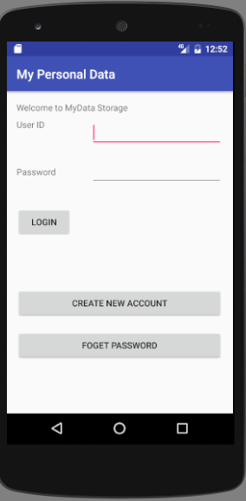 | Enter the registration information.  Click Registration button.  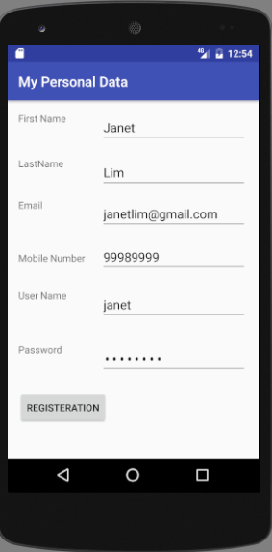 | Data will be pass to the ConfirmRegistrationActivity Intent.  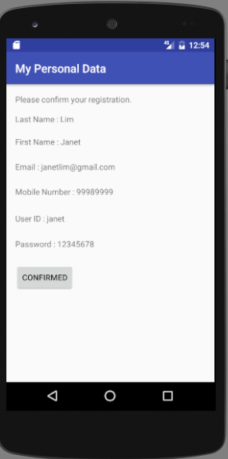

Implementing the Alert Dialog.

Step 8:
If user did not enter User Name and Password, an Alert Dialog will be shown.

Modify the NewAccountActivity.java.

public class NewAccountActivity extends AppCompatActivity implements View.OnClickListener {

private String pFName, pLName, pEmail, pUId, pPW,pMobileNo;

private EditText edFName, edLName, edEmail, edUID, edPW, edMobileNo;

@Override
protected void onCreate(Bundle savedInstanceState) {
super.onCreate(savedInstanceState);
setContentView(R.layout.activity_new_account);

edFName = (EditText) findViewById(R.id.txtFName);
edLName = (EditText) findViewById(R.id.txtLName);
edEmail = (EditText) findViewById(R.id.txtEmail);
edMobileNo = (EditText) findViewById(R.id.txtTelNo);
edUID = (EditText) findViewById(R.id.txtUsrName);
edPW = (EditText) findViewById(R.id.txtPassword);

}

@Override
public void onClick(View view) {
// Collect all data from the EditTextBox
pFName = edFName.getText().toString();
pLName = edLName.getText().toString();
pEmail = edEmail.getText().toString();
pMobileNo = edMobileNo.getText().toString();
pUId = edUID.getText().toString();
pPW = edPW.getText().toString();

switch (view.getId()){
case R.id.btnRegister:

// Check for empty data
if (pUId.length() == 0 || pPW.length() == 0){
// Alert user
// Creating Alert Dialog < ---- Insert Alert Dialog Code
AlertDialog.Builder alertUser = new AlertDialog.Builder(this);
alertUser.setMessage("User Name and Password cannot be empty").setTitle("Alert");
AlertDialog alertDialog = alertUser.create();
alertDialog.setButton(DialogInterface.BUTTON_POSITIVE,"OK", new DialogInterface.OnClickListener(){
@Override
public void onClick(DialogInterface alertDialog, int which){

}
});
alertDialog.show();
// End of Create Dialog < ---- End of Insert Alert Dialog Code
}else{
Intent confirmPage = new Intent (this, ConfirmRegistrationActivity.class);
confirmPage.putExtra("strFName",pFName);

Step 9:
Run the Application.
Do not enter any value for User Name or Password:

Click on the Create New Account. | Enter the registration information.  Do not enter any value for User Name or Password  Click Registration button.  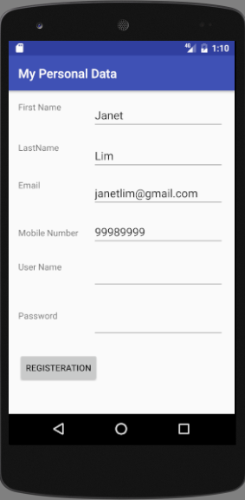 | Alert Dialog will display if user did not enter User Name and Password.  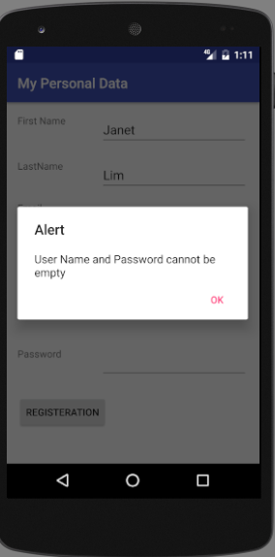

-- End of Practical 11 --

