School of Digital Media and Infocomm Technology (DMIT)
ST0281 Mobile Applications
Practical 12

Objectives:

After completing this lab, you will be able to:

- Understand what a Broadcast Receiver is
- Program a Broadcast Receiver within an activity to monitor an incoming SMS
- Program a notification as a response to the incoming SMS
- Program an activity upon tapping on the notification

Broadcast receivers allow an Android application to monitor Android system events or phone events like time ticked, boot completed or an incoming or outgoing call, or an incoming or outgoing SMS etc.

The list of Android system and telephony events is found at: <android-sdk-folder>\sdk\platforms\android-16\data\broadcast_actions.txt

In the Android application, each event that the Android application wants to monitor needs to be registered. This registration can be done either at the AndroidManifest.xml file or within the Java class representing the activity.

In this practical, we will show the example of monitoring an incoming SMS within an activity.

Follow the steps described below:

PART A

1. Create a new Android project, name BroadcastReceiver.

Step 1: Start a new Project.

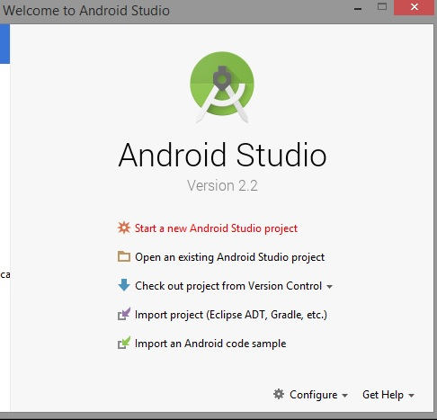

Step 2:
Application name: AndroidActivity
Company Domain: sg.com.mapp (optional)
Package name: mapp.com.sg.androidactivity
Click Next.
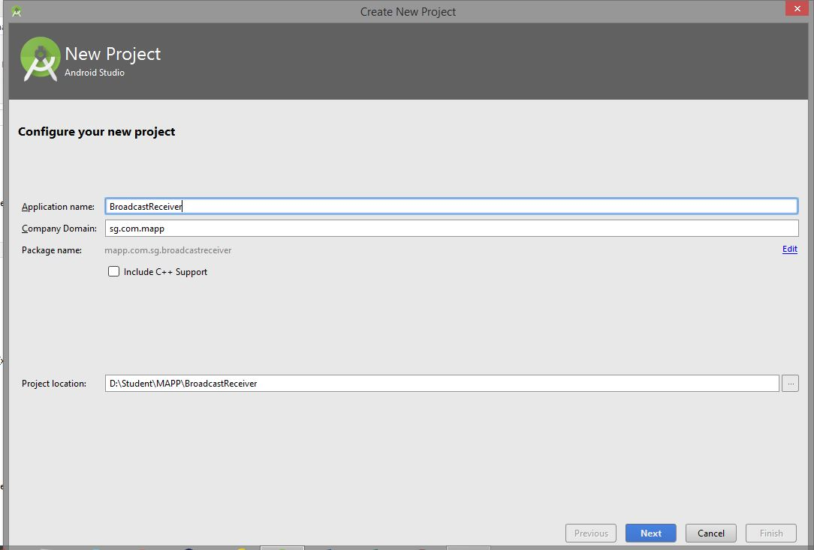

Step 3:
Minimum SDK: API 16: Android 4.1 (Jelly Bean)

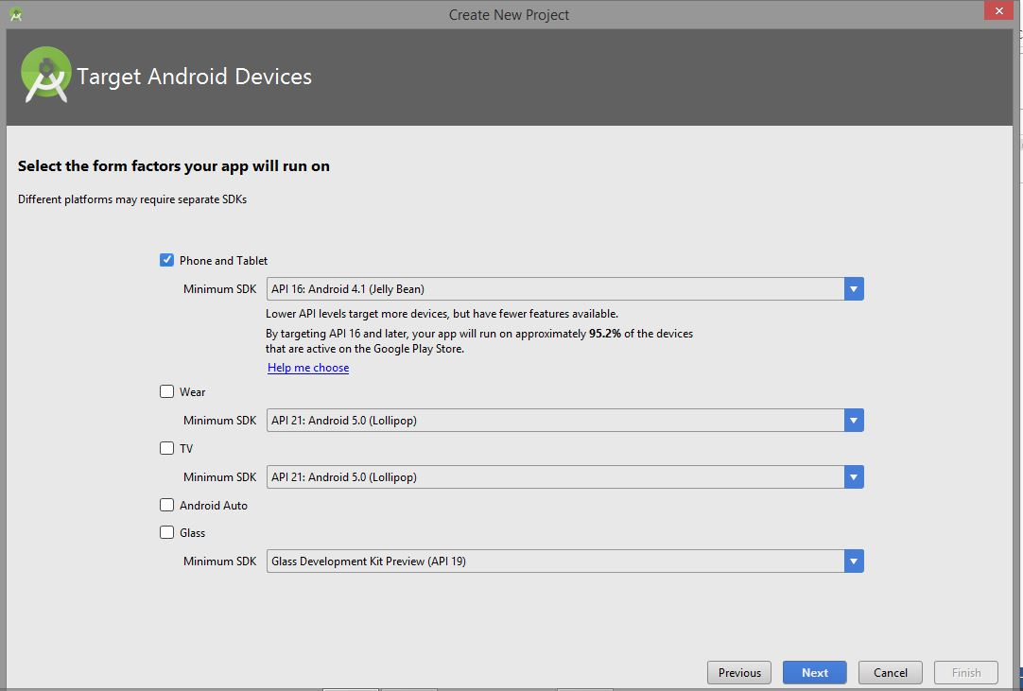

Note: The Lower API levels target more devices, but fewer features available.

Step 4:
Select Empty Activity
Click Next.
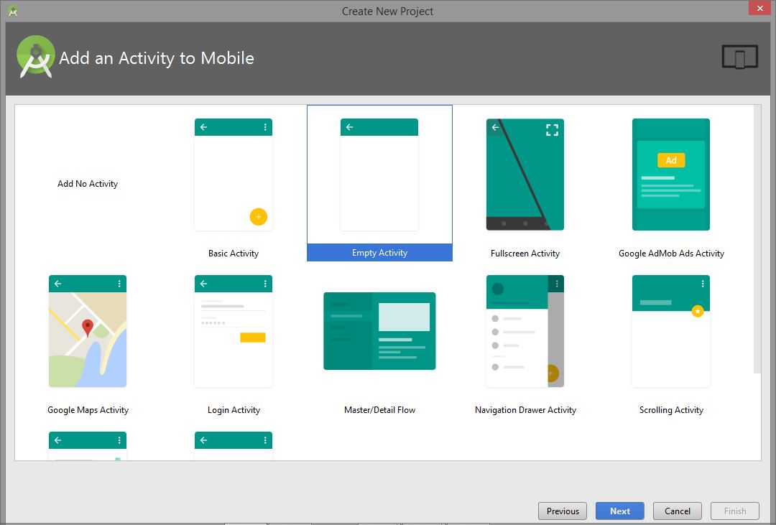

Step 5:
Activity Name: MainActivity
Layout Name: activity_main
Click Finish.
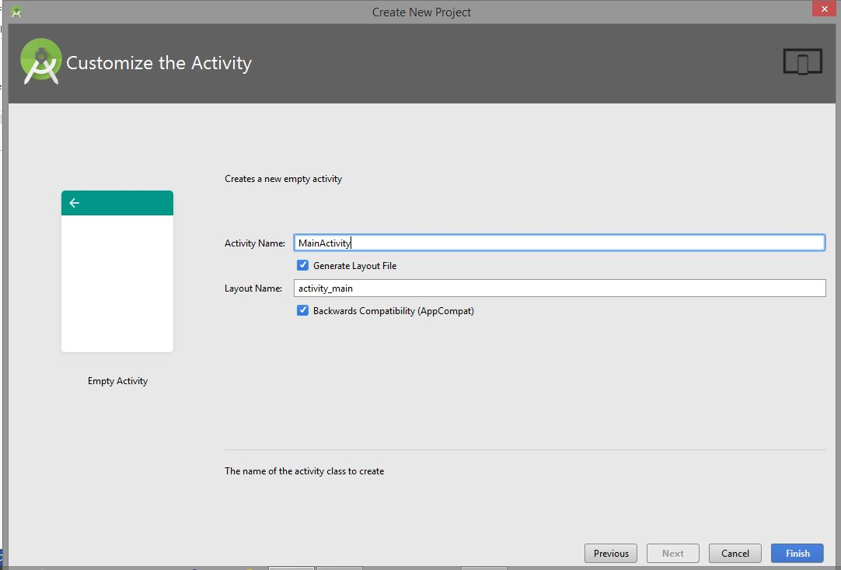

Note: This process of creating new project will be used throughout the MAPP practical lesson.
Step6:
Modify the AndroidManifest.xml file, add in the permissions needed for SMS.

<?xml version="1.0" encoding="utf-8"?>
<manifest xmlns:android="http://schemas.android.com/apk/res/android"
package="mapp.com.sg.broadcastreceiver">

<uses-permission android:name="android.permission.RECEIVE_SMS"></uses-permission>
<uses-permission android:name="android.permission.READ_SMS"></uses-permission>
<uses-permission android:name="android.permission.SEND_SMS"></uses-permission>

<application
android:allowBackup="true"
android:icon="@mipmap/ic_launcher"
android:label="@string/app_name"
android:supportsRtl="true"
android:theme="@style/AppTheme">
<activity android:name=".MainActivity">
<intent-filter>
<action android:name="android.intent.action.MAIN" />

<category android:name="android.intent.category.LAUNCHER" />
</intent-filter>
</activity>

</application>

</manifest>

Step 7:
In order to monitor an event (in this case an incoming SMS) in your activity, that event has to be registered. For this registration to happen, a BroadcastReceiver object is required and an IntentFilter object. The IntentFilter object is needed to let the Android system know “when” the BroadcastReceiver object will be activated. The BroadcastReciever object will handle the event itself.

public class MainActivity extends Activity {
private static final int NOTIFY_ME_ID = 1337;

private BroadcastReceiver the_receiver = new BroadcastReceiver() {
@Override
public void onReceive(Context context, Intent intent) {
int duration = Toast.LENGTH_LONG;
Toast toast = Toast.makeText(context, "SMS Message Received!", duration);
toast.show();
}
};

private IntentFilter filter = new IntentFilter("android.provider.Telephony.SMS_RECEIVED");

@Override
protected void onCreate(Bundle savedInstanceState) {
super.onCreate(savedInstanceState);
setContentView(R.layout.activity_main);

@Override
protected void onResume(){

// Register receiver if activity is in front
this.registerReceiver(the_receiver, filter);
super.onResume();
}

@Override
protected void onPause(){

// Unregister receiver if activity is not in front
this.unregisterReceiver(the_receiver);
super.onPause();

}
}

Notice above that the method onRecieve() needs to be implemented for the BroadcastReceiver object the_receiver. In this example above, a Toast message is shown when an incoming SMS is received.

In this practical, we will register the event in the onResume() method [recall activity life cycle] and unregister it (because we don’t need it anymore when the activity is not visible) in the onPause() method. Hence, add these to your Java class:

Step 8:

Save all files and run the example in an actual device. Test the application by sending an SMS to your device and see the Toast message appearing upon the SMS coming in. If you do not have an actual device, create another instance of the emulator to test it out.
PART B

In this part, notification button will be added in the activity_main.xml. Upon tapping on a button, a label on the button should display “Show Notification” as depicted in the following screen shot:

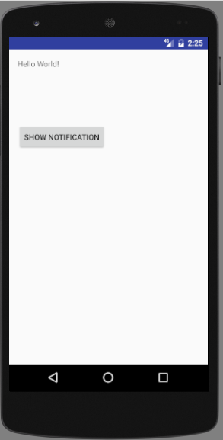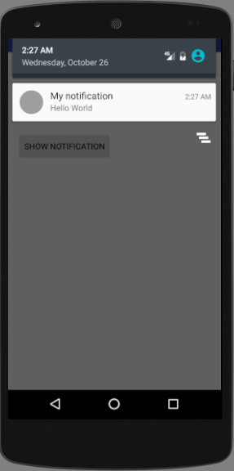
On tapping the button, a notification icon is shown in the status bar, see above.

Step 1:
In the Java class (MainActivity.java) of your activity, you will have the following code:

public class MainActivity extends Activity {
private static final int NOTIFY_ME_ID = 1337;

private BroadcastReceiver the_receiver = new BroadcastReceiver() {
@Override
public void onReceive(Context context, Intent intent) {
int duration = Toast.LENGTH_LONG;
Toast toast = Toast.makeText(context, "SMS Message Received!", duration);
toast.show();
}
};

private IntentFilter filter = new IntentFilter("android.provider.Telephony.SMS_RECEIVED");

@Override
protected void onCreate(Bundle savedInstanceState) {
super.onCreate(savedInstanceState);
setContentView(R.layout.activity_main);

/****** Add the following Code ******/
final Button notify = (Button) findViewById(R.id.notify);

notify.setOnClickListener(new View.OnClickListener() {

public void onClick(View view) {
/**** Create Notification ****/
final NotificationManager mgr = (NotificationManager) getSystemService(Context.NOTIFICATION_SERVICE);

// Create intent object first

Intent i = new Intent(getBaseContext(), NotifyMessage.class);

PendingIntent pi = PendingIntent.getActivity(getBaseContext(), 0, i,0);

Notification note =
new Notification.Builder(getApplicationContext())
.setSmallIcon(R.drawable.stat_notify_chat)
.setContentTitle("My notification")
.setContentText ("Hello World").setAutoCancel(true)
.setContentIntent(pi).build();

mgr.notify(NOTIFY_ME_ID, note);
}

});
}

/**** End of adding Code ****/
@Override
protected void onResume(){

// Register receiver if activity is in front
this.registerReceiver(the_receiver, filter);
super.onResume();
}

@Override
protected void onPause(){

// Unregister receiver if activity is not in front
this.unregisterReceiver(the_receiver);
super.onPause();

}
}

Step 2:
Modify the activity_main.xml, to include the Notification button.

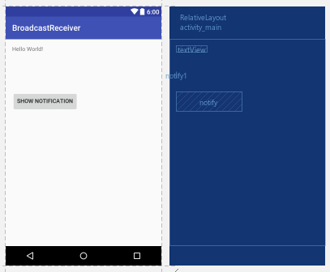

<?xml version="1.0" encoding="utf-8"?>
<RelativeLayout xmlns:android="http://schemas.android.com/apk/res/android"
xmlns:tools="http://schemas.android.com/tools"
android:id="@+id/activity_main"
android:layout_width="match_parent"
android:layout_height="match_parent"
android:paddingBottom="@dimen/activity_vertical_margin"
android:paddingLeft="@dimen/activity_horizontal_margin"
android:paddingRight="@dimen/activity_horizontal_margin"
android:paddingTop="@dimen/activity_vertical_margin"
tools:context="mapp.com.sg.broadcastreceiver.MainActivity">

<TextView
android:layout_width="wrap_content"
android:layout_height="wrap_content"
android:text="Hello World!"
android:id="@+id/textView" />

<TextView
android:layout_width="wrap_content"
android:layout_height="wrap_content"
android:layout_below="@+id/textView"
android:layout_marginTop="47dp"
android:id="@+id/notify1"
android:layout_alignParentLeft="true"
android:layout_alignParentStart="true" />

<Button
android:text="Show Notification"
android:layout_width="wrap_content"
android:layout_height="wrap_content"
android:layout_below="@+id/notify1"
android:layout_toRightOf="@+id/notify1"
android:layout_toEndOf="@+id/notify1"
android:layout_marginTop="33dp"
android:id="@+id/notify" />
</RelativeLayout>

Step 3:
Create a new java class, NotifyMessage.java.
Note: No code are required for the NotifyMessage.java.
Create a new stat_notify_chat.xml in the app/res/drawable folder.
Note: Not xml code are required for the stat_notify_chat.xml.

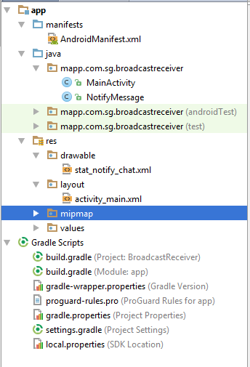

You realize that in the intent object, it is specified that NotifyMessage.java is being launched when the user tap on the notification after swiping down the notification drawer from the status bar. Hence, create this activity called NotifyMessage.java. Inside the NotifyMessage.java class, just show a TextView having this string:

Run your application in the emulator and ensure that you see the desired outcome.

Tasks:
1. Try combining Part A and B so that when a SMS comes in, show the notification.

-- End of Practical 12 --

