School of Digital Media and Infocomm Technology (DMIT)
ST0281 Mobile Applications
Practical 3

Objectives:

After completing this lab, you will be able to:

- Understand what localization or internationalization means
- Localise your application to a particular language
- Change the setting on a mobile device to view the localized language

Localization or internationalization refers to creating an application based on a local language. For example, if you application targets audience in Japan, you may want to change your application into Japanese. More details are found at https://developer.android.com/studio/write/translations-editor.html

- Create localization values folder

Continue from the Hello World project created in practical 2.
There are few way to create localization for Android application. You can use the Translations Editor to lets you view and update all your string resources in one convenient place. The editor gives you a single view of all of your translated resources, making it easy to change or add translations, and even find missing translations.

- Running the Translation Editor

Step 1:
In the Project window on the left side of Android Studio, select Android from the dropdown list.
Open the res folder, and then open the values folder.
If a strings.xml folder is present, open this folder.
Right-click the strings.xml file (not folder) and select Open Translations Editor.
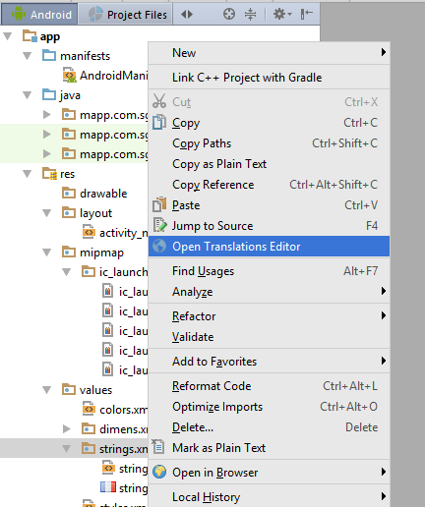

Step 2:
Click on the Add Locale
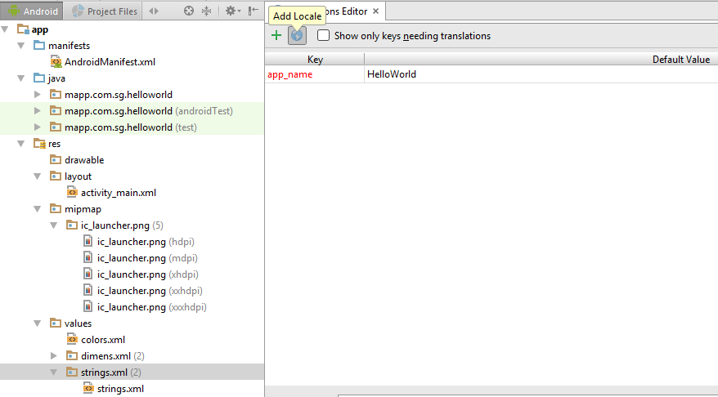

Step 3:
Select French (fr).

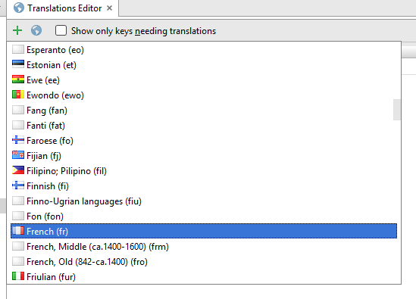

Step 4:
Change the text on the French (Fr) Column to Bonjour.
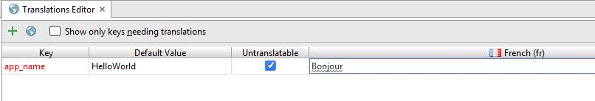

Step 5:
A strings.xml with a France flag is created by the Android Studio. The new folder values-fr is created and the filename is strings.xml. This folder store the values for French language.

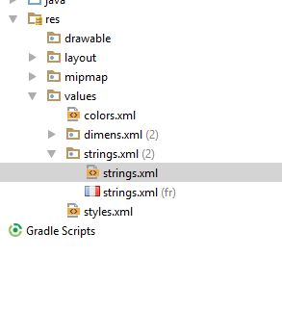
Note: You can also access the Translations Editor by opening a strings.xml file for editing and clicking the Open editor link, or clicking the globe icon in the Design layout view and choosing Edit Translations.

- Testing and viewing the localized application

Launch the Android emulator and run the HelloWorld Application.

In order to view the change in language or localization, change the language setting to French and run the application. You should see the localized text showing.

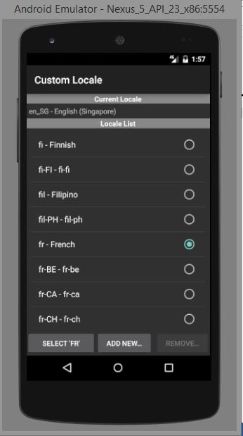 | 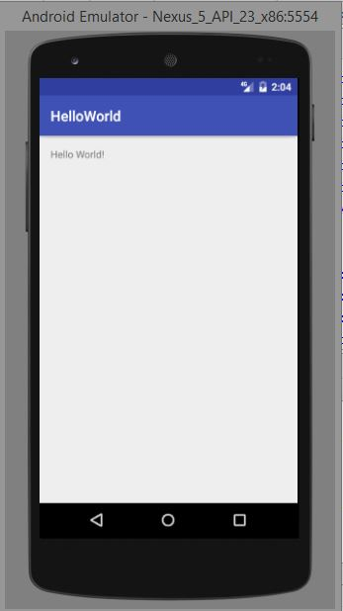 | 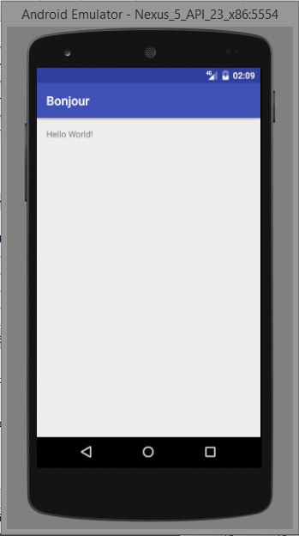
Change the language | In English | In French

Note: Depend on the devices, the setting varies.

- Tasks

1. Add another language of your choice and test the Android application.

2. What is the advantage of using localization in application?

3. Submit the completed practical, filename: P3_Class_AdminNo_Name.zip

-- End of Practical 3 --

