School of Digital Media and Infocomm Technology (DMIT)
ST0281 Mobile Applications
Practical 4

Objectives:

After completing this lab, you will be able to:

- Implement a splash screen in Android
- Activate another activity once the splash screen has been dismissed

1. Creating a new class in the HelloWorld project

Go to the HelloWorld project you have created in Practical 2.
Right click on your package name under the java folder and select New->Java Class. Key in the details similar to the one below.
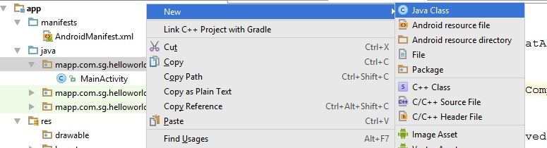
Name: SplashScreen

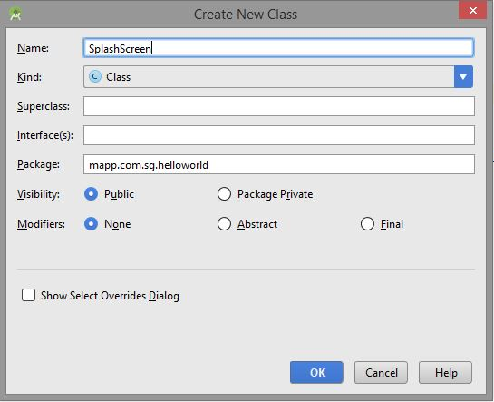

Note:
Ensure you select the same package name as the one you are using in the Hello World project.
Use your own source folder and package name
2. Creating splash.xml in res/layout folder
Similarly, Right click on the res\layout folder and select New->Layout resource file.
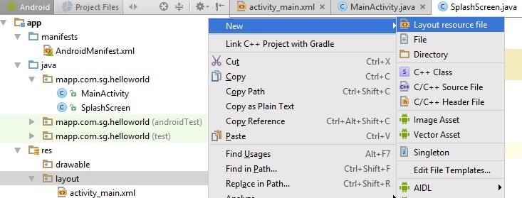

Filename: splash

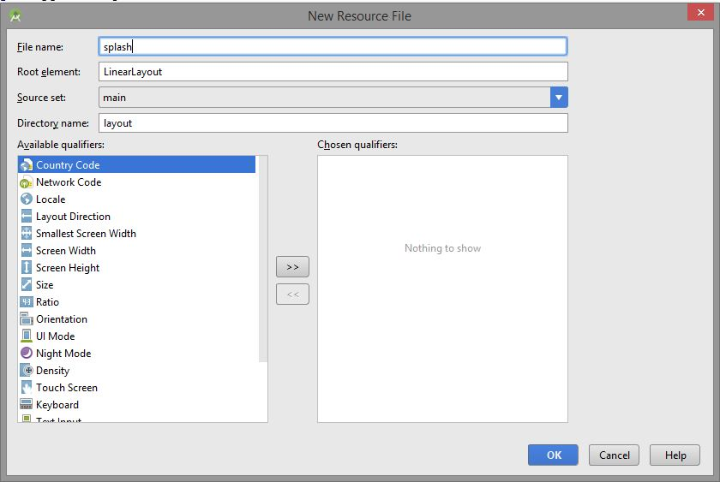

Note: In fact you can use other file names as long as it is lower case and without spaces.

3. Modifying splash.xml
Double-click on the splash.xml and the following will be shown:

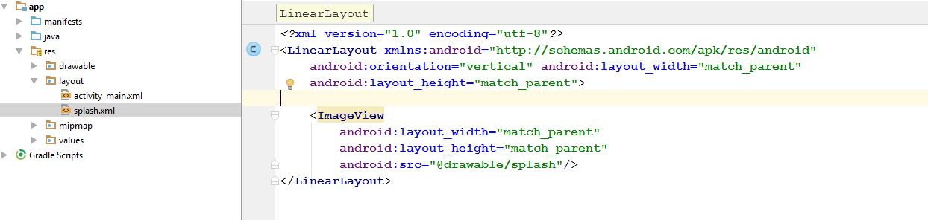

Add the ImageView tag within the LinearLayout tags like this and save:

<?xml version="1.0" encoding="utf-8"?>
<LinearLayout xmlns:android="http://schemas.android.com/apk/res/android"
android:orientation="vertical" android:layout_width="match_parent"
android:layout_height="match_parent">

<ImageView
android:layout_width="match_parent"
android:layout_height="match_parent"
android:src="@drawable/splash"/>
</LinearLayout>

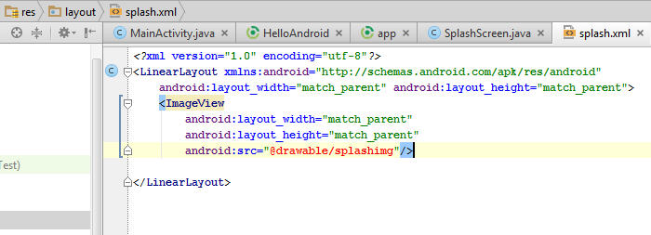

4. Modifying AndroidManifest.xml:
Note that the main activity launched by the system should now be the SplashScreen activity. The MainActivity activity is now the next one that will be displayed when the splash screen disappears. Note: Make sure you use your own Java class file names representing the activities.

<?xml version="1.0" encoding="utf-8"?>
<manifest xmlns:android="http://schemas.android.com/apk/res/android"
package="mapp.com.sg.helloworld">

<application
android:allowBackup="true"
android:icon="@mipmap/ic_launcher"
android:label="@string/app_name"
android:supportsRtl="true"
android:theme="@style/AppTheme">

<activity android:name=".SplashScreen">
<intent-filter>
<action android:name="android.intent.action.MAIN" />

<category android:name="android.intent.category.LAUNCHER" />
</intent-filter>
</activity>
<activity android:name=".MainActivity" android:label="@string/app_name">

</activity>
</application>

</manifest>

5. Copying images into the res\drawable folder:
Using the normal Windows Explorer, select an image (called splash.png) and copy it into the drawable folder under the res folder.

Refresh your res folder to reflect that the file is there (note also your splash.xml does not contain red text now):
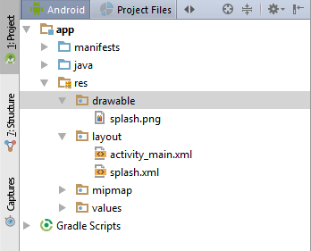

6. Modifying SplashScreen.java:
Now open the SplashScreen.java file and modify it as follows.

package mapp.com.sg.helloworld;

import android.app.Activity;
import android.app.IntentService;
import android.content.Intent;
import android.os.Bundle;
import android.view.Window;

public class SplashScreen extends Activity {
@Override
protected void onCreate(Bundle savedInstanceState) {
super.onCreate(savedInstanceState);
// Launch the layout -> splash.xml
setContentView(R.layout.splash);
Thread splashThread = new Thread() {

public void run() {
try {
// sleep time in milliseconds (3000 = 3sec)
sleep(3000);
} catch(InterruptedException e) {
// Trace the error
e.printStackTrace();
} finally
{
// Launch the MainActivity class
Intent intent = new Intent(SplashScreen.this, MainActivity.class);
startActivity(intent);
}

}
};
// To Start the thread
splashThread.start();
}
}

Save all the files and run the project and you should see your splash screen appearing before the main UI comes on.

-- End of Practical 4 --

