School of Digital Media and Infocomm Technology (DMIT)
ST0281 Mobile Applications
Practical 8

Objectives:

After completing this lab, you will be able to:

- Implement a RelativeLayout
- Implement an ImageButton
- Program an activity as the response to user clicking on a ImageButton

In this practical, you will explore another type of button called ImageButton. An image button provides better flexibility in situations when you want to have an image as the landing screen of your application and yet at the same time allows the user to be able to navigate from it.

Given an image that looks like this, you can divide the image into different areas and select the divided areas as the background image to your image buttons:

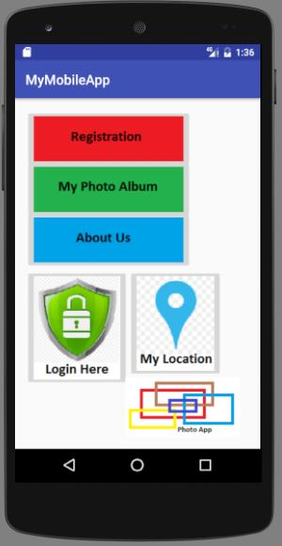
Figure 1

Download the imageButtons.zip file from Blackboard. These will later be unzipped and put in the drawable folders.

Follow the following steps:
Step 1:
Create a new project called MyMobileApp.
Note: Refer to Practical 5 on the step to create a new project.

1. Application name: MyMobileApp  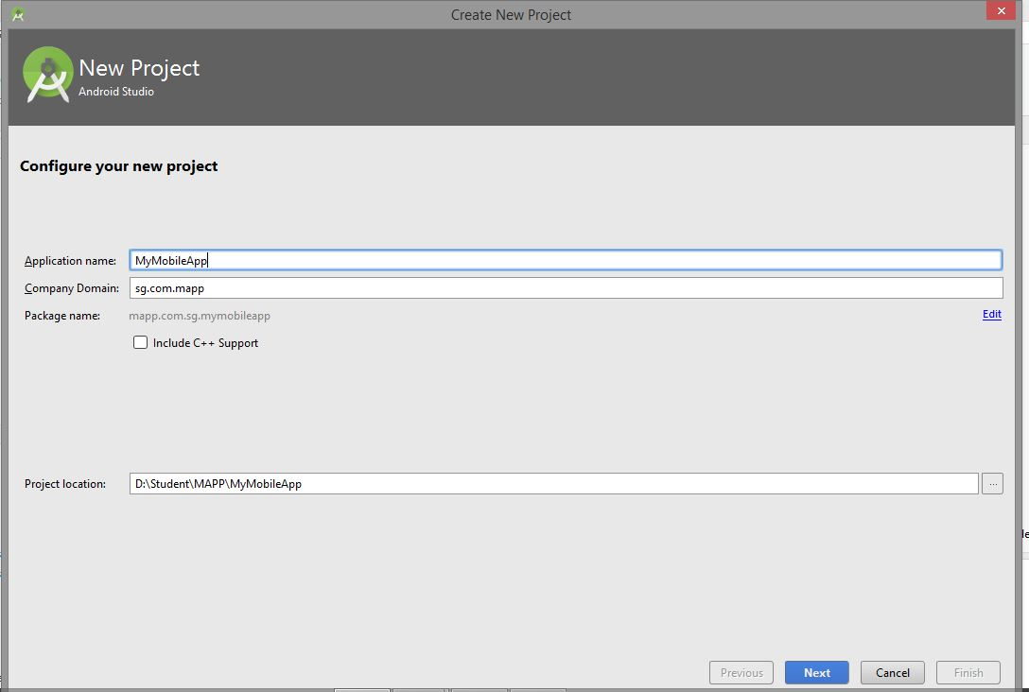 | 2.  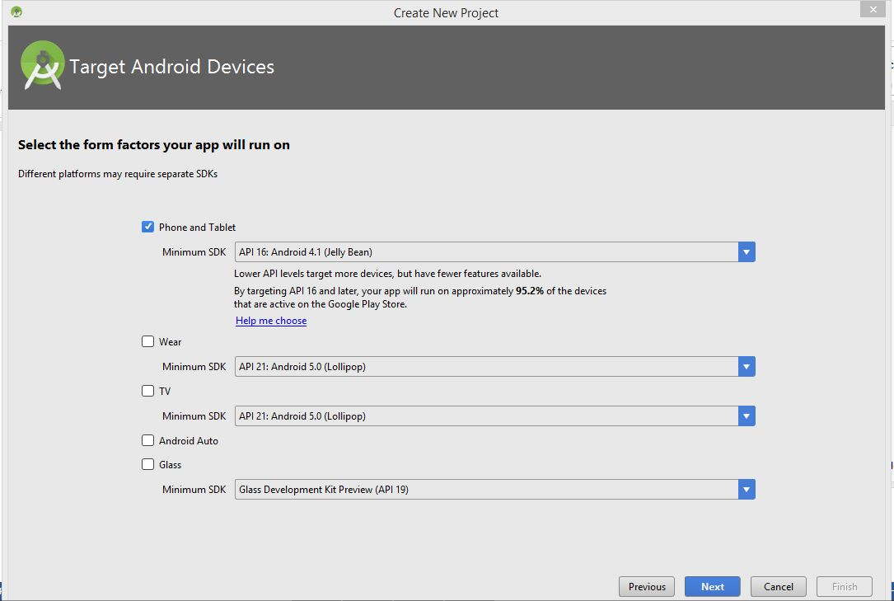
3. Empty Activity  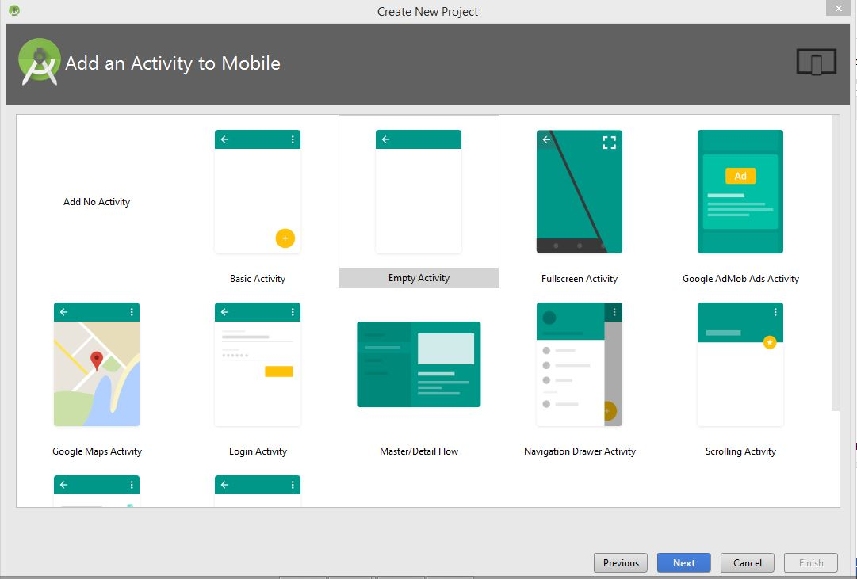 | 4. Activity Name:MainImageActivity  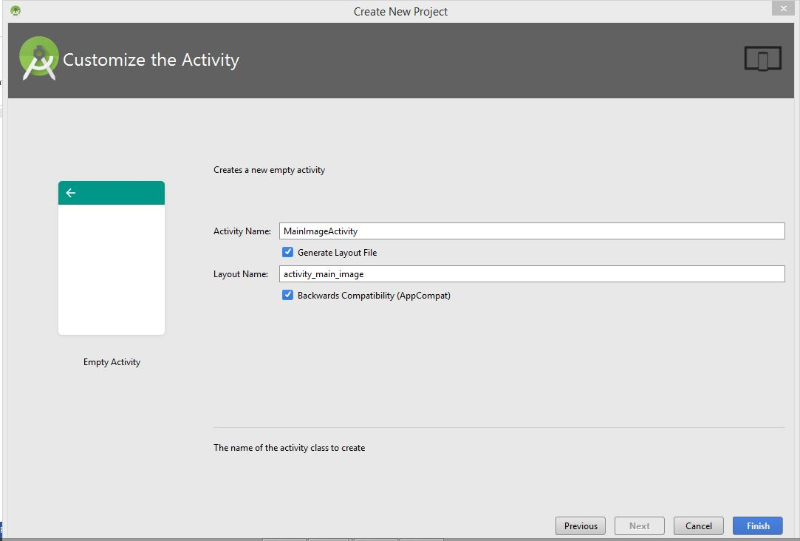

Step 2:
Modify the activity_main_image.xml.
Note: You may use the graphic interface to design the layout.
Unzip the imageButtons.zip and place the images in the drawable folders in your project. Save all the files and run the project as an Android application. You should now see the main screen similar to Figure 1.

<?xml version="1.0" encoding="utf-8"?>
<RelativeLayout xmlns:android="http://schemas.android.com/apk/res/android"
xmlns:app="http://schemas.android.com/apk/res-auto"
xmlns:tools="http://schemas.android.com/tools"
android:id="@+id/activity_main_image"
android:layout_width="match_parent"
android:layout_height="match_parent"
android:paddingBottom="@dimen/activity_vertical_margin"
android:paddingLeft="@dimen/activity_horizontal_margin"
android:paddingRight="@dimen/activity_horizontal_margin"
android:paddingTop="@dimen/activity_vertical_margin"
tools:context="mapp.com.sg.mymobileapp.MainImageActivity">

<ImageButton
android:layout_width="wrap_content"
android:layout_height="wrap_content"
app:srcCompat="@drawable/registration"
android:layout_alignParentTop="true"
android:layout_alignParentLeft="true"
android:layout_alignParentStart="true"
android:id="@+id/register" />

<ImageButton
android:layout_width="wrap_content"
android:layout_height="wrap_content"
app:srcCompat="@drawable/myphotoalbum"
android:layout_marginTop="74dp"
android:id="@+id/photoalbum"
android:layout_alignParentTop="true"
android:layout_alignParentLeft="true"
android:layout_alignParentStart="true" />

<ImageButton
android:layout_width="wrap_content"
android:layout_height="wrap_content"
app:srcCompat="@drawable/about"
android:id="@+id/about"
android:layout_below="@+id/register"
android:layout_alignParentLeft="true"
android:layout_alignParentStart="true"
android:layout_marginTop="62dp" />

<ImageButton
android:layout_width="wrap_content"
android:layout_height="wrap_content"
app:srcCompat="@drawable/loginhere"
android:layout_below="@+id/about"
android:layout_alignParentLeft="true"
android:layout_alignParentStart="true"
android:id="@+id/login" />

<ImageButton
android:layout_width="wrap_content"
android:layout_height="wrap_content"
app:srcCompat="@drawable/mylocation"
android:id="@+id/myloc"
android:layout_below="@+id/about"
android:layout_toRightOf="@+id/login"
android:layout_toEndOf="@+id/login" />

<ImageView
android:layout_width="wrap_content"
android:layout_height="wrap_content"
app:srcCompat="@drawable/logo"
android:id="@+id/logoview"
android:layout_below="@+id/myloc"
android:layout_alignParentRight="true"
android:layout_alignParentEnd="true" />
</RelativeLayout>

Hence, by using RelativeLayout and properly dividing and editing the images, the activity_main_image.xml is presented in Figure 2.
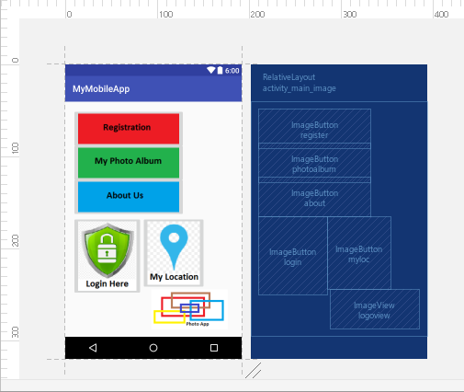
Figure 2.

Step 3:
Implementing the ImageButton, “MyPhotoAlbum”.
On tapping the MyPhotoAlbum, user will be re-direct the another activity (activity_photo_album.xml) showing a TextView and an ImageView. The method to start another activity was shown in Practical 6.

Hint:
acticvity_photo_album.xml.
<?xml version="1.0" encoding="utf-8"?>
<RelativeLayout xmlns:android="http://schemas.android.com/apk/res/android"
xmlns:app="http://schemas.android.com/apk/res-auto"
xmlns:tools="http://schemas.android.com/tools"
android:id="@+id/activity_photo_album"
android:layout_width="match_parent"
android:layout_height="match_parent"
android:paddingBottom="@dimen/activity_vertical_margin"
android:paddingLeft="@dimen/activity_horizontal_margin"
android:paddingRight="@dimen/activity_horizontal_margin"
android:paddingTop="@dimen/activity_vertical_margin"
tools:context="mapp.com.sg.mymobileapp.PhotoAlbum">
<TextView
android:text="My Vacation"
android:layout_width="wrap_content"
android:layout_height="wrap_content"
android:layout_alignParentTop="true"
android:layout_alignParentLeft="true"
android:layout_alignParentStart="true"
android:id="@+id/txtVacation" />
<ImageView
android:layout_width="wrap_content"
android:layout_height="wrap_content"
app:srcCompat="@drawable/pic1"
android:layout_below="@+id/txtVacation"
android:layout_alignParentLeft="true"
android:layout_alignParentStart="true"
android:layout_marginTop="27dp"
android:id="@+id/imageView3" />
</RelativeLayout>

Step 4:
Modify the MainImageActivity.java.
Add in the following to start the new Intent.
@Override
public void onClick(View view) {
switch (view.getId()){
case R.id.photoalbum:
Intent i = new Intent(this, PhotoAlbum.class);
startActivity(i);
break;
}
}

On tapping on the “My Photo Album” ImageButton, you should see this screen appearing:

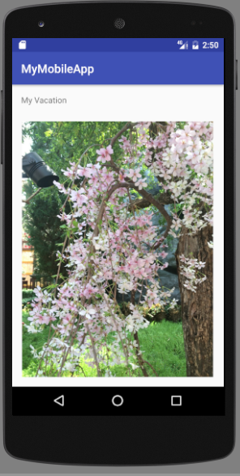

-- End of Practical 8 --

