School of Digital Media and Infocomm Technology (DMIT)
ST0281 Mobile Applications
Practical 9

Objectives:

After completing this lab, you will be able to:

- Implement the Action Bar menu.
- Program a dialog as a response to tapping on a menu.
- Program logging of execution details as a debugging tool

In this practical, you will implement the Action Bar menu button found on Android devices. Upon clicking the physical Menu button, the application will bring up a settings screen for the user to select the item in the menu.

This is a continuation of Practical 8. Hence, launch Android Studio and open the project that you have created in Practical 8.

Follow the steps below:
Step 1:
Create the Android resource directory.
Right-click on the app->res->New->Android resource directory

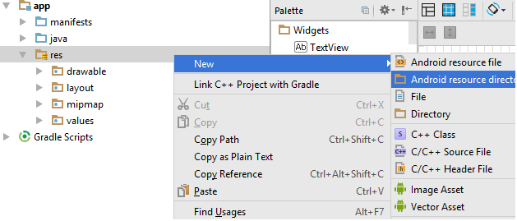

Step 2:
Directory name: menu
Click Ok.
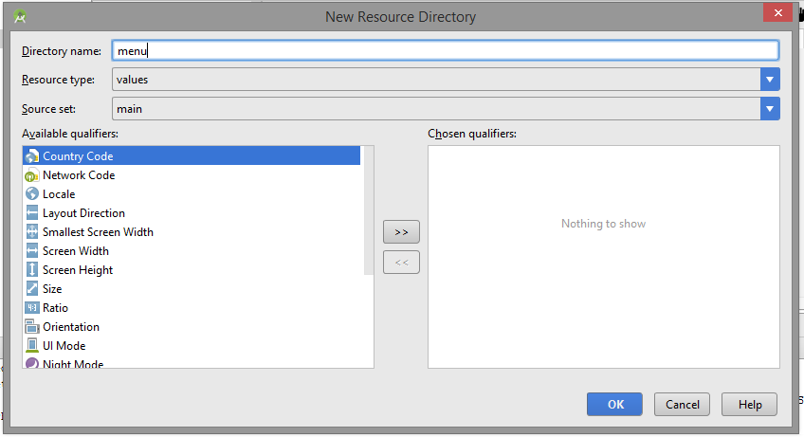

Step 3:
Right click on app->res->menu->New->Menu resource file

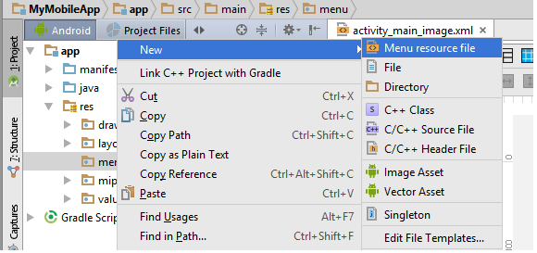

Step 4:
File name: menu_main
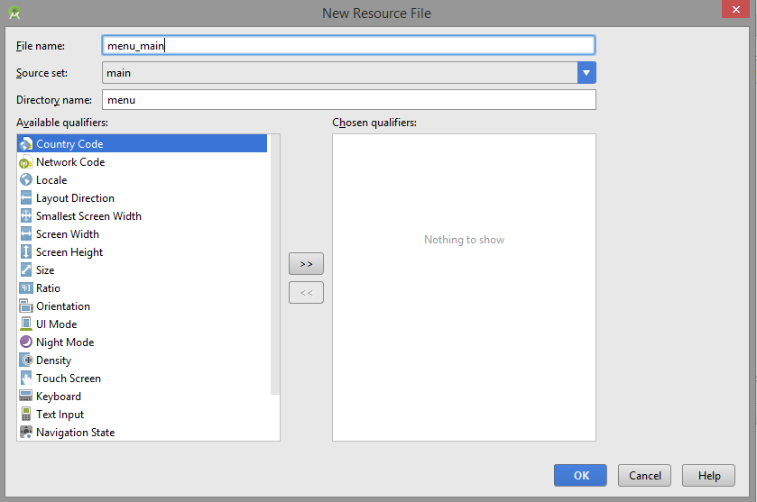

Step 5:

Modify the res/menu/menu_main.xml.

<?xml version="1.0" encoding="utf-8"?>
<menu xmlns:app="http://schemas.android.com/apk/res-auto"
xmlns:android="http://schemas.android.com/apk/res/android">

<item android:id="@+id/about"
android:title="@string/item1" />

<item android:id="@+id/help"
android:title="@string/item2" />

<item android:id="@+id/chkupd"
android:title="@string/item3" />

<item android:id="@+id/pref"
android:title="@string/item4" />

</menu>

Modify the res/value/strings.xml
<resources>
<string name="app_name">MyMobileApp</string>
<string name="item1">About</string>
<string name="item2">Help</string>
<string name="item3">Check for Update</string>
<string name="item4">Preference</string>
</resources>

Step 5:
Edit MainImageActivity.java to include the OptionsMenu.

package mapp.com.sg.mymobileapp;

import android.app.AlertDialog;
import android.content.DialogInterface;
import android.content.Intent;
import android.support.v7.app.AppCompatActivity;
import android.os.Bundle;
import android.view.Menu;
import android.view.MenuInflater;
import android.view.MenuItem;
import android.view.View;
import android.widget.Toast;

public class MainImageActivity extends AppCompatActivity implements View.OnClickListener {

@Override
protected void onCreate(Bundle savedInstanceState) {
super.onCreate(savedInstanceState);
setContentView(R.layout.activity_main_image);
}

@Override
public boolean onCreateOptionsMenu(Menu menu){ ← Add this into the code
super.onCreateOptionsMenu(menu);
MenuInflater inflater = getMenuInflater();
inflater.inflate(R.menu.menu_main, menu);
return true;
}

@Override
public boolean onOptionsItemSelected(MenuItem item){
switch (item.getItemId()){
case R.id.about:
// Do Something
Toast.makeText(getApplicationContext(),"About...",
Toast.LENGTH_SHORT).show();
return true;
case R.id.help:
// Do Something
Toast.makeText(getApplicationContext(),"Help...",
Toast.LENGTH_SHORT).show();

return true;
case R.id.chkupd:
// Do Something
Toast.makeText(getApplicationContext(),"Check for Update...",
Toast.LENGTH_SHORT).show();

return true;

case R.id.pref:
// Do Something
startActivity(new Intent(this, Prefs.class));
return true;
}
return false;

}
@Override
public void onClick(View view) {
switch (view.getId()){
case R.id.photoalbum:
Intent i = new Intent(this, PhotoAlbum.class);
startActivity(i);
break;
}
}
}

Step 6:
Creating the setting.xml.
Right click res->New->Android resource directory

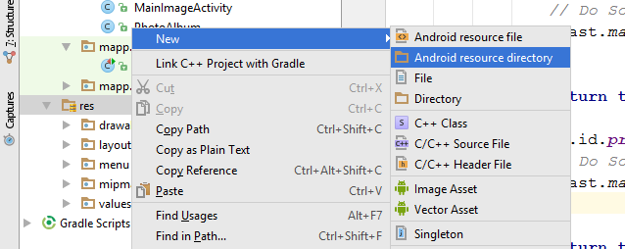

Directory name: xml
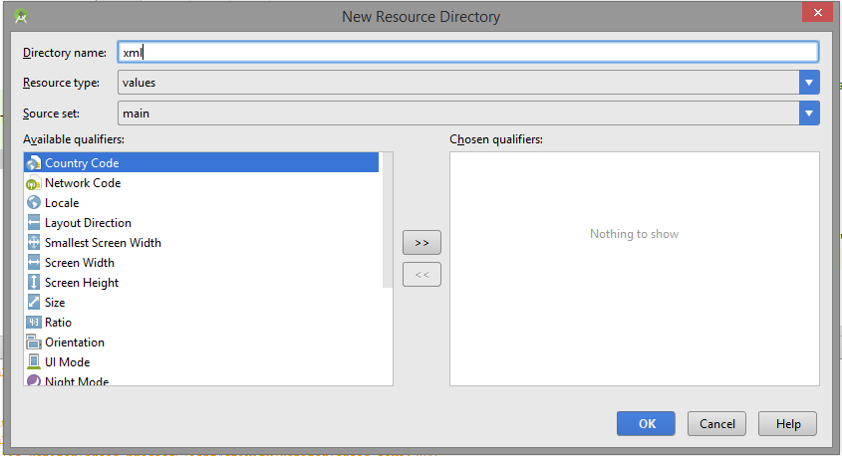
Right click res->xml->New->XML resource file

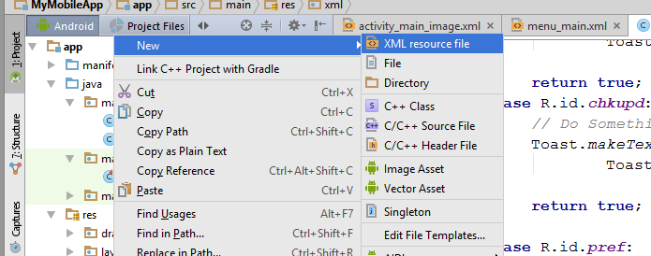

File name: settings.xml
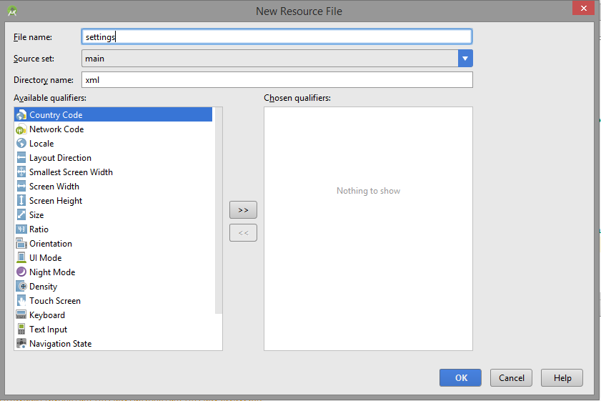

Right click app->java->New->Java Class

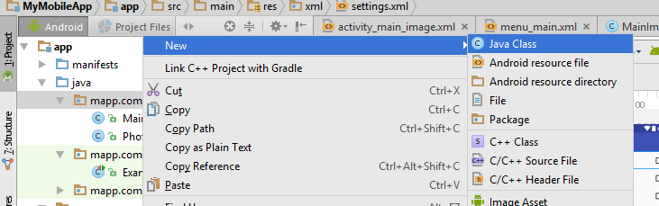
Name: Prefs.java

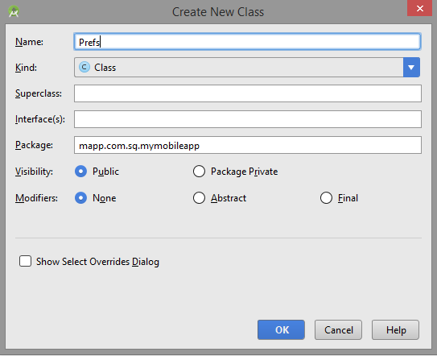

Step 7:
Modify the settings.xml

<?xml version="1.0" encoding="utf-8"?>
<PreferenceScreen xmlns:android="http://schemas.android.com/apk/res/android">

<CheckBoxPreference
android:defaultValue="false"
android:title="Sound"
android:key="check_box_preference_1" />
<CheckBoxPreference
android:defaultValue="True"
android:title="Alert"
android:key="check_box_preference_2" />
<CheckBoxPreference
android:defaultValue="false"
android:title="Location"
android:key="check_box_preference_3" />
</PreferenceScreen>

Step 8:
Modify the Prefs.java file.

package mapp.com.sg.mymobileapp;

import android.os.Bundle;
import android.preference.PreferenceActivity;
import android.preference.PreferenceFragment;

public class Prefs extends PreferenceActivity {
@Override
protected void onCreate(Bundle savedInstanceState){
super.onCreate(savedInstanceState);
// Display the fragment as the main content.
getFragmentManager().beginTransaction().replace(android.R.id.content, new MyPrefrenceFragment()).commit();
}

public static class MyPrefrenceFragment extends PreferenceFragment{
@Override
public void onCreate(final Bundle savedInstanceState){
super.onCreate(savedInstanceState);
addPreferencesFromResource(R.xml.settings);

}
}
}

Step 9:
Modify the Androidmanifest.xml file by adding the following:

<activity android:name=".Prefs"></activity>

Save all files.

Step 10:

Run the Android application and you should see the emulator with the following outcome (you have to tap on the top right corner (3 vertical dots) to see the “Settings” and then tap the “Settings” to see the preference screen:

Tab on the Preference, it will the display the Preference menu.

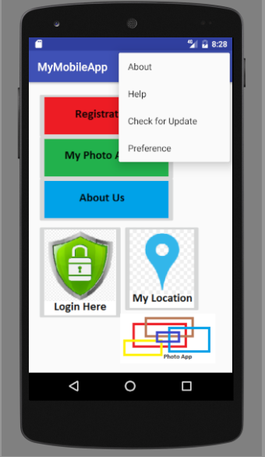 | 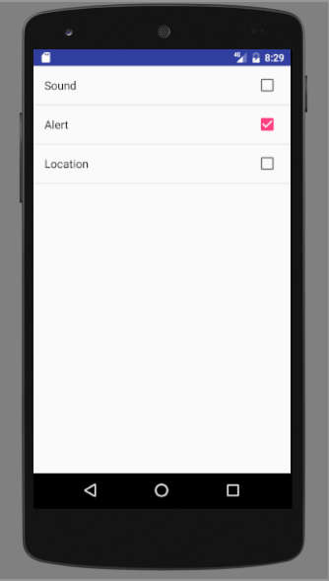

Tab on other item in the setting and the Toast will appear.

Implement an Alert Dialog Box.

Modify the MainImageActivity.java

case R.id.about:
// Do Something
Toast.makeText(getApplicationContext(),"About...",
Toast.LENGTH_SHORT).show();

// Add the following code
AlertDialog alertDialog = new AlertDialog.Builder(MainImageActivity.this).create();
alertDialog.setTitle("About");
alertDialog.setMessage("My Personal Photo Album.");
alertDialog.setButton(AlertDialog.BUTTON_NEUTRAL, "OK",
new DialogInterface.OnClickListener() {
public void onClick(DialogInterface dialog, int which) {
dialog.dismiss();
}
});
alertDialog.show();
// End of adding code
return true;

Run the Android application.
Tab on the About button.
The alert dialog box will appear.

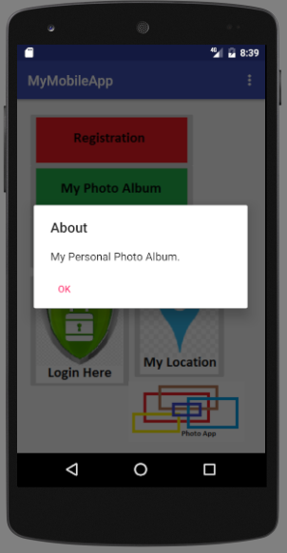

-- End of Practical 9 --

