3.2 Website Sitemap and Information Architecture
Information architecture (IA) is the practice of organising, structuring and labelling the content of a digital product so that users can find information and complete tasks efficiently (Rosenfeld, Morville and Arango, 2015). A sitemap is a visual representation of this structure. It shows the pages that will exist within a website and how they relate to one another in a hierarchy, which helps designers and stakeholders agree on scope and navigation before any visual design work begins (Nielsen Norman Group, 2024).
The sitemap below was developed for the GreenLeaf Garden Services website using the user stories and personas identified in Part 1 of this portfolio. The structure follows a shallow hierarchy of no more than two levels below the homepage, which is recommended practice because it keeps the majority of content reachable within a small number of clicks and reduces the cognitive load placed on users (Krug, 2014).
Ten primary sections branch from the Home page. Customer-facing pages such as Services, Get a Quote and the Customer Portal were prioritised in the top level of the hierarchy because they directly support the customer user stories identified in section 1.3, for example requesting a quote and tracking a job in real time. Supporting content such as Careers, the blog and legal pages were placed at the same level but are visually and functionally secondary, since they are used less frequently. The Customer Portal groups all authenticated, account-specific functionality — bookings, job tracking, invoices and additional work requests — behind a single login entry point, which keeps sensitive or personal information separate from the public marketing pages and mirrors the mental model recommended for account-based systems (Interaction Design Foundation, 2024).

Figure 3.1: GreenLeaf Garden Services – Website Sitemap
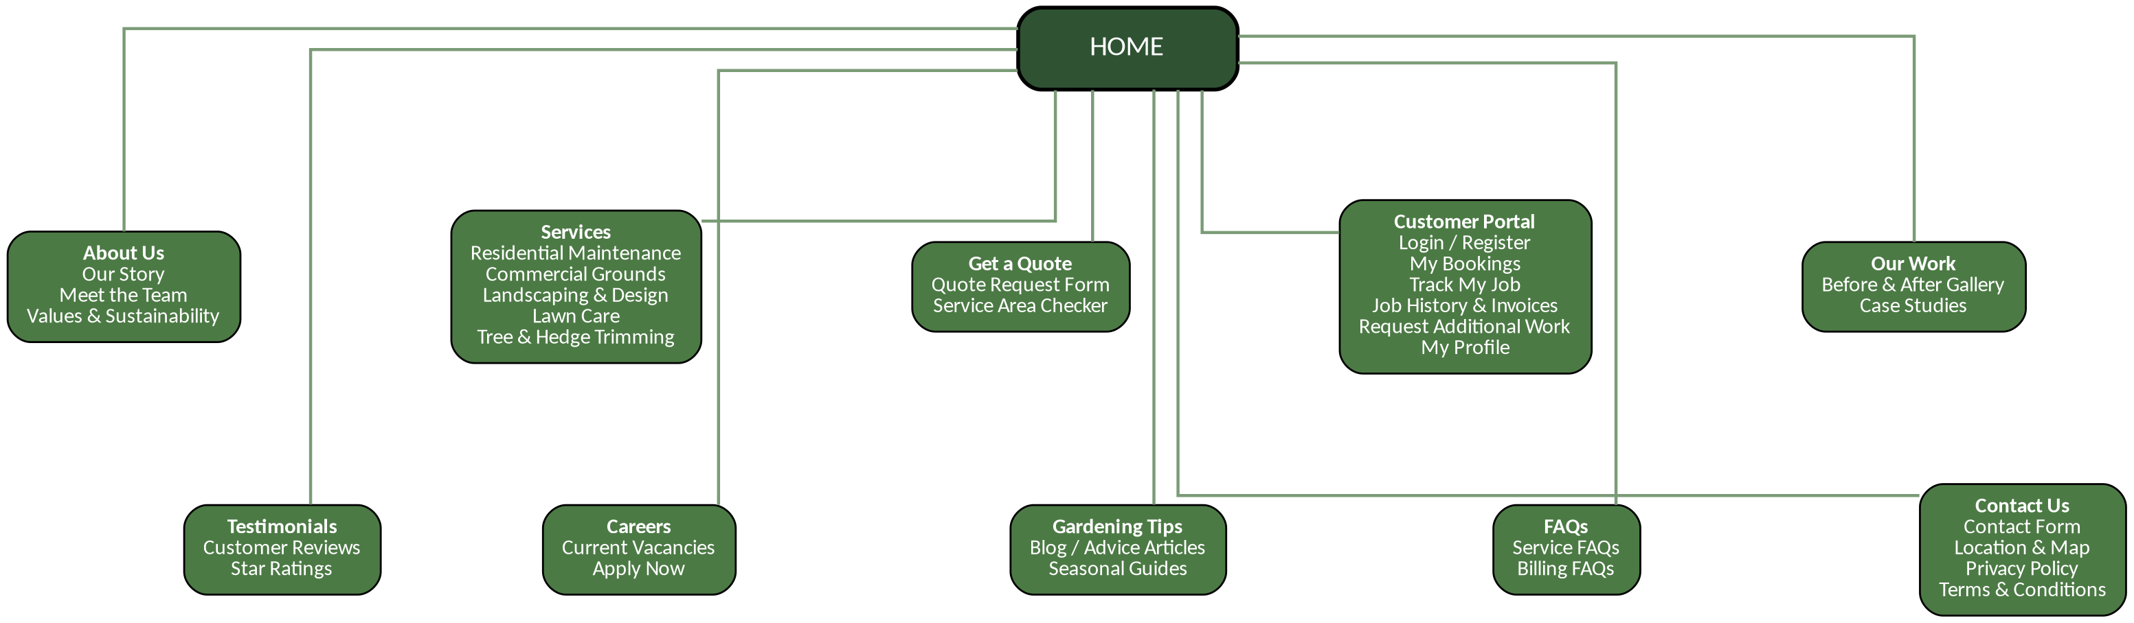
(Own work, created in Graphviz, 2026)

Page Content Overview
Table 3.1 below sets out the intended content of each page in the sitemap and links each page back to the primary user group it serves, ensuring that every section of the website has a clear purpose grounded in the user research conducted in Part 1.

Page | Appropriate Content | Primary User(s)
Home | Landing page introducing GreenLeaf Garden Services, a snapshot of core services, a prominent “Get a Quote” call-to-action, featured before/after images and a summary of customer testimonials. | All (Customer, Manager, Office Staff)
About Us | Company story, mission and values, an introduction to the team and information on the business’s approach to sustainable gardening practices. | Customer
Services | Detailed descriptions, pricing indicators and example work for each service line (residential maintenance, commercial grounds, landscaping and design, lawn care, tree and hedge trimming). | Customer
Get a Quote | A short quote-request form (property type, service needed, address, preferred date) and a service-area checker so visitors can confirm GreenLeaf operates in their area before enquiring. | Customer
Customer Portal | Secure login/registration area containing My Bookings, Track My Job (live job status and arrival window), Job History & Invoices, a Request Additional Work form and an editable profile. | Customer, Office Staff
Our Work | A before-and-after image gallery and short case studies that build trust by showing the quality and range of completed jobs. | Customer
Testimonials | Customer reviews and star ratings pulled from completed jobs, reinforcing credibility for prospective clients. | Customer
Careers | Current vacancies for gardeners and office staff, with a simple online application form. | Prospective employees
Gardening Tips | A blog of seasonal advice articles that supports search visibility and positions GreenLeaf as a knowledgeable service provider. | Customer
FAQs | Common questions grouped by topic (service, billing) to reduce repetitive phone and email enquiries to office staff. | Customer, Office Staff
Contact Us | Contact form, business location and map, plus links to the Privacy Policy and Terms & Conditions. | Customer

Overall, this structure gives customers a fast route from discovering GreenLeaf’s services to requesting a quote and, once they are an active client, a dedicated portal for tracking jobs and managing their account — directly addressing the communication and visibility problems raised in the original business brief.

