Rmarkdown-starter

François Birgand

3/24/2022

## R Markdown

This is an R Markdown document. Markdown is a simple formatting syntax for authoring HTML, PDF, and MS Word documents. For more details on using R Markdown see <http://rmarkdown.rstudio.com>.

The beauty of Markdown is to embed R codes, within the text, such that in the end, a document could contain all the text and code to create figures and tables, in ***one document***. I have written a crash course on R Markdown, which you can find at [this link](https://francoisbirgand.github.io/tutorial-RMarkdown_instructions.html).

There are three components to an R Mardown document (.Rmd):

* YAML header
* Text
* Code chunks

After you are done reading [the crash course](https://francoisbirgand.github.io/tutorial-RMarkdown_instructions.html), you will want to be able to find a [reference summary of R markdown here](https://rstudio.com/wp-content/uploads/2016/03/rmarkdown-cheatsheet-2.0.pdf).

* YAML header: The header of the document starts with a YAML which acronym started as “Yet Another Markup Language” and now apparently stands for “YAML Ain’t Markup Language”… The YAML Header specifies how the document will be formatted.
* Text: most of your writing will be done using plain text, very much like you have been doing with Word, with mark-up alterations. Many details on mark-up are in [the crash course](https://francoisbirgand.github.io/tutorial-RMarkdown_instructions.html). Spell check can be done using
  + A spell check button to the right of the save button (with “ABC” and a check mark).
  + Edit > Check Spelling…
  + The F7 key
* Code Chunks: This is where you will add the actual R code that will create tables and figures.

When you click the **Knit** button a document will be generated that includes both content as well as the output of any embedded R code chunks within the document. You can embed an R code chunk like this:

summary(cars)

## speed dist   
## Min. : 4.0 Min. : 2.00   
## 1st Qu.:12.0 1st Qu.: 26.00   
## Median :15.0 Median : 36.00   
## Mean :15.4 Mean : 42.98   
## 3rd Qu.:19.0 3rd Qu.: 56.00   
## Max. :25.0 Max. :120.00

## Including Plots

You can also embed plots, for example a plot of this hydrograph:

## Warning: package 'shape' was built under R version 3.6.2

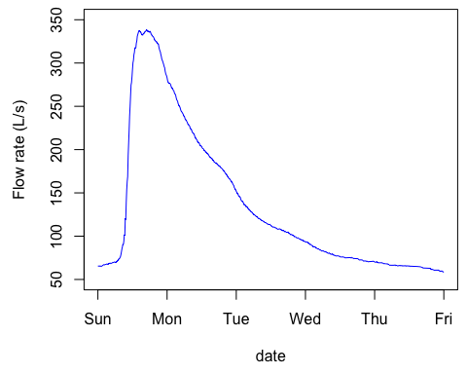

Note that the echo = FALSE parameter was added to the code chunk to prevent printing of the R code that generated the plot.

You can calculate things and incorporate them directly into your R markdown document. For example,

You can embed some r code within the text by using Maximum flow = `r signif(max(Q),3)` m&sup3; to give 3 significant digits to the maximum flow.

You can embed some r code within the text by using Maximum flow = 338 m³ to give 3 significant digits to the maximum flow. The code to make ³ for m³ is &sup3;