Executive Summary:
An analysis of the local Provigo on Milton Parc by examining how various sentiment analysis approaches align with star ratings of Yelp reviews. We used and compared VADER, Sentistrength, and a supervised KNN model in a multivariate regression, having star rating as a dependent variable.
In a second step, we built a classifier using a KNN-method to detect whether a review belong to the service category.
Results show that Sentistrength is the approach with the best fit and is the strongest predictor of customer ratings having the largest and statistically significant coefficient (0.7139). VADER also provides some meaningful insights, while the KNN model doesn’t significantly explain variation in the star ratings (with a 5% threshold). The three sentiment scores overall explain a bit more than half of the variation in star ratings, showcasing that other factors than text also impact how customers evaluate Provigo, or that our approach could be more refined.
These results show that sentiment analysis can be a useful tool for retailers to keep an eye on customer satisfaction.
Methods:
Unsupervised, lexicon-based models such as VADER or Sentistrength use language-specific dictionaries. Since those models were developed from and for English only, we chose to work only with reviews written in English, thus filtering out the French reviews from the dataset before running our 3 models. Although we briefly considered translating French reviews using the Google Translation API tool in Python, we saw that this method can introduce semantic errors, especially in online reviews that contain slang or abbreviations. Since sentiment analysis mainly relies on word choice and contextual tone, those translations errors could bias our models. Removing French reviews allows us to focus on language consistency over dataset size.
For the KNN model, we chose to remove stopwords using NLTK lists. Since stopwords carry little semantic values, keeping them would increase the number of dimensions without improving predictive power. By removing them, we’re able to reduce noise and improve our model’s accuracy. For document representation, we vectorized the text using the TF-IDF method. These vectors were then used to develop a KNN model where similarity/distance between reviews are measured using cosine similarity.
For the VADER approach, we applied minimal preprocessing steps to the text since the model uses all textual elements to score the reviews (punctuation, capitalization, etc.). Each review was analyzed using VADER’s SentimentIntentisityAnalyze, producing a sentiment score which we in turn normalized to a scale ranging from -1 to +1.
For the Sentistrength model, we introduced some preprocessing steps before sentiment scoring. Reviews were tokenized and POS-tagged using NLTK dictionaries. We then only kept words tagged as adjectives or adverbs since those words are more likely to carry sentiment charge. For the Sentistrength model, sentiment was measured on a scale of -4 to 4.
Then, with all models created, we shifted the scale of the models, specifically Sentistrength and VADER, allowing them to predict on a scale of 1 to 5, rather than on their original predictive scales. This allows us to more easily complete our multivariate analysis.
Findings:
In order to determine which approach was most significant for our data, we created a multivariate regression model, with rating as the dependent variable and our three different models as the independent variables. With this created model, we found that, for our data, the approach that best predicted the star rating was Sentistrength. It has the highest coefficient, at 0.7139, and is also statistically significant with a p-value of .0117. On the other hand, the model that was worst for our data was KNN, as it had the lowest coefficient, and did not have a significant p-value. VADER was also a statistically significant approach, although the coefficient fell short of that of Sentistrength.
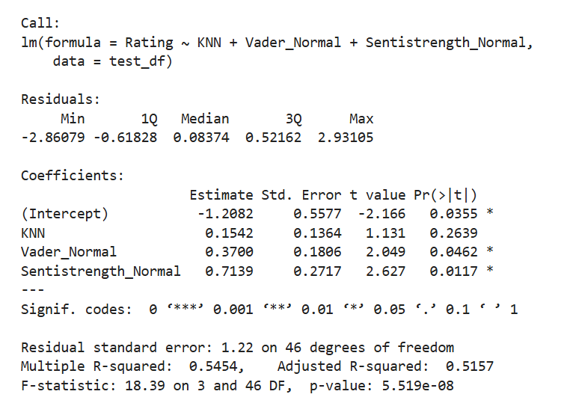
Figure One: Multivariate Regression
We can further look at the summary of our model to determine other important features. Observing the adjusted R-squared value, we can see that our model explains around fifty percent of the variability, which isn’t much. However, when compared to the R-squared of the VADER model (0.3838), it’s much higher. Similarly, the R-squared of our model is also higher than that of just the Sentistrength model (0.4469), suggesting that adding VADER, and potentially KNN, is a positive decision for the performance of our model.
Discussion:
Sentistrength performing better than VADER or KNN models implies that grocery store reviews often include strong emotional language in connection with pricing, cleanliness, convenience and quality of service. By focusing on emotionally charged adjectives and adverbs, Sentistrengh captures well the direct tone of Provigo customers associated with the star ratings. Customers clearly express positive or negative sentiments which fits SentiStrength’s lexicon based scoring.
Focusing on punctuation, capitalization and lingo, VADER performs decently, though it’s less effective at capturing the strength of praises or negative sentiment due to its general purpose lexicon. It’s also possible that, due to unpredictable customer behaviour, the inclusion of intensity modifiers might cause VADER, which is highly sensitive to this wording, to perform worse than Sentistrength, which is less affected by modifiers. KNN performing badly shows that similarity in vocabulary between reviews doesn’t, in this case, reflect sentiment similarity. Indeed, grocery reviews often discuss the same topics (pricing, quality of service, product availability) while feeling very polar sentiments about those topics, limiting the effectiveness and use of any distance-based approach. There’s also an issue of having a small training set, which could limit KNN’s effectiveness.
While sentiment scores help explain a big part of variations in star ratings, there remains a significant unexplained portion. This is consistent with our previous analyses that showed that positive reviews often reflect functional satisfaction rather than outstanding experiences, while negative reviews are very situational. For Provigo and other retailers, sentiment analysis could be used to quickly identify growing sources of dissatisfaction such as interactions with staff, or issues with product availability. These sentiment analysis models, and particularly Sentistrengh, are very useful for pin-pointing very negative experiences that are Provigo’s biggest concern. However, it should be used alongside other operational metrics as opposed to being a stand-alone measure of performance, since it captures only a part of the reasons justifying customer evaluations.

