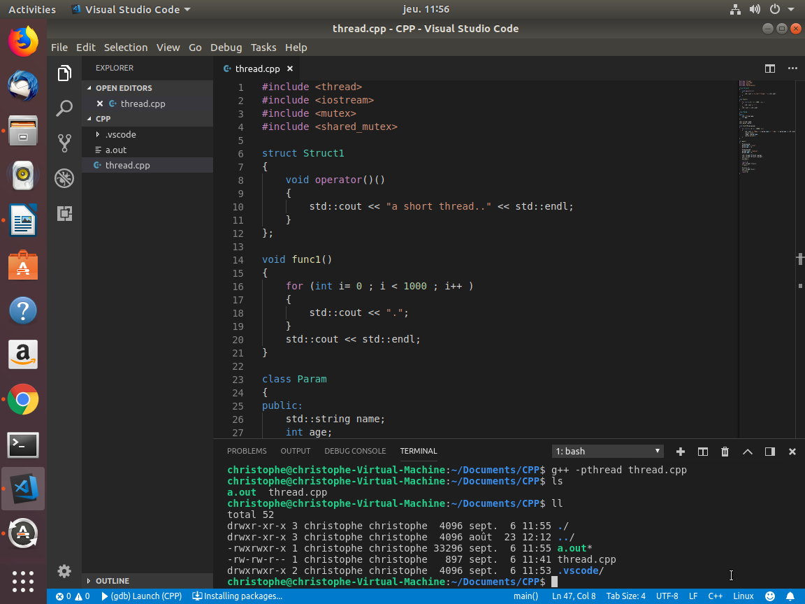

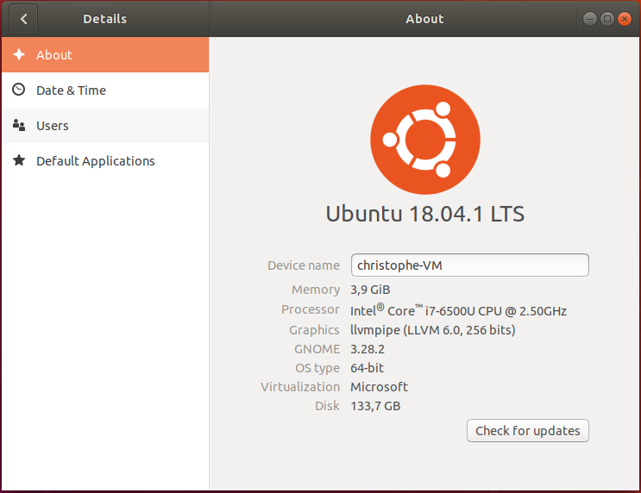

#include <thread>
#include <iostream>

struct Struct1
{
void operator()()
{
std::cout << "a short thread.." << std::endl;
}
};

void func1()
{
for (int i= 0 ; i < 1000 ; i++ )
{
std::cout << ".";
}
std::cout << std::endl;
}

int main()
{
std::thread t(func1);
t.join();

Struct1 s1;
std::thread t2(s1);
t2.join();
return 0;
}

class Param
{
public:
std::string name;
int age;
};

void func3(Param param)
{
std::cout << "Name:" << param.name << ", Age:" << param.age << std::endl;
}

int main()
{
Param param;
param.name = "Lisa";
param.age = 12;
std::thread t3(func3, param);
t3.join();
}

{
public:
Struct2(Param param, double * result)
{
_param = param;
_res = result;
}

public:
void operator()()
{
std::cout << "Name:" << _param.name
<< ", Age:" << _param.age << std::endl;
*_res = 10;
}

private:
double * _res;
Param _param;
};

int main()
{
Param param;
param.name = "Lisa";
param.age = 12;

double d = 0;
Struct2 s2(param, &d);
std::thread t4(s2);
t4.join();
std::cout << "ret d=" << d << std::endl;
}

std::string _name;
std::mutex _mutex;

void func5(Param param)
{
for (int i = 0; i < 100; i++)
{
std::cout << "Name:" << param.name << ", Age:"
<< param.age << std::endl;
_mutex.lock();
_name = param.name;
_mutex.unlock();
}
}

int main()
{
Param param;
param.name = "Lisa";
param.age = 12;

Param param2;
param2.name = "Audrey";
param2.age = 8;

std::thread t5(func5, param);
std::thread t6(func5, param2);
t5.join();
t6.join();
}

std::shared_mutex _smutex;

void func6(Param param)
{
for (int i = 0; i < 10000; i++)
{
_smutex.lock();
_name = param.name;
_smutex.unlock();

_smutex.lock_shared();
std::cout << "Name:" << _name << std::endl;
_smutex.unlock_shared();
}
}

int main()
{
Param param;
param.name = "Lisa";
param.age = 12;

Param param2;
param2.name = "Audrey";
param2.age = 8;

std::thread t5(func6, param);
std::thread t6(func6, param2);
t5.join();
t6.join();

int MySum(int i, int j)
{
return i + j;
}

void ft()
{
std::packaged_task<int(int, int)> task(MySum); // wrap the function
std::future<int> f1 = task.get_future(); // get a future
std::thread t(std::move(task), 10, 20); // launch on a thread
f1.wait();
std::cout << "Done! result: " << f1.get() << std::endl;
t.join();
}

void ft3()
{
// future from a promise
std::promise<int> p;
std::future<int> f3 = p.get_future();
std::thread([&p] { p.set_value_at_thread_exit(9); }).detach();

std::cout << "Waiting..." << std::flush;
f3.wait();
std::cout << "Done! result: " << f3.get() << std::endl;
}

void ft2()
{
// future from an async()
std::future<int> f2 = std::async(std::launch::async, [] { return 8; });
f2.wait();
std::cout << "Done! result: " << f2.get() << std::endl;
}




