Lack of recovery and Alle effect strength in Atlantic cod stocks

Introduction
Under typical density‐dependent population dynamics, per capita population growth is expected to increase as abundance declines, owing to reduced intraspecific competition at low density (Nicholson 1933). However, below a critical threshold this relationship can reverse, such that per capita growth declines with further reductions in abundance. This phenomenon, known as an Allee effect, introduces depensatory dynamics that can substantially slow or prevent recovery from depletion (Courchamp et al. 1999; Minto et al. 2008; Neubauer et al. 2013).
Despite their theoretical importance, Allee effects are rarely detected in empirical analyses of exploited marine fish stocks (Hilborn et al. 2014). When depensation has been reported, it has most often been documented in Atlantic cod (Gadus morhua) stocks (Keith and Hutchings 2012), potentially reflecting the widespread and prolonged depletion experienced by this species. Most empirical studies have implicitly assumed that Allee effects arise through recruitment limitation at low spawning biomass. Winter et al. 2023 showed that changes in water temperature and/or in spawner weight of multiple cod stocks could modify the Allee effect strength, defined as the relative change between maximum and minimum recruitment per capita at low abundance. Depensatory dynamics can also emerge through elevated mortality rates (Kuparinen and Hutchings 2014). This distinction is particularly relevant for Northwest Atlantic cod stocks, several of which have experienced substantial increases in natural mortality in recent decades, including predation-driven depensation in NAFO Division 4TVn associated with grey seal predation (Neuenhoff et al. 2019).
Surplus production provides an integrative framework for examining Allee effects arising from multiple biological processes. Surplus production represents the net change in biomass in the absence of fishing and reflects the combined effects of recruitment, somatic growth, maturity, and natural mortality. As such, surplus production dynamics are sensitive to depensatory processes regardless of whether they originate from reduced recruitment, elevated mortality, or changes in population demography induced by fishing. Despite this, few studies have systematically examined Allee effects across multiple cod stocks using surplus production, and fewer still have quantified the strength of depensation measured from production in a way that allows direct comparison among stocks.
A central but underexplored aspect of Allee effects is their magnitude. While the existence of depensatory dynamics has been widely discussed, comparatively little empirical work has focused on quantifying how strongly production is reduced at low biomass or on identifying the biomass ranges over which depensation operates. For exploited fish stocks, even moderate reductions in production at low abundance may have important consequences for recovery trajectories, particularly following severe depletion.
Here, we use surplus production dynamics to examine the presence and strength of Allee effects across multiple Atlantic cod stocks within a common analytical framework, with particular emphasis on how productivity changes at low biomass and how these changes relate to recovery following collapse. Specifically, we assess whether cod stocks exhibit Allee effect thresholds in surplus production dynamics, quantify the strength of depensatory effects using a consistent production-based approach, and evaluate whether variation in Allee effect strength and low-biomass productivity is associated with differences in stock recovery outcomes.

Methods
Stocks
Add stock names description , units, assessment model and sources
NW Atlantic stocks
2J3KL – time varying M (assessment) or B process error (SPM)
3PS – time varying M
3Pn4RS – time varying M
4TVn – time varying M (assessment) or B process error (SPM)
4VsW – time varying M
4X5Y – time varying M
GoM
GB
RAM stocks

Surplus production was calculated as:
- $P_{t}= C_{t}+B_{t+1}-B_{t}$
Where $t$ indexes year, $P$ is the stock surplus production, $C$ is the fishery catch and $B$ is the stock biomass.
Following Hutchings 2015, the Allee effect threshold was defined as the biomass where the per capita population growth rate declines with declining biomass. The Allee threshold was defined as the point where production becomes negative as biomass decreases. Piecewise regressions of production rate (${P_{t}}/{B_{t}}$) as a function of 2+ biomass were conducted using the segmented package (Fasola et al. 2018) in the R statistical software. The phi parameter estimate (regression breakpoint) was used as the Allee effect threshold value. Linear regressions were also fit to each stock. Slopes of all regressions were used to assess the direction of the effect. Stocks with positive slopes before the breakpoint and negative slopes after the breakpoint were classified as stocks experiencing allee effects. For stocks where a linear regression model was lower AIC than a segmented regression, the sign of the slope was used to assess for depensation.
Strength of the effect was defined as
$$As= \frac{{pr}_{min.b}^{dep}-{pr}_{min.b}^{comp}}{{pr}_{min.b}^{comp}}$$
Define proper method for defning if allee occurred
Is a segmented regression better than linear
Are slopes significant
etc

Results
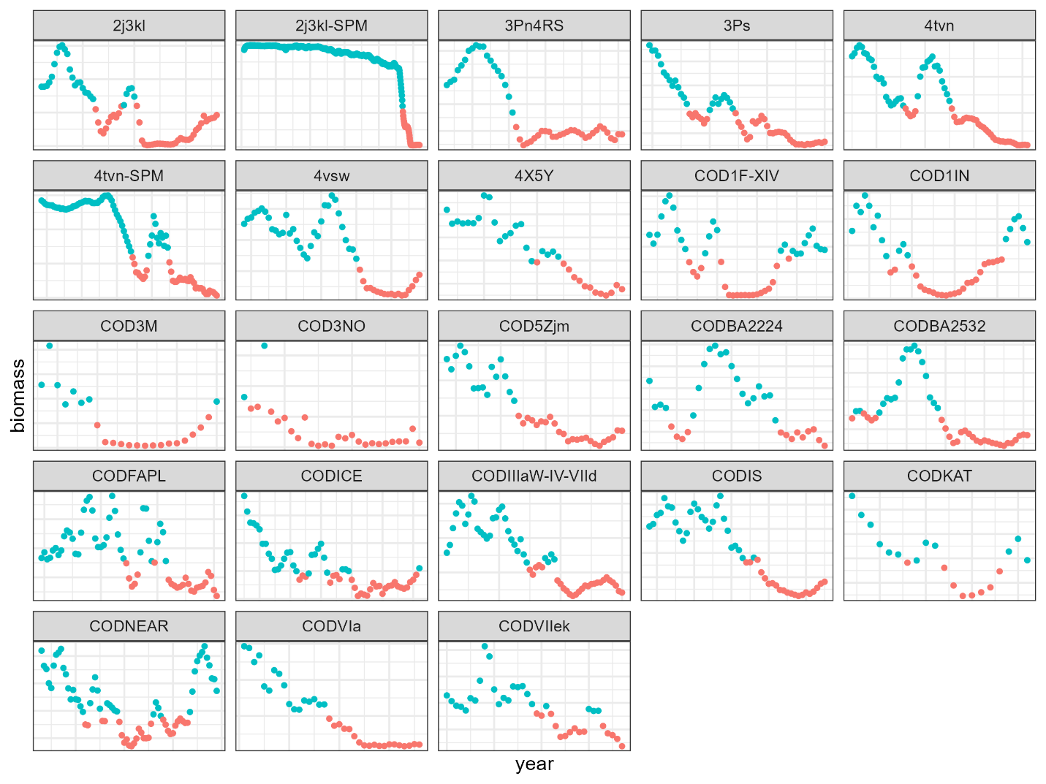

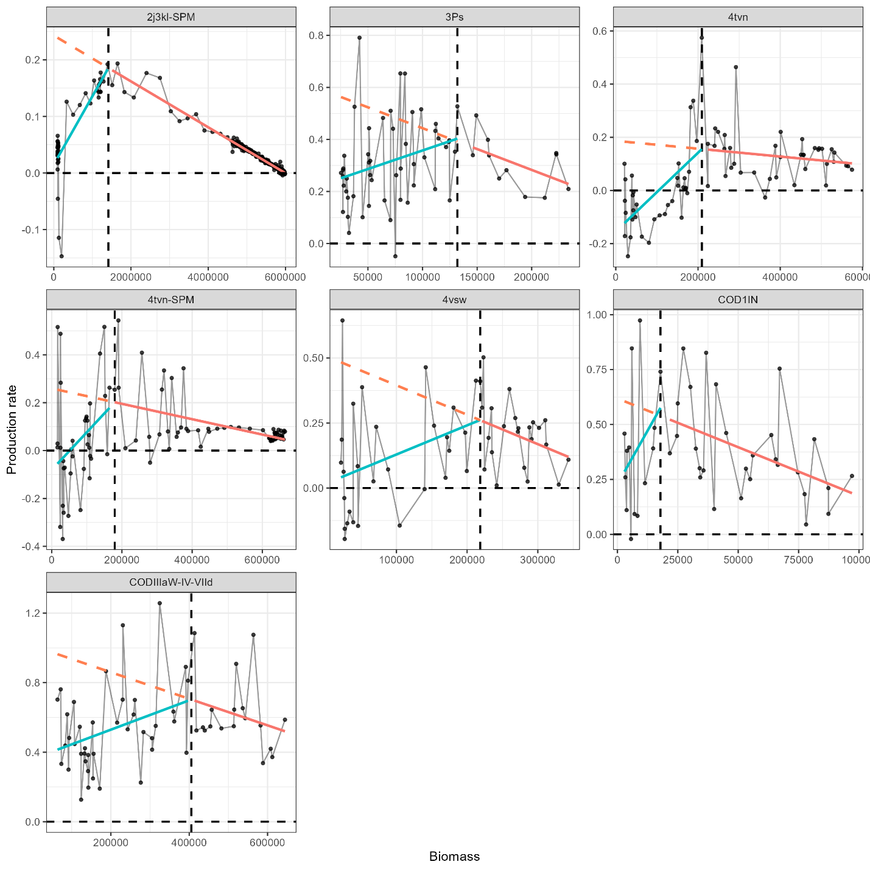
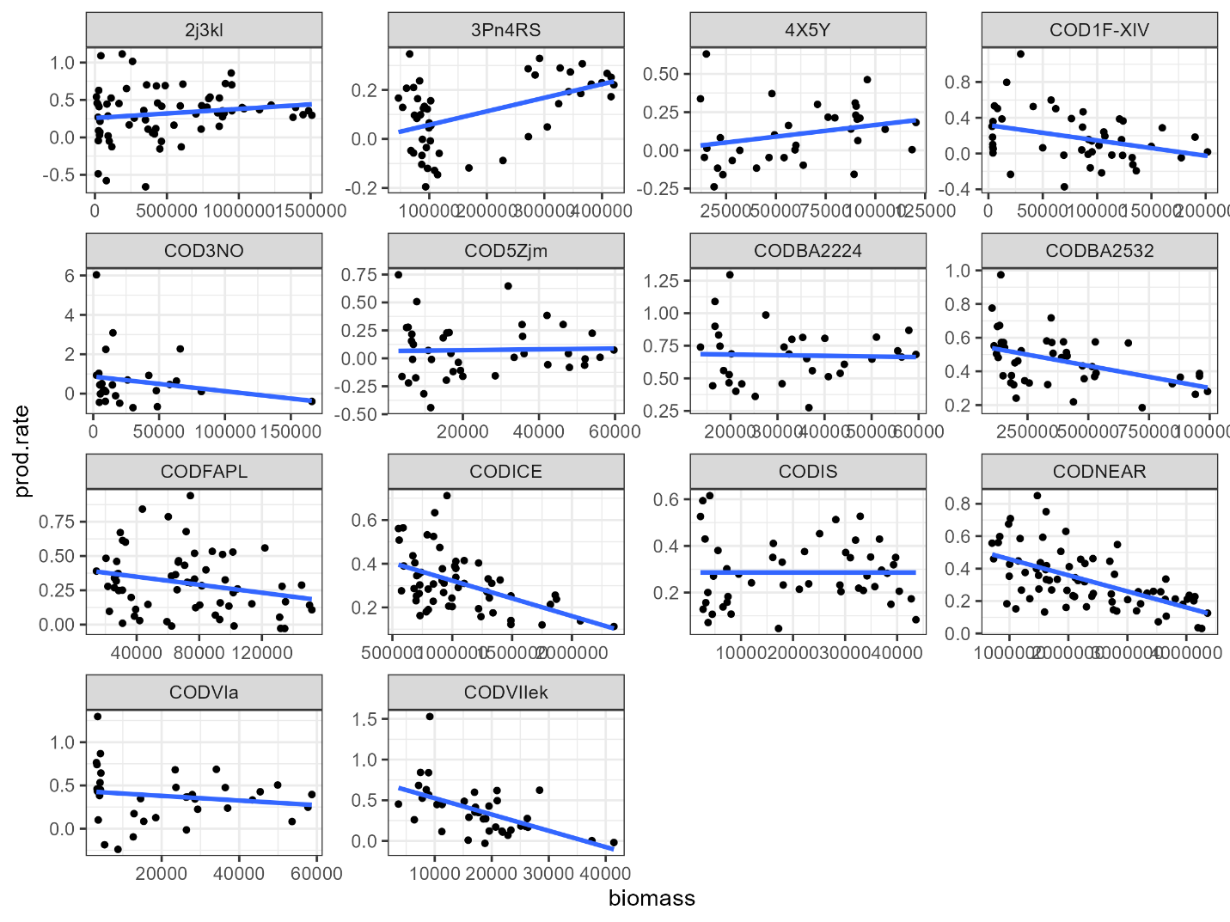

stock | As | delta_0 | Depletion (smaller number is more depleted) | collapsed | Allee effect | recovered
CODICE | -0.35 | 0.51 | 0.59 | yes | No | yes
CODBA2224 | -0.53 | 0.87 | 0.57 | yes | No | No
CODNEAR |  | 0.51 | 0.41 | yes | No | Yes
3Pn4RS |  | 0.03 | 0.28 | yes | Yes | No
3Ps | 0.55 | 0.25 | 0.27 | yes | Yes
CODBA2532 | -0.47 | 0.69 | 0.26 | yes | No
4X5Y |  | 0.03 | 0.25 | yes | Yes
CODIIIaW-IV-VIId | 0.57 | 0.41 | 0.25 | yes | Yes
CODFAPL | 0.46 | 0.33 | 0.24 | yes | No
CODVIIek | -0.76 | 0.73 | 0.22 | yes | No
4vsw | 0.92 | 0.04 | 0.16 | yes | Yes
CODVIa |  | 0.74 | 0.14 | yes | No
COD5Zjm |  | 0.31 | 0.13 | yes | No
CODIS | -1.08 | 0.53 | 0.13 | yes | No
4tvn | 1.67 | -0.12 | 0.09 | yes | Yes
COD1IN | 0.53 | 0.29 | 0.08 | yes | Yes | yes
4tvn-SPM | 1.22 | -0.06 | 0.06 | yes | Yes
COD1F-XIV | 0.25 | 0.34 | 0.04 | yes | No | yes
2j3kl-SPM | 0.89 | 0.03 | 0.04 | yes | Yes
COD3NO |  |  | 0.04 | yes | No
2j3kl |  | 0.26 | 0.02 | yes | Yes

Table X summarizes cod stocks that experienced severe historical depletion and evaluates their recovery outcomes in relation to production at the lowest observed biomass (δ0\delta_0δ0​) and the estimated strength of Allee effects (AsA_sAs​). All stocks listed reached very low relative biomass levels (depletion ≤ 0.6, with smaller values indicating greater depletion), and all are classified as collapsed. Despite broadly comparable depletion histories, recovery outcomes varied substantially among stocks.
Stocks that recovered generally retained positive production at their lowest observed biomass and showed little or no evidence of an Allee effect. For example, CODICE (As=−0.35A_s = -0.35As​=−0.35) and CODNEAR recovered with δ0≈0.5\delta_0 \approx 0.5δ0​≈0.5, indicating positive production even at their lowest observed biomass despite a modest relative reduction in production rate. Recovery was also observed for COD1F-XIV and COD1IN at much lower depletion levels (< 0.1). Although COD1IN exhibited a negative AsA_sAs​ (−0.53-0.53−0.53), indicating a relative reduction in production rate at low biomass, production remained positive (δ0=0.29\delta_0 = 0.29δ0​=0.29), suggesting that depensation was not strong enough to prevent recovery.
In contrast, many stocks that failed to recover exhibited strong Allee effects, reflected by negative AsA_sAs​ values and very low or negative production at the lowest observed biomass. Stocks such as 3Pn4RS, 4X5Y, 4vsw, 4tvn, 4tvn-SPM, and 2J3KL-SPM showed pronounced reductions in production rate at low biomass (As<0A_s < 0As​<0) combined with δ0\delta_0δ0​ values near zero or negative (≤ 0.04). These stocks also tended to be among the most severely depleted (depletion < 0.3), indicating that depensatory dynamics likely constrained population growth following collapse.
Stocks with positive AsA_sAs​ values, indicating no detectable Allee effect, displayed mixed recovery outcomes depending on production at low biomass. Several such stocks (e.g., CODBA2224, CODBA2532, CODVIIek, CODVIa, COD5Zjm, CODIS, and COD3NO) did not recover despite the absence of depensation, reflecting limited production at their lowest observed biomass. Conversely, recovery in COD1F-XIV, which had a positive AsA_sAs​ and moderate δ0\delta_0δ0​, underscores the importance of maintaining positive production at low biomass even in the absence of Allee effects.
Overall, these results indicate that recovery potential is jointly determined by depletion severity, production at the lowest observed biomass, and the strength of depensatory dynamics. Stocks experiencing extreme depletion combined with strong reductions in production rate at low biomass (negative AsA_sAs​) and near-zero or negative δ0\delta_0δ0​ consistently failed to recover. In contrast, recovery was most likely when production remained positive at the lowest observed biomass, even when moderate reductions in production rate were present, highlighting the critical role of low-biomass productivity in rebuilding depleted stocks.
Discussion
Novelty here is using surplus production and a quantification of the alle effect strength. Easier to routinely implement in stock assessments than a stock recruit function with depensation parameter.
The biomass estimates used in surplus production are population model estimates from stock assessment models and are dependant of assumptions therein.

notes
Ray Hilborn, Daniel J. Hively, Olaf P. Jensen, Trevor A. Branch, The dynamics of fish populations at low abundance and prospects for rebuilding and recovery, ICES Journal of Marine Science, Volume 71, Issue 8, October 2014, Pages 2141–2151, https://doi.org/10.1093/icesjms/fsu035
How to test if allee effects are m induced? – plot srr and look for depensation to rule out recruitment (but M induced age truncation and reduced fecundity of older larger females may be reflected in SRR, along with changes in growth and maturity).
Notes from Neuenhoff et al 2019 4tvn cod
Atlantic cod in the sGSL are currently experiencing a strong Allee effect, with the rate of surplus production declining to neg- ative values as population biomass has decreased over the past decade. Changes in recruitment dynamics do not appear to be the primary cause of this negative productivity. While there does ap- pear to have been a weakening in recruitment compensation be- tween the 1970s and 1990s (cf. Keith and Hutchings 2012), there is no evidence for depensatory recruitment dynamics in this stock. Instead, the positive density dependence of population productivity at low abundance ofthis stock appears to result from predation-driven Allee effects. Given a type II func- tional response, the predation mortality generated per predator increases as prey abundance declines, resulting in a demographic Allee effect (Gascoigne and Lipcius 2004). This is reflected in the slight peak in predation mortality in the mid-1970s and the sharp increase in predation mortality as the stock collapsed in the late 1980s and early 1990s (Fig. 2c). However, much of the large in- crease in 5+ M in the 1990s and 2000s reflects an emergent Allee effect, resulting from increasing grey seal abundance when Atlan- tic cod abundance is severely depleted.

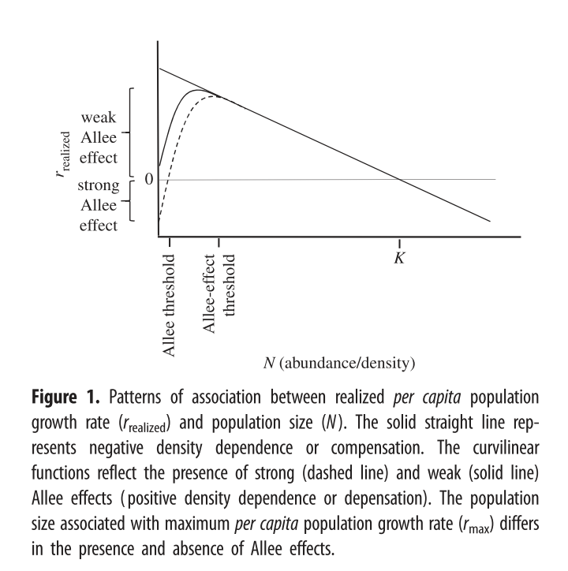

Notes
Kuparinen, A., and Hutchings, J.A. 2025. Increased natural mortality at low abundance can generate an Allee effect in a marine fish Subject Areas : Author for correspondence : R. Sic. open sci. (December). doi:10.1098/rsos.140075/224120/rsos.140075.pdf.
Our results suggest that increased mortality at low abundance can generate a demographic Allee effect that slows the recovery of depleted populations. In addition to the general importance of this finding for threatened species, our work has specific relevance to the rebuilding of over-exploited populations, indicating that recovery can be significantly retarded even in the absence of exploitation.

Winter, A.M., Vasilyeva, N., and Vladimirov, A. 2023. Spawner weight and ocean temperature drive Allee effect dynamics in Atlantic cod, Gadus morhua: inherent and emergent density regulation. Biogeosciences 20(17): 3683–3716. doi:10.5194/bg-20-3683-2023.
The Allee effect is defined as a decline in the individual growth rate or recruitment per capita ratio, Rcap, at small population density or abundance (Courchamp et al., 1999; Hutchings, 2015). The threshold below which recruitment per capita decreases is termed the Allee effect threshold. If the individual growth rate decreases to zero at a positive population abundance, the Allee effect is usually considered strong (Berec et al., 2007; Hutchings, 2015). Here, we esti- mated the Allee effect strength, As, as the ratio between Rcap at the Allee effect threshold SSB0 and the minimum Rcap at SSBN below the Allee effect threshold (Eq. 9). With- out an Allee effect, SSB0 is simply the inflection point. We considered SSBN in order to focus on spawner abundance, because Allee effects are density- or abundance-dependent phenomena. At the Allee effect threshold, Rcap is maximal, and the corresponding biomass is SSB0. Because all stocks show to some extent a decline in the per capita growth rate (Fig. 3), an Allee effect can be quantified for each stock as the decline in recruitment per capita relative to its maximum so that As ∈ [0,1]. When there is no Allee effect As = 0 and As = 1 when recruitment per capita declines to 0. Ap- pendix C Fig. C1 shows a scheme of the definition:

Keith, D.M., and Hutchings, J.A. 2012. Population dynamics of marine fishes at low abundance. Can. J. Fish. Aquat. Sci. 69(7): 1150–1163. doi:10.1139/F2012-055.
Our analysis suggests that the assumption of an increase in Recruits per SSB as SSB declines is well founded for many species across much of their historical range in SSB. Overall, there is a steady increase in RPSZ as SSB declines, although this trend slows at the lowest values of SSB. At their lowest his- torical abundances, there is an estimated decline in RPSZ in over 20% of species.
They use recruits per ssb as y axis, implying that this is the mechanism behind population growth. We use surplus production rate per capita.

Hutchings, J.A. 2015. Thresholds for impaired species recovery. Proc. R. Soc. B Biol. Sci. 282(1809). doi:10.1098/rspb.2015.0654.
The concept of ‘threshold’ is central to Allee effects. If the pat- tern between realized and N changes from a negative to a positive relationship as populations decline, an obvious and fundamental question emerges: at what level of abundance are Allee effects likely to be manifest in natural populations? Despite the logical necessity in posing this question, surpris- ingly little work has been devoted to answering it. This might reflect an influence of the prevailing conservation- biology paradigms and their emphasis on extinction rather than recovery, resulting in greater study being directed to strong rather than weak Allee effects ([13,30,36]; ISI Web of Science searches).

From Jacobsen and Essington: Here, we quantified the role of natural mortality fluctuations onforage fish population dynamics, illustrating a depensatory trend inmortality in periods of population cycles leading to population peaksand troughs. Namely, we found that density-dependent mortalityworked in two ways: on average mortality increased before a troughand decreased before a peak, albeit with a stronger signal beforetrough. The analysis also showed that the peaks and troughs wouldhave occurred if mortality was constant, but in smaller magnitudes(Figure 4). This result does not implicate that mortality will always bedepensatory during population cycles, but that depensatory mortal-ity is frequently occurring in forage fish populations. As fishing am-plifies crashes in forage fish populations (Beverton, 1990; Essingtonet al., 2015), the effects of natural and fishing mortality are likelysynergistic in contributing to the large-scale fluctuations often ob-served in forage fish populations. This work contributes to specificcase-studies illustrating Allee effects and depensation (Gascoigne &Lipcius, 2004; Wood, 1987), but is the first to demonstrate naturalmortality as a widespread depensatory mechanism across multiplemarine fish populations

Maybe - Investigate the likely sources of the Allee effects by looking for signs of depensation in stock recruit relationships, and M analysis? Other productivity drivers

Allee effects are most often investigated via stock recruit relationships, however the mechanism is a decrease in the production rate, which does not necessarily translate to a decrease in recruitment rate. Other drivers (growth,maturity and mortality) can also contribute to the emergence of allee effects.

