notes
Ray Hilborn, Daniel J. Hively, Olaf P. Jensen, Trevor A. Branch, The dynamics of fish populations at low abundance and prospects for rebuilding and recovery, ICES Journal of Marine Science, Volume 71, Issue 8, October 2014, Pages 2141–2151, https://doi.org/10.1093/icesjms/fsu035
How to test if allee effects are m induced? – plot srr and look for depensation to rule out recruitment (but M induced age truncation and reduced fecundity of older larger females may be reflected in SRR, along with changes in growth and maturity).
Notes from Neuenhoff et al 2019 4tvn cod
Atlantic cod in the sGSL are currently experiencing a strong Allee effect, with the rate of surplus production declining to neg- ative values as population biomass has decreased over the past decade. Changes in recruitment dynamics do not appear to be the primary cause of this negative productivity. While there does ap- pear to have been a weakening in recruitment compensation be- tween the 1970s and 1990s (cf. Keith and Hutchings 2012), there is no evidence for depensatory recruitment dynamics in this stock. Instead, the positive density dependence of population productivity at low abundance ofthis stock appears to result from predation-driven Allee effects. Given a type II func- tional response, the predation mortality generated per predator increases as prey abundance declines, resulting in a demographic Allee effect (Gascoigne and Lipcius 2004). This is reflected in the slight peak in predation mortality in the mid-1970s and the sharp increase in predation mortality as the stock collapsed in the late 1980s and early 1990s (Fig. 2c). However, much of the large in- crease in 5+ M in the 1990s and 2000s reflects an emergent Allee effect, resulting from increasing grey seal abundance when Atlan- tic cod abundance is severely depleted.

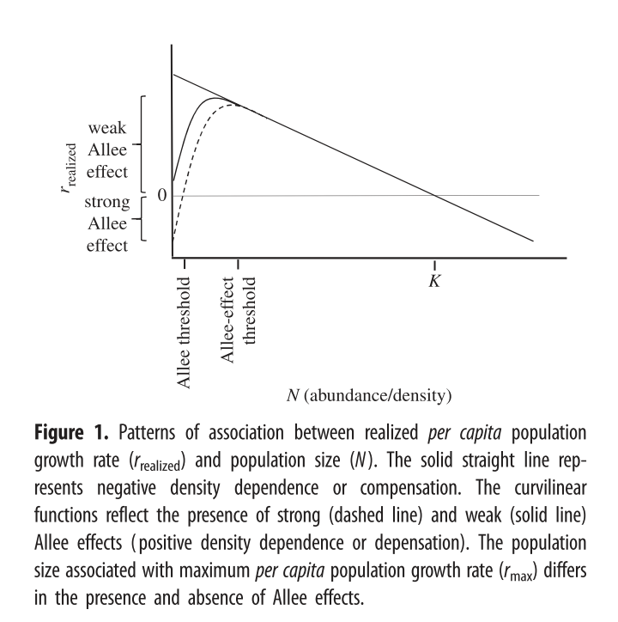

Notes
Kuparinen, A., and Hutchings, J.A. 2025. Increased natural mortality at low abundance can generate an Allee effect in a marine fish Subject Areas : Author for correspondence : R. Sic. open sci. (December). doi:10.1098/rsos.140075/224120/rsos.140075.pdf.
Our results suggest that increased mortality at low abundance can generate a demographic Allee effect that slows the recovery of depleted populations. In addition to the general importance of this finding for threatened species, our work has specific relevance to the rebuilding of over-exploited populations, indicating that recovery can be significantly retarded even in the absence of exploitation.

Winter, A.M., Vasilyeva, N., and Vladimirov, A. 2023. Spawner weight and ocean temperature drive Allee effect dynamics in Atlantic cod, Gadus morhua: inherent and emergent density regulation. Biogeosciences 20(17): 3683–3716. doi:10.5194/bg-20-3683-2023.
The Allee effect is defined as a decline in the individual growth rate or recruitment per capita ratio, Rcap, at small population density or abundance (Courchamp et al., 1999; Hutchings, 2015). The threshold below which recruitment per capita decreases is termed the Allee effect threshold. If the individual growth rate decreases to zero at a positive population abundance, the Allee effect is usually considered strong (Berec et al., 2007; Hutchings, 2015). Here, we esti- mated the Allee effect strength, As, as the ratio between Rcap at the Allee effect threshold SSB0 and the minimum Rcap at SSBN below the Allee effect threshold (Eq. 9). With- out an Allee effect, SSB0 is simply the inflection point. We considered SSBN in order to focus on spawner abundance, because Allee effects are density- or abundance-dependent phenomena. At the Allee effect threshold, Rcap is maximal, and the corresponding biomass is SSB0. Because all stocks show to some extent a decline in the per capita growth rate (Fig. 3), an Allee effect can be quantified for each stock as the decline in recruitment per capita relative to its maximum so that As ∈ [0,1]. When there is no Allee effect As = 0 and As = 1 when recruitment per capita declines to 0. Ap- pendix C Fig. C1 shows a scheme of the definition:

Keith, D.M., and Hutchings, J.A. 2012. Population dynamics of marine fishes at low abundance. Can. J. Fish. Aquat. Sci. 69(7): 1150–1163. doi:10.1139/F2012-055.
Our analysis suggests that the assumption of an increase in Recruits per SSB as SSB declines is well founded for many species across much of their historical range in SSB. Overall, there is a steady increase in RPSZ as SSB declines, although this trend slows at the lowest values of SSB. At their lowest his- torical abundances, there is an estimated decline in RPSZ in over 20% of species.
They use recruits per ssb as y axis, implying that this is the mechanism behind population growth. We use surplus production rate per capita.

Hutchings, J.A. 2015. Thresholds for impaired species recovery. Proc. R. Soc. B Biol. Sci. 282(1809). doi:10.1098/rspb.2015.0654.
The concept of ‘threshold’ is central to Allee effects. If the pat- tern between realized and N changes from a negative to a positive relationship as populations decline, an obvious and fundamental question emerges: at what level of abundance are Allee effects likely to be manifest in natural populations? Despite the logical necessity in posing this question, surpris- ingly little work has been devoted to answering it. This might reflect an influence of the prevailing conservation- biology paradigms and their emphasis on extinction rather than recovery, resulting in greater study being directed to strong rather than weak Allee effects ([13,30,36]; ISI Web of Science searches).

From Jacobsen and Essington: Here, we quantified the role of natural mortality fluctuations onforage fish population dynamics, illustrating a depensatory trend inmortality in periods of population cycles leading to population peaksand troughs. Namely, we found that density-dependent mortalityworked in two ways: on average mortality increased before a troughand decreased before a peak, albeit with a stronger signal beforetrough. The analysis also showed that the peaks and troughs wouldhave occurred if mortality was constant, but in smaller magnitudes(Figure 4). This result does not implicate that mortality will always bedepensatory during population cycles, but that depensatory mortal-ity is frequently occurring in forage fish populations. As fishing am-plifies crashes in forage fish populations (Beverton, 1990; Essingtonet al., 2015), the effects of natural and fishing mortality are likelysynergistic in contributing to the large-scale fluctuations often ob-served in forage fish populations. This work contributes to specificcase-studies illustrating Allee effects and depensation (Gascoigne &Lipcius, 2004; Wood, 1987), but is the first to demonstrate naturalmortality as a widespread depensatory mechanism across multiplemarine fish populations

Maybe - Investigate the likely sources of the Allee effects by looking for signs of depensation in stock recruit relationships, and M analysis? Other productivity drivers

Allee effects are most often investigated via stock recruit relationships, however the mechanism is a decrease in the production rate, which does not necessarily translate to a decrease in recruitment rate. Other drivers (growth,maturity and mortality) can also contribute to the emergence of allee effects.
NW Atlantic stocks
2J3KL – time varying M (assessment) or B process error (SPM)
3PS – time varying M
3Pn4RS – time varying M
4TVn – time varying M (assessment) or B process error (SPM)
4VsW – time varying M
4X5Y – time varying M

