Lack of recovery and widespread depensation in Northwest Atlantic cod stocks

François Turcotte¹, Timothy J. Barrett²
¹Fisheries and Oceans Canada, Gulf Fisheries Centre, Moncton, NB E1C 9B6, Canada
²Fisheries and Oceans Canada, St. Andrews Biological Station, St. Andrews, NB E5B 2L9, Canada

Keywords: Atlantic Cod, stock recovery, Allee effects, population dynamics

Abstract
Limited recovery following widespread collapses of Atlantic cod (Gadus morhua) stocks suggests that depensatory processes may constrain rebuilding. While most studies investigate for component Allee effects (on recruitment), we evaluated the presence and strength of demographic Allee effects across 24 cod stocks using relative surplus production as a proxy for per capita population growth rate. Surplus production integrates recruitment, somatic growth, and natural mortality and was estimated from catch and biomass time series from stock assessments. Allee effect thresholds were estimated . using segmented regressions of relative surplus production versus biomass. The strength of depensation was quantified as the relative reduction in production at low biomass compared to the production expected assuming compensatory dynamics. All but 2 stocks declined below 20% of maximum observed biomass in each time series, indicating widespread depletion; however, recovery trajectories varied substantially. Stocks that recovered to at least 40% of the maximum observed biomass generally maintained positive production at low biomass and exhibited weak or no evidence of Allee effects. In contrast, non-recovering stocks frequently displayed strong depensatory dynamics, with near-zero or negative production at their lowest observed biomass. The strength of the Allee effect was positively associated with both the severity of depletion and the likelihood of failed recovery. Some stocks without detectable Allee effects also failed to recover, reflecting persistently low productivity across their biomass range. These results demonstrate that using relative surplus production as a proxy for the per capita population growth rate provides a robust and integrative framework for detecting and quantifying demographic Allee effects. Recovery potential in Atlantic cod appears to depend jointly on depletion severity, productivity at low biomass, and the strength of depensatory processes.

Introduction
Understanding the dynamics of populations following collapse is central to conservation and management, as recovery potential is closely linked to per capita population growth rate and can be constrained by continued overexploitation during and after collapse. Under density-dependent population dynamics, per capita growth is expected to increase as abundance declines due to reduced intraspecific competition (Nicholson 1933). However, below a critical threshold, this relationship may reverse, where a positive relationship between population abundance and per capita population growth rate is observed. This phenomenon, known as a demographic Allee effect, introduces depensatory dynamics that can substantially slow or even prevent recovery from depletion (Courchamp et al. 1999; Minto et al. 2008; Neubauer et al. 2013; Hutchings 2015).
Hutchings (2015) distinguishes a demographic Allee effect from a component Allee effect (positive relationship between population abundance and any component of individual fitness). In the fisheries literature Allee effects are also termed “depensation” (e.g., Liermann and Hilborn, 1997; Hutchings 2015). Despite their theoretical importance, Allee effects are rarely detected in empirical analyses of exploited marine fish stocks (Hilborn et al. 2014). When they have been reported, it has most often been a component Allee effect, as a positive association with population size and recruitment for Atlantic cod (Gadus morhua) stocks (e.g., Keith and Hutchings 2012; Perälä et al. 2022; Winter et al. 2023). Depensatory dynamics can also emerge through elevated adult mortality rates (Kuparinen et al. 2014). This distinction is particularly relevant for Northwest Atlantic cod stocks, several of which have experienced substantial increases in natural mortality in recent decades, including predation-driven depensation in NAFO Division 4TVn associated with grey seal predation (Neuenhoff et al. 2019).
The focus of studies on depensatory dynamics in fishes has primarily been focused on component Allee effects. The degree to which a component Allee effect is likely to result in a demographic Allee effect is not clear. For example, it assumes that an increase in one component of fitness automatically leads to an increase in overall fitness (Hutchings 2015). Looking at only one component of fitness (e.g., recruitment), can lead to failing to detect an Allee effect caused by other components (e.g., adult mortality) (Hutchings 2015).
Detecting recruitment depensation using stock–recruit relationships (SRRs) is widely recognized as challenging (Hilborn et al. 2014; Liermann and Hilborn 1997; Myers et al. 1995). For example, Myers et al. (1995) found evidence of depensation in only 3 of 128 SRRs. Similarly, an analysis of the RAM Legacy database by Keith and Hutchings (2012), which examined recruits-to-SSB ratios across 104 species, found little evidence of recruitment depensation except for Atlantic cod. More recently, Albertsen et al. (2025) identified recruitment depensation in 5 of 81 ICES stocks. Hilborn et al. (2014) repeated the Myers et al. (1995) analysis with 15 more years of additional data from the RAM Legacy database and only found significant depensation in 4 of 113 stocks when looking at the relationship between recruitment (component) and biomass but in 8 of 109 stocks when looking at the relationship between surplus production (i.e., a proxy for population growth; demographic Allee effect) and biomass. Overall, the detection of Allee effects depend on multiple factors, including species and life-history type, time series length and stock state, data sources (e.g., the availability of data at low biomass), and analytical method.
Walters et al. (2008) suggest that surplus production–biomass relationships can provide a useful diagnostic for assessing whether stocks exhibit strong compensatory responses. Surplus production reflects the net change in biomass in the absence of fishing and is an integrated indicator of population growth (combined influence of recruitment, somatic growth, maturation, and natural mortality). Surplus production is sensitive to depensatory processes regardless of whether they arise from reduced recruitment, increased mortality, or shifts in population demography driven by fishing or environmental effects. The ratio of surplus production to biomass therefore serves as a proxy for the per capita population growth rates (i.e., an indicator for a demographic Allee effect). Neuenhoff et al. (2019) identified evidence of a demographic Allee effect in NAFO 4TVn Atlantic cod using surplus production per biomass versus biomass relationships, whereas no such signal was detected using the stock–recruit relationship for the same stock. Despite these advantages, relatively few studies (see Hilborn et al. 2014) have used production-based approaches to detect demographic Allee effects or to quantify the strength of depensation across multiple stocks.
Here, we use relative surplus production (ratio of surplus production to biomass) as a proxy for the per capita population growth rate to assess and quantify the strength of demographic Allee effects across multiple Atlantic cod stocks within a common analytical framework, with particular emphasis on how productivity changes at low biomass and how these changes relate to recovery following collapse. Specifically, we assess the presence of Allee effect thresholds (biomass below which relative surplus production decreases with decreasing biomass) and Allee thresholds (biomass below which relative surplus production is negative) in cod stocks. We quantify the strength of depensatory effects using a consistent production-based approach, and evaluate whether variation in Allee effect strength, low-biomass productivity and the level of depletion are associated with differences in historical stock recovery outcomes.

Methods
Atlantic Cod catch and biomass data were obtained from the RAM database (Ricard et al. 2012) and stock assessment reports (Table 1). For each stock, relative depletion was defined as the annual estimate of stock biomass relative to the maximum biomass in the time series. Depleted stocks were defined as those with a biomass below 20% of the maximum observed biomass (B_{max}) in the time series (e.g., following Hilborn et al. 2014) and recovered stocks were defined as those that fell below 20% B_{max} and increased to 40% B_{max} and remained above B_{max} until the end of the time series.
Surplus production was calculated following Hilborn et al. (2014) as:
- $P_{t}= B_{t+1}-B_{t}+C_{t}$
Where $t$ indexes year, $P$ is the stock surplus production, $B$ is the stock biomass (either total stock biomass or spawning stock biomass – depending on available data), and $C$ is the fishery catch. Surplus production was used as a measure of the population growth. A proxy for the per capita population growth rate was defined as ${P_{t}}/{B_{t}}$ (i.e., relative surplus production). The presence of an Allee effect was investigated using the relationship between relative surplus production and biomass. Following Hutchings (2015), the Allee effect threshold was defined as the biomass below which ${P_{t}}/{B_{t}}$ declines with declining biomass and the Allee threshold was defined as the biomass below which ${P_{t}}/{B_{t}}$ becomes negative as biomass decreases.
Piecewise regressions of ${P_{t}}/{B_{t}}$ as a function of biomass were conducted using the segmented package (Fasola et al. 2018) in the R statistical software (R Core Team 2021). A single breakpoint (Ψ) per regression was estimated using the package’s heuristic iterative algorithm for approximate maximum likelihood estimation, which detects change points through repeated fitting of simple linear regression models. The estimated breakpoint was interpreted as the Allee effect threshold and used in subsequent analyses. was used as the Allee effect threshold value for downstream analyses.
For each stock, separate linear regressions were fitted to observations below Ψ, above Ψ, and across the full range of biomass values using the lm() function in R. Stocks exhibiting a significantly positive slope below the breakpoint (the depensation zone) and a significantly negative slope above the breakpoint (the compensation zone) were classified as exhibiting demographic Allee effects.
For stocks in which a single linear regression fitted across the full biomass range resulted in a lower AIC (Akaike Information Criterion; Akaike 1974) than the segmented regression model, stocks with a significantly positive slope were classified as exhibiting demographic Allee effects over the observed biomass range. Statistical significance for all regression parameters was evaluated at α = 0.05.
For stocks with an Allee effect threshold, production rates between Ψ and the lowest observed biomass (the expected compensatory production rates) were estimated using the linear regression from the compensation zone. This allowed an estimate of the production rates for each stock if depensation at low biomass did not occur.
For each stock, the strength of the Allee effect (As) was defined as:
$$As= \frac{{pr}_{c}-{pr}_{d}}{{pr}_{c}}$$
Where ${pr}_{c}$ is the expected compensatory production rate at minimum observed biomass, ${pr}_{d}$ is the predicted production rate at minimum observed biomass in the depensation zone (Figure 1). $As$ is a relative measure of the decrease in production rate from the Allee effect threshold and can be compared across stocks. Weak Allee effects (${P_{t}}/{B_{t}}$ remains above zero) have a value of $As$ between 0 and 1, while strong Allee effects (${P_{t}}/{B_{t}}$ fall below zero) have a value of $As$ greater than 1.
Table 1: Atlantic cod stock identification label (Stock ID), stock unit definition, year range of data and data source.
Stock ID | Stock unit | Years | Biomass | Source
Northwest Atlantic stocks
2j3kl | NAFO 2J3KL | 1508-2018 | total | Schijns et al. 2021
3Pn4RS | NAFO 3Pn4RS | 1973-2021 | 2+ | Ouellette-Plante et al. 2025
3Ps | NAFO 3Ps | 1959-2020 | ssb | Varkey et al. 2025
4tvn | NAFO 4TVn | 1917-2023 | 2+ | Turcotte et al. 2024
4vsw | NAFO 4Vsw | 1958-2008 |  | Mohn and Rowe 2012
4X5Y | NAFO 4X5Y | 1983-2016 | ssb | Andrushchenko et al. 2022
5Zjm | NAFO 5Zjm | 1978-2020 | total | RAM
GB | Georges Banks | 1978-2022 | ssb | Amanda Hart (personal communication 2026)
EGOM | Eastern Gulf of Maine | 1981-2022 | ssb | Charles Perretti (personal communication 2026)
SNE | Southern New England | 1981-2022 | ssb | Alex Hansell (personal communication 2026)
WGOM | Western Gulf of Maine | 1981-2022 | ssb | Cameron Hodgdon (personal communication 2026)
3NO | Southern Grand Banks | 1953-2011 | 3+ | Rideout et al. 2021
1IN | NAFO Subarea 1 (inshore) | 1976-2021 | total | RAM
1F-XIV | NAFO 1F and ICES 14 | 1973-2021 | total | RAM
Northeast Atlantic stocks
BA2224 | Western Baltic | 1985-2021 | total | RAM
BA2532 | Eastern Baltic | 1946-2021 | total | RAM
FAPL | Faroe Plateau | 1958-2022 | total | RAM
ICE | Iceland Grounds | 1955-2023 | total | RAM
IIIaW-IV-VIId | ICES 3a(west)-4-7d | 1962-2022 | total | RAM
IS | Irish Sea | 1968-2023 | total | RAM
NEAR | North-East Arctic | 1943-2021 | total | RAM
VIa | West of Scotland | 1980-2022 | total | RAM
VIIek | Celtic Sea | 1980-2021 | total | RAM

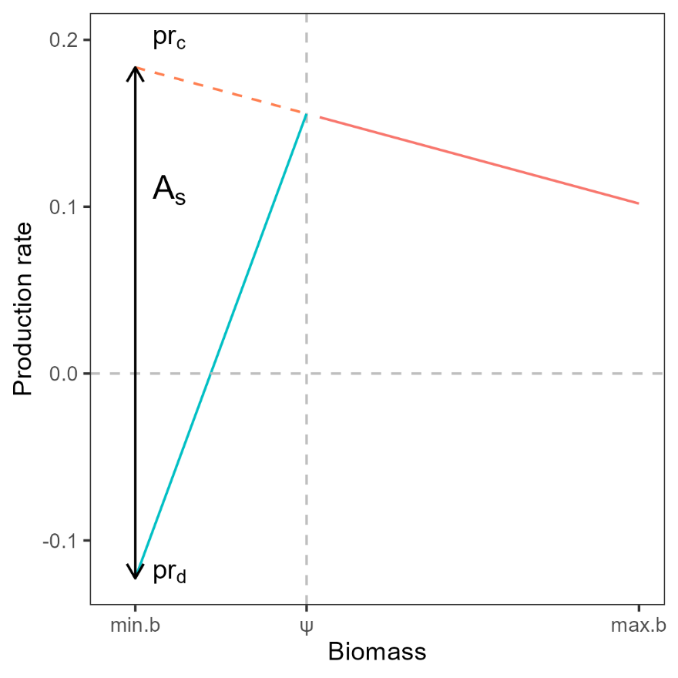
Figure 1 : Conceptual representation of estimated quantities for stocks analyses. Biomass (x-axis) is the stock biomass for all years, production rate (y-axis) is the relative surplus production for all years, Ψ is the estimated breakpoint in the relationship between production rate and biomass, the red solid line is a linear regression line in the compensation zone (biomass > Ψ), the blue solid line is a linear regression line in the depensation zone (biomass < Ψ), the red dashed line is the expected compensatory production rates at biomass < Ψ, pr_{c} is the expected compensatory production rate at minimum biomass, pr_{d} is the production rate at minimum biomass in the depensation zone, the black vertical double arrow illustrates the distance between pr_{c} and pr_{d}, A_{s} is the Allee effect strength.

Results
Data from 24 Atlantic cod stocks were analyzed: 15 from the northwest Atlantic and 9 from the northeast Atlantic (Table 1). For most stocks, biomass was greatest early in the time series and declined over time. All but 2 stocks (BA224 and ICE) declined below 20% B_{max} and were therefore classified as depleted (Figure 2; Table 2). Four stocks were classified as recovered; three from the northwest Atlantic (1F-XIV, 1IN and NEAR) and one from the northeast Atlantic (3M; Figure 2; Table 2).
Regional differences were observed in mean production at low biomass and depletion levels. Mean production at low biomass (pr_{d}) differed significantly between regions (Wilcoxon rank-sum test: W = 106, p = 0.007), with higher values in the Northeast Atlantic. Depletion also differed between regions (Wilcoxon rank-sum test: W = 106, p = 0.007), with Northwest Atlantic stocks exhibiting greater depletion.
Significant regression breakpoints (Ψ), as well as depensatory and compensatory zones, were identified for eight stocks, suggesting the occurrence of emergent Allee effects (Figure 3). For these stocks, Allee effect strength (A_{s}) ranged from 0.53 to 1.22. Although negative production rate observations were present in most stocks, the mean production rate at the lowest observed biomass (pr_{d}) was negative, indicating a strong Allee effect, only for the 4TVn stock. Across these stocks, pr_{d} ranged from −0.06 to 0.43, and depletion averaged 0.06 and ranged from 0.02 to 0.11. Of the eight stocks, only 1IN was classified as recovered.
Two stocks exhibited significant positive slopes across the full biomass range, indicating the presence of an Allee effect throughout the available time series (Figure 4). Three stocks exhibit positive slopes but they were not significant (Figure 4). Hence, these stocks where categorized as not compensatory, but for which Allee effects could not be identified. For these five stocks, mean production at low biomass (pr_{d}) ranged from 0.03 to 1.22. Depletion averaged 0.06 and ranged from 0.01 to 0.11. All three stocks were from the northwest Atlantic, and none were classified as recovered.
Eleven stocks exhibited either significant or non-significant negative slopes and were therefore classified as not exhibiting an Allee effect (Figure 5). Across these stocks, pr_{d} ranged from 0.11 to 0.87, depletion averaged 0.1 and ranged from 0.02 to 0.23. Eight of these stocks were from the northeast Atlantic. Among stocks in this category, two of the three northwest Atlantic stocks and two of the eight northeast Atlantic stocks were classified as recovered.
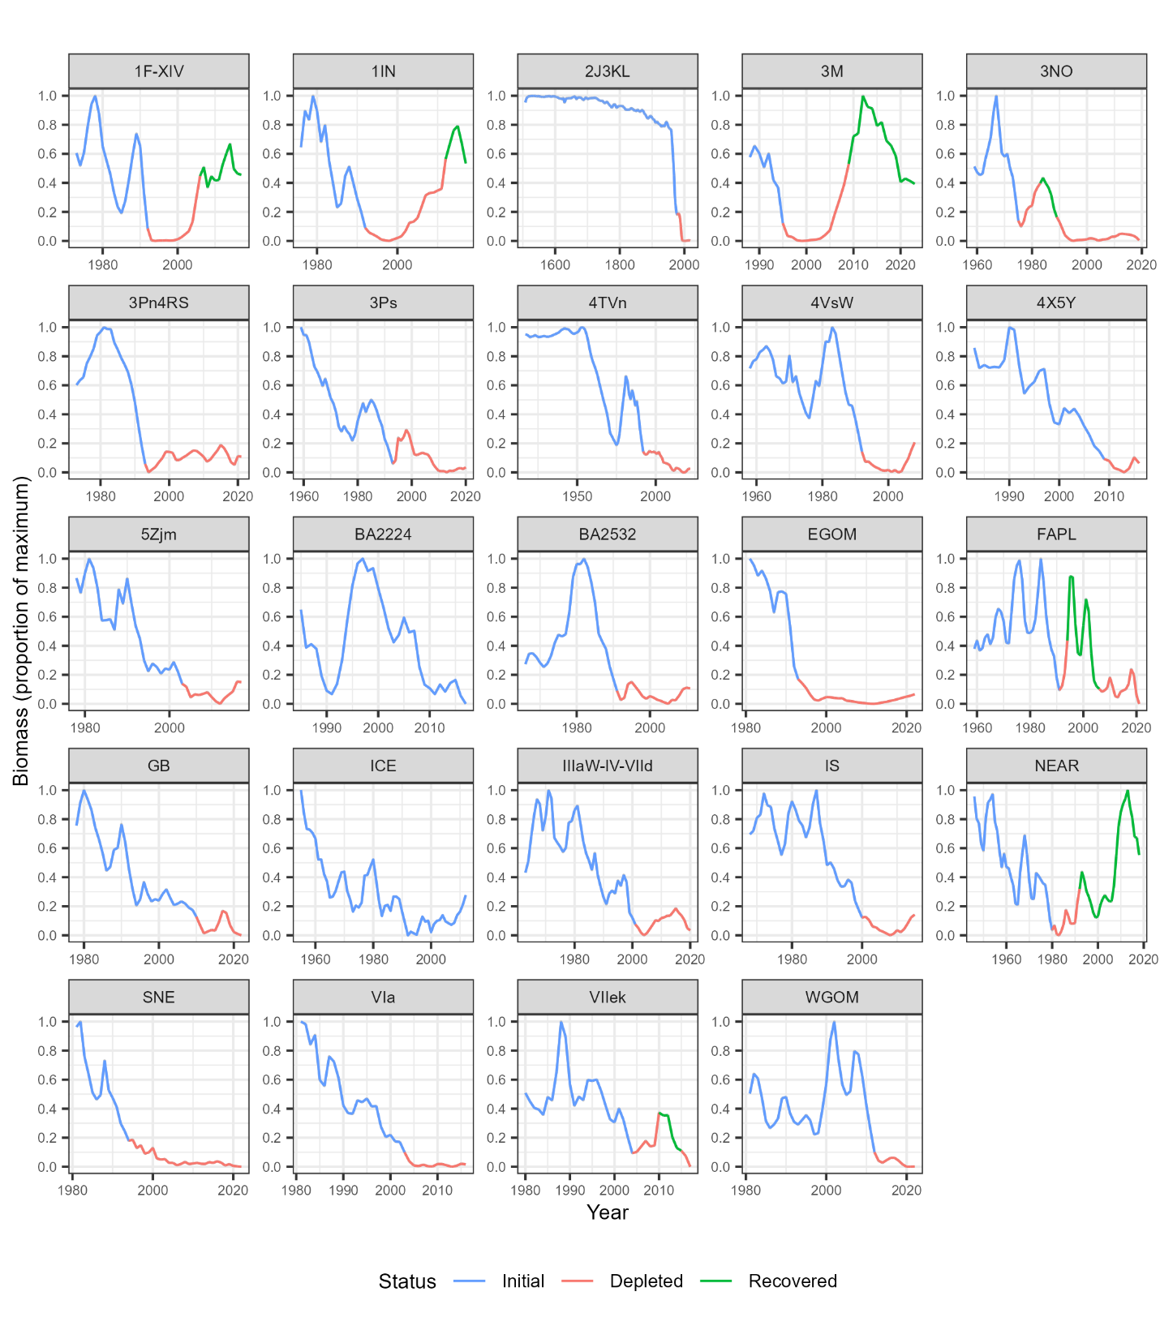
Figure 2: Time (x axis) series of biomass (relative to the maximum; y axis) for all stocks considered in the analysis, blue segments are initial biomass, red segments are depleted biomass and green segments are recovered biomass.
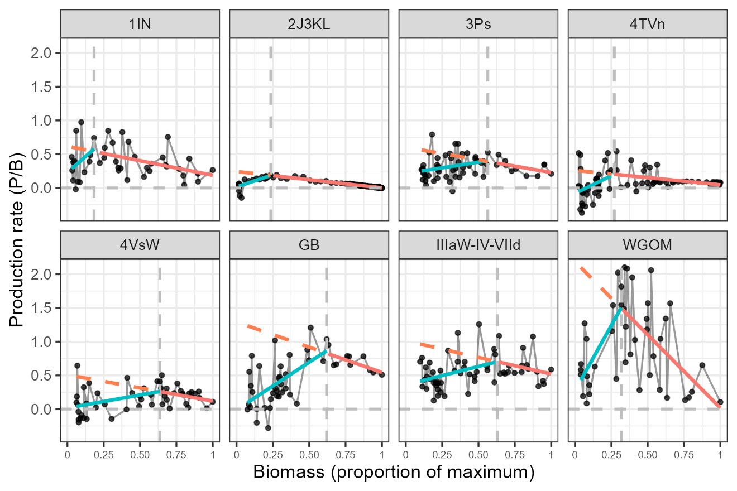
Figure 3: Production rate (y axis) in function of biomass (x axis), the black vertical dashed line is the estimated breakpoint (Ψ) in the relationship between production rate and biomass, the red solid line is a linear regression line in the compensation zone (biomass > Ψ), the blue solid line is a linear regression line in the depensation zone (biomass < Ψ), the red dashed line is the expected compensatory production rates at biomass < Ψ.

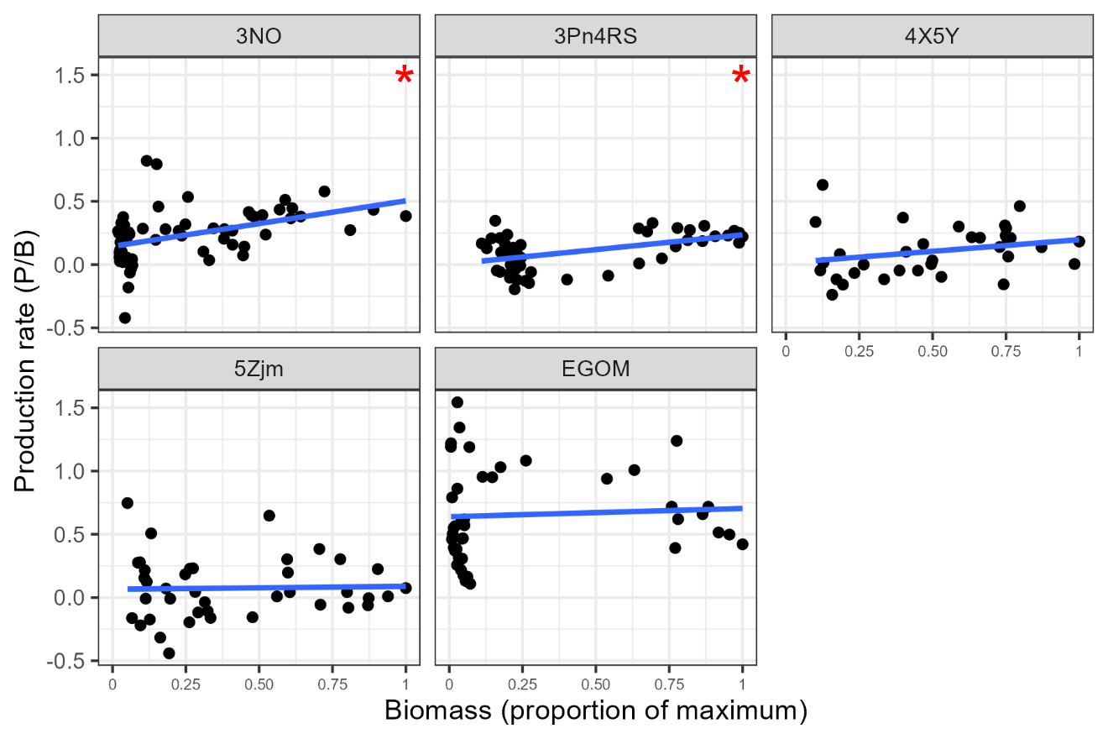
Figure 4: Depensation stocks; Atlantic cod stocks production rate (y axis) in function of biomass (x axis) the blue solid line is a linear regression line over the range of data, showing only stock where a linear regression had a positive slope and lower AIC than a segmented regression model.

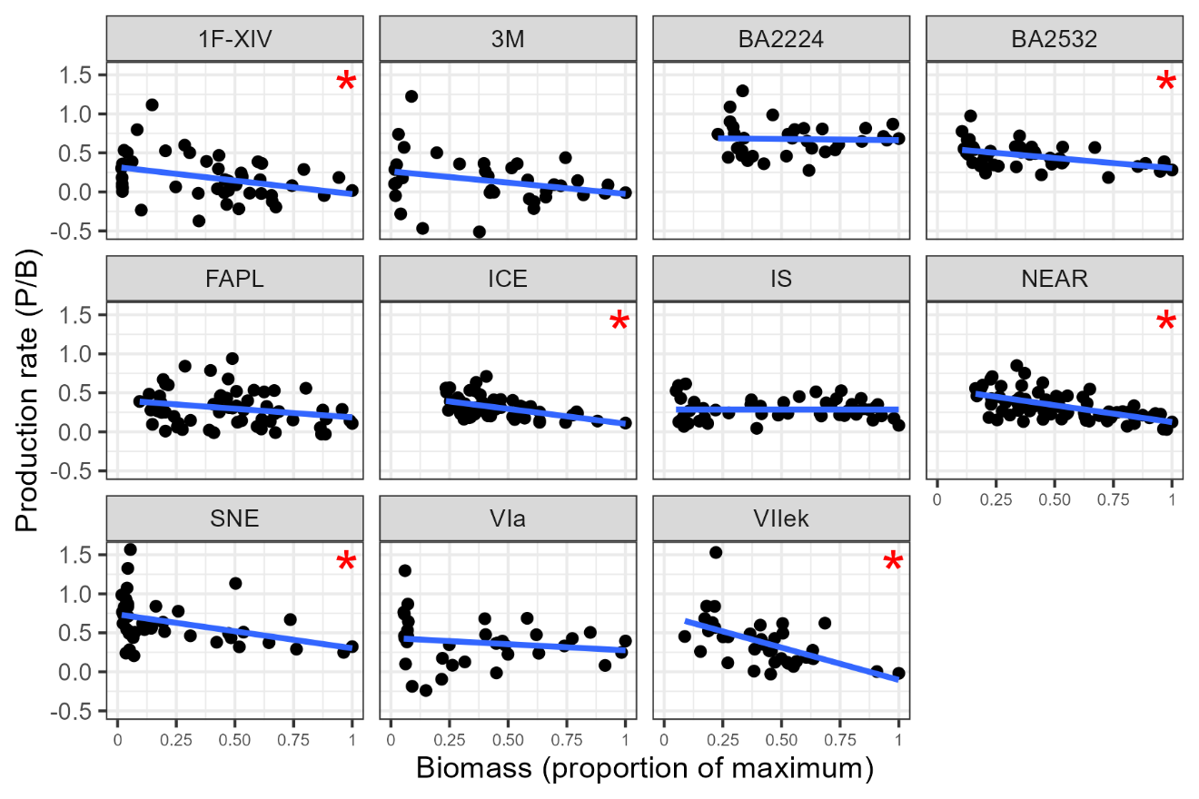
Figure 5: Compensation stocks; Atlantic cod stocks production rate (y axis) in function of biomass (x axis) the blue solid line is a linear regression line over the range of data, showing only stock where a linear regression had a negative slope and lower AIC than a segmented regression model
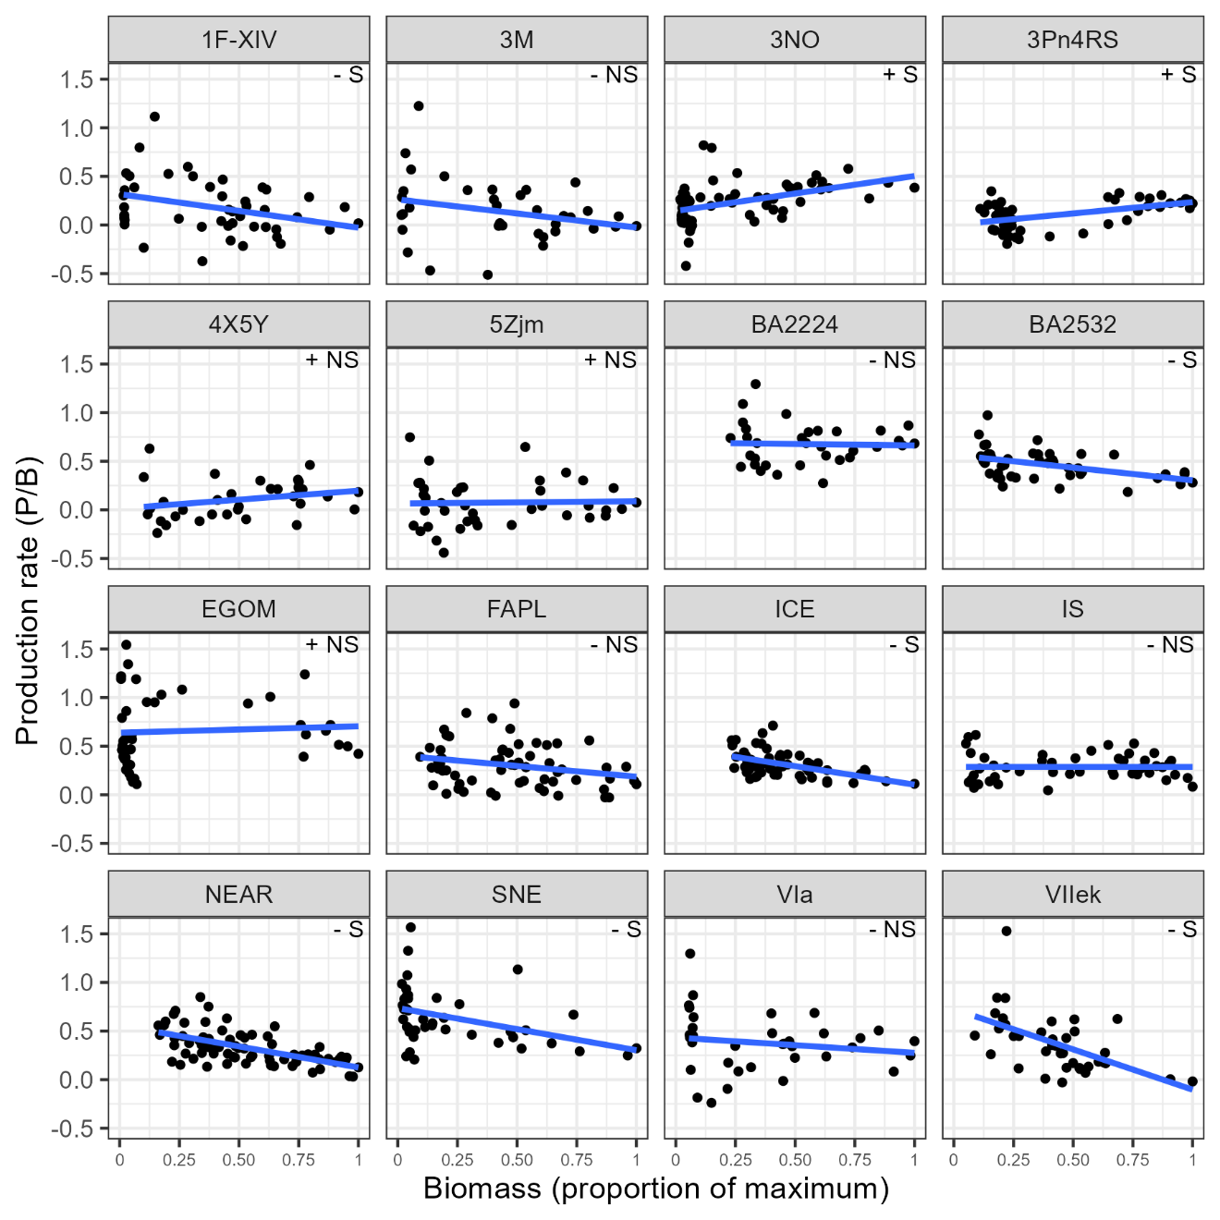
Alternative figure with all lm stocks , compared to the 2 figures above. I am somewhat unsatisfied by both options. Would like to summarize the information a bit more
Table 2: Atlantic cod stock identification label (Stock ID), Allee effect strength (As), production rate at lowest observed biomass, lowest depletion level (fraction of proxy for biomass limit reference point), Allee effect detected, and stock status in terminal year.
Stock ID | Allee effect | Allee effect strength (A_{s}) | Allee threshold/Bmax | Allee effect thrshold/Bmax | Mean production rate at lowest observed biomass (pr_{d}) | Minimum Depletion (relative to B_{max}) | Status
Northwest Atlantic stocks
4TVn | Yes | 1.22 | 0.27 | 0.07 | -0.06 | 0.02 | Depleted
4VSw | Yes | 0.92 | 0.64 |  | 0.04 | 0.06 | Depleted
GB | Yes | 0.92 | 0.62 |  | 0.10 | 0.07 | Depleted
2J3KL | Yes | 0.89 | 0.24 |  | 0.03 | 0.02 | Depleted
WGOM | Yes | 0.80 | 0.32 |  | 0.43 | 0.04 | Depleted
3Ps | Yes | 0.55 | 0.56 |  | 0.25 | 0.11 | Depleted
1IN | Yes | 0.53 | 0.18 |  | 0.29 | 0.03 | Recovered
3Pn4RS | Yes | - |  |  | 0.03 | 0.11 | Depleted
4X5Y | Yes | - |  |  | 0.03 | 0.10 | Depleted
3NO | No | - |  |  | 0.14 | 0.02 | Depleted
5Zjm | No | - |  |  | 0.31 | 0.05 | Depleted
EGOM | No | - |  |  | 1.22 | 0.01 | Depleted
1F-XIV | No | - |  |  | 0.34 | 0.02 | Recovered
3M | No | - |  |  | 0.11 | 0.02 | Recovered
SNE | No | - |  |  | 0.80 | 0.02 | Depleted
Northeast Atlantic stocks
IIIaW-IV-VIId | Yes | 0.57 | 0.63 |  | 0.41 | 0.10 | Depleted
ICE | No | - |  |  | 0.51 | 0.23 | Recovered
BA2224 | No | - |  |  | 0.87 | 0.23 | Depleted
NEAR | No | - |  |  | 0.51 | 0.16 | Recovered
BA2532 | No | - |  |  | 0.69 | 0.10 | Depleted
FAPL | No | - |  |  | 0.33 | 0.09 | Depleted
VIIek | No | - |  |  | 0.73 | 0.09 | Depleted
VIa | No | - |  |  | 0.74 | 0.05 | Depleted
IS | No | - |  |  | 0.53 | 0.05 | Depleted

Discussion
Main findings
Demographic Allee effects were detected in 10 of the 24 Atlantic cod stocks analyzed, with a strong geographic pattern: nine occurred in the Northwest Atlantic, and only one in the Northeast Atlantic. Eight stocks exhibited depensation below a breakpoint in the production versus biomass relationship, while 2 stocks showed consistent depensation across the full biomass range (i.e., the Allee effect threshold was greater than the maximum observed biomass in the time series). By using relative surplus production as a proxy for the per capita population growth rate, this study provides a quantitative and comparable measure of Allee effect strength across stocks. Lastly, stocks that recovered generally maintained positive production at low biomass and showed weak or no depensation, indicating that recovery potential is jointly influenced by depletion severity, low-biomass production, and the strength of depensatory dynamics.
Regional differences
Northwest Atlantic stocks were characterized by biomass depletion to lower levels, lower production at low biomass and high occurrence of depensation when compared to northeast Atlantic stocks. This spatial contrast is consistent with previous findings indicating that reduced recovery potential has largely been confined to Northwest Atlantic cod stocks, whereas stocks in the Eastern Atlantic, particularly those around mainland Europe, generally exhibit higher recovery potential (Keith et al. 2026). These regional differences have been attributed to factors such as fisheries-induced evolution, shifts in life-history traits (e.g., age and size at maturity), the loss of large, old spawners, and environmental conditions in the Western Atlantic (see Keith et al. 2026 and references therein). These findings are consistent with recent evidence of Allee effects in specific Northwest Atlantic cod stocks (e.g., Perälä et al. 2022), further supporting the prevalence of depensatory dynamics in this region.
Add text about Georges Bank/GOM/Scotian Shelf stocks with similar non-significant slopes. – among the shortest time series
Depletion and Recovery
All stocks reached very low relative biomasses, with depletion ranging from 1% and 23% of B_{max} across stocks. Under these levels of depletion, all stocks but two were classified as depleted at one point over time. Despite broadly similar depletion trajectories, recovery outcomes varied substantially among stocks.
Stocks that recovered maintained relatively high production rates at their lowest observed biomass and exhibited weak or no evidence of depensation. For example, ICE and NEAR stocks showed compensatory dynamics across their observed biomass range and retained production rates over 0.5 at low biomass, enabling recovery from being depleted. Recovery was also observed from lower depletion levels for stocks 1F-XIV, 1IN and 3M. 1F-XIV did not show depensation and showed compensatory dynamics, allowing recovery. The 1IN stock recovered from important depletion (0.03) even if displayed an Allee effect. However, this stock displayed the weakest Allee effect of all stocks and maintained relatively high production rates at low biomass, allowing recovery even when depensation occurred.
In contrast, many stocks that failed to recover exhibited strong depensation. These stocks also exhibited very low or negative production at their lowest observed biomass. Stocks such as 3Pn4RS, 4X5Y, 4VSw, 4TVn and 2J3KL showed depensation, with production at low biomass near zero or negative (≤ 0.04). These stocks were also among the most severely depleted, suggesting that depensatory dynamics constrained population growth following depletion to low levels, as suggested by Hutchings (2015).
Stocks with no detectable Allee effect, showed mixed recovery outcomes. Several such stocks (e.g., BA2224, BA2532, VIIek, VIa, 5Zjm, IS, and 3NO) did not recover despite the absence of depensation, likely reflecting low production across their biomass range and weak compensatory dynamics. It also is possible that the time series for these stocks are from highly depleted states, masking a potential breakpoint in the production versus biomass relationships.
Overall, recovery potential appears to be jointly influenced by depletion severity, production at low biomass, and the strength of depensatory dynamics. Stocks experiencing important depletion, Allee effects and near-zero or negative production at low biomass consistently failed to recover. Conversely, recovery was most likely when production remained high at low biomass, even when weak depensation was present.
Production analyses and depensation strength
A key contribution of this study is the use of relative surplus production as a proxy for the per capita population growth rate to evaluate demographic Allee effects and quantify the strength of depensation. Expressing depensation in production units provides a more direct measure of the demographic Allee effect compared to other studies that focus on components of fitness (e.g., stock recruitment relationships). The estimation of depensation parameters in stock recruitment relationships are challenging and often depend on priors to be defined in a Bayesian modeling framework (e.g., Perälä et al. 2022; Barrett and Huynh 2025). In addition, these models assume that recruitment is primarily driven by spawner abundance or biomass, yet many stocks exhibit weak or inconsistent recruitment dependence once environmental variability is considered. Sparse observations at both low and high stock sizes may further limit the ability to estimate the curves steepness or asymptotes, while non-stationary dynamics driven by environmental variability or regime shifts can further undermine inference. Under such conditions, stock recruitment models may introduce structural uncertainty and potentially obscure underlying population processes.
Previous large-scale analyses based on stock recruitment relationships have generally found limited evidence for depensation (e.g., Myers et al. 1995; Liermann and Hilborn 1997; Hilborn et al. 2014), likely reflecting both low statistical power at low abundance and the focus on recruitment (i.e., a component Allee effect) as the sole pathway for density dependence (Hutchings and Rangeley 2011). By contrast, the surplus production approach used here captures depensatory processes acting across multiple vital rates, including growth, maturity and survival, and may therefore provide greater sensitivity for detecting emergent depensation.
Although biomass estimates are derived from stock assessment models and thus inherit model assumptions, the use of relative surplus production provides a direct and semi-empirical characterization of population dynamics. In contrast to fully parametric surplus production models (e.g., Schaefer-type), this approach does not impose a fixed functional form on the production–biomass relationship, reducing the risk that model structure masks depensatory dynamics.
Implications for stock assessment and management
Breakpoints in the production versus biomass relationship, interpreted here as thresholds for depensatory dynamics, provide a biologically grounded indicator of impaired stock productivity. For example, such a breakpoint has been used to identify serious harm in 4TVn Atlantic cod (Turcotte et al. 2026), consistent with theoretical expectations that depensation emerges at low abundance and can constrain recovery (Courchamp et al. 1999; Hutchings 2014, 2015). These thresholds therefore offer a practical basis for defining biologically meaningful limit reference points.

The identification of such thresholds likely depends on how the relationship between production and biomass is modeled. Although the breakpoint was estimated here using segmented linear regression, the theoretical form of the relationship between per capita population growth and abundance in the presence of depensation is non-linear (e.g., Figure 1 of Hutchings 2015). The use of a segmented regression is a simplified assumption, but serves the purpose here of identifying the Allee effect threshold while also facilitating comparison with the linear relationship expected under purely compensatory dynamics.

Despite this simplification, the resulting thresholds may still have important management applications. Incorporating these thresholds into reference point setting could improve the alignment between assessment outputs and management objectives by explicitly accounting for depensatory dynamics (Hutchings 2014). In particular, LRPs set above estimated breakpoints would reduce the risk of entering states where productivity is impaired and recovery potential is limited, thereby supporting more precautionary and biologically informed management (Hutchings 2015).

Acknowledgements
The authors thank Carly Weber for gathering data from reports.
References
Akaike, H. 1974. A new look at the statistical model identification. IEEE Trans. Autom. Control. 19, 716–723.
Albertsen, C. M., Perälä, T., Cardinale, M., Winker, H., and Trijoulet, V. 2025. Rebuilding and reference points under compensatory and depensatory recruitment: a meta-analysis of Northeast Atlantic fish stocks. Fish and Fisheries, 26(1), 171–192. https://doi.org/10.1111/faf.12872
Allee, W.H. 1931. Animal Aggregations, A Study in General Sociology; University Chicago Press: Chicago, IL, USA.
Andrushchenko, I., Clark, D., Irvine, F., MacEachern, E., Martin, R. and Wang, Y. 2022. 2018 4X5Y Atlantic Cod Framework Data Inputs. DFO Can. Sci. Advis. Sec. Res. Doc. 2022/006.v + 86 p.
Courchamp, F., Clutton-Brock, T., and Grenfell, B. 1999. Inverse density dependence and the Allee effect. Trends Ecol. Evol. 14: 405–410
DFO. 2009. A fishery decision-making framework incorporating the precautionary approach. Last updated 2009-03-23.
DFO. 2019. Stock Assessment of Atlantic Cod (Gadus morhua) in NAFO Divisions 4X5Y. DFO Can. Sci. Advis. Sec. Sci. Advis. Rep. 2019/015.
DFO. 2023. Science advice on guidance for limit reference points under the fish stocks provisions. DFO Can. Sci. Advis. Sec. Sci. Advis. Rep. 2023/009.
Fasola, S., Muggeo, V.M., and Kuchenhoff, H. 2018. A heuristic, iterative algorithm for change-point detection in abrupt change models. Computational Statistics, 33(2), 997-1015.
Hilborn, R., Hively, D.J., Jensen, O.P., and Branch, T.A. 2014. The dynamics of fish populations at low abundance and prospects for rebuilding and recovery, ICES Journal of Marine Science; 71,8, 2141-2151, https://doi.org/10.1093/icesjms/fsu035
Hutchings, J.A., and Rangeley, R.W. 2011. Correlates of recovery for Canadian Atlantic cod (Gadus morhua). Canadian Journal of Zoology, 89(5), 386–400. https://doi.org/10.1139/Z11-022
Hutchings, J.A. 2014. Renaissance of a caveat: Allee effects in marine fish. ICES Journal of Marine Science, 71(8), 2152–2157. https://doi.org/10.1093/icesjms/fst179
Hutchings, J.A. 2015. Thresholds for impaired species recovery. Proc. R. Soc. B Biol. Sci. 282(1809). doi:10.1098/rspb.2015.0654.
Keith, D.M., and Hutchings, J.A. 2012. Population dynamics of marine fishes at low abundance. Can. J. Fish. Aquat. Sci. 69(7): 1150–1163. doi:10.1139/F2012-055.
Keith, D.M., Bowlby, H.D., Albouy, C., Auber, A., Baribeau, D.M., Boyce, D.G., et al. 2026 Demographics and recovery potential of exploited marine teleosts. PLoS One 21(1): e0340369. https://doi.org/10.1371/journal. pone.0340369
Kuparinen, A., Keith, D.M., and Hutchings, J A. 2014. Allee effect and the uncertainty of population recovery. Conservation Biology, 28(3), 790–798. https://doi.org/10.1111/cobi.12216
Liermann, M., and Hilborn, R. 1997. Depensation in fish stocks: a hierarchic Bayesian meta-analysis. Can. J. Fish. Aquat. Sci. 54(9):1976–1984. doi:10.1139/cjfas-54-9-1976.
Minto, C., Myers, R. A., and Blanchard, W. 2008. Survival variability and population density infish populations. Nature, 452: 344–347
Mohn, R.K., and Rowe, S. 2012. Recovery Potential Assessment for the Laurentian South Designatable Unit of Atlantic Cod (Gadus morhua): The Eastern Scotian Shelf Cod Stock (NAFO Div. 4VsW). DFO Can. Sci. Advis. Sec. Res. Doc. 2011/138: viii + 71p.
Myers, R.A., Barrowman, N.J., Hutchings, J.A., and Rosenberg, A.A. 1995. Population dynamics of exploited fish stocks at low population levels. Science, 269(5227): 1106–1108. doi:10.1126/science.269.5227.1106.
Nicholson, A. 1933. The balance of animal populations. J. Anim. Ecol. 2: 131–178
Neubauer, P., Jensen, O. P., Hutchings, J. A., and Baum, J. K. 2013. Resilience and recovery of overexploited marine populations. Science, 340: 347–349.
Neuenhoff, R.D., Swain, D.P., Cox, S.P., McAllister, M.K., Trites, A.W., Walters, C.J., and Hammill, M.O. 2019. Continued decline of a collapsed population of Atlantic Cod. Can. J.Fish. Aquat. Sci. 76: 168–184
Ouellette-Plante, J., Benoît, H.P., and Lussier, J.-F. 2025. The Status of the Northern Gulf of St. Lawrence (3Pn, 4RS) Atlantic Cod (Gadus morhua) Stock in 2022. DFO Can. Sci. Advis. Sec. Res. Doc. 2025/039. xx + 244 p.
Perälä, T, Hutchings, J.A., and Kuparinen, A. 2022. Allee effects and the Allee-effect zone in northwest Atlantic cod. Biol. Lett. 18(2): 20210439. doi:10.1098/rsbl.2021.0439
R Core Team. 2021. R: A language and environment for statistical computing. R Foundation for Statistical Computing, Vienna, Austria. URL https://www.R-project.org/.
Ricard, D., Minto, C., Jensen, O.P. and Baum, J.K. (2012) Evaluating the knowledge base and status of commercially exploited marine species with the RAM Legacy Stock Assessment Database. Fish and Fisheries 13 (4) 380-398. DOI: 10.1111/j.1467-2979.2011.00435.x
Schijns, R., Froese, R., Hutchings, J.A., and Pauly, D. 2021. Five centuries of cod catches in Eastern Canada. ICES J. Mar. Sci. 78(8): 2675–2683. Oxford University Press. doi:10.1093/icesjms/fsab153.
Shelton, P.A., and Rice, J.C. 2002. Limits to overfishing: reference points in the context of the Canadian perspective on the precautionary approach. DFO Can. Sci. Advis. Sec. Res. Doc. 2002/084. 29p.
Turcotte, F., McDermid, J.L., and Ricard, D. 2024. Scientific requirement for the rebuilding plan of southern Gulf of St. Lawrence (NAFO Division 4TVn) Atlantic Cod (Gadus morhua). DFO Can. Sci. Advis. Sec. Res. Doc. 2024/053(July): iv + xx.
Turcotte, F., McDermid, J L., Ricard, D., and Swain, D.P. 2026. Defining a biomass limit reference point under time-varying productivity: a case study of Atlantic cod in the southern Gulf of St. Lawrence, Canada. Canadian Journal of Fisheries and Aquatic Sciences, 83, 1–12. https://doi.org/10.1139/cjfas-2025-0147
Varkey, D., Wheeland, L.J., Regular, P., Rideout, R., Kumar, R., Rogers, B., and Vigneau, J. 2025. Analytical Assessment for the Status of Atlantic Cod (Gadus morhua) Stock in NAFO Subdivision 3Ps in 2021. DFO Can. Sci. Advis. Sec. Res. Doc. 2025/043. iv + 48 p.
Walters, C.J., Hilborn, R., and Christensen, V. 2008. Surplus production dynamics in declining and recovering fish populations. Canadian Journal of Fisheries and Aquatic Sciences, 65(11), 2536–2551. https://doi.org/10.1139/F08-170
Winter, A.M., Vasilyeva, N., and Vladimirov, A. 2023. Spawner weight and ocean temperature drive Allee effect dynamics in Atlantic cod, Gadus morhua: inherent and emergent density regulation. Biogeosciences 20(17): 3683–3716. doi:10.5194/bg-20-3683-2023.

