
Main Manuscript for

WHEN IDEOLOGY CLOUDS JUDGEMENT.
The Anchoring Effect Of Ideology On Opinion Change

Patricio Nogueroles^{1#}, Tomas Alves Salgueiro^{1,2#}, Esperanza Emilia Celestino Battagliero^{1,3}, Danai Broggi^{1,3}, Maria Ayelén Caramés¹, Carlos Luddwing Muñoz^{1,3}, Stefan Efraín Vera^{1,3}, Silvina Brussino^{4,5}, Pablo Nicolas Fernandez Larrosa^{1,2,6*}
# These authors contributed equally to this work

Affiliation:
¹ Instituto de Fisiología, Biología Molecular y Neurociencias (IFIBYNE), CONICET-UBA, Buenos Aires, Argentina.
² Consejo Nacional de Investigaciones Científicas y Técnicas (CONICET), Buenos Aires, Argentina.
³ Facultad de Psicología, Universidad de Buenos Aires (UBA), Buenos Aires, Argentina.
⁴ Instituto de Investigaciones Psicológicas [CONICET-UNC]
⁵ Facultad de Psicología, Universidad Nacional de Córdoba, Argentina.
⁶ Facultad de Ciencias Exactas y Naturales, Universidad de Buenos Aires (UBA), Buenos Aires, Argentina.

*corresponding author name:
Pablo Nicolas Fernández Larrosa
CONICET Researcher
in Memory Modulation Neurobiology Lab Consciousness Lab coordinator IFIByNE (UBA-CONICET) - Office 352
Ciudad Universitaria -CABA (1428).
phones: (+54-11) 4576-3368/3386/3428 (int 336)
Integrative Neurophisiology assistant professor Physiology, Molecular and Cellular Biology Department, Faculty of Exact and Natural Sciences
Buenos Aires University ,
Ciudad Universitaria - CABA, Argentina
Email: fernandezlarrosa@fbmc.fcen.uba.ar

Author Contributions: PNFL and SEV developed the experimental design. CLM developed the code for the experiment to be uploaded to Neuron.AR so that it can be carried out online. PN processed the datasets for the posterior analysis. PN and TAS performed the exploratory analysis and the statistical models. MAC performed the gender and age analysis. TAS performed the Sankey’s figures, MAC the gender and age figures and SEV the other figures. EECB and DB were responsible for organising all the data and creating all the model results tables. SB collaborated on the reduced version of the PI operational scales and contributed the theoretical framework to the discussions in the paper. PNFL wrote the manuscript. All authors participated in reaching the final version of the manuscript.

Competing Interest Statement: The authors declare no competing interests.
Classification: SOCIAL SCIENCES; Political Sciences & Psychological and Cognitive Sciences
Keywords: Politic Ideology; Anchoring Bias; Opinion Change; Polarization; Gender; Decision-making

This PDF file includes:
Abstract
Significance Statement Main Text
Figures 1 to 5

ABSTRACT
Political ideology shapes how individuals evaluate information, acting both as a heuristic and as an intersubjective framework that anchors beliefs. We tested whether ideological orientation influences opinion change when political statements are associated with candidates of opposing or congruent ideologies. We hypothesized that more ideologically polarized populations would show greater opinion shifts consistent with their beliefs, while centrist populations would be less influenced.
Using an ecological experimental design during the 2023 Argentine Elections, we characterized six voter populations (left-wing, progressive, centre, moderate and libertarian right-wing) based on self-perception scales, policy preferences, and candidate proximity. Participants rated statements with and without candidate associations, allowing calculation of Opinion Change Indices (OCI) under congruent and incongruent conditions. Robust regression analyses assessed how ideology, socio- demographic variables, and media exposure influenced opinion change.
Results indicate that opinion shifts are strongly modulated by ideological alignment: progressive populations changed opinions more on progressive items, right-wing populations more on conservative items, and centrist populations showed minimal shifts. Congruent associations led to faster, more automatic agreement, while incongruent associations slowed responses and reduced agreement. Socio-demographic factors and social media influence further shaped ideological expression, particularly among libertarian right-wing participants.
These findings suggest that political ideology functions as an implicit anchor, biasing judgment of politically relevant information and facilitating rapid, heuristic-based decisions. Importantly, broader electoral competition did not increase radicalization of opinion among extremes. Promoting critical and reflective thinking may enhance individual autonomy in political decision-making while preserving opinion diversity, strengthening democratic deliberation.

SIGNIFICANCE STATEMENT
Most research on political ideology and decision-making has focused on populations in the US or Europe, limiting its global generalizability. We conducted two ecological experiments during the 2023 Argentine presidential elections, combining three symbolic scales—including a Peronist & Anti-Peronist measure—and two operational scales to capture culturally specific decision-making processes. Opinion change was measured as the shift in ratings of politicized items associated with right- or left-wing candidates, or presented neutrally. We hypothesized that more ideologically polarized populations would show greater opinion change aligned with their political identity. Our findings suggest that political ideology not only structures beliefs but can also act as an implicit cognitive anchor, shaping the evaluation of information and influencing political decisions.

INTRODUCTION
What affects the judgement of information relevant to complex decision-making? While decision making can be understood as the process of selecting an option from a set of alternatives based on its likelihood of leading to the best possible outcome, not all decisions involve the same cognitive complexity. Here we will focus on those that can be conceptualised as complex decisions, such as political ones (1, 2). They were traditionally addressed separately in economic or moral decisions, by the theoretical corpus of Game Theory (3, 4). This original approach assumed that decision-makers are rational and prefer the choice that offers the highest expected utility. These assumptions were first broken down by Kahneman, whose perspective allows us to think of decisions as processes whose potential outcomes can be perceived as positive (gain) or negative (loss), depending on internal references that may be affected by various factors, such as social norms, expectations or level of aspiration, beliefs, which may or may not be realistic (5, 6). This has opened a new chapter in the study of decisions: their biases and heuristics. It is now firmly accepted that decision makers are affected by implicit processes such as cognitive biases (7–11), emotions (12, 13), self-deception (14–
16), priming (1, 17) and aspects of social behaviour (18) during such processes.
Cognitive biases are well-documented processes. Confirmation bias is the cognitive tendency to weigh positively information that confirms one's own beliefs or hypotheses, underestimating other alternatives (6, 8). “Individuals who hold strong positions are less susceptible to new information, more likely to argue against information contrary to their positions, and to recognise information more consistent with their prior beliefs” (9, 10). The other bias that deserves attention is Anchoring bias (6, 19). This bias has been conceptualised as the disproportionate influence on decision makers to make judgments that are biased toward an initially presented value (6). Most studies in this area use estimation paradigms based on general knowledge or factual questions; however, when studied in real-world judgement and decision-making tasks, the anchoring effect proved to be very robust (19). The processes underlying anchoring bias can be varied and are still open to debate (19). On the one hand, the anchoring-and- adjustment heuristic hypothesis proposes that the anchoring effect is caused by insufficient adjustment, as initial values are assimilated as more (6). On the other hand, the selective accessibility model (20) proposes that the anchor activates selective information relevant to the anchor.
These cognitive processes could be the underlying bases (among others) for understanding the development of strong (political) positions, due to identification with or belonging to a specific political or ideological space, and which give rise to political polarization (21–25). But what does this ideological identification imply? Political ideology (PI) has been conceptualized by different theoretical frameworks in dispute. Firstly, it can be understood as a socially shared system of beliefs about the socio- political order that operates as a heuristic or cognitive shortcut (6, 26). Heuristics are characterised as an ‘intuitive, rapid, and automatic system’ (27), which ‘reduce the complex tasks of assessing probabilities and predicting values to simpler judgmental operations’ (6). This perspective is framed within the theories of Dual Processes (DPTs),

which propose two different types of processes involved in reasoning and decision making: system 1 is characterized as fast and automatic, implicit processing and whose response does not involve conscious access; whereas system 2 involves explicit, deliberative, flexible, slow processing that is always accompanied by awareness (28–30).
Secondly, PI was also interpreted as a dimension of personality and originally addressed to understand fascist ideology and authoritarianism (31, 32). Updating Adorno's “authoritarian personality” theory, some authors propose that right-wing ideology is a manifestation of intellectual traits (such as dogmatism, aversion to complexity and a craving for certainty or “closure” in argumentation) that has repercussions in defining a cognitive style. In this sense, it is proposed that this cognitive style implies a reflexive closed-mindedness towards empirical evidence hostile to ideologically conservative beliefs, values or political preferences (33). The Dual-Process Motivational model of ideological attitudes proposes two cognitive dimensions (right-wing authoritarianism and social dominance orientation) to analyse right-wing/conservative thinking and behaviour (34). On the other hand, some of the DPT´s literature suggests that progressives and conservatives may differ in dominance or confidence when outputting which system, 1 or 2, to make a decision (35).
Lastly, it is important to recognize the intersubjective dimension of PI: political groups implicitly use it as a social reference to communicate their political positions and orientations (26). As symbolic map, its coordinates may vary among the different political subjects, but there are common aspects, which can be grouped by moral, religious, economic, political agreements.
Although the literature on heuristics proposes cognitive processes that can potentially modulate how information relevant to political decisions is monitored (6), there are few studies that evaluate this empirically in the context of such decisions (36–40). Although these processes may be generalisable, much of this literature has been carried out with populations from the USA or Europe, evidencing a clear bias in the literature, leaving aside the cognitive context in peripheral countries. On the other hand, much of this literature is mainly based on the theoretical framework of Motivated reasoning, proposing that people evaluate information in a biased manner to explicitly defend prior beliefs. Here we propose that the belief systems underlying different patterns of political ideology are memories that, when activated, can implicitly modulate the monitoring of information relevant to political decisions. To evaluate this process, two ecological experiments were performed during the Argentine presidential elections of 2023. Opinion change was assessed here as the change in rating of items with politicised content, depending on whether it is associated with a right-wing or left-wing candidate or with no association at all. Our working hypothesis is that more ideologically polarised populations will be associated with greater opinion change, in a direction consistent with the ideological identification of the populations. In this sense, we propose that political ideology, besides the previously conceptualisations, could have an anchoring effect on information monitoring and, thus, could influence political decision making.

MATERIALS AND METHODS

Participants
The experiments were conducted in the two periods of the electoral process: 1. Previous to General election (1st at 22, October 2023); 2. Previous to Ballotage (1st at 19 November 2023). The former was completed by 2839 participants (76 were excluded from the analysis, leaving 2197 women, 516 men and 50 other genders; mean age: 38.01
± 10.13; age range: 16-82), and the latter by 1294 participants (45 were excluded from the analysis, leaving 959 women, 267 men and 23 other genders; mean age: 40.81 ±
8.39; age range: 16-76), all residents of Argentina (Supplementary Table 1). All participants gave their informed consent to participates and publish the results.

Ethical approval
The study and all methods were carried out in accordance with the relevant guidelines and regulations, previously approved by the ethics committee of the Clinic Hospital “José de San Martín”, of the University of Buenos Aires. The study complies with the principles of the Declaration of Helsinki. All participants gave informed consent to participate in the experiments; also informed consent was obtained from all subjects for publication of identifying images or information in an online open-access publication. The participation was completely anonymous.

Experimental design
This experiment aims to evaluate the role of the participants' Political Ideology (PI) in the valuation of semantic items with social and political content, and their change of rating when these items are associated with candidates associated to opposing ideology. For this purpose, two equivalent experiments were carried out during the 2023 Argentinean presidential elections period. The first one before the general elections (Experiment#1; with 5 lists/candidates competing); the second one before the ballotage (Experiment#2; with only 2 lists/candidates). Both experiments were programmed in JavaScript and conducted on our digital platform Neuron.AR (1, 17). Each experiment consisted of a total of seven (7) phases (Figure 1A), which could be completed in an average of approximately 20 minutes. After the experiment information and consent for participation and data publication (as required by the ethics committee), the first phase consisted of personal characterisation of the participants (age, gender, education, social status, residence, etc.). The second phase consisted of the political characterisation of the participants. The first questions refer to their vote in the presidential elections of 2019 and in the PASO of 2023. Then, the participants' Political Ideology (PI) is evaluated symbolically (26) using three 10-point Likert scales according to how Left-wing&Right-wing, Conservative&Progressive, Peronist&anti-Peronist they perceive themselves to be. These three symbolic measurements were included in order to add ecological validity to the experiment and, above all, to distinguish between basic/universal and cultural decision-making processes. Then, they were asked how political close they felt to each of the candidates, assessed on a 5-point Likert scale. The thirst phase consisted of characterising the emotionality of the participants during the electoral process. For this purpose, a locally adapted (and shortened) version of the Emotional Climate

instrument by Paez et al (41) was used. The objective is to control for the impact of emotionality on our variables of interest in the analysis.
In the fourth phase, the image of each candidate is presented and the participants had to rate them according to the symbolic PI scales (left-right and conservative- progressive). This phase is central to generating an individual basis for each participant for candidates they consider left- or right-wing. Since the assessment is symbolic, what is meant by each of these categories may vary between subjects; on the other hand, leaving the association between these categories and individual candidates fixed would reproduce researcher bias. This information will be used in phase 6.
In the fifth phase, participants' PI will be assessed operationally. For this purpose, an adapted Progressivism and Conservatism Scales, previously published with the Argentinean population by Brussino et al (42), was used. Both scales consist of a series of conservative or progressive items that must be rated on a 5-point Likert scale according to the degree of agreement with each statement (Supplementary Table 2). These scales allow us to profile the operational dimension of the subjects' PI, while at the same time showing us the assessment of each item without association with any candidate.
The sixth phase is the experimental phase. In this, the experimental algorithm will randomly select (for each subject) 10 of the previously presented items (from the operational PI instrument), and will present them twice more: the first time associated with the image of a candidate previously assessed as being on the right or on the left extreme. The item will be accompanied on this occasion by the candidate's image and the text ‘Candidate X states:’ plus the item. The second exposure will be the same but associated with a candidate rated at the opposite end of the Left-wing&Right-wing scale from the first. The selection of the items, the order of appearance and the associated candidates will be randomised for each subject (the only condition being that the second candidate has been rated opposite to the first in phase 4). At each occurrence of an item, participants will be asked to rate again how strongly they agree or disagree.
The last phase (7) consists of a final questionnaire to assess the status of the subjects during the experiment and exclusion criteria. All the instruments used (and their adaptations) in this work are shown in detail in supplementary material.

Data Processing
Variables‘processing: From the PASO_vote variable, the levels referring to equivalent political forces/candidates were collapsed to create the PASO_vote_category variable, with the following levels: 1. Left-wing; 2. Progressivism; 3. Centre; 4. Moderate right- wing; and 5. Libertarian right-wing. Only in the case of Moderate Right-wing, the voter populations for each candidate competing in the PASO within the same political force were analysed separately Only in the case of the moderate right were the voters for each candidate competing in the PASO within the same political party analysed separately, as both populations, in a preliminary exploratory analysis, showed differences in the indicators assessed: the moderate right (a) and the moderate right (b) (see supplementary material; Supplementary Table 3).

Indexes´ creation: From the robust data, several indices were calculated to perform the analysis of results:
Positivity index: to assess whether emotionality during elections could be an impact variable in our study, the positivity index was calculated using an adapted and shortened version of the Paez test (41) (See Supplementary material). Values higher than 17.5 correspond to higher positivity; lower values correspond to higher negativity.
Progressivism and Conservatism Indexes: They were obtained using a shortened version of the previously published scales (42). For both scales, 10 different items were presented, with either progressive or conservative content, and subjects were asked to rank their agreement or disagreement on a 5-point Likert scale (Supplementary Table 2). The index was calculated as the average of the responses. To aid in the visualisation of the results, the values of each item were inverted, so that a higher index value corresponds to a higher level of conservatism or progressivism.
In addition to the responses for each item, response time was measured to calculate the mean and median response time associated with progressive or conservative indices.
Opinion Change Indexes (OCI): to assess whether association with a candidate changes the degree of agreement or disagreement that subjects have regarding progressive or conservative items, the Opinion Change Index was calculated by each item as:

OCIitem(i;c) = 𝐼𝑡𝑒𝑚(𝑖) − 𝐼𝑡𝑒𝑚(𝑖; 𝑐)
“i” refers to the item i within the conservative or progressive scale.
“c” refers to the ideological condition of the candidate associated with the item, whether right-wing or left-wing. Therefore, “c” can be “r” if it is associated with the right-wing candidate, or “l” if it is associated with the left-wing candidate.

In order to explore deeply the general conditions for opinion change, different Opinion Change Indexes were calculated (See Supplementary Material). Besides, the difference in response time was calculated when items were associated with a candidate.

Statistical Analysis
All statistical analyses were performed with RStudio (R language) and VisualStudio (Python language).
Post hoc power analyses (α = .05) indicated power ≈ 1.00 to detect small (d = 0.20), medium (d = 0.50), and large (d = 0.80) effects in both samples. Sensitivity analyses showed that very small effects were detectable (General Election: d ≈ 0.05–0.07; Ballotage: d ≈ 0.08–0.10 for 80%–95% power), suggesting that non-significant results are unlikely due to insufficient power (43, 44).
Statistical models. To assess which independent variables are significant (and with what impact) in explaining PI variables, Generalised Linear Models (GLM) were run with a Gaussian distribution. Each model was first explored with all the variables of interest, and finally we were left with only the significant variables to build the final models. For Closeness to candidates, Binary Models (BM) were used. Finally, Robust Regression

Models (RRM) were used to assess changes in opinion. There was no evidence that the assumptions were not met in any case.
Post-hoc comparison: To evaluate the significant differences in the variables of interest between the different populations, segregated by the variable PASO_vote_category, a Kruskal-Wallis and post-hoc Dunn Test was performed. To compare the OCI and response time changes for individual items, Dunn's test was used.

Clustering Analysis
To identify distinct patterns of political attitudes among participants, we performed a cluster analysis based on the subjects' responses to the conservative and progressive items. This analysis was conducted separately for each group of items to explore how individuals aggregated according to their ideological leanings in both the General and Ballotage elections. We use agglomerative hierarchical clustering, a bottom-up approach that is also deterministic. The optimal number of clusters for both group of items was determined using the Elbow Method. For a more detailed description of the methodology, see Supplementary Material.

Availability of data and materials.
The surveys, scripts and datasets generated and/or analysed during the current study are available in the OSF repository, https://osf.io/ygdxt/.

Acknowledgments.
This research project, like others, has only been possible thanks to a network of support from fellow researchers, among whom we would like to especially acknowledge Dr. Eliana Ruetti (IFIBYNE, UBA-CONICET), Alejandro Delorenzi (IFIBYNE, UBA-CONICET) and Matías Blaustein (IB3, Facultad de Ciencias Exactas y Naturales, UBA). We would also like to thank Axel Casas and Giulietta Lucente for their initial contribution to the project; Axel Brzostowski for the development of the Neuron.AR platform, and María José García Uriburu for the help in the management of the online social networks to widen the diffusion of the experiments. The passionate and disinterested contribution of each of the co-authors and collaborators has been fundamental to carry out this work, in a critical moment for local science, with an anti-science national government, which spreads fake news, and whose policy involves the destruction of state science and public education.

RESULTS
In this paper we will assess whether or not the political ideology of the subjects favours the change in the rating of items when they are associated with candidates. We propose to evaluate this by means of an original experimental design, allowing us to reach general conclusions. However, as this is an ecological experiment that takes advantage of the instance of the 2023 Argentine presidential General Elections (GE) and Ballotage (BE), the background of elections is presented in Supplementary Material. The main political forces competing were representatives of Progressivism and the Libertarian Right-wing; thought in the general elections, the Left-wing, representatives of the Moderate Right-wing, and the Centre also competed (Figure 1B). Only the formers went

on to the ballotage (Figure 1C). Figure 1D shows the flow of alliances between different forces since the 2019 elections and the 2023 elections, consistent with those previously published (45). Figures 1E-F show the ideological political perception of the participants in the experiments on the different political forces, which allowed for the classification of politically and ideologically distinct populations.

Who votes for whom? Characterisation of populations
In order to understand how the ideological representations of each population might impact on opinions about particular policy statements, the next step in our analysis involved characterising each of the six populations politically and ideologically: 1. Left- wing; 2. Progressivism; 3. Centre; 4. Moderate right-wing (a); 5. Moderate right-wing (b); and 6. Libertarian right-wing.
Each dependent variable of interest involved a different model. To simplify the reporting of the results, results of coefficients, AIC, BIC and p-value for each model constructed from significant independent variables only are presented in Supplementary Table 4, and those significant independent variables with their coefficients and p-value in Supplementary Table 5-9. Hereafter, we will present the most interpretable results and post-hoc differences of interest in this paper. The results shown here correspond mainly to those of the General Elections and are comparable to those of the Ballotage (Supplementary Figure 1).
Each population showed a symbolic ideological left-wing to right-wing self-perception consistent with the original segregation criteria in these populations (Fig. 2Ai). The GLM model to explain this PI indicator for GE population [Deviance explained: 0.56; F-value:
222.36; AIC: 9656.32; BIC: -16806.75; p-value of the overall model: 1.11e-16] shows that some political variables (vote 2019, PASO_2023_category), as well as some written Media are significant independent variables (Supplementary Table 5). The Conservative&Progressive self-perception scale was also consistent but showed less discriminatory capacity (Fig. 2Aii), which could reflect that part of the population represented as Libertarian Right-wing does not perceive itself as entirely conservative. The GLM model to explain the Conservative&Progressive scale [Deviance explained: 0.26; F-value: 64.03; AIC: 11700.04; BIC: -11223.47; p-value of the overall model: 1.11e- 16] shows also age, some argentinean regions, written Media and an online social network (facebook) as significant variables (Supplementary Table 6). The Peronism&anti-Peronism symbolic scale clearly showed two poles: one very anti- peronist (Moderate and Libertarian right-wing) and the other peronist (Progressivism). Interestingly, both the Left-wing and the Centre populations have a wide distribution with a neutral mean (Fig. 2Aiii). This GLM model [Deviance explained: 0.56; F-value:
198.55; AIC: 11475.17; BIC: -12054.54; p-value of the overall model: 1.11e-16] shows some political variables (vote 2019, PASO_2023_category), some written Media and some online social network as significant variables (Supplementary Table 7).
When the populations were analysed using the progressivism and conservatism scales, the results were also consistent (Fig.2Bi; Bii). Given that both scales are constructed based on the response of independent items -despite belonging to the same instrument

(42)-, the degree of redundancy of both scales was assessed by correlation. A significant correlation coefficient of -0.66 was observed, indicating that both scales are consistent with each other, but not completely redundant (Fig.2C). The GLM model for progressivism [Deviance explained: 0.70; F-value: 383.06; AIC: 2906.61; BIC:-21499.70; p-value: 1.11e-16] shows PASO_2023_category and written Media as significant variables, while the conservativism index model [Deviance explained: 0.64; F-value:
219.96; AIC: 1212.22; BIC: -21823.78; p-value: 1.11e-16] also shows gender (male), e- social variables, and political variables (vote 2019, PASO_2023_category, Peronist&Anti- Peronist self-perception, conservative cluster) as significant variables (Supplementary Table 8-9).
Since the indices of conservatism and progressivism are calculated on the basis of responses to several items (Supplementary Table 2), the indices themselves do not allow us to discriminate between different conservative or progressive profiles. To explore whether different profiles existed, a clustering analysis was performed on the basis of each subject's responses for either the conservative or the progressive items. We observed 5 different clusters for the conservative dimension, and 6 for the progressive dimension. However, taking into account the number of subjects in each cluster, only 2 conservative and 3 progressive clusters were taken into account for the analysis (Fig.2D), the remaining ones being assumed to be noisy clusters. Conservative cluster 1 seems to be composed of the most conservative population: opposing women's and children's rights (items 3, 8 and 19), indigenous and immigrants’ rights (item 16 and 23), state participation in the economy (items 6, 9, 27 and 29), and health and responsible consumption policies (item 11); and in favour of increased restrictions on social protests (item 24) and even in favour of a military government (item 7). Progressive clusters (cluster 0 being less progressive and cluster 2 more progressive) are mainly discriminated according to degrees of agreement with state involvement in the economy (items 6, 9, 20, 27 and 29), indigenous and immigrants’ rights (item 16 and 23), with health and responsible consumption policies (item 11), and with social mobilisations (item 24). All this analysis suggests that there could be at least 4 qualitatively different profiles when analysing both scales (Fig.2Diii).
When assessing closeness to each candidate for each of the populations analysed, the results were also consistent with expectations and conservativism index (Fig.2E-F). The binary models constructed for closeness to each candidate (Supplementary Table 10) show different significant independent variables (and with different odds ratios), which reinforces the decision to analyse the populations separately. In general, as expected, different political variables end up explaining the variance of closeness to different candidates (Supplementary Table 11). In the case of the model for closeness to Massa, the positivity index was also significant. In fact, when comparing the means of the positivity index for each population, values below 17.5 were observed in all cases, demonstrating that a negative electoral climate prevailed. However, the progressive population showed less negativity than the other populations (Supplementary Figure 1D).

Further analysis was carried out to characterise these populations in terms of socio- economic variables. The results of General Election (to see results of Ballotage, see Supplementary Figure 2) show that in the Moderate right-wing (b) and Libertarian right- wing populations, men perceived themselves to be more right-wing than women in the same or other populations (Fig. 3Ai). In contrast to the other populations, the Libertarian population showed a lower mean age of men compared to women in the same population and in the other populations (Fig.3D). Although a significant proportion perceived themselves as having a medium to medium-low socio-economic level, similar to the left-wing and progressive population, the libertarian population had a higher proportion of subjects with a maximum level of secondary education (compared to the other populations) (Fig.3E). It is also the population that recognises a greater influence of social networks, especially networks with audiovisual content (Instagram, Facebook, Youtube, Tiktok) but also Whatsapps and Twitter (X) (Supplementary Figure 3). No differences were observed between the populations with respect to written Media influence, although greater consumption of Clarin, La Nacion and Infobae was observed in the right-wing populations, and Pagina12 in the progressive population, consistent with previous results (45).

Voter's political ideology and opinion change
To evaluate the change of rating of items with politicised content, we use the Opinion Change Indices (OCI) and their response time differences. In the first case, we assess the difference between the rating of items with no association to any candidate and when associated with a right-wing or left-wing candidate. Given the nature of the data, robust regression models were used here to assess which independent variables explain the variance of the opinion change indices (Supplementary Tables 12-15).
Robust regression models showed that ideological orientation is a key predictor of opinion change (Supplementary Tables 12-15). In the OCIcon model [Robust scale = 0.32; AIC = 4738.61; BIC=4821.64; p=2.80e-20], the Conservatism Index showed one of the greatest effect [Coefficient=-0.32; p=1.66e-21], indicating a negative and highly significant relationship: the more conservative, the lower the OCIcon score. Similarly, in the model of OCIpro [Robust scale = 0.39; AIC = 5268.98; BIC=5363.88; p=5.02e-28], the Progressivism Index [Coefficient=-0.31; p=1.07e-33] and Conservatism Index [Coefficient=-0.13; p=3.82e-4] had one of the most pronounced impact, showing that higher levels of conservatism are associated with a lower willingness to change on progressive issues. The analyses of Opinion Change disaggregated by association (OCIcon;r; OCIcon;l; OCIpro;r; OCIpro;l) confirmed these relationships with the conservatism and progressivism indices (Supplementary Tables 12-15). Overall, the results confirm that ideological orientations—progressivism and conservatism—exert a substantive and negative influence on the magnitude of opinion change, suggesting that such beliefs may function as cognitive anchors that limit variability in the monitoring of relevant information.

However, the general analysis has certain limitations. When the Opinion Change was analysed by item, differences were observed between items, suggesting that the change of ranting was dependent on the item´s politic content (Fig.4A). For this more comprehensive analysis, robust regression models were performed for items that showed significant differences between populations (Supplementary Table 13 and 15). For progressive items associated with left-wing candidates, the models showed that the Progressiveness Index variable had the greatest impact [item 24: β=-0.13 (p=3.9e-2); item 5: β=-0.33 (p=1.73e-4); item 9: β=-0.20 (p=1.77e-2); item 25: β=-0.37 (p=5.28e-6)],
suggesting that the more progressive the participant, the less change of opinion there is on these items associated with left-wing candidates. For conservative items associated with left-wing candidates, the models showed that the conservatism index variable had the greatest impact [item 8: β=-0.27 (p=1.9e-3); item 10: β=-0.54 (p=1.49e-7)]; this was also the case when the items were associated with right-wing candidates [item 10: β=-
0.67 (p=3.90e-8); item 30: β=-0.67 (p=1.76e-9]. These results suggest that the more conservative the participant, the less likely they are to change their opinion on these items associated with left-wing or right-wing candidates.
To assess the magnitude of the opinion change, the difference between the opinion change associated with left-wing candidates and that associated with right-wing candidates was evaluated. This analysis was performed separately for progressive items (OCIpro) and conservative items (OCIcon). It was observed that left-wing and progressive populations showed a greater magnitude in the OCI for progressive items, while for right-wing populations, the greatest magnitude was seen for the OCI of conservative items (Fig. 4B). These results suggest that ideological extremes show similar patterns of opinion change associated with candidates, but that these patterns depend on the political content of the items.
In order to assess whether the cognitive processes behind these changes of opinion are related to the congruence between the type of item (conservative or progressive) and the type of association (right-wing or left-wing candidate), congruent (OCICON: progressive items associated to left-wing candidates and conservative items associated to right-wing candidates) versus incongruent (OCIINC: progressive items associated to right-wing candidates and conservative items associated to left-wing candidates) changes of opinion were evaluated. In the OCICON model [Robust scale = 0.26; AIC = 4136.70; BIC=4243.49; p=2.77e-20], the Conservatism [Coefficient=-0.24; p=2.17e-16] and progressivism [Coefficient=-0.17; p=1.02e-18] indices showed the greatest effect, indicating a negative and highly significant relationship. In the OCIINC model [Robust scale = 0.24; AIC = 3924.06; BIC=3989.31; p=7.52e-18], also the Conservatism [Coefficient=-0.20; p=1.21e-12] and progressivism [Coefficient=-0.17; p=1.72e-21] indices showed the greatest effect. It should be noted that when the association is congruent, the change of opinion reflects greater agreement, while when the association is incongruent, the change of opinion reflects less agreement (Fig. 4Ci). In the first condition (OCICON), participants take significantly less time to respond than in the second condition (OCIINC) (Fig.4Cii). When these differences were analysed separately for each voter population, similar differences were observed, but not all

populations showed significant differences (Fig. 4D). We examined whether the congruency effect (Congruent – Incongruent) persisted after controlling for gender and age using OLS regression (46). The OCI congruency effect remained significant after controlling for gender and age in both the full sample (β = 0.200, p < 0.001) and the Ballotage subsample (β = 0.179, p = 0.034). In contrast, the effect was not significant in either sample when both age and gender were controlled for differences in response time in both conditions. When comparing the patterns of opinion change between the two elections, some differences were observed. The magnitude of opinion change between the congruent and incongruent conditions is greater for the first election than for the second one (Fig. 4C-D), while response times showed a (non-significant) tendency to be shorter for the second election.
To assess the change of opinion when the association with a candidate is consistent with the ideological self-perception of the population, we analysed the change of opinion on conservative or progressive items in the left-wing population (such as the integration of left-wing and progressive populations) associated with a left-wing candidate, or in the right-wing population (moderate and libertarian right-wing) associated with a right-wing candidate. Here, a congruent condition occurs when, for the left-wing population, the change of opinion on progressive items is analysed, while for the right-wing population, it is analysed on conservative items. The inverse combination for each population (left- wing population – left-wing candidate – conservative items or right-wing population – right-wing candidate – progressive items) corresponds to incongruent conditions. This analysis was done using the rating of non-associated items as a reference. As the population per se is unbalanced, with a higher proportion of left-wing or progressive participants, a balanced mean value was calculated for the rating of each item. To do this, the same number of left-wing/progressive participants as right-wing participants (n=605) were randomly selected and the mean was calculated. In this way, the balanced curve reflects a population mean value for a population with an equivalent proportion of left-wing and right-wing participants. Figure 4E shows the opinion change curves based on this reference for both populations, comparing with centre population, under the associations described above, for the general elections (i) or the ballotage (ii). The rating of the centre's population was evaluated as the average of the association of both candidates, as no significant differences were found between the two associations. A quantification of the effect (Fig. 4Eiii) shows that, when the condition is congruent, both populations show greater agreement with affinity political content, with no differences observed between populations or elections. However, when the association is incongruent, the right-wing population shows a greater effect than the left-wing population [Fig.4Eiii: for General Election, p = 0.0091; for Ballotage, p = 0.0073]. Both populations showed a greater range of opinion change compared to the centre population, suggesting that, in line with our hypothesis, ideological extremes are more susceptible to opinion change due to ideological association.
All these results suggest that opinion change may be influenced not only by the ideological content of the item being evaluated, but also by its association with a political candidate who is consistent or inconsistent with that content. When the

association is consistent, the process takes on the characteristics of a more automatic process (system 1), in line with the theoretical framework of cognitive shortcuts. Analysis between elections suggests that greater polarisation in the electoral offer does not necessarily lead to greater radicalisation of opinions.

DISCUSSION
The aim of this study is to assess whether participants change their opinion regarding political statements when associated with opposing ideological references (candidates), and whether this opinion change depends on the ideological positioning of the participants.
Political ideology has been conceptualised as an aspect of personality (31), a heuristic (5), or an intersubjective map of identification with certain beliefs systems (26). The association of political references may evoke these ideological beliefs, which, in turn, could act as an anchor for the judgement of such statements. These belief systems, totally or partially shared by groups of people, can contribute to the constitution of the political and ideological identities of those groups. These identities are fundamental in generating a sense of belonging, such that individuals and political parties conceive of themselves as representatives of social and cultural categories (47). Social Identity Theory suggests a tendency to evaluate the traits of members of other identity groups negatively (48), since membership generates a marked distinction between members of different groups (49).
To evaluate our objective, it was necessary to identify the different populations politically, assess the evaluation of these statements without anchoring (without any association with a political candidate), and then analyse how this judgement changes when associated with a left-wing or right-wing candidate. Given that references to the left or right may vary depending on the participant, our experimental design uses each participant's own references, rather than establishing fixed associations (which could lead to ideological bias on the part of the researchers).
Populations were characterized in terms of their political ideology, using symbolic self- perception and operational scales. Most ideological scales showed a consistent gradient associated with each population. However, they were insufficient to discriminate between left-wing and progressist populations, for which the Peronist&anti-Peronist scale was also useful. This scale proved to be irreducible to the others. The proximity to the candidates representing each force was also consistent with expectations. Clustering analysis based on responses to conservative and progressive items revealed the coexistence of three different populations. Using progressive items as a substrate, we identified three different clusters, while with conservative items, only two clusters. The progressive clusters differ mainly in their stance on social policies and state involvement in the economy, while the conservative clusters differ more in their stance on policies to expand social rights (notably abortion, sex education, immigrants) and, to a lesser extent, state involvement in the economy. Although the literature describes two conservative profiles (50), here we cannot discriminate between these two populations.

The positions found in the conservative population seem to oppose mainly the social policies that were bastions of previous progressive governments.
When we analysed the different populations in terms of socio-economic variables, we found that the libertarian population had a lower average age, that men perceived themselves as more right-wing, and that social networks had a greater influence. These results are consistent with the literature on these new right-wing populations in other countries (51–54), or countries as Argentina (55, 56). These right-wing groups are opposed to social rights, particularly gender policies—which in our case can be clearly seen in the assessments of related elements—and defend economic liberalism, with minimal state intervention in the economy. At the same time, consumption of certain media outlets is a significant variable in symbolic and operational political ideology models. This is consistent with what was previously observed for the 2019 (1, 45). Although it is not possible to demonstrate a causal relationship between consumption of certain media outlets and the political ideology of the consumers the media may constitute channels for the dissemination of biased and partisan information. And thus, contribute to reinforcing consumers' political beliefs. We have previously evaluated how Media outlets can contribute to the effect of repetition and emotional priming favouring the election of certain candidates over others (1, 45). However, the “new right” tends to make greater use of new information technologies (apps, social networks, AI) to engage in politics (57). Our characterisation of the libertarian population supports this previously published observation, as they themselves recognised the greater influence of online social media when informing themselves about their political options. These platforms also promote misinformation (fake news, deepfakes, biased news), which, when consumed within communities determined by algorithms (trained by the consumption preferences of those same communities). Once again, the belief systems shared by the community itself end up being reinforced. The mere repetition of this content can promote its trustworthiness (58), helping to strengthen these belief systems, which will then be used to judge information relevant to political decisions. Confirmation bias can occur during the process of judging information (i.e., after accessing the information), but also a priori during the search for information. In this case, we can speak of an information sampling bias (59). All this processes and conditions enhances the echo chamber effect (60–62).
Here we evaluate the anchoring effect on implicit information (associated with ideological beliefs) shared by a social group. In this case, it is very difficult to conceive an experimental design in which the treatment is anchoring (since it precedes the experimental instance). Here, we are not interested in evaluating whether or not information can act as an anchor for the judgement of other information, but specifically whether information incorporated into these belief systems could have an anchoring effect. To this end, our experimental design is ecological and uses precisely this a priori information as an explanatory variable for the phenomenon under study: the change of opinion.

Under the hypothesis that the most ideologically polarised populations tend to change opinion anchoring in their ideological beliefs, we analyse the change in assessment for each type of item and whether it is associated with a right-wing or left-wing candidate. Our results suggest that changes in opinion, evaluated as changes in the degree of agreement or disagreement with those political statements, are modulated by ideological identification, both of the participants and of the ideological references with which these statements are associated. When a general analysis was carried out, responses were very noisy. A more exhaustive analysis for each item, broken down by voter population, showed differences, allowing us to infer that these belief systems share common elements but not necessarily all elements. In other words, although populations can be characterised as more or less progressive or conservative, this does not mean that they agree equally on all items, or that the judgement of all items is equally susceptible to modulation. Some items did not show patterns of change of opinion, while others did. When our hypothesis was analysed, it was observed that the more ideologized populations tended to show greater change of opinion on those items that reflect common ideological positions. Thus, left-wing and progressive populations showed greater magnitude in the OCI for progressive items, while more right-wing populations showed greater magnitude for conservative items.
To characterise the cognitive processes beyond these changes of opinion, opinion changes were evaluated under two different conditions: congruent and incongruent. The first refers to the condition of progressive items associated with left-wing candidates and conservative items associated with right-wing candidates. This type of association is consistent with what is expected for both ideological belief systems. However, the incongruent condition presents an inconsistent situation: progressive items associated with right-wing candidates and conservative items associated with left- wing candidates. This condition is expected to generate a kind of cognitive dissonance
(63) that affects the evaluation process at a metacognitive level, either by affecting its fluidity or response time. In the first condition, the OCI was positive, reflecting greater agreement, while response time was shorter. In line with the theoretical framework of heuristics (5), our results support the idea that Political Ideology can act as a cognitive shortcut for evaluating information, leading more quickly to a more favourable assessment. On the other hand, the incongruent condition showed greater disagreement and a less rapid cognitive process. This is also consistent with certain literature on anchoring bias. In some ways, the incongruent condition supports a more extreme anchor, which could mediate a decline in the perception of plausibility, initiating a process of attitude change towards anchoring and a decrease in its effect (19).
When comparing the patterns of opinion change between the two elections, some differences were observed. Although both data sets are independent (they do not necessarily involve the same participants), this analysis allows us to explore how opinion change may vary in a context where five political forces compete (general elections) versus a context where only two political forces compete (second round of elections). We observed that the magnitude of opinion change between congruent and

incongruent conditions is greater in the first election than in the second, suggesting that greater polarisation in the electoral offer does not necessarily lead to a radicalisation of opinions associated with both ideological extremes. Response times showed a (non- significant) tendency to be shorter in the second election. It is also important to note that the ballotage is the final election, so it could also be influencing expectations regarding the election outcome.
Our results suggest that political ideology can indeed act as an implicit anchor for judging information relevant to political decisions. On the one hand, it supports the idea that Political Ideology can act as an intersubjective map that allows for the recognition of political options related to belief systems shared by groups with a strong ideological identity. On the other hand, it is compatible with the idea that, at the cognitive level, it can act as a heuristic, favouring more automatic and rapid processes (system 1) and disadvantaging reflective processes (system 2). But, how does it operate in this direction? Our theoretical proposal is that association with ideologically extreme candidates evokes the belief systems that sustain common identification within a politically ideologized group. Once these beliefs are brought into play, they act as an anchor to bias the process of judging the relevant information (in this case, political statements) associated with them. This process is implicit, as subjects are not aware of the bias, and it is faster than explicit processes. Finally, going further in our interpretative proposal, we suggest that the belief systems underlying political ideology are implicit memories acquired in the context of social experiences, whether direct or verbally transmitted. Unlike other implicit memories as the priming described before (1, 17), these memories are reinforced by repetition within the communities that share them, which also reinforces their identitarian character. For the Motivated Reasoning model, during the processing of information modulable by some type of affective priming, the activation of information is facilitated when it is congruent, while it is inhibited if it is incongruent (64). These memories can have strong emotional or affective associations. When these memories are activated, their affective component is also activated. These emotions are used explicitly for the judgement of information relevant to decisions, on the one hand; and on the other, they implicitly contribute to generating an internal affective state that modulates the anchoring effect (19). This perspective could help to understand the contrasting emotionality that may account for the affective polarisation (65), and how this affect complex decisions. This can be observed in the Conservative&Progressive dichotomy. At both ideological extremes, belief systems refer to strong emotional experiences regarding the social policies of progressist governments: for progressive populations, positive emotions are at stake, anchored in those social policies, while for conservatives, emotions are negative towards the same experiences. This may be also one of the strongest causes explaining the emergence of new globally right-wing movements, whose belief systems are charged with negative emotions (fear, hate) and are constituted mainly as “negative” or “anti” identities (66– 68).
Although this work has several limitations that prevent us from delving deeper into these speculations, we propose the challenge of providing an interpretation of how the

belief systems that sustain ideologies undermine people's degrees of freedom, making their decisions less reflective and more automatic. We believe that policies aimed at fostering greater critical and scientific thinking among the general population could allow for greater degrees of freedom without sacrificing diversity of opinion, which would lead to better democratic systems.

LIMITATIONS AND PERSPECTIVES
The main limitation of this study is the population sampling, as right-wing and left- wing/progressive populations are not equally represented in the data. This may be due to the fact that the former has anti-science beliefs, which discourages participation in experiments. However, given that the n populations were large, this allows for sufficient data collection from the former population (as well as the centrist population) to carry out the analyses proposed in the paper.

REFERENCES

- F. A. Bernal, et al., Top-down modulation impairs priming susceptibility in complex decision-making with social implications. Sci Rep 12, 17867 (2022).
- P. N. Fernández Larrosa, La Democracia en la era de la Post-Coherencia. Revista Sociedad
2–24 (2023).
- O. Morgenstern, J. Von Neumann, Theory of games and economic behavior (Princeton university press, 1953).
- A. G. Sanfey, Social decision-making: insights from game theory and neuroscience.
Science 318, 598–602 (2007).
- D. Kahneman, Thinking, fast and slow (Macmillan, 2011).
- A. Tversky, D. Kahneman, Judgment under uncertainty: Heuristics and biases. science
185, 1124–1131 (1974).
- S. Schulz-Hardt, D. Frey, C. Lüthgens, S. Moscovici, Biased information search in group decision making. Journal of personality and social psychology 78, 655 (2000).
- J. Klayman, Varieties of confirmation bias. Psychology of learning and motivation 32, 385–418 (1995).
- D. Chong, J. N. Druckman, Counterframing effects. The Journal of Politics 75, 1–16 (2013).
- J. N. Druckman, Political Preference Formation: Competition, Deliberation, and the (Ir)relevance of Framing Effects. The American Political Science Review 98, 671–686 (2004).

- T. R. W. de Wilde, F. S. Ten Velden, C. K. W. De Dreu, The anchoring-bias in groups.
Journal of Experimental Social Psychology 76, 116–126 (2018).
- A. D. Angie, S. Connelly, E. P. Waples, V. Kligyte, The influence of discrete emotions on judgement and decision-making: A meta-analytic review. Cognition & Emotion 25, 1393– 1422 (2011).
- G. R. J. Hockey, A. John Maule, P. J. Clough, L. Bdzola, Effects of negative mood states on risk in everyday decision making. Cognition and Emotion 14, 823–855 (2000).
- A. Rieznik, et al., A massive experiment on choice blindness in political decisions: Confidence, confabulation, and unconscious detection of self-deception. PloS one 12, e0171108 (2017).
- L. Hall, et al., How the polls can be both spot on and dead wrong: Using choice blindness to shift political attitudes and voter intentions. PloS one 8, e60554 (2013).
- L. Hall, P. Johansson, T. Strandberg, Lifting the veil of morality: Choice blindness and attitude reversals on a self-transforming survey. PloS one 7, e45457 (2012).
- A. Carames, T. Alves Salgueiro, A. Brzostowski, P. Fernandez Larrosa, Repetition and emotional priming modulate complex decision-making processes differently depending on the task´s nature. Current Psychology (2024).
- U. Hertz, M. Romand-Monnier, K. Kyriakopoulou, B. Bahrami, Social influence protects collective decision making from equality bias. Journal of Experimental Psychology: Human Perception and Performance 42, 164 (2016).
- A. Furnham, H. C. Boo, A literature review of the anchoring effect. The journal of socio- economics 40, 35–42 (2011).
- B. Englich, T. Mussweiler, F. Strack, Playing Dice With Criminal Sentences: The Influence of Irrelevant Anchors on Experts’ Judicial Decision Making. Pers Soc Psychol Bull 32, 188– 200 (2006).
- F. Barrera Lemarchand, V. Semeshenko, J. Navajas, P. Balenzuela, Polarizing crowds: Consensus and bipolarization in a persuasive arguments model. Chaos: An Interdisciplinary Journal of Nonlinear Science 30, 063141 (2020).
- T. Strandberg, J. A. Olson, L. Hall, A. Woods, P. Johansson, Depolarizing American voters: Democrats and Republicans are equally susceptible to false attitude feedback. Plos one 15, e0226799 (2020).
- D. Baldassarri, A. Gelman, Partisans without constraint: Political polarization and trends in American public opinion. American Journal of Sociology 114, 408–446 (2008).
- M. Rollwage, L. Zmigrod, L. de-Wit, R. J. Dolan, S. M. Fleming, What underlies political polarization? A manifesto for computational political psychology. Trends in cognitive sciences 23, 820–822 (2019).
- A. P. P. García, S. Brussino, D. Alonso, Efectos del tratamiento periodístico sesgado ideológicamente en el procesamiento cognitivo de información política. Un abordaje experimental. Opinião Pública 26, 351–376 (2020).

- S. (Coord y aut ) Brussino, et al., Políticamente. Contribuciones desde la Psicología Política en Argentina (Consejo Nacional de Investigaciones Científicas y Técnicas (CONICET), 2017).
- S. Shiloh, E. Salton, D. Sharabi, Individual differences in rational and intuitive thinking styles as predictors of heuristic responses and framing effects. Personality and Individual Differences 32, 415–429 (2002).
- M. Osman, An evaluation of dual-process theories of reasoning. Psychonomic bulletin & review 11, 988–1010 (2004).
- J. S. B. Evans, Dual process theory: Perspectives and problems. (2018).
- J. S. B. Evans, K. E. Frankish, In two minds: Dual processes and beyond. (Oxford University Press, 2009).
- T. Adorno, The authoritarian personality (Verso Books, 2019).
- T. W. Adorno, Freudian theory and the pattern of fascist propaganda. The essential Frankfurt school reader 118–37 (1982).
- I. Feygina, J. T. Jost, R. E. Goldsmith, System justification, the denial of global warming, and the possibility of “system-sanctioned change.” Personality and social psychology bulletin 36, 326–338 (2010).
- J. Duckitt, C. G. Sibley, Personality, ideology, prejudice, and politics: A dual-process motivational model. Journal of personality 78, 1861–1894 (2010).
- D. Lane, D. Sulikowski, Bleeding-heart conservatives and hard-headed liberals: The dual processes of moral judgements. Personality and Individual Differences 115, 30–34 (2017).
- J. Christensen, D. P. Moynihan, Motivated reasoning and policy information: Politicians are more resistant to debiasing interventions than the general public. Behavioural Public Policy 8, 47–68 (2024).
- A. Trucharte, et al., Heart over Mind: Unravelling Motivated Reasoning in an Unprecedented Socio-Political Context. (2025).
- U. J. Hahnel, C. Mumenthaler, T. Spampatti, T. Brosch, Ideology as filter: motivated information processing and decision-making in the energy domain. Sustainability 12, 8429 (2020).
- T. Bolsen, R. Palm, “Motivated reasoning and political decision making” in Oxford Research Encyclopedia of Politics, (2019).
- D. M. Kahan, Ideology, motivated reasoning, and cognitive reflection. Judgment and Decision making 8, 407–424 (2013).
- D. Páez, et al., Clima emocional: su concepto y medición mediante una investigación transcultural. Revista de Psicología social 12, 79–98 (1997).
- S. Brussino, et al., Dimensiones de la ideología política. Un abordaje operativo desde la Teoría de Respuesta al Ítem. Acta Colombiana de Psicología 24, 9–22 (2021).

- J. Cohen, Statistical power analysis for the behavioral sciences (routledge, 2013).
- D. Lakens, Sample size justification. Collabra: psychology 8, 33267 (2022).
- E. Recart Zapata, T. Alves Salgueiro, P. N. Fernández Larrosa, Role of ideology and the media in promoting familiarity and trust in political decisions: the case of Argentina’s 2019 elections. Frontiers in Social Psychology 3, 1448677 (2025).
- R. Azen, D. Budescu, Applications of multiple regression in psychological research. The SAGE handbook of quantitative methods in psychology 285–310 (2009).
- S. Iyengar, M. Krupenkin, The Strengthening of Partisan Affect. Political Psychology 39, 201–218 (2018).
- H. Tajfel, Experiments in Intergroup Discrimination. Scientific American 223, 96–103 (1970).
- B. Simon, D. L. Hamilton, Self-stereotyping and social context: The effects of relative in- group size and in-group status. Journal of Personality and Social Psychology 66, 699–711 (1994).
- N. Akrami, B. Ekehammar, Right-Wing Authoritarianism and Social Dominance Orientation. Journal of Individual Differences 27, 117–126 (2006).
- G. Dietze, “Right-Wing Populism and Gender” in The Palgrave Handbook of Populism, M. Oswald, Ed. (Springer International Publishing, 2022), pp. 277–290.
- S. C. Lee, Anti-Gender Politics, Economic Insecurity, and Right-Wing Populism: The Rise of Modern Sexism among Young Men in South Korea. Social Politics: International Studies in Gender, State & Society jxae016 (2024).
- A. Serdar, E. Öztürk, K. G. Nygren, A typology of right-wing populism in Europe: Intersections of gender, religion and secularity in Women’s Studies International Forum, (Elsevier, 2023), p. 102680.
- V. M. Moghadam, G. Kaftan, Right-wing populisms north and south: Varieties and gender dynamics in Women’s Studies International Forum, (Elsevier, 2019), p. 102244.
- C. Leonard, Nuevas derechas anti-género:: el caso del Frente Joven en Argentina.
Perspectivas: revista de ciencias sociales 7, 509–527 (2022).
- P. Clerici, G. Kessler, G. Vommaro, Vínculos juveniles con la política: brechas generacionales y de género, y neoautoritarismo en Argentina, Brasil, Colombia y México. Colombia Internacional 147–186 (2025).
- A. E. Kakavand, Far-right social media communication in the light of technology affordances: A systematic literature review. Annals of the International Communication Association 48, 37–56 (2024).
- A. Todorov, M. Pakrashi, N. N. Oosterhof, Evaluating Faces on Trustworthiness After Minimal Time Exposure. Social Cognition 27, 813–833 (2009).

- A. M. van der Valk, A. C. Walker, J. A. Fugelsang, D. J. Koehler, Disclosing sample bias fails to fully correct judgments of partisan extremity. Cognition 256, 106050 (2025).
- M. Del Vicario, et al., Echo chambers in the age of misinformation. arXiv preprint arXiv:1509.00189 (2015).
- A. Ross Arguedas, C. Robertson, R. Fletcher, R. Nielsen, Echo chambers, filter bubbles, and polarisation: A literature review. (2022).
- M. Cinelli, G. De Francisci Morales, A. Galeazzi, W. Quattrociocchi, M. Starnini, The echo chamber effect on social media. Proc. Natl. Acad. Sci. U.S.A. 118, e2023301118 (2021).
- L. Festinger, J. M. Carlsmith, Cognitive consequences of forced compliance. The journal of abnormal and social psychology 58, 203 (1959).
- S. Kim, A Model of Political Judgment: An Agent-Based Simulation of Candidate Evaluation. JASSS 14, 3 (2010).
- J. N. Druckman, M. S. Levendusky, What do we measure when we measure affective polarization? Public opinion quarterly 83, 114–122 (2019).
- Z. Bauman, Community: seeking safety in an insecure world Polity. (2001).
- R. Brubaker, Why populism? Theor Soc 46, 357–385 (2017).
- R. Kuhar, D. Paternotte, Eds., Anti-gender campaigns in Europe: mobilizing against equality, First paperback edition (Rowman & Littlefield International, 2018).

FIGURES

Figure 1.
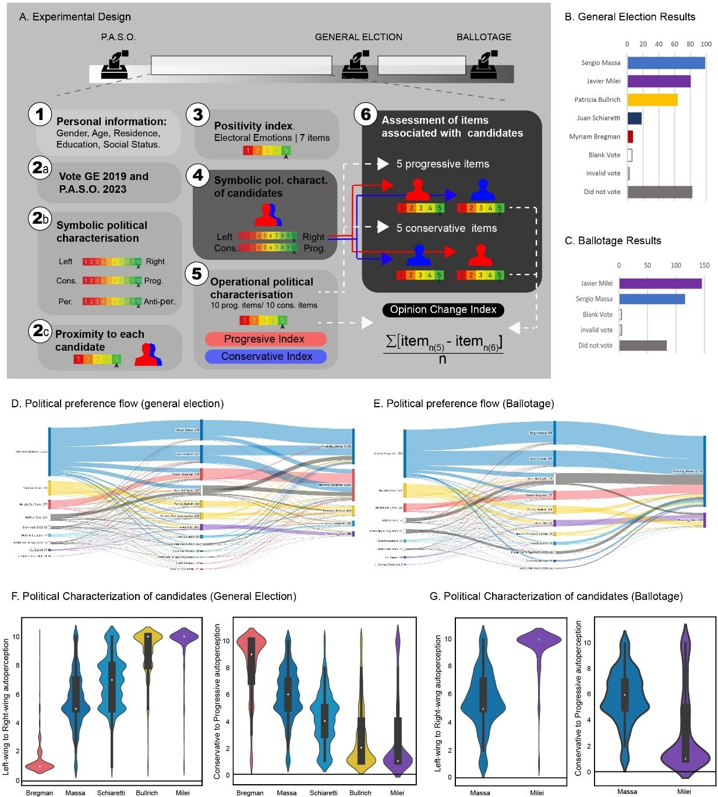

Figure 2.
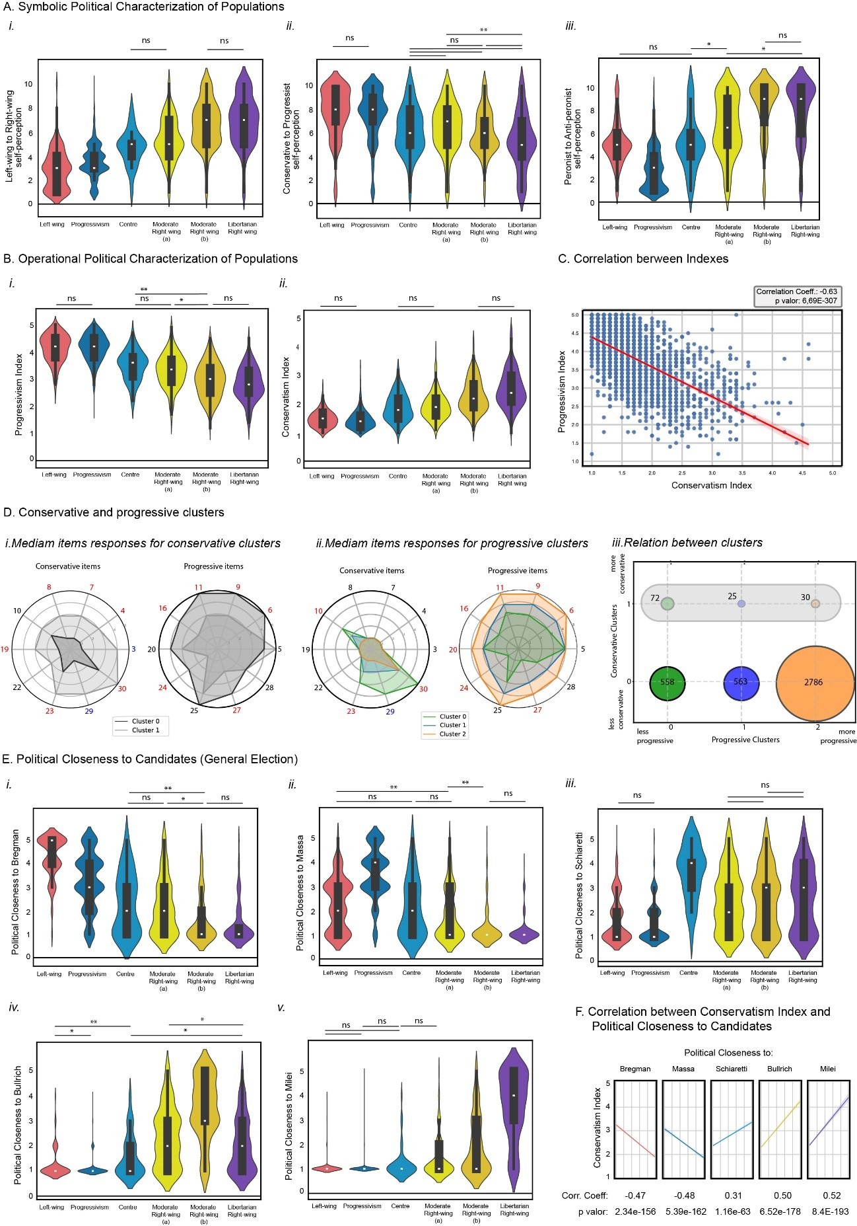

Figure 3.
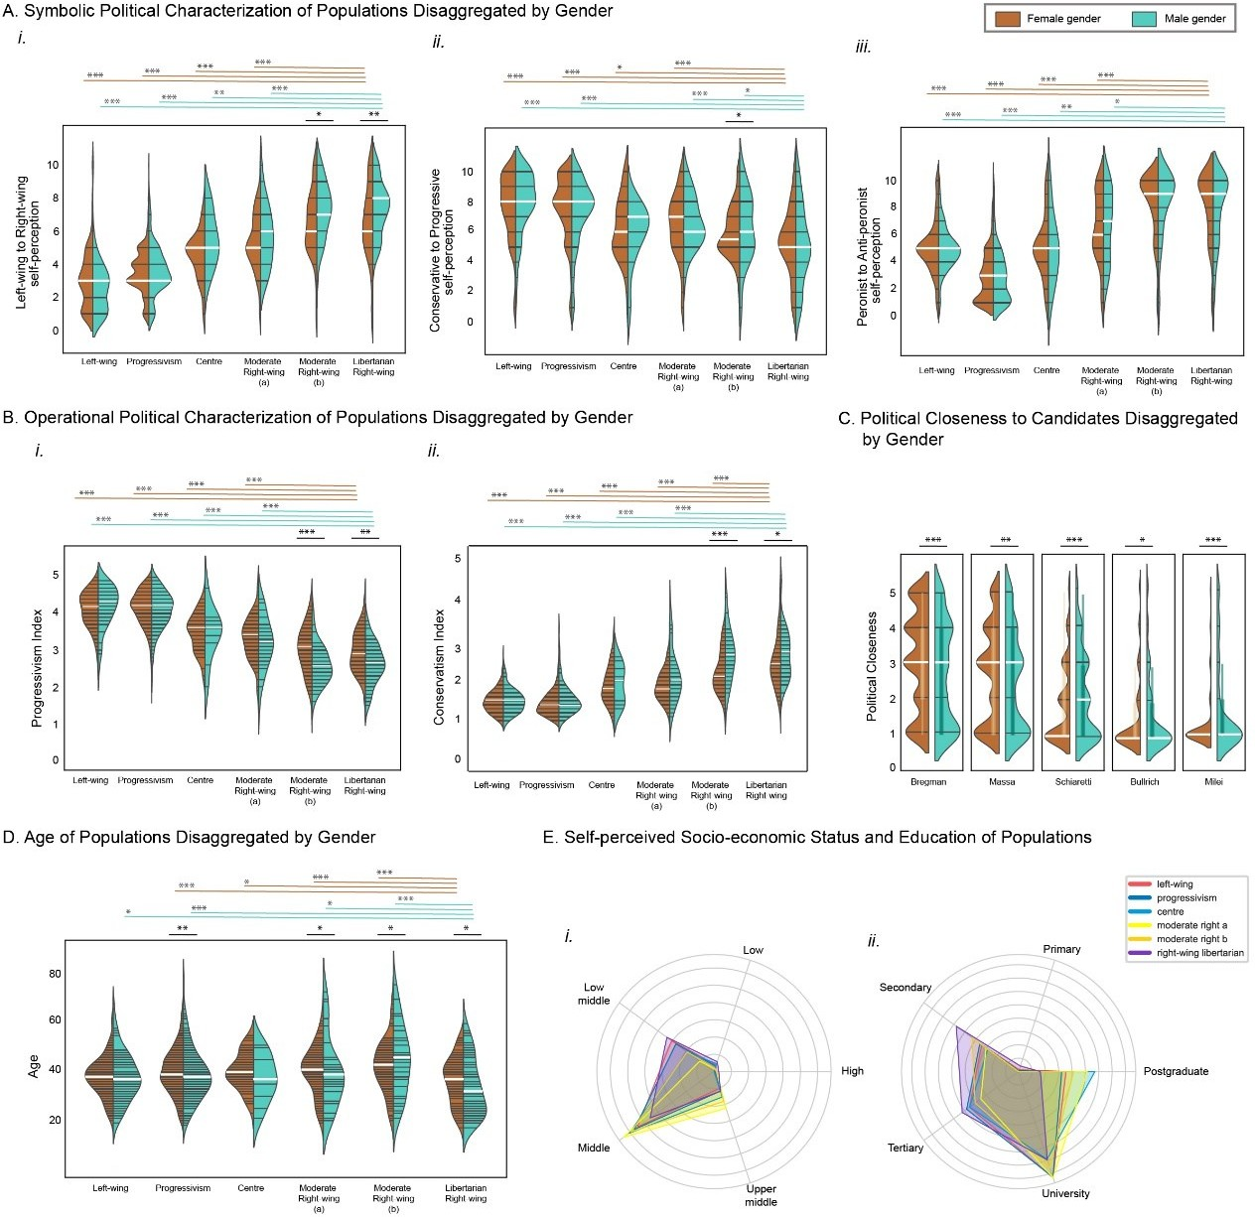

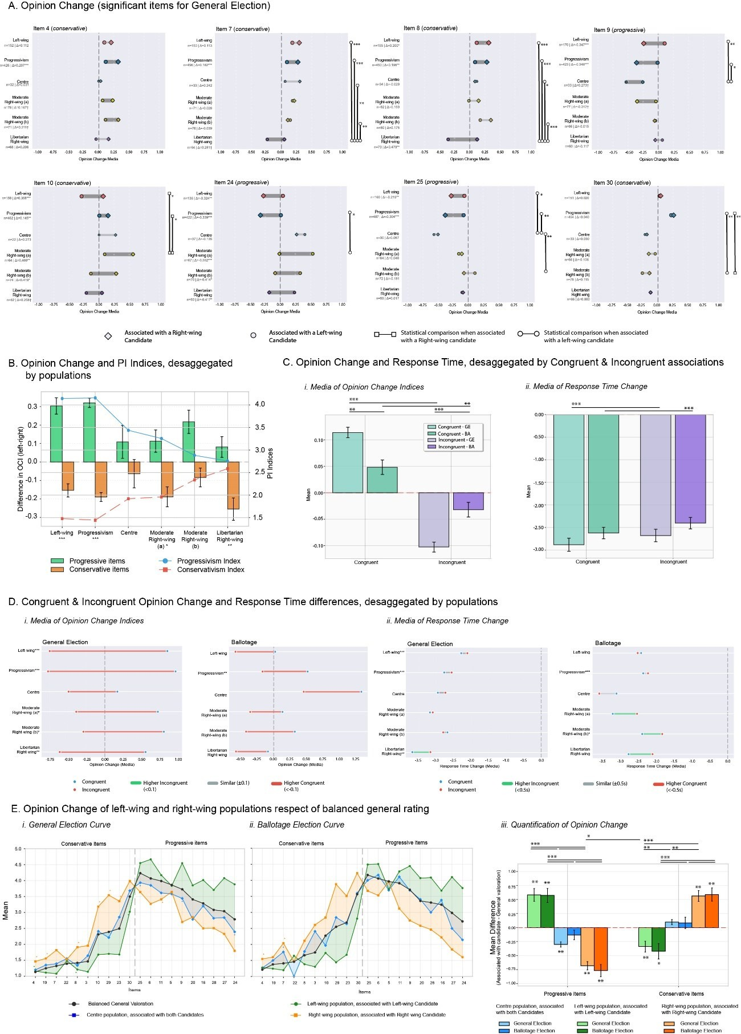
Figure 4.

Legends.

Figure 1. Political Scenario of 2023 Argentine Presidential Elections. Schematic of the experimental design (A). Electoral results of the General Election (B), and of the Ballotage (C). Sankey graph showing the electoral preference associated with the vote in the 2019 elections, the PASO elections in 2023 and the political closeness to each candidate in the General Election
(D) and Ballotage (G). Political perception of each candidate on the symbolic scales of left- wing/right-wing and conservatism-progressivism for the General Elections (F) and Ballotage (G).

Figure 2. Political Characterization of voting populations. A. Symbolic political characterization:
i) Left-wing&Right-wing self-perception for each population (Kruskal-Wallis: p-value =2.41e- 190); ii). Conservative&Progressive self-perception for each population (Kruskal-Wallis: p-value
=6.25e-66); iii) Peronist/anti-peronist self-perception for each population (Kruskal-Wallis: p- value =1.28e-222). B. Operational political characterization: i) Progressivism scale for each population (Kruskal-Wallis: p-value =5.31e-222); ii) Conservatism scale for each population (Kruskal-Wallis: p-value =1.94e-208). C. Correlation between Progressivism and Conservatism indexes. D. Cluster analysis from median conservative or progressive items: Median items responses for Conservative (i) and Progressive (ii) clusters. The items marked in red represent differences of 2 points between clusters; the items marked in blue represent differences of 3 points. iii. Relation between Conservative and Progressive clusters, using all data (General Elections + Ballotage). The number corresponds to the number of participants included in the cluster. E. Political closeness to: i) Bregman: Kruskal-Wallis: p-value =1.61e-190; ii) Massa: Kruskal-Wallis: p-value =7.24e-230; iii) Schiaretti: Kruskal-Wallis: p-value =6.86e-81; iv) Bullrich: Kruskal-Wallis: p-value =9.15e-233; v) Milei: Kruskal-Wallis: p-value =3.06e-273. In all cases, post-hoc Dunn Test reveals by default significant differences (p-value < 0.001) in all comparations excepts when it was indicated (* p-value < 0.05; ** p-value < 0.01) or for those indicated as non-significant (ns). F. Correlation between Conservatism index and each candidate´s closeness.

Figure 3. Social Characterization of voting populations. A. Symbolic political characterization disaggregated by Gender and population: i) Left-wing&Right-wing self-perception; ii). Conservative&progressive self-perception; iii) Peronist&anti-peronist self-perception. B. Operational political characterization: i) Progressivism scale; ii) Conservatism scale. C. Closeness to candidates disaggregated by Gender. D. Age (white line represent the median) of population disaggregated by Gender and populations. E. Self-perceived socio-economic status (i) and maximus education level (ii) disaggregated by populations. In all cases, Mann-Whitney U Test (two-sided) significant results are shown in orange for female comparations, cyan for male comparations and black for comparisons between females and males within the same population: * p-value < 0.05; ** p-value < 0.01; *** p-value < 0.001.

Figure 4. Opinion Change of items. A. Opinion Change of significant items desegregated by populations: the diamonds represent Opinion Change of items associated with right-wing candidates, while the circles represent left-wing candidates’ association. Significant differences between populations were assessed using the Dunn Test with Bonferroni correction: * p-value
< 0.05; ** p-value < 0.01; *** p-value < 0.001. Significant differences between associations are

indicated in the figure. B. Differences between the rates of opinion change associated with left- wing and right-wing candidates (shown separately for progressive and conservative items) and the indices of progressivism and conservatism, disaggregated by voter populations. Significant differences between associations are indicated: * p-value < 0.05; ** p-value < 0.01; *** p-value
< 0.001. C. Congruent & incongruent opinion change for the general election and ballotage: i. Mean opinion change. ii. Mean response time differences associated with such congruent and incongruent opinion changes in both elections. D. Opinion change disaggregated by voter population in each election: i. Mean opinion change; ii. Mean response time differences. Significant differences are indicated: * p-value < 0.05; ** p-value < 0.01; *** p-value < 0.001. Tests for these comparisons (Wilcoxon signed-rank against zero and Mann-Whitney between populations and elections) are reported in Reporte_Analisis_Poblaciones_Segmentadas. E. Opinion Change of left-wing (integrating left-wing and progressive populations), right-wing populations (integrating moderate and libertarian right-wing populations) and Centre population, respect of general rating. To obtain a balanced general rating, the right-wing population was combined with a number of left-wing participants (chosen randomly) equivalent to the right-wing population (for GE: n=605; for Ballotage: n=254). The orange curve corresponds to the right-wing population, associated with right-wing candidates. The green curve corresponds to the left-wing population, associated with left-wing candidates. The blue curve corresponds to average of Centre population associated with a both Candidates (for GE: n=84; for Ballotage: n=43); no significant differences were observed between both associations. On the left side of each graph, the values of conservative items are represented, while on the right side, progressive items are represented. i. General election curve; ii. Ballotage election curve; iii. Quantification of the curves for each condition. The significance between different populations and elections in quantification (iii) was assessed using the Mann-Whitney test, while the difference from zero was assessed using the Wilcoxon signed-rank test (Reporte_Analisis_Poblaciones_Segmentadas): * p-value < 0.05; ** p-value < 0.01; *** p-value
< 0.001.

