**Docx Design Report:**

XDocReport give you the capability to **create report with MS Word docx**. Fields to replace must follow **Freemarker/Velocity syntax**. Typing directly field name can work, but you can have trouble if you style the field. So it is advisable to **use MergeField to set fields to replace**.

To add **MergeField** in your docx report you can :

* [Use standard MS Word MergeField](https://code.google.com/p/xdocreport/wiki/DocxDesignReport#Create_with_MS_Word) creation.
* [Use Macro](https://code.google.com/p/xdocreport/wiki/DocxDesignReportMacro) which display in a dialog box fields available for the model.

To [manage Dynamic Image](https://code.google.com/p/xdocreport/wiki/DocxDesignReport#Manage_Dynamic_Image) in your docx report you must :

* insert a "template" image (any image).
* set a name for the image by using Bookmark.

For the "template" image you can for instance use this image : http://wiki.xdocreport.googlecode.com/git/screenshots/template.png.

**Create MergeField with MS Word:**

This section explains how to add MergeField **$project.Name** after Project: content. Here steps to add this MergeField :

* Do **Ctrl+F9** after Project: content :

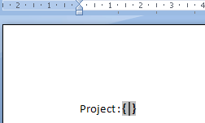

* MS Word generate you **{ }**. Select it and click on right mouse to open contextual menu and select **Field modification...** (Modification du champs...) menu:

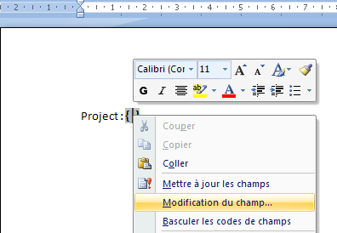

* this action opens the Field dialog. Select **MergeField tree item** (ChampsFusion) :

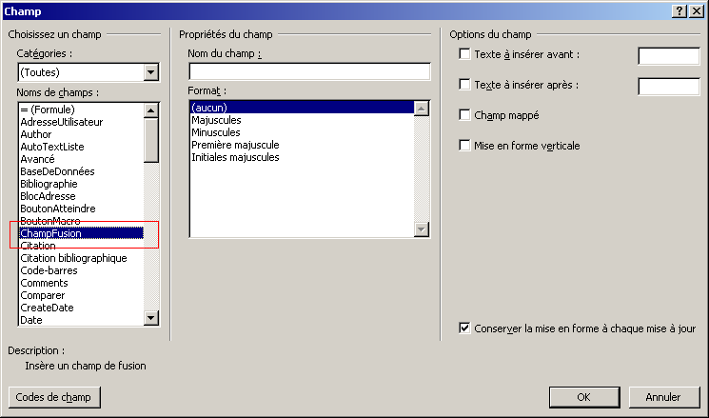

* Select **MergeField tree item** (Champs de fusion) and type **$project.Name** in the field name (Nom du champs) and click on OK button :

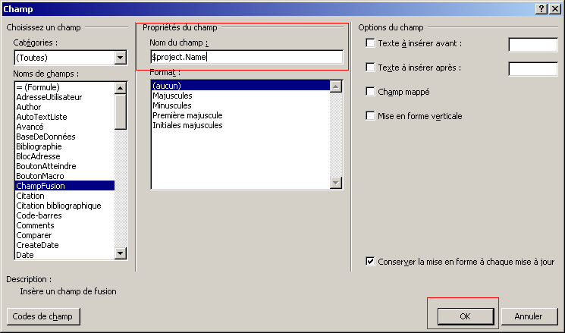

* MergeField is created :

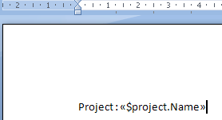

* Now you can style it if you wish. To do that, select the whole mergefield :

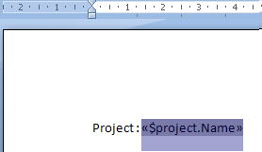

* Style it as you wish :

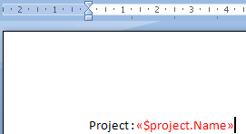

**Manage Dynamic Image:**

This section explains how to add Dynamic Image **$logo** in a docx document. Here steps to add this dynamic image :

* go to the menu **Insert/Image** (Insertion/Image) :

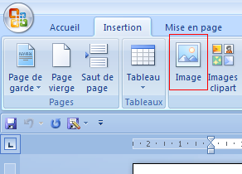

* this action opens the dialog to select an image (in this screenshot, template.png http://wiki.xdocreport.googlecode.com/git/screenshots/template.png is selected) :

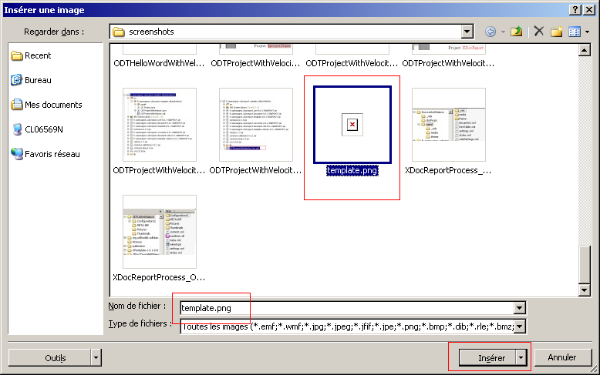

* after clicking on **Insert** button, image is inserted in the document. Now you must name the image. To do that, we must link with the image a bookmark named with **logo**. To do that, select the image, click on **Insert/Bookmark** (Insertion/Signet) :

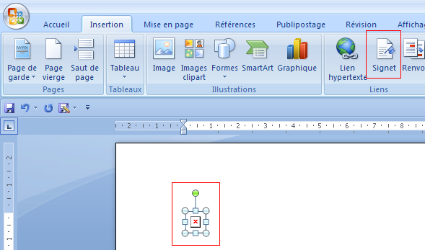

* this action opens the bookmark dialog box. Type **logo** in the **bookmark name** input field and on **Add** button :

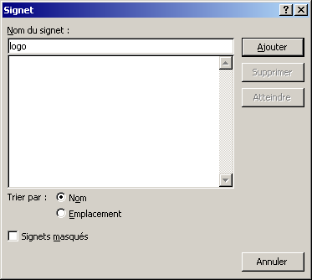

Dynamic image is now available with **logo** name.

* You can go to the Bookmark to select the linked image with Bookmark Dialog:

