**Ticket Manager Testing**

1. Notes are successfully added, edit and delete.
2. In Asset Manager, When we click on Add Asset and Select Asset Template then we close the asset pop-up form. the form is not reset
3. 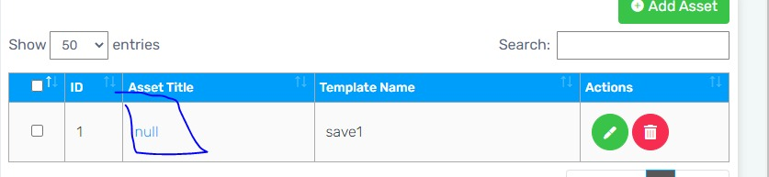
4. 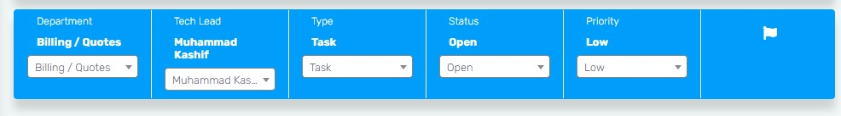
5. Add Follow Up form also not reset when we close it.
6. 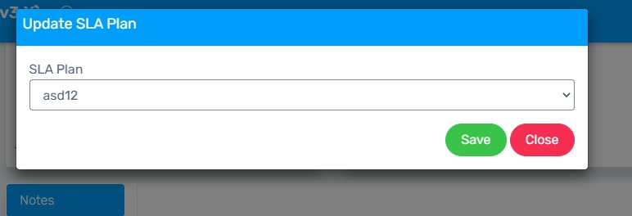
7. Default SLA plan is not added in dropdown.
8. 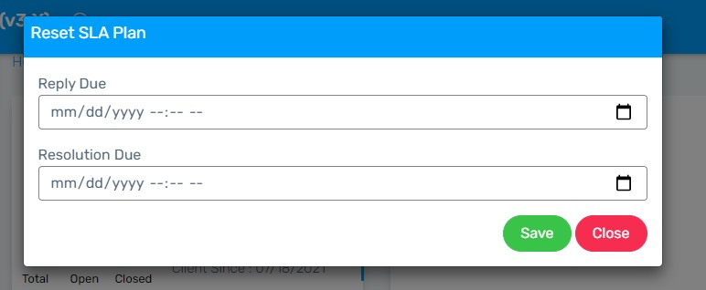
9. In Reset SLA Plan show reply due date and resolution due date, Reset button working fine as expected.
10. In Ticket replies, I added images, videos and doc files all working fine. but when we click on Add ticket button and attach videos and documents they not open properly.

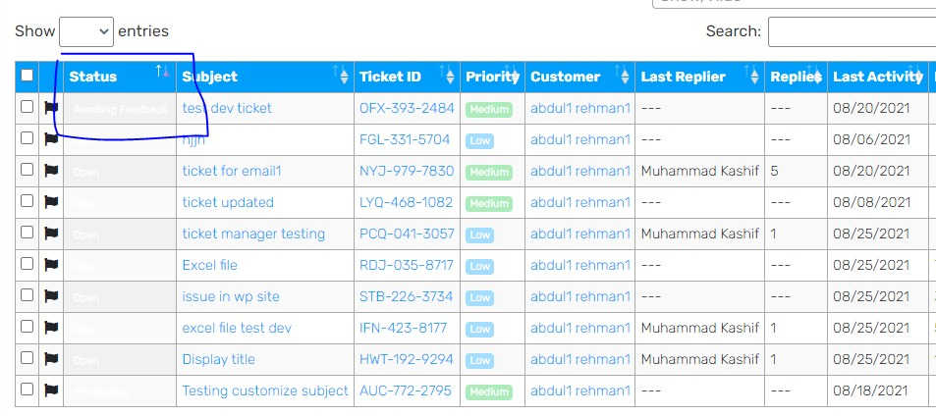

1. not working

