DESIGN CONCEPT

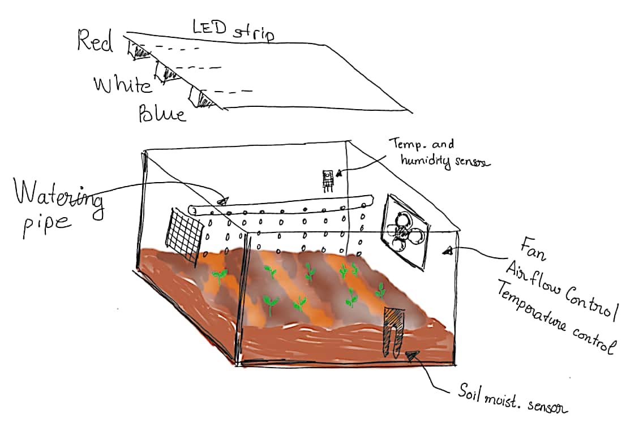

BILL OF MATERIAL
Index | Item | Qty | Price | Total | Remark
1 | Plastic box | 1
2 | Red LED strip | 1
3 | White LED strip | 1
4 | Blue LED strip | 1
 | Fan | 1
 | Soil moisture sensor
 | Humidity and temperature sensor
 | LCD monitor

