# Proof of completion:

1. Using the below screenshot prooving that I have completed the problem set

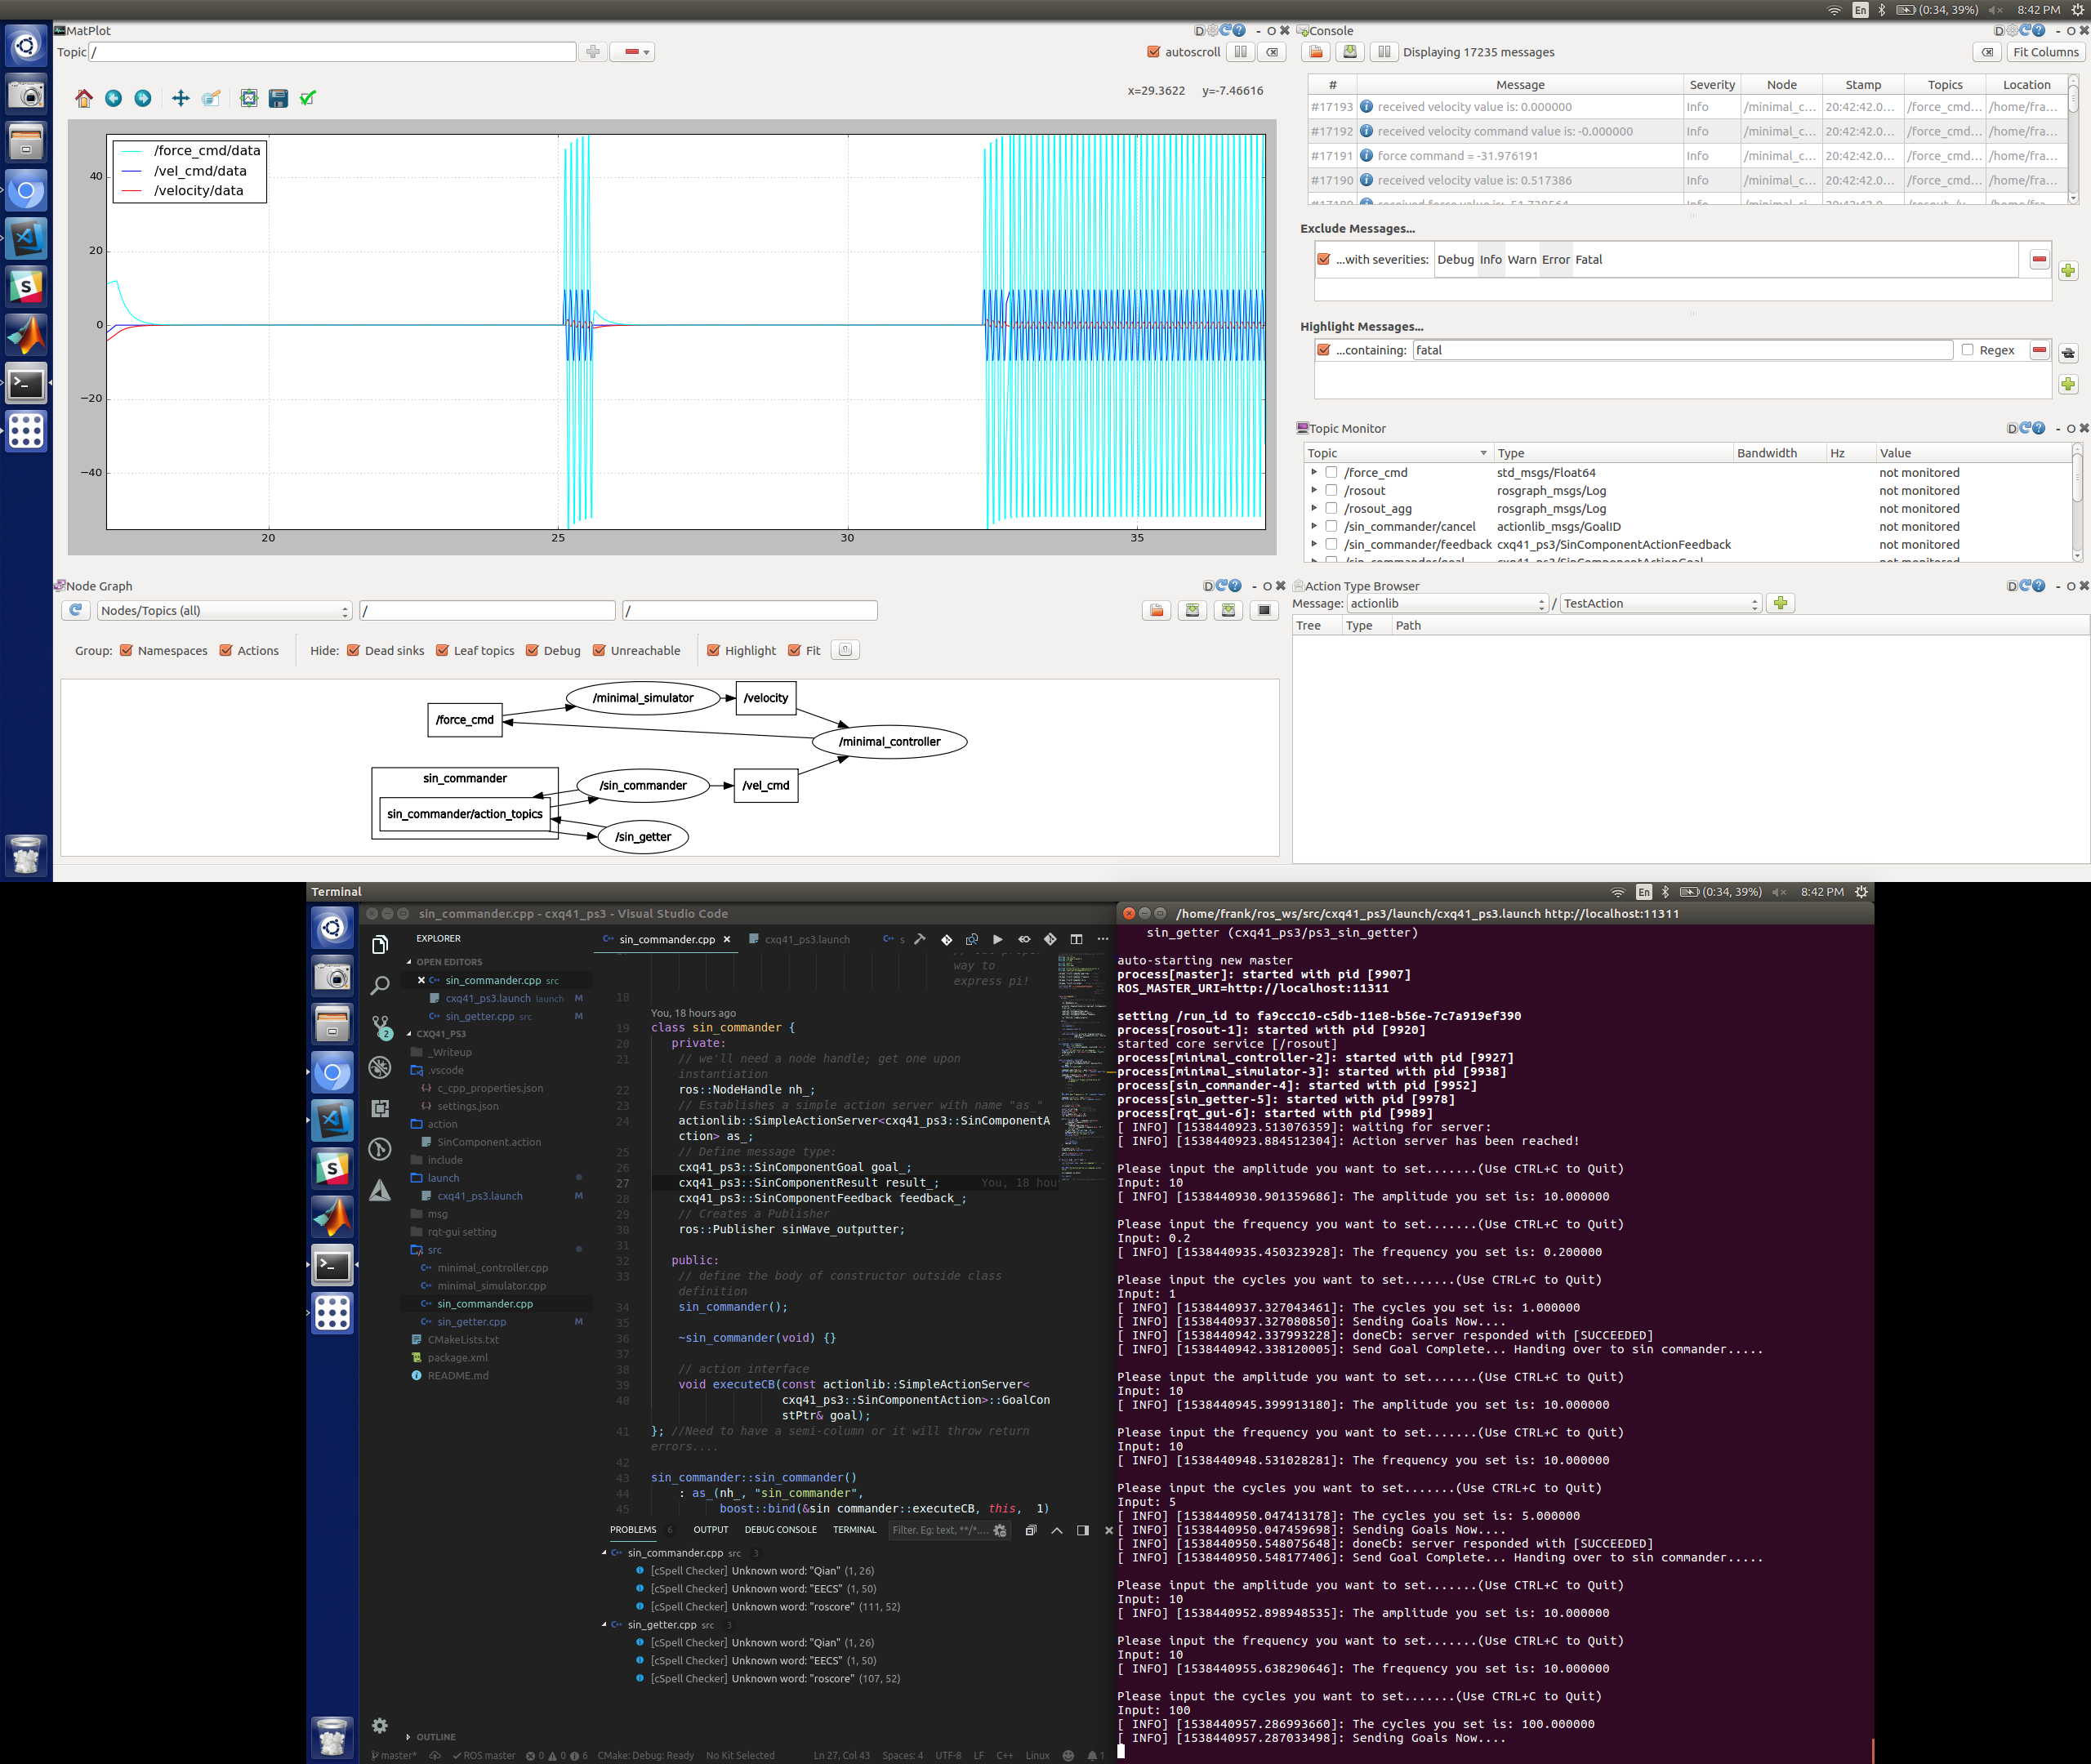

1. Showing update of cycle works set cycle of 2:

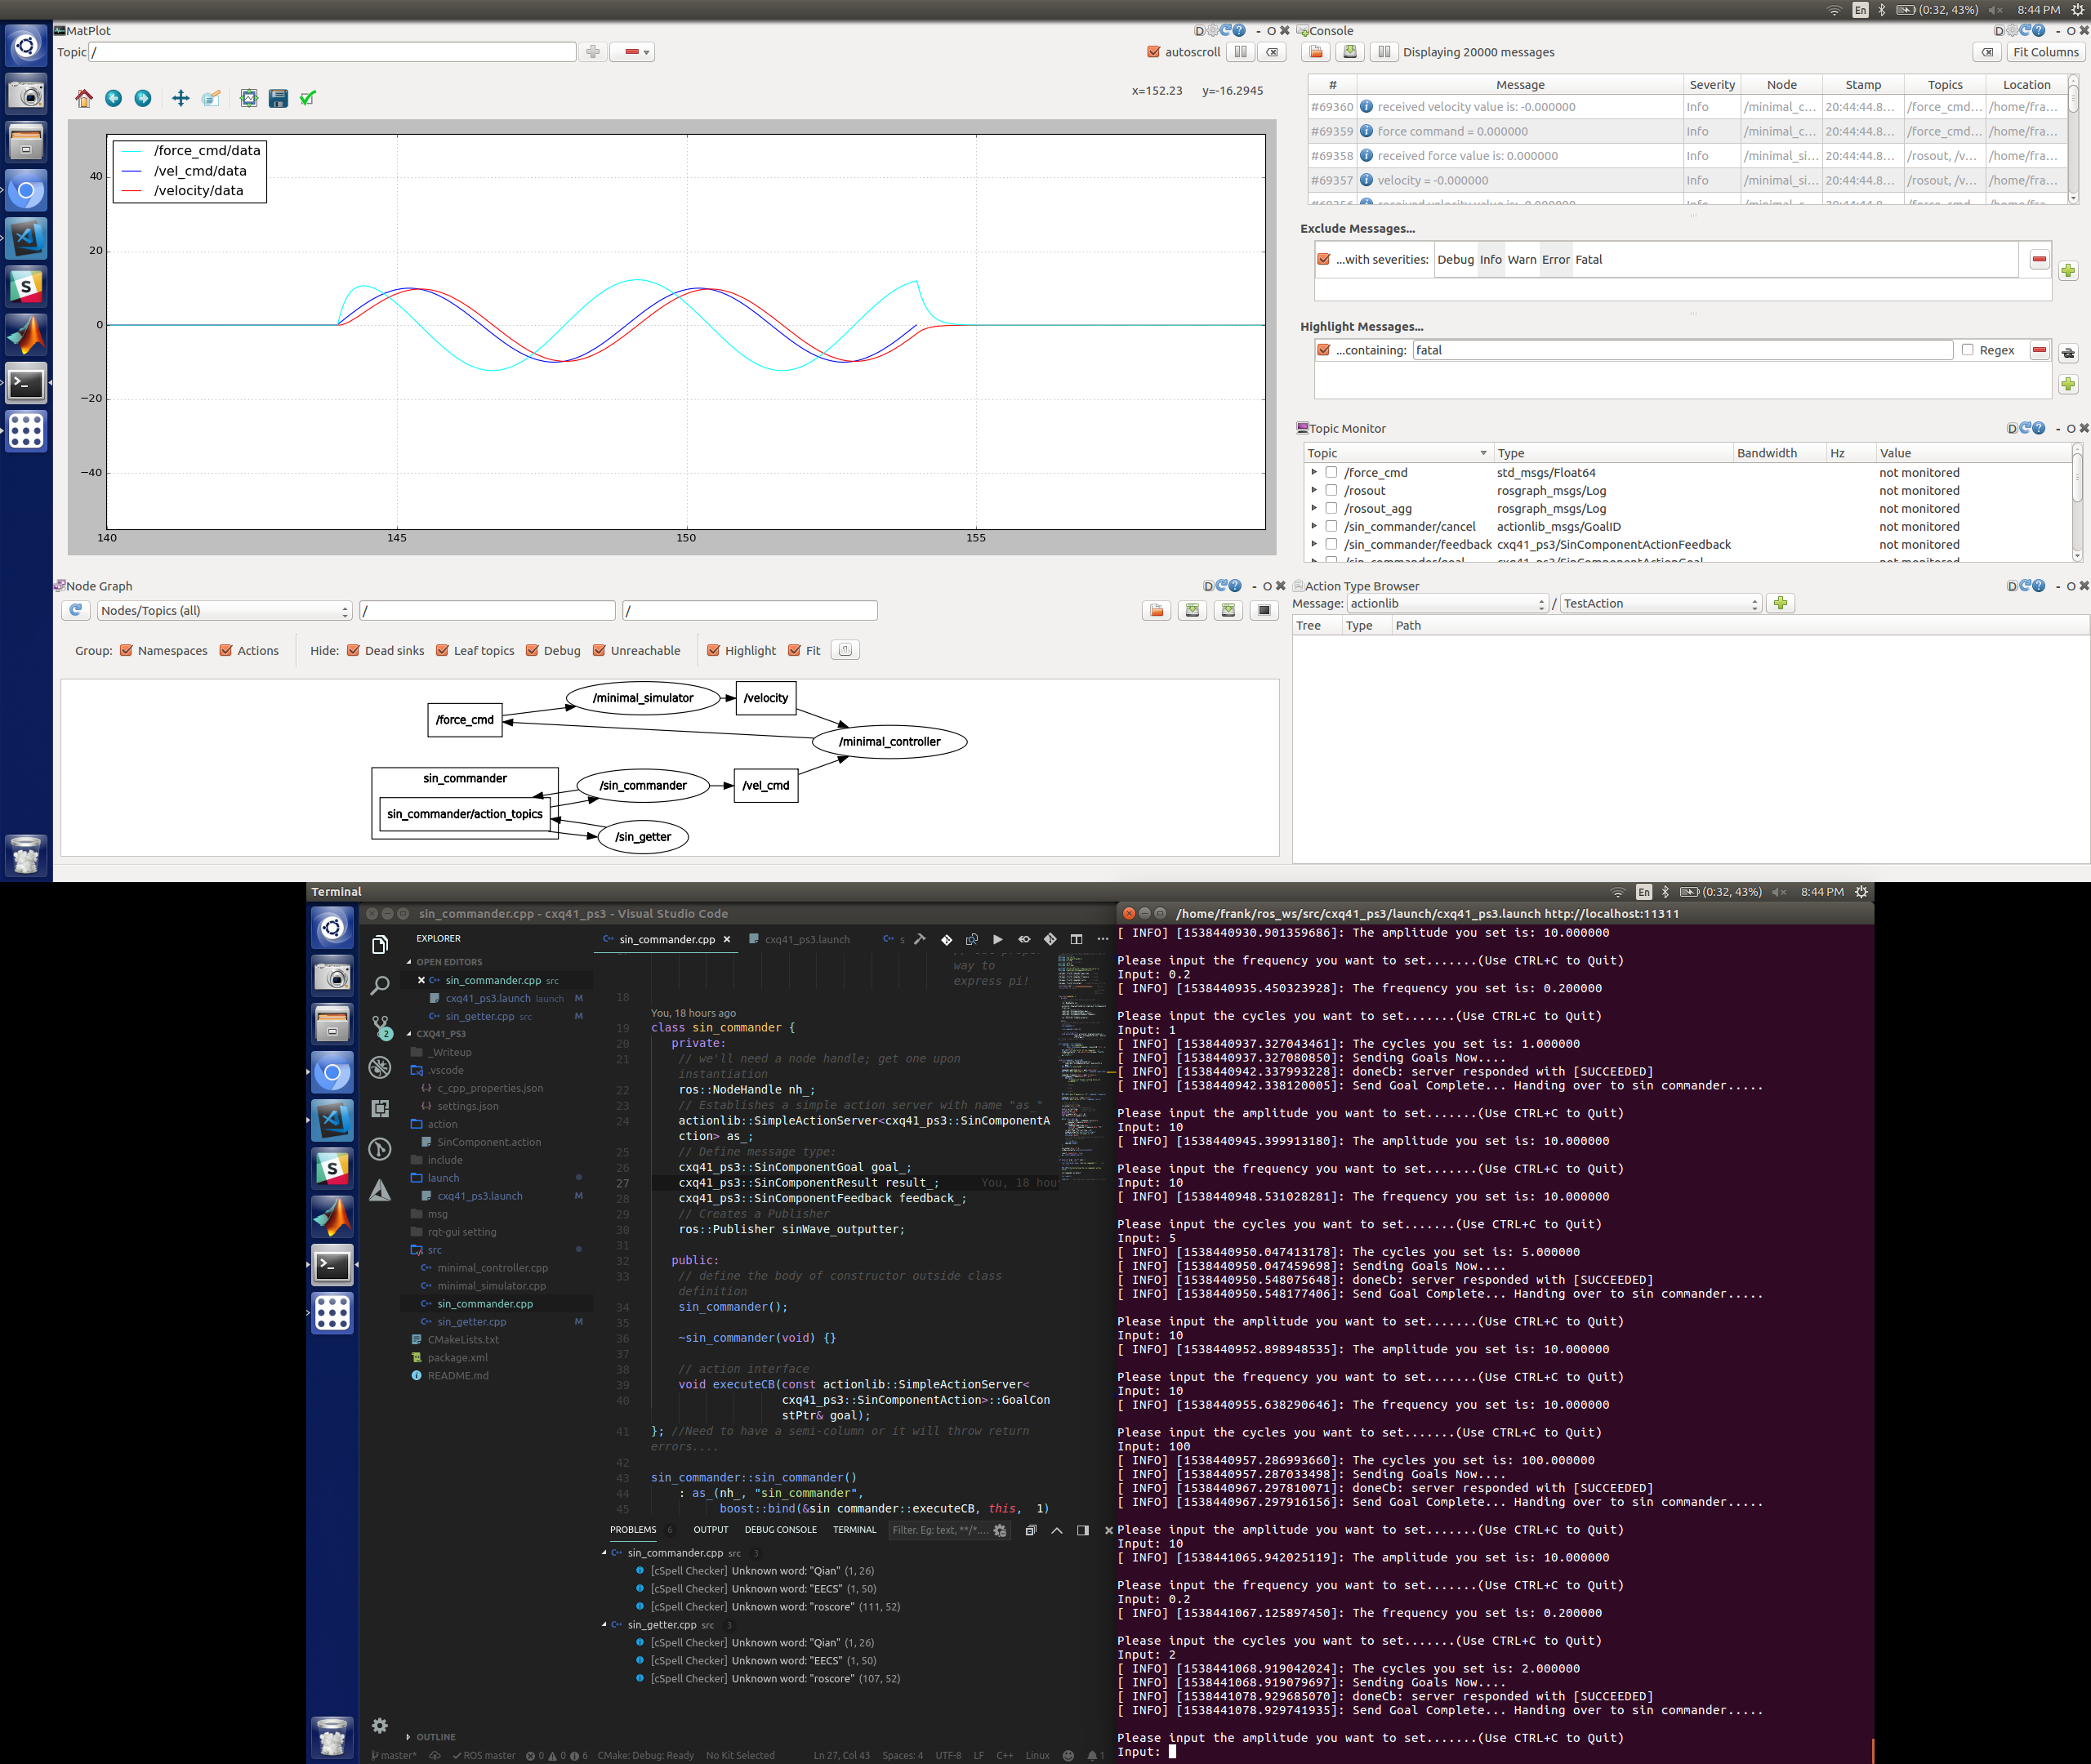

1. Showing update of frequency =0 have no mistake and throws fatal error notification:

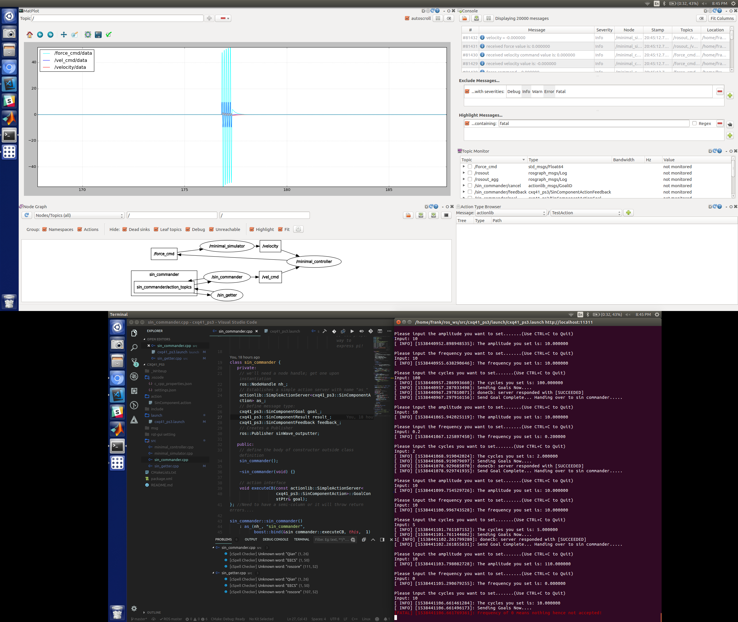

**Code included in zip file.**