Open Loop Control
This control method is also known as dead reckoning. It was horrible to achieve what I wish to complete: drive the robot out the maze. The robot unfortunately seems to have a tendency to turn towards the right hand side, and therefore, when way points are laid out taking into consideration of the tendency to go right. It is actually very common in mobile robot that a vehicle has a tendency to go one single direction. It could be caused by the uneven distribution of weight, or simply uneven distribution of cable impedance.
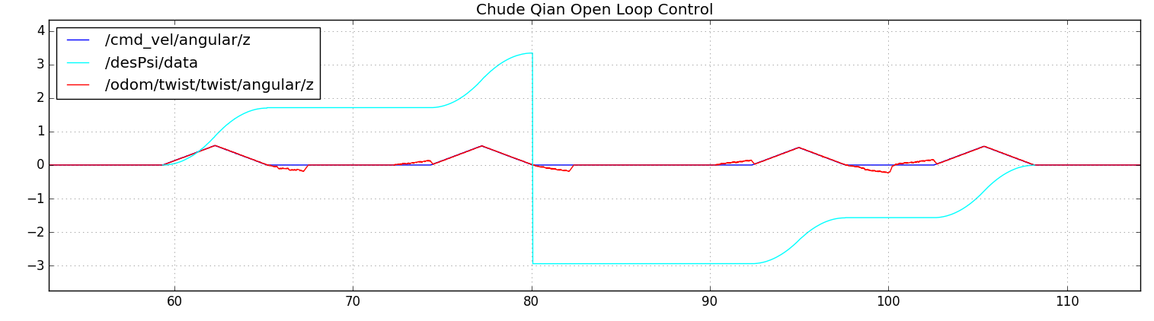

Close Loop Control
This control method counts in the potential loss for “accidents”, therefore my target setting can be more accurate and “real” and I don’t need to manually offset a difference. The robot is able to correct itself faster. Without changing anything from the header file, the robot is already performing much better. When it turns, it turns correctly and when it drives, it no longer drastically drifts out the desired line.

Tuning Parameters:
I started randomly tuning K_PHI and K_DISP. I first start to increase in the magnitude of 10, as well as increase the max speed and max omega. I got an unstable oscillation, which is not surprising since I technically overshoot everything and made the system an unstable system with poles on right hand side.
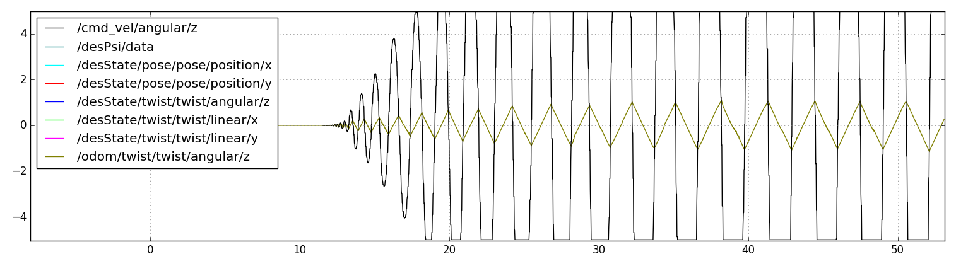
So I decided to start small, with small increment for K_PHI, I am able to get the robot converge faster.
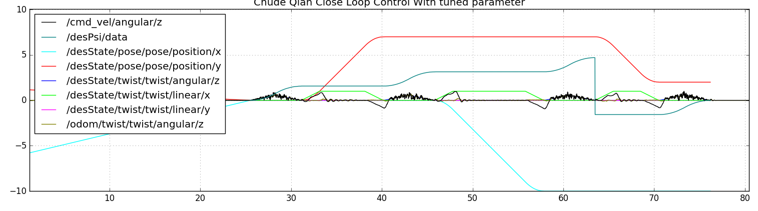
As you can see, the robot is constantly aware of where it might be and is constantly aware of what it want to get to. This gives us the advantage of not worrying the robot drift away from its designated path.
I also noticed that when speed is set to a very high value, the robot has a higher chance of losing control. Therefore speed is set to a reasonable value at lin = 20, ang = 15. K_PHI = 15, K_DISP = 12.
The result is demoed in the video as well as in RQT plot down:
It is worth noticing that there are still some overshoot, but overall the system is stable, and controllable.
