1. Prove that your analytic computation matches the values of these estimates:

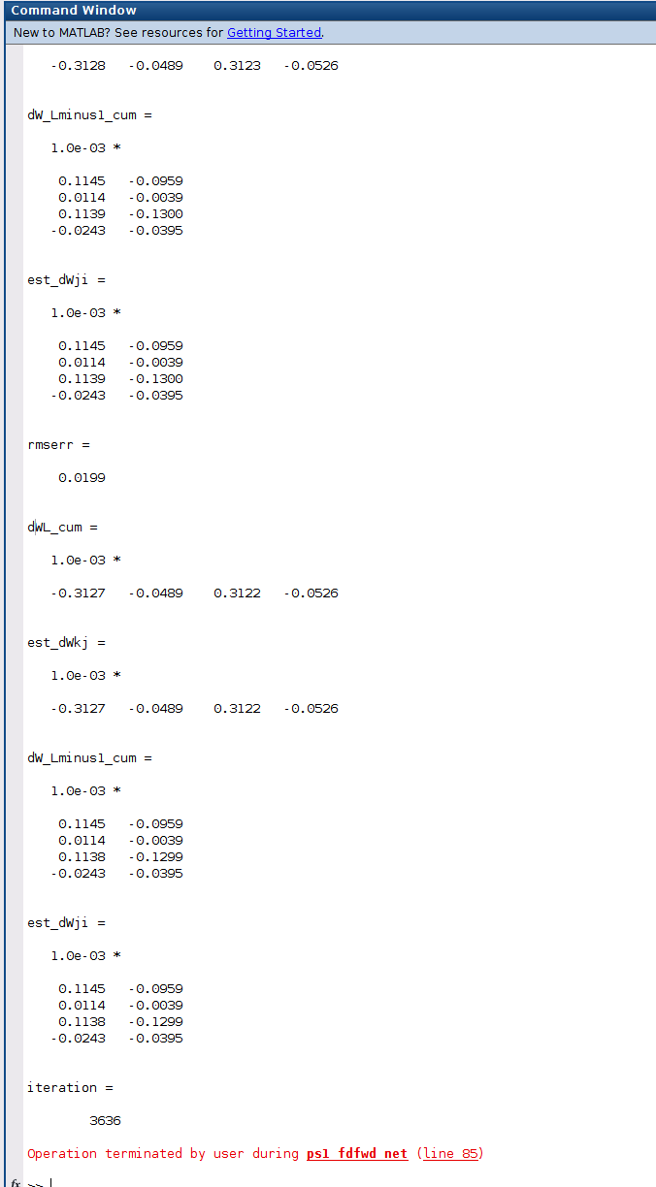

1. Functional Code:

phi_prime_L_vec = (outputk).*(1-outputk); *%* FIXed!!*

delta_L = (phi_prime_L_vec).*(err_vec); *%* FIXed!!*

delta_L_cum=delta_L_cum + delta_L;

dWL = (delta_L).*(outputj).'; *%* FIXed!!*

dWL_cum = dWL_cum+dWL;

phi_prime_Lminus1_vec = (outputj).*(1-outputj); *%* FIXed!!*

delta_Lminus1 = (((Wkj).')*delta_L) .* phi_prime_Lminus1_vec; *%* FIXed!!*

delta_Lminus1_cum = delta_Lminus1_cum + delta_Lminus1;

dW_Lminus1 = (delta_Lminus1).*(stim_vec).'; *%* FIXed!!*

dW_Lminus1_cum = dW_Lminus1_cum+dW_Lminus1;

1. Evaluate the influence of number of interneurons and choice of epsilon for gradient-descent computations
2. Plot of work
3. Hold