The repeatability and reproducibility of the Collagen Membrane

Frank

2022-09-27

## 1. Configure environment and include the data

The analysis is powered by R version 4.2.1 (2022-06-23 ucrt). It requires the following packages:

library(readxl)  
library(UsingR)  
library(lessR)  
library(ggplot2)  
library(knitr)  
library(ggsignif)  
library(ggpubr)  
library(metRology)  
library(outliers)  
library(stats)  
library(rstatix)

Read the data from the excel files

## 2. Group the data based on the buffer pH, centrifuge force, and centrifuge time

### 2.1. construct the sub datasets for analysis

### 2.2. Uncompressed

#### 2.2.1. The means of pH 7.7 collagen without compression in different time

## Operator  
## Date Frank 沢崎  
## 2021-12-27 0.0000 499.5648  
## 2022-08-28 471.7582 0.0000  
## 2022-09-04 259.6742 0.0000  
## 2022-09-08 293.5103 0.0000  
## 2022-09-14 385.9428 0.0000

#### 2.2.2. The SD of pH 7.7 collagen without compression in different time

## Operator  
## Date Frank 沢崎  
## 2021-12-27 0.00000 72.99595  
## 2022-08-28 85.20293 0.00000  
## 2022-09-04 34.35673 0.00000  
## 2022-09-08 17.12355 0.00000  
## 2022-09-14 13.99215 0.00000

### 2.3. Compressed at 3000 rpm for 10 min

#### 2.3.1. The means of pH 7.7 collagen after compressed

## Operator  
## Date Frank 沢崎  
## 2021-12-27 0.00000 42.78022  
## 2022-09-01 137.87673 0.00000

#### 2.3.2. The SD of pH 7.7 collagen after compressed

## Operator  
## Date Frank 沢崎  
## 2021-12-27 0.000000 9.426426  
## 2022-09-01 10.487338 0.000000

## 3. outlier

### 3.1. Repeatability (Cochran’s C test)

#### 3.1.1. The uncompressed

##   
## Cochran test for outlying variance  
##   
## data: `Thickness (μm)` ~ Date.x  
## C = 0.81304, df = 5, k = 4, p-value = 0.001004  
## alternative hypothesis: Group 2022-08-28 has outlying variance  
## sample estimates:  
## 2022-08-28 2022-09-04 2022-09-08 2022-09-14   
## 7259.5384 1180.3846 293.2159 195.7804

##### Try to eliminate the outliers

##   
## Cochran test for outlying variance  
##   
## data: `Thickness (μm)` ~ Date.x  
## C = 0.47112, df = 4.5, k = 4.0, p-value = 0.3844  
## alternative hypothesis: Group 2022-09-04 has outlying variance  
## sample estimates:  
## 2022-08-28 2022-09-04 2022-09-08 2022-09-14   
## 836.1023 1180.3846 293.2159 195.7804

It has shown that 2022-08-28 has outlying variance. The outliers are fathomed at quater 3 and 4 in 35mm Petri Dish. The plausible reason might be that the unbalanced stage of AFM cause various the depth for the first time. I measure the precise data after the second try.

#### 3.1.2. The compressed

##   
## Cochran test for outlying variance  
##   
## data: `Thickness (μm)` ~ Date.x  
## C = 1, df = 5, k = 1, p-value = NA  
## alternative hypothesis: Group 2022-09-01 has outlying variance  
## sample estimates:  
## 2022-09-01   
## 109.9843

Only one group can’t compare to the previous.

### 3.2. Reproducibility (Grubbs’ Test)

#### 3.2.1 The uncompressed

##   
## Grubbs test for one outlier  
##   
## data: aggregate.data.frame(reproducibilityUncomp[c("Thickness (μm)")], list(Date = reproducibilityUncomp$Date.x), mean)$`Thickness (μm)`  
## G = 1.15818, U = 0.58082, p-value = 0.5939  
## alternative hypothesis: lowest value 259.6742 is an outlier

##### 3.2.1.1. Mandel’s h plot

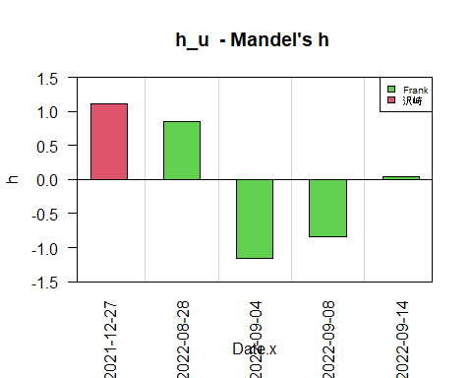

##### 3.2.1.2. Mandel’s k plot

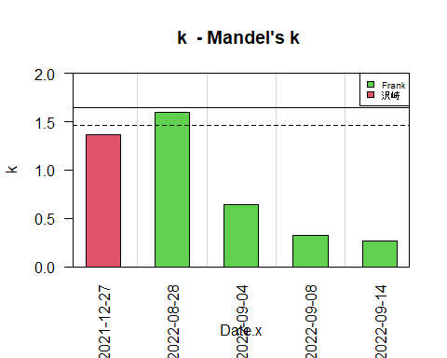

The uncompressed group has no significant outlier though Mandel’s k indicate higher SD at 8/28.

#### 3.2.2. The compressed

##   
## Grubbs test for one outlier  
##   
## data: aggregate.data.frame(reproducibilitycomp[c("Thickness (μm)")], list(Date = reproducibilitycomp$Date.x), mean)$`Thickness (μm)`  
## G = 0.70711, U = NA, p-value = NA  
## alternative hypothesis: highest value 137.876727272727 is an outlier

##### 3.2.2.1. Mandel’s h plot

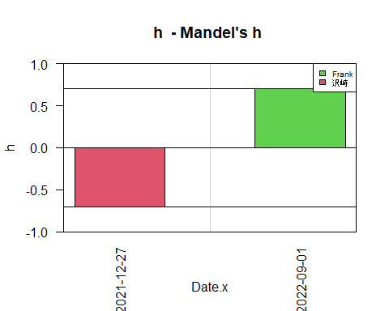

##### 3.2.2.2. Mandel’s k plot

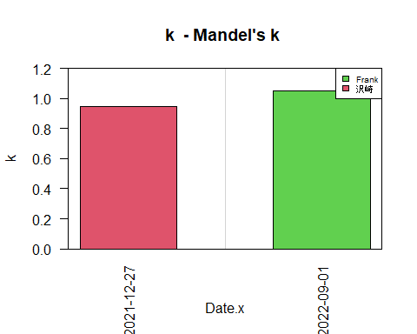

The repeatability conducted by Cochran’s C test has shown that 2022-08-28 has outlying variance. After compressed, the thickness of collagen membrane doesn’t contains the outliers.

## 4. The relationship between SD and means

### 4.1. The uncompressed

#### 4.1.1. Linear model

The Pearson correlation between SD and mean reach 0.77 which represent the strong correlation.

##   
## Call:  
## lm(formula = UncompSD$`Thickness (μm)` ~ UncompMean$`Thickness (μm)`)  
##   
## Residuals:  
## 1 2 3 4 5   
## 0.5371 19.3066 18.5132 -6.7055 -31.6514   
##   
## Coefficients:  
## Estimate Std. Error t value Pr(>|t|)  
## (Intercept) -45.4408 45.1320 -1.007 0.388  
## UncompMean$`Thickness (μm)` 0.2360 0.1147 2.058 0.132  
##   
## Residual standard error: 24.24 on 3 degrees of freedom  
## Multiple R-squared: 0.5854, Adjusted R-squared: 0.4472   
## F-statistic: 4.237 on 1 and 3 DF, p-value: 0.1317

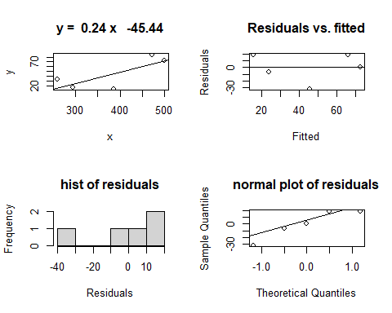

##   
## Call:  
## lm(formula = y ~ x)  
##   
## Coefficients:  
## (Intercept) x   
## -45.441 0.236

#### 4.1.2. Log model

##   
## Call:  
## lm(formula = log10(UncompSD$`Thickness (μm)`) ~ log10(UncompMean$`Thickness (μm)`))  
##   
## Residuals:  
## 1 2 3 4 5   
## 0.09604 0.20618 0.25991 -0.13446 -0.42767   
##   
## Coefficients:  
## Estimate Std. Error t value Pr(>|t|)  
## (Intercept) -2.897 3.367 -0.86 0.453  
## log10(UncompMean$`Thickness (μm)`) 1.728 1.310 1.32 0.279  
##   
## Residual standard error: 0.3267 on 3 degrees of freedom  
## Multiple R-squared: 0.3673, Adjusted R-squared: 0.1564   
## F-statistic: 1.742 on 1 and 3 DF, p-value: 0.2786

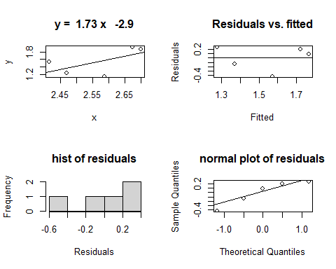

##   
## Call:  
## lm(formula = y ~ x)  
##   
## Coefficients:  
## (Intercept) x   
## -2.897 1.728

The uncompressed thickness doesn’t fit the linear and log model. The pearson correlation indicates the thicker the collagen membrane is, the higher SD the measurement is. The plausible reason might be the dispense error which results in the undulated surface at first trial. The correction measurement is to stir the Petri dish as soon as dispensing the collagen mixture.

### 4.2. The compressed

#### 4.2.1. Linear model

## [1] 1

##   
## Call:  
## lm(formula = compSD$`Thickness (μm)` ~ compMean$`Thickness (μm)`)  
##   
## Residuals:  
## ALL 2 residuals are 0: no residual degrees of freedom!  
##   
## Coefficients:  
## Estimate Std. Error t value Pr(>|t|)  
## (Intercept) 8.94916 NaN NaN NaN  
## compMean$`Thickness (μm)` 0.01116 NaN NaN NaN  
##   
## Residual standard error: NaN on 0 degrees of freedom  
## Multiple R-squared: 1, Adjusted R-squared: NaN   
## F-statistic: NaN on 1 and 0 DF, p-value: NA

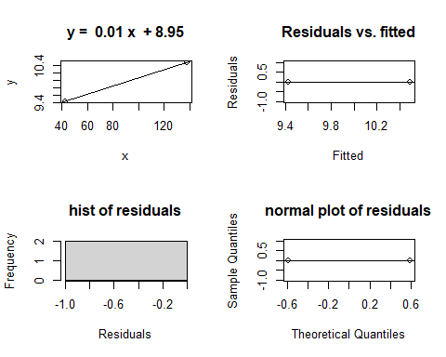

##   
## Call:  
## lm(formula = y ~ x)  
##   
## Coefficients:  
## (Intercept) x   
## 8.94916 0.01116

It fits the linear line though the small sample size data exists. Thus, log model is unnecessary. It is consistent with the uncompressed collagen membrane. The thicker the collagen membrane is, the higher SD the measurement is.

## 5. Reproducibility by one-way ANOVA

### 5.1. The uncompressed

## Df Sum Sq Mean Sq F value Pr(>F)   
## Date.x 4 322011 80503 21.89 0.0000000154 ***  
## Residuals 30 110313 3677   
## ---  
## Signif. codes: 0 '***' 0.001 '**' 0.01 '*' 0.05 '.' 0.1 ' ' 1

## # A tibble: 10 × 9  
## term group1 group2 null.v…¹ estim…² conf.…³ conf.…⁴ p.adj p.adj…⁵  
## * <chr> <chr> <chr> <dbl> <dbl> <dbl> <dbl> <dbl> <chr>   
## 1 Date.x 2021-12-27 2022-08-28 0 -27.8 -119. 63.0 8.99e-1 ns   
## 2 Date.x 2021-12-27 2022-09-04 0 -240. -331. -149. 1.47e-7 ****   
## 3 Date.x 2021-12-27 2022-09-08 0 -206. -297. -115. 2.66e-6 ****   
## 4 Date.x 2021-12-27 2022-09-14 0 -114. -204. -22.8 8.6 e-3 **   
## 5 Date.x 2022-08-28 2022-09-04 0 -212. -323. -101. 4.85e-5 ****   
## 6 Date.x 2022-08-28 2022-09-08 0 -178. -289. -67.0 5.63e-4 ***   
## 7 Date.x 2022-08-28 2022-09-14 0 -85.8 -197. 25.4 1.94e-1 ns   
## 8 Date.x 2022-09-04 2022-09-08 0 33.8 -77.4 145. 9.01e-1 ns   
## 9 Date.x 2022-09-04 2022-09-14 0 126. 15.0 238. 1.99e-2 *   
## 10 Date.x 2022-09-08 2022-09-14 0 92.4 -18.8 204. 1.4 e-1 ns   
## # … with abbreviated variable names ¹​null.value, ²​estimate, ³​conf.low,  
## # ⁴​conf.high, ⁵​p.adj.signif

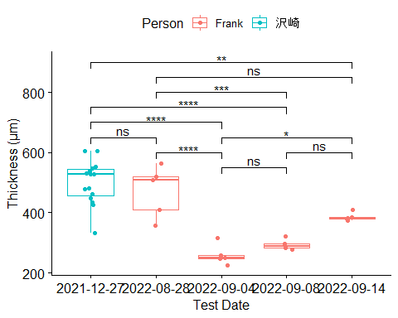

### 5.2. The compressed

## Df Sum Sq Mean Sq F value Pr(>F)   
## Date.x 1 33913 33913 362.5 0.000000000000225 ***  
## Residuals 18 1684 94   
## ---  
## Signif. codes: 0 '***' 0.001 '**' 0.01 '*' 0.05 '.' 0.1 ' ' 1

## # A tibble: 1 × 9  
## term group1 group2 null.v…¹ estim…² conf.…³ conf.…⁴ p.adj p.adj…⁵  
## * <chr> <chr> <chr> <dbl> <dbl> <dbl> <dbl> <dbl> <chr>   
## 1 Date.x 2021-12-27 2022-09-01 0 95.1 84.6 106. 2.32e-13 ****   
## # … with abbreviated variable names ¹​null.value, ²​estimate, ³​conf.low,  
## # ⁴​conf.high, ⁵​p.adj.signif

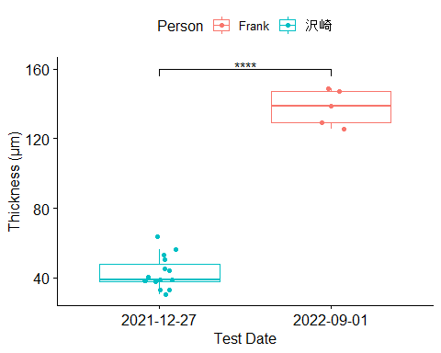

# Conclusion: The reproducibility conducted by Grubbs’ test has shown that the measurement error is consistent with 沢崎さん even compressed. However, the mean thickness of the collagen membrane are out of the previous data.