108年台北醫學大學生物統計學分班第四次作業

Bo-Jiang Lin

2019-10-20

##### 請利用此章節之資料（新生兒持續性肺動脈高壓PPHN），回答下列問題：顯著水準為0.05。

## Loading required package: ggplot2

## [1] "sex" "fecalInhale" "X...A...o" "X.a.u2." "weeks"   
## [6] "weight" "X1mm_apgar" "X5mm_apgar" "PH" "AaDO2"   
## [11] "death"

1. 在懷孕週數、出生體重、1分鐘apgar、5分鐘apgar、酸鹼值（PH值）、AaDO2，上述6個變項中，哪個變項在死亡和存活兩組別間，其平均數上具有統計上之顯著差異。使用的統計方法稱為什麼？(選一個變數分析)

week_death <- PP$weight[which(PP$death == 1), drop = F]  
week_survival <- PP$weight[which(PP$death == 0 & PP$weight <= 4000 & PP$weight >= 2000)]  
  
par(mfcol = c(1, 2))  
qqnorm(week_death, ylab = "death")  
qqline(week_death, col= "red")  
qqnorm(week_survival, ylab = "survival")  
qqline(week_survival, col= "blue")

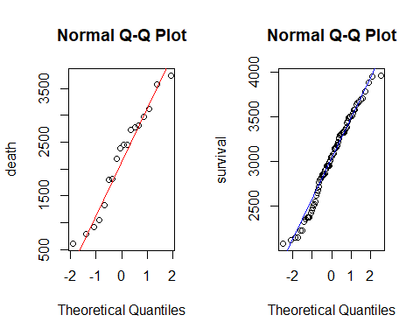

shapiro.test(week_death)

##   
## Shapiro-Wilk normality test  
##   
## data: week_death  
## W = 0.9524, p-value = 0.4639

shapiro.test(week_survival)

##   
## Shapiro-Wilk normality test  
##   
## data: week_survival  
## W = 0.97987, p-value = 0.2253

var.test(week_survival, week_death)

##   
## F test to compare two variances  
##   
## data: week_survival and week_death  
## F = 0.2431, num df = 81, denom df = 17, p-value = 1.501e-05  
## alternative hypothesis: true ratio of variances is not equal to 1  
## 95 percent confidence interval:  
## 0.1035851 0.4731081  
## sample estimates:  
## ratio of variances   
## 0.243101

t.test(week_survival, week_death, var.equal = FALSE)

##   
## Welch Two Sample t-test  
##   
## data: week_survival and week_death  
## t = 3.6101, df = 18.852, p-value = 0.001884  
## alternative hypothesis: true difference in means is not equal to 0  
## 95 percent confidence interval:  
## 349.2643 1314.1937  
## sample estimates:  
## mean of x mean of y   
## 3026.451 2194.722

1. 在懷孕週數、出生體重、1分鐘apgar、5分鐘apgar、酸鹼值（PH值）、AaDO2，上述6個變項中，在死亡和存活兩組別間，哪些變項其存活組之中位數是顯著大於死亡組之中位數。使用的統計方法稱為什麼？(選一個變數分析)

weight_survival <- PP$weight[which(PP$death == 0)]  
weight_death <- PP$weight[which(PP$death == 1)]  
par(mfcol = c(1,2))  
qqnorm(weight_death, ylab = "weight_death")  
qqline(weight_death, col="red")  
qqnorm(weight_survival, ylab = "weight_survival")  
qqline(weight_survival, col="green")

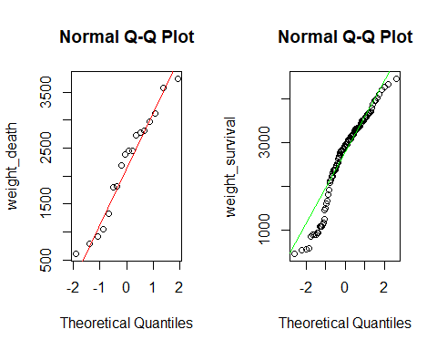

##   
## Shapiro-Wilk normality test  
##   
## data: weight_death  
## W = 0.9524, p-value = 0.4639

##   
## Shapiro-Wilk normality test  
##   
## data: weight_survival  
## W = 0.93856, p-value = 6.732e-05

因weight_survival為非normal distribution，故採用用中位數評估方法 - Wilcoxon Rank SUm test

wilcox.test(weight_survival,weight_death)

##   
## Wilcoxon rank sum test with continuity correction  
##   
## data: weight_survival and weight_death  
## W = 1322.5, p-value = 0.02812  
## alternative hypothesis: true location shift is not equal to 0

所以死亡組和存活組的出生體重確實有差異(P-value = 0.03 < 0.05)。

1. 在胎便吸入與否、出生方式、早期破水與否，這三個變項中，哪些變項在死亡和存活兩組間的比例分布是具有顯著差異。使用的統計方法稱為什麼？(選一個變數分析)

fecal <- table(PP$fecalInhale, PP$death, dnn = c("fecal inhale","death"))  
fecal

## death  
## fecal inhale 0 1  
## 0 78 16  
## 1 34 3

fecal_death <- c(fecal[2, 2], rowSums(fecal)[[2]])  
nonfecal_death <- c(fecal[1, 2], rowSums(fecal)[[1]])

prop.test(fecal_death,nonfecal_death)

##   
## 2-sample test for equality of proportions with continuity  
## correction  
##   
## data: fecal_death out of nonfecal_death  
## X-squared = 1.6985, df = 1, p-value = 0.1925  
## alternative hypothesis: two.sided  
## 95 percent confidence interval:  
## -0.45793146 0.04569742  
## sample estimates:  
## prop 1 prop 2   
## 0.187500 0.393617

胎便吸入與否並未造成胎兒死亡(P-value = 0.19 > 0.05，拒絕Ha假設)。

1. 上述1.~3.問題，分別是雙尾檢定、左尾檢定或右尾檢定？

* 皆為雙尾檢定(two-tailed)。

1. 上述1.問題中，在檢定兩組平均數是否相等時，你會選擇使用什麼方法？為什麼？需要注意哪些假設及條件。

* 先以Shapiro-test確認兩組別的數值是否常態分佈，確認皆為常態分佈，則進行var.test以F-est方式確認兩組的變異數是否相同，則接下來將選擇Student T-test進行分析。

1. 比較死亡組之1分鐘apgar、5分鐘apgar間是否有差異。(第6,7題選一題分析)

apgar1mm <- PP$X1mm_apgar[which(PP$death == 1)]  
apgar5mm <- PP$X5mm_apgar[which(PP$death == 1)]  
  
par(mfcol = c(1, 2))  
qqnorm(apgar1mm, ylab = "1分鐘apgar")  
qqline(apgar1mm, col="red")  
qqnorm(apgar5mm, ylab = "5分鐘apgar")  
qqline(apgar5mm, col="blue")

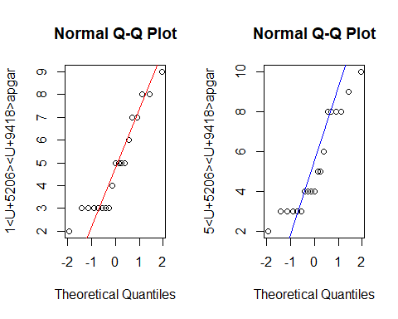

shapiro.test(apgar1mm)

##   
## Shapiro-Wilk normality test  
##   
## data: apgar1mm  
## W = 0.88916, p-value = 0.0311

shapiro.test(apgar5mm)

##   
## Shapiro-Wilk normality test  
##   
## data: apgar5mm  
## W = 0.88087, p-value = 0.02224

非常態分佈，故選用Wicoxon Rank Sum Test進行中位數分析。

wilcox.test(apgar1mm,apgar5mm)

## Warning in wilcox.test.default(apgar1mm, apgar5mm): cannot compute exact p-  
## value with ties

##   
## Wilcoxon rank sum test with continuity correction  
##   
## data: apgar1mm and apgar5mm  
## W = 163, p-value = 0.6122  
## alternative hypothesis: true location shift is not equal to 0

1分鐘apgar和5分鐘apgar造成的死亡並無統計差異(P-value = 0.61 > 0.05，拒絕Ha假設。)