源码分析---15：dataio-task-executor
3rd Dec 2021

综述
参考FATE的flowchart，常规任务开始的第一个组件，就是dataio。同前文，在${job_log_dir}/fate_flow_scheduler.log中输出如下命令后，开始通过task_executor执行dataio。输出的日志如下：
[INFO] [2021-06-04 14:42:02,995] [1:140456603948800] - job_utils.py[line:310]: start process command: /opt/app-root/bin/python /data/projects/fate/python/fate_flow/operation/task_executor.py -j 202106041441554669404 -n dataio_0 -t 202106041441554669404_dataio_0 -v 0 -r guest -p 9989 -c /data/projects/fate/jobs/202106041441554669404/guest/9989/dataio_0/202106041441554669404_dataio_0/0/task_parameters.json --run_ip 10.200.224.59 --job_server 10.200.224.59:9380
[INFO] [2021-06-04 14:42:03,005] [1:140456603948800] - job_utils.py[line:333]: start process command: /opt/app-root/bin/python /data/projects/fate/python/fate_flow/operation/task_executor.py -j 202106041441554669404 -n dataio_0 -t 202106041441554669404_dataio_0 -v 0 -r guest -p 9989 -c /data/projects/fate/jobs/202106041441554669404/guest/9989/dataio_0/202106041441554669404_dataio_0/0/task_parameters.json --run_ip 10.200.224.59 --job_server 10.200.224.59:9380 successfully, pid is 1657

[INFO] [2021-06-04 14:42:03,972] [1657:139893886592832] - task_executor.py[line:56]: enter task process
[INFO] [2021-06-04 14:42:03,972] [1657:139893886592832] - task_executor.py[line:57]: Namespace(component_name='dataio_0', config='/data/projects/fate/jobs/202106041441554669404/guest/9989/dataio_0/202106041441554669404_dataio_0/0/task_parameters.json', job_id='202106041441554669404', job_server='10.200.224.59:9380', party_id=9989, role='guest', run_ip='10.200.224.59', task_id='202106041441554669404_dataio_0', task_version=0)
具体的执行日志，会输出在dataio_0/DEBUG.log中。

执行细节
- task_executor.py：执行python命令，前期参数准备类似upload，但在init federation部分两者不同，upload是local的，data_io是多方协同的。两者在日志上的差别如下所示：
upload的
[DEBUG] [2021-07-26 08:20:39,837] [90:139687957583680] - _federation.py[line:35]: [federation.eggroll]init federation: rp_session_id=202107260820309976351_upload_0_0_local_0, rs_session_id=202107260820309976351_upload_0_0, party=Party(role=local, party_id=0), proxy_endpoint=rollsite:9370

data_io的
[DEBUG] [2021-08-20 10:01:15,929] [2673:140340420417344] - _federation.py[line:35]: [federation.eggroll]init federation: rp_session_id=202108201000594960226_dataio_0_0_guest_9989, rs_session_id=202108201000594960226_dataio_0_0, party=Party(role=guest, party_id=9989), proxy_endpoint=rollsite:9370
- task_executor.py：准备好相关参数之后，通过run，开始具体的执行任务。代码如下：
这里需要注意的是，DataIO类（源码：python/federatedml/util/data_io.py）没有重写run方法，故这里调用的是类ModelBase的run方法（源码：python/federatedml/model_base.py）。代码逻辑如下描述所示：
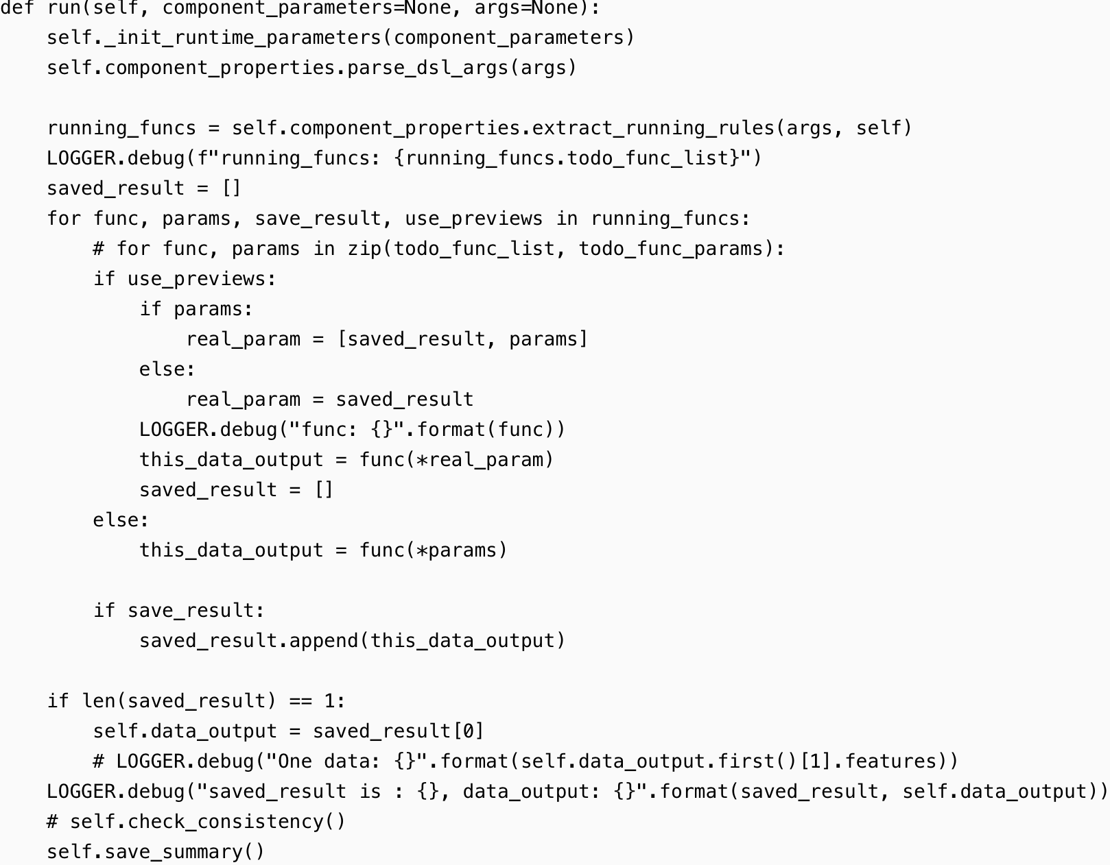
- model_base.py：执行_init_runtime_parameters初始化runtime_parameters，实际是调用component_properties.py的parse_component_param，输出日志如下：
[DEBUG] [2021-08-20 10:01:16,473] [2673:140340420417344] - component_properties.py[line:73]: {'DataIOParam': {'input_format': 'dense', 'delimitor': ',', 'data_type': 'float64', 'exclusive_data_type': None, 'tag_with_value': False, 'tag_value_delimitor': ':', 'missing_fill': True, 'default_value': 0, 'missing_fill_method': None, 'missing_impute': None, 'outlier_replace': True, 'outlier_replace_method': None, 'outlier_impute': None, 'outlier_replace_value': 0, 'with_label': True, 'label_name': 'y', 'label_type': 'int', 'output_format': 'dense', 'need_run': True}, 'initiator': {'role': 'guest', 'party_id': 9989}, 'job_parameters': {'job_type': 'train', 'work_mode': 1, 'backend': 0, 'computing_engine': 'EGGROLL', 'federation_engine': 'EGGROLL', 'storage_engine': 'EGGROLL', 'engines_address': {'computing': {'cores_per_node': 20, 'nodes': 1}, 'federation': {'host': 'rollsite', 'port': 9370}, 'storage': {'cores_per_node': 20, 'nodes': 1}}, 'federated_mode': 'MULTIPLE', 'task_parallelism': 1, 'computing_partitions': 4, 'federated_status_collect_type': 'PULL', 'model_id': 'arbiter-10000#guest-9989#host-10000#model', 'model_version': '202108201000594960226', 'eggroll_run': {'eggroll.session.processors.per.node': 4}, 'spark_run': {}, 'rabbitmq_run': {}, 'adaptation_parameters': {'task_nodes': 1, 'task_cores_per_node': 4, 'task_memory_per_node': 0, 'request_task_cores': 4, 'if_initiator_baseline': False}}, 'role': {'guest': [9989], 'host': [10000], 'arbiter': [10000]}, 'config': '/data/projects/fate/python/cl/fc/config/20210819/train_20210819_cgame2122_part.json', 'dsl': '/data/projects/fate/python/cl/fc/env/pattern/train_job_dsl.json', 'function': 'submit_job', 'local': {'role': 'guest', 'party_id': 9989}, 'CodePath': 'federatedml/util/data_io.py/DataIO', 'module': 'DataIO', 'output_data_name': ['train']}
[DEBUG] [2021-08-20 10:01:16,474] [2673:140340420417344] - component_properties.py[line:80]: need_run: True, need_cv: False
- model_base.py：component_properties.parse_dsl_args，调用component_properties.py的parse_dsl_args解析参数。
- 先判断是否有model或isometric_model参数
- 解析哪些有类型的datatype
[DEBUG] [2021-08-20 10:01:16,473] [2673:140340420417344] - component_properties.py[line:73]: {'DataIOParam': {'input_format': 'dense', 'delimitor': ',', 'data_type': 'float64', 'exclusive_data_type': None, 'tag_with_value': False, 'tag_value_delimitor': ':', 'missing_fill': True, 'default_value': 0, 'missing_fill_method': None, 'missing_impute': None, 'outlier_replace': True, 'outlier_replace_method': None, 'outlier_impute': None, 'outlier_replace_value': 0, 'with_label': True, 'label_name': 'y', 'label_type': 'int', 'output_format': 'dense', 'need_run': True}, 'initiator': {'role': 'guest', 'party_id': 9989}, 'job_parameters': {'job_type': 'train', 'work_mode': 1, 'backend': 0, 'computing_engine': 'EGGROLL', 'federation_engine': 'EGGROLL', 'storage_engine': 'EGGROLL', 'engines_address': {'computing': {'cores_per_node': 20, 'nodes': 1}, 'federation': {'host': 'rollsite', 'port': 9370}, 'storage': {'cores_per_node': 20, 'nodes': 1}}, 'federated_mode': 'MULTIPLE', 'task_parallelism': 1, 'computing_partitions': 4, 'federated_status_collect_type': 'PULL', 'model_id': 'arbiter-10000#guest-9989#host-10000#model', 'model_version': '202108201000594960226', 'eggroll_run': {'eggroll.session.processors.per.node': 4}, 'spark_run': {}, 'rabbitmq_run': {}, 'adaptation_parameters': {'task_nodes': 1, 'task_cores_per_node': 4, 'task_memory_per_node': 0, 'request_task_cores': 4, 'if_initiator_baseline': False}}, 'role': {'guest': [9989], 'host': [10000], 'arbiter': [10000]}, 'config': '/data/projects/fate/python/cl/fc/config/20210819/train_20210819_cgame2122_part.json', 'dsl': '/data/projects/fate/python/cl/fc/env/pattern/train_job_dsl.json', 'function': 'submit_job', 'local': {'role': 'guest', 'party_id': 9989}, 'CodePath': 'federatedml/util/data_io.py/DataIO', 'module': 'DataIO', 'output_data_name': ['train']}
[DEBUG] [2021-08-20 10:01:16,474] [2673:140340420417344] - component_properties.py[line:80]: need_run: True, need_cv: False
只要四种类型的data，有一种没有，has_normal_input_data就为true，

提交任务http请求

总结

https://blog.csdn.net/qq_28540443/article/details/104562797?spm=1001.2101.3001.6650.8&utm_medium=distribute.pc_relevant.none-task-blog-2%7Edefault%7ECTRLIST%7Edefault-8.highlightwordscore&depth_1-utm_source=distribute.pc_relevant.none-task-blog-2%7Edefault%7ECTRLIST%7Edefault-8.highlightwordscore

https://blog.csdn.net/yao544303963/article/details/120393274?spm=1001.2101.3001.6650.11&utm_medium=distribute.pc_relevant.none-task-blog-2%7Edefault%7EOPENSEARCH%7Edefault-11.no_search_link&depth_1-utm_source=distribute.pc_relevant.none-task-blog-2%7Edefault%7EOPENSEARCH%7Edefault-11.no_search_link

