dubbo源代码分析--dubbo与Spring整合原理
13TH Jul,2022

整体架构
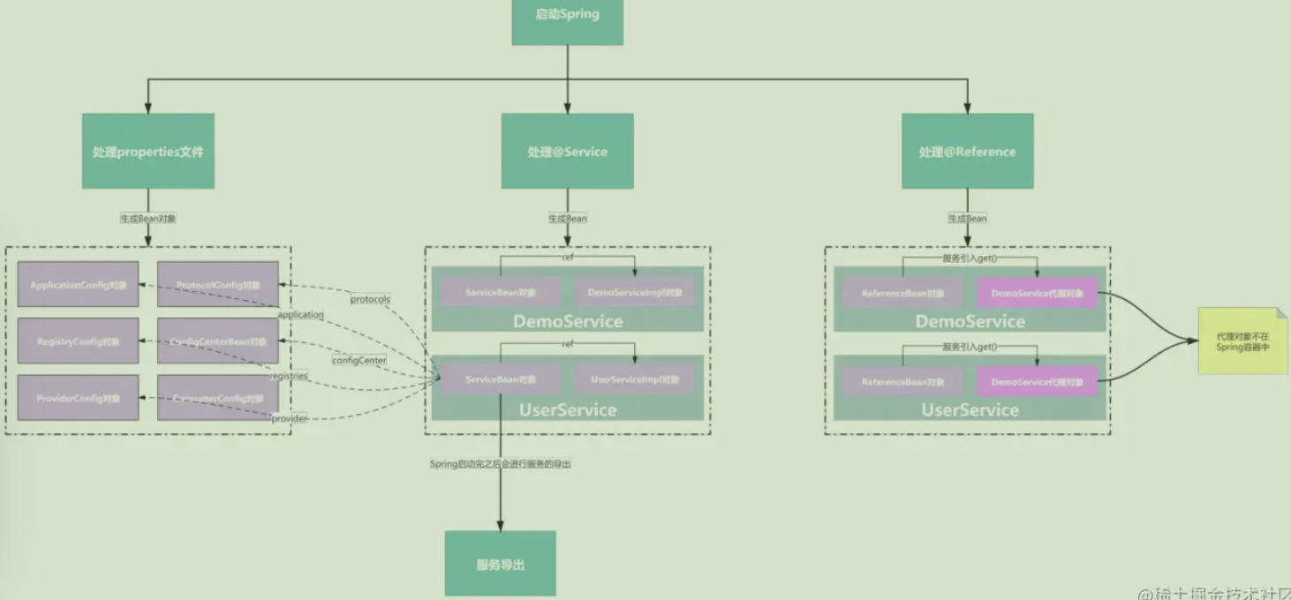

启动类和配置
package com.zyz;

import org.apache.dubbo.config.spring.context.annotation.EnableDubbo;
import org.springframework.context.annotation.AnnotationConfigApplicationContext;
import org.springframework.context.annotation.Configuration;
import org.springframework.context.annotation.PropertySource;

public class Application {
public static void main(String[] args) throws Exception {
AnnotationConfigApplicationContext context =
new AnnotationConfigApplicationContext(ProviderConfiguration.class);
context.start();
System.in.read();
}

@Configuration
@EnableDubbo(scanBasePackages = "org.apache.dubbo.demo.provider")
@PropertySource("classpath:/spring/dubbo-provider.properties")
static class ProviderConfiguration {

}
}

源码分析

EnbleDubbo注解
先从该注解开始，这个注解的作用是对指定包下的类进行扫描，扫描@Service与@Reference注解，并且进行处理。
查看该注解，发现包含两个很重要的注解@EnableDubboConfig和@DubboComponentScan，根据名字猜测，一个是将配置文件中的属性转成Bean并赋值，另外一个是扫描@Service和@Reference的注解。
@Target({ElementType.TYPE})
@Retention(RetentionPolicy.RUNTIME)
@Inherited
@Documented
@EnableDubboConfig
@DubboComponentScan
@EnableDubboLifecycle

@EnableDubboConfig注解
进入该注解，发现@Import了DubboConfigConfigurationRegistrar类：
@Target({ElementType.TYPE})
@Retention(RetentionPolicy.RUNTIME)
@Inherited
@Documented
@Import(DubboConfigConfigurationRegistrar.class)

DubboConfigConfigurationRegistrar类
根据Spring的一贯作风，被@Import注解的类，会执行注册方法，把自己注册为一个Bean。那么来看一下这个类的注册方法。
@Override
public void registerBeanDefinitions(AnnotationMetadata importingClassMetadata, BeanDefinitionRegistry registry) {

AnnotationAttributes attributes = AnnotationAttributes.fromMap(
importingClassMetadata.getAnnotationAttributes(EnableDubboConfig.class.getName()));

boolean multiple = attributes.getBoolean("multiple");

//单一绑定配置
registerBeans(registry, DubboConfigConfiguration.Single.class);

//多个实例绑定配置
if (multiple) { // Since 2.6.6 https://github.com/apache/dubbo/issues/3193
registerBeans(registry, DubboConfigConfiguration.Multiple.class);
}

//注册DubboConfigAliasPostProcessor后置处理器
registerDubboConfigAliasPostProcessor(registry);

//注册NamePropertyDefaultValueDubboConfigBeanCustomizer
registerDubboConfigBeanCustomizers(registry);

}
上述代码中有DubboConfigConfiguration.Single和DubboConfigConfiguration.multiple两种，其区别如下：
DubboConfigConfiguration.Single:单一绑定
dubbo.protocol.name=dubbo
dubbo.protocol.port=20880
DubboConfigConfiguration.multiple多实例绑定
dubbo.protocols.p1.id=dubbo1
dubbo.protocols.p1.name=dubbo
dubbo.protocols.p1.port=20881
dubbo.protocols.p1.host=0.0.0.0

dubbo.protocols.p2.id=dubbo2
dubbo.protocols.p2.name=dubbo
dubbo.protocols.p2.port=20882
dubbo.protocols.p2.host=0.0.0.0

dubbo.protocols.p3.id=dubbo3
dubbo.protocols.p3.name=dubbo
dubbo.protocols.p3.port=20883
dubbo.protocols.p3.host=0.0.0.0

DubboConfigConfiguration类
DubboConfigConfiguration通过DubboConfigConfigurationRegistratrar类包装得到，该类的作用就是将配置文件中的配置信息与具体的类进行绑定。
比如将dubbo.protocol同ProtocolConfig.class进行绑定。代码如下：
public class DubboConfigConfiguration {

/**
* Single Dubbo {@link AbstractConfig Config} Bean Binding
*/
@EnableConfigurationBeanBindings({
@EnableConfigurationBeanBinding(prefix = "dubbo.application", type = ApplicationConfig.class),
@EnableConfigurationBeanBinding(prefix = "dubbo.module", type = ModuleConfig.class),
@EnableConfigurationBeanBinding(prefix = "dubbo.registry", type = RegistryConfig.class),
@EnableConfigurationBeanBinding(prefix = "dubbo.protocol", type = ProtocolConfig.class),
@EnableConfigurationBeanBinding(prefix = "dubbo.monitor", type = MonitorConfig.class),
@EnableConfigurationBeanBinding(prefix = "dubbo.provider", type = ProviderConfig.class),
@EnableConfigurationBeanBinding(prefix = "dubbo.consumer", type = ConsumerConfig.class),
@EnableConfigurationBeanBinding(prefix = "dubbo.config-center", type = ConfigCenterBean.class),
@EnableConfigurationBeanBinding(prefix = "dubbo.metadata-report", type = MetadataReportConfig.class),
@EnableConfigurationBeanBinding(prefix = "dubbo.metrics", type = MetricsConfig.class),
@EnableConfigurationBeanBinding(prefix = "dubbo.ssl", type = SslConfig.class)
})
public static class Single {

}

/**
* Multiple Dubbo {@link AbstractConfig Config} Bean Binding
*/
@EnableConfigurationBeanBindings({
@EnableConfigurationBeanBinding(prefix = "dubbo.applications", type = ApplicationConfig.class, multiple = true),
@EnableConfigurationBeanBinding(prefix = "dubbo.modules", type = ModuleConfig.class, multiple = true),
@EnableConfigurationBeanBinding(prefix = "dubbo.registries", type = RegistryConfig.class, multiple = true),
@EnableConfigurationBeanBinding(prefix = "dubbo.protocols", type = ProtocolConfig.class, multiple = true),
@EnableConfigurationBeanBinding(prefix = "dubbo.monitors", type = MonitorConfig.class, multiple = true),
@EnableConfigurationBeanBinding(prefix = "dubbo.providers", type = ProviderConfig.class, multiple = true),
@EnableConfigurationBeanBinding(prefix = "dubbo.consumers", type = ConsumerConfig.class, multiple = true),
@EnableConfigurationBeanBinding(prefix = "dubbo.config-centers", type = ConfigCenterBean.class, multiple = true),
@EnableConfigurationBeanBinding(prefix = "dubbo.metadata-reports", type = MetadataReportConfig.class, multiple = true),
@EnableConfigurationBeanBinding(prefix = "dubbo.metricses", type = MetricsConfig.class, multiple = true)
})
public static class Multiple {

}
}

@EnableConfigurationBeanBindings
该注解就是包含所有的配置信息，注意的是，该注解@Import了ConfigurationBeanBindingRegister类。

ConfigurationBeanBindingRegister类
既然是被@Import引入的，还是看这个类的注册方法。其代码如下：
@Override
public void registerBeanDefinitions(AnnotationMetadata importingClassMetadata, BeanDefinitionRegistry registry) {
//获取配置文件中的属性(用key-value存储的)
AnnotationAttributes attributes = AnnotationAttributes.fromMap(
importingClassMetadata.getAnnotationAttributes(EnableConfigurationBeanBindings.class.getName()));
//获取配置的属性，就是dubbo.registrie这些值
AnnotationAttributes[] annotationAttributes = attributes.getAnnotationArray("value");

ConfigurationBeanBindingRegistrar registrar = new ConfigurationBeanBindingRegistrar();

registrar.setEnvironment(environment);
//循环注册bean
for (AnnotationAttributes element : annotationAttributes) {
registrar.registerConfigurationBeanDefinitions(element, registry);
}
}

registerConfigurationBeanDefinitions方法
上一节的代码中，registerConfigurationBeanDefinitions方法，将Bean注册到IOC中。该方法的代码如下描述所示：
protected void registerConfigurationBeanDefinitions(AnnotationAttributes attributes, BeanDefinitionRegistry registry) {

String prefix = environment.resolvePlaceholders(attributes.getString("prefix"));

Class<?> configClass = attributes.getClass("type");

boolean multiple = attributes.getBoolean("multiple");

boolean ignoreUnknownFields = attributes.getBoolean("ignoreUnknownFields");

boolean ignoreInvalidFields = attributes.getBoolean("ignoreInvalidFields");

registerConfigurationBeans(prefix, configClass, multiple, ignoreUnknownFields, ignoreInvalidFields, registry);
}

registerConfigurationBeans方法
该方法将配置属性中的值注册为一个一个的Bean，但是这个时候还没有赋值，而是通过注册一个赋值的后置处理器，后续进行赋值。
private void registerConfigurationBeans(String prefix, Class<?> configClass, boolean multiple,
boolean ignoreUnknownFields, boolean ignoreInvalidFields,
BeanDefinitionRegistry registry) {

Map<String, Object> configurationProperties = PropertySourcesUtils.getSubProperties(environment.getPropertySources(), environment, prefix);

if (CollectionUtils.isEmpty(configurationProperties)) {
if (log.isDebugEnabled()) {
log.debug("There is no property for binding to configuration class [" + configClass.getName()
+ "] within prefix [" + prefix + "]");
}
return;
}
//获取bean名称
Set<String> beanNames = multiple ? resolveMultipleBeanNames(configurationProperties) :
singleton(resolveSingleBeanName(configurationProperties, configClass, registry));
//注册为一个bean，但是不赋值。
for (String beanName : beanNames) {
registerConfigurationBean(beanName, configClass, multiple, ignoreUnknownFields, ignoreInvalidFields,
configurationProperties, registry);
}

//注册绑定bean属性值的后置处理器
registerConfigurationBindingBeanPostProcessor(registry);
}

ConfigurationBeanBindingPostProcessor类
这里会用到Spring的后置处理器的知识，首先通过PostProcessBeanFactory对类进行初始化，然后当Spring容器调用第一个后置处理器的时候，将之前初始化的bean进行赋值。
@Override
public void postProcessBeanFactory(ConfigurableListableBeanFactory beanFactory) throws BeansException {
//初始化bean工厂
this.beanFactory = beanFactory;
//初始化ConfigurationBeanBinder绑定器
initConfigurationBeanBinder();

initBindConfigurationBeanCustomizers();
}
@Override
public Object postProcessBeforeInitialization(Object bean, String beanName) throws BeansException {

BeanDefinition beanDefinition = getNullableBeanDefinition(beanName);

//判断是不是配置类型的Bean
if (isConfigurationBean(bean, beanDefinition)) {
//为Bean赋值
bindConfigurationBean(bean, beanDefinition);
//绑定后的处理，执行setName和getName方法
customize(beanName, bean);
}

return bean;
}

小结
到这里为止，Dubbo已经把我们在配置文件中配置的属性，转换为Dubbo的配置Bean，并赋值。其流程如下：
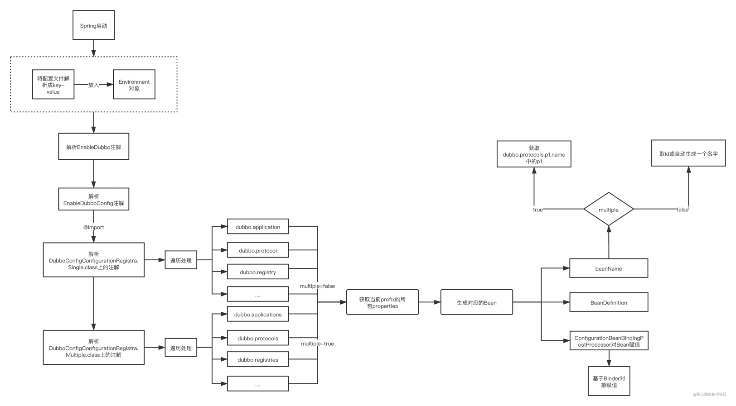

Dubbo和Spring配合使用的项目中，一般都有一个Dubbo的服务入口类，如下代码描述所示：
public class Application {
public static void main(String[] args) throws Exception {
AnnotationConfigApplicationContext context = new AnnotationConfigApplicationContext(ProviderConfiguration.class);
context.start();
System.in.read();
}

@Configuration
@EnableDubbo(scanBasePackages = "org.apache.dubbo.demo.provider")
@PropertySource("classpath:/spring/dubbo-provider.properties")
static class ProviderConfiguration {
@Bean
public RegistryConfig registryConfig() {
RegistryConfig registryConfig = new RegistryConfig();
registryConfig.setAddress("zookeeper://127.0.0.1:2181");
return registryConfig;
}
}
上述代码中static class ProviderConfiguration就是dubbo服务的入口类，该类使用@Configuration、@EnableDubbo、@PropertySource三个注解修饰，其中@PropertySource是Spring下的一个注解类，其作用就是利用Spring解析配置文件，把解析得到的内容放入到Environment类的环境中，让Dubbo方便获取。这里的Spring解析的配置文件就是@PropertySource注解描述的配置文件就是classpath:/spring/dubbo-provider.properties。其内容示例如下所示：
dubbo.application.name=dubbo-demo-annotation-provider
dubbo.protocol.name=dubbo
dubbo.protocol.port=20880
这里的描述对应了上图中Spring启动后进入的对配置文件的解析及放入到Environment环境的流程。

获取@Service流程
查看@EnableDubbo的源代码，有注解@DubboComponentScan，查看该注解的源代码，发现@Import了DubboComponentScanRegistrar类，那么该类就是解析@Service和@Reference注解的类，同时@Import将DubboComponentScanRegistrar类自动生成Bean并注入到了Spring的IOC中（参见Spring对@Import注解的解析）。类DubboComponentScanRegistrar类的注册方法如下：
@Override
public void registerBeanDefinitions(AnnotationMetadata importingClassMetadata, BeanDefinitionRegistry registry) {
//获取扫描包目录，也就是配置了dubbo.scan.base-packages或@EnableDubbo(scanBasePackages = "com.zyz.provider.service")的包
Set<String> packagesToScan = getPackagesToScan(importingClassMetadata);
//注册ServiceAnnotationBeanPostProcessor后置处理器，作用就是⼀旦扫描到某个@Service注解就把它以及被它注解的类当做⼀个Dubbo服务，进⾏服务导出
registerServiceAnnotationBeanPostProcessor(packagesToScan, registry);
//2.3的时候分析
registerReferenceAnnotationBeanPostProcessor(registry);

}
registerServiceAnnotationBeanPostProcessor就是注册了ServiceAnnotationBeanPostProcessor类，这个类就是注册了被@Service注解的类。通过方法registerServcieAnnocationBeanPostProcessor类实现注册的目的就是后置处理。DubboComponentScanRegistrar类实现对所有注解了@Service的类进行注册。

ServiceAnnotationBeanPostProcessor
@Override
public void postProcessBeanDefinitionRegistry(BeanDefinitionRegistry registry) throws BeansException {

// 注册DubboBootstrapApplicationListener类
registerBeans(registry, DubboBootstrapApplicationListener.class);
//再次解析扫描类
Set<String> resolvedPackagesToScan = resolvePackagesToScan(packagesToScan);

if (!CollectionUtils.isEmpty(resolvedPackagesToScan)) {
//注册ServiceBean
registerServiceBeans(resolvedPackagesToScan, registry);
} else {
if (logger.isWarnEnabled()) {
logger.warn("packagesToScan is empty , ServiceBean registry will be ignored!");
}
}
}
注册registerServiceBeas方法实现对所有Bean的注册，其代码如下：
private void registerServiceBeans(Set<String> packagesToScan, BeanDefinitionRegistry registry) {
//初始化Dubbo自己的扫描类，扫描@Service注解
DubboClassPathBeanDefinitionScanner scanner =
new DubboClassPathBeanDefinitionScanner(registry, environment, resourceLoader);
//初始化BeanName生成器
BeanNameGenerator beanNameGenerator = resolveBeanNameGenerator(registry);

scanner.setBeanNameGenerator(beanNameGenerator);

scanner.addIncludeFilter(new AnnotationTypeFilter(Service.class));

/**
* Add the compatibility for legacy Dubbo's @Service
*
* The issue : https://github.com/apache/dubbo/issues/4330
* @since 2.7.3
*/
scanner.addIncludeFilter(new AnnotationTypeFilter(com.alibaba.dubbo.config.annotation.Service.class));

for (String packageToScan : packagesToScan) {

//先注册被@Service注解的类，这里注册的是Spring的Bean
scanner.scan(packageToScan);

//找到Spring里的Bean(上边注册的)
Set<BeanDefinitionHolder> beanDefinitionHolders =
findServiceBeanDefinitionHolders(scanner, packageToScan, registry, beanNameGenerator);

if (!CollectionUtils.isEmpty(beanDefinitionHolders)) {

for (BeanDefinitionHolder beanDefinitionHolder : beanDefinitionHolders) {
//这里注册的是Dubbo的ServiceBean
registerServiceBean(beanDefinitionHolder, registry, scanner);
}

if (logger.isInfoEnabled()) {
logger.info(beanDefinitionHolders.size() + " annotated Dubbo's @Service Components { " +
beanDefinitionHolders +
" } were scanned under package[" + packageToScan + "]");
}

} else {

if (logger.isWarnEnabled()) {
logger.warn("No Spring Bean annotating Dubbo's @Service was found under package["
+ packageToScan + "]");
}

}

}

}
函数registerServiceBeans方法中调用了对每个Bean的注册，该函数为registerServiceBean，其代码如下：
private void registerServiceBean(BeanDefinitionHolder beanDefinitionHolder, BeanDefinitionRegistry registry,
DubboClassPathBeanDefinitionScanner scanner) {
//获取被@Service注解的Class
Class<?> beanClass = resolveClass(beanDefinitionHolder);
//获取@Service注解
Annotation service = findServiceAnnotation(beanClass);

//获取@Service注解的属性值
AnnotationAttributes serviceAnnotationAttributes = getAnnotationAttributes(service, false, false);
//获取该类实现的接口
Class<?> interfaceClass = resolveServiceInterfaceClass(serviceAnnotationAttributes, beanClass);
//获取该类名称
String annotatedServiceBeanName = beanDefinitionHolder.getBeanName();

AbstractBeanDefinition serviceBeanDefinition =
buildServiceBeanDefinition(service, serviceAnnotationAttributes, interfaceClass, annotatedServiceBeanName);

//获取ServiceBeanName，比如:ServiceBean:com.zyz.DemoService:async
String beanName = generateServiceBeanName(serviceAnnotationAttributes, interfaceClass);

if (scanner.checkCandidate(beanName, serviceBeanDefinition)) {
//注册ServiceBean
registry.registerBeanDefinition(beanName, serviceBeanDefinition);

if (logger.isInfoEnabled()) {
logger.info("The BeanDefinition[" + serviceBeanDefinition +
"] of ServiceBean has been registered with name : " + beanName);
}

} else {

if (logger.isWarnEnabled()) {
logger.warn("The Duplicated BeanDefinition[" + serviceBeanDefinition +
"] of ServiceBean[ bean name : " + beanName +
"] was be found , Did @DubboComponentScan scan to same package in many times?");
}

}

}

小结
到此，以注解@DubboComponentScan为入口的代码已经分解完毕。实际上就是注册了两个Bean。其流程如下：
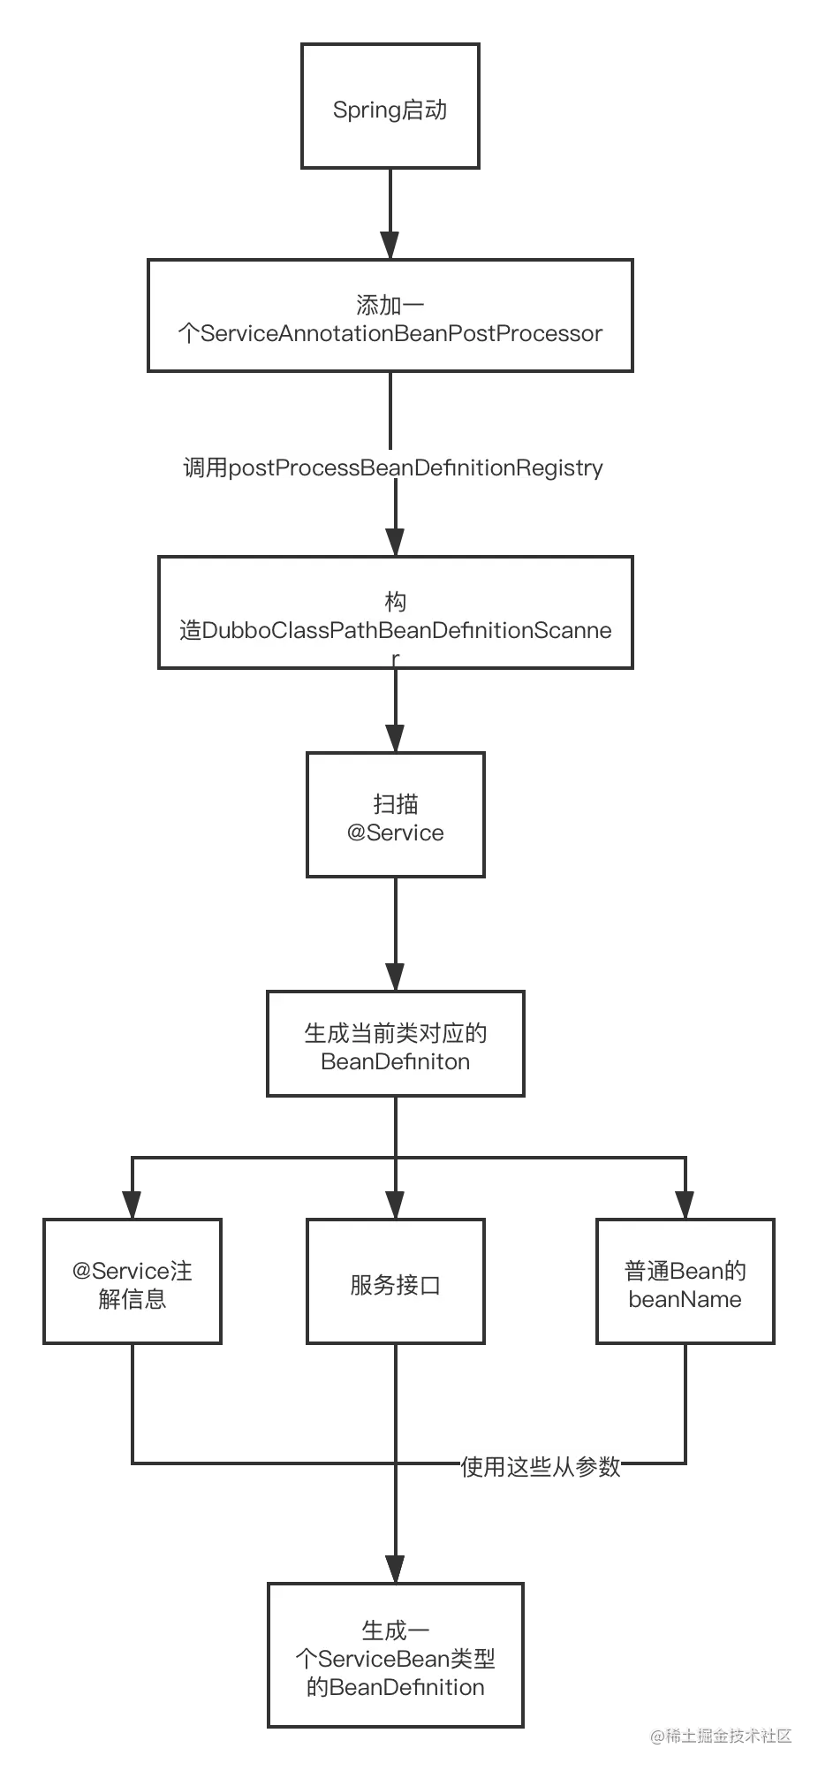

获取@Reference流程
在上一节中有一个registerReferenceAnnotationBeanPostProcessor方法，该方法就是注册ReferenceAnnocationBeanPostProcessor这个后置处理器的，用来获取@Reference注解的类和方法，并注入属性。该类又继承了AbstractAnnotationBeanPostProcessor类。

AbstractAnnotationBeanPostProcessor
会先调用该类的postProcessorPropertyValues方法。该方法代码如下：
@Override
public PropertyValues postProcessPropertyValues(
PropertyValues pvs, PropertyDescriptor[] pds, Object bean, String beanName) throws BeanCreationException {
//获得所有注入属性
InjectionMetadata metadata = findInjectionMetadata(beanName, bean.getClass(), pvs);
try {
metadata.inject(bean, beanName, pvs);
} catch (BeanCreationException ex) {
throw ex;
} catch (Throwable ex) {
throw new BeanCreationException(beanName, "Injection of @" + getAnnotationType().getSimpleName()
+ " dependencies is failed", ex);
}
return pvs;
}
findInjectionMetadata方法用来查找所有注入bean的元数据。其代码如下：
private InjectionMetadata findInjectionMetadata(String beanName, Class<?> clazz, PropertyValues pvs) {
//获得缓存key
String cacheKey = (StringUtils.hasLength(beanName) ? beanName : clazz.getName());
// Quick check on the concurrent map first, with minimal locking.
AbstractAnnotationBeanPostProcessor.AnnotatedInjectionMetadata metadata = this.injectionMetadataCache.get(cacheKey);
if (InjectionMetadata.needsRefresh(metadata, clazz)) {
synchronized (this.injectionMetadataCache) {
metadata = this.injectionMetadataCache.get(cacheKey);
if (InjectionMetadata.needsRefresh(metadata, clazz)) {
if (metadata != null) {
metadata.clear(pvs);
}
try {
//构建属性
metadata = buildAnnotatedMetadata(clazz);
this.injectionMetadataCache.put(cacheKey, metadata);
} catch (NoClassDefFoundError err) {
throw new IllegalStateException("Failed to introspect object class [" + clazz.getName() +
"] for annotation metadata: could not find class that it depends on", err);
}
}
}
}
return metadata;
}
findInjectionMetadata首先根据beanName从缓存中获取metadata，如果找到且不需要刷新则直接返回该metadata；否则将该metadata从PropertyValues中将其删除，接着构建metadata。代码在函数buildAnnotationMetadata，创建完成之后将其放入到injectionMetadataCache中。构建metadata的代码如下：
private AbstractAnnotationBeanPostProcessor.AnnotatedInjectionMetadata buildAnnotatedMetadata(final Class<?> beanClass) {
//获取类上的@Reference
Collection<AbstractAnnotationBeanPostProcessor.AnnotatedFieldElement> fieldElements = findFieldAnnotationMetadata(beanClass);
//获取方法上的@Reference
Collection<AbstractAnnotationBeanPostProcessor.AnnotatedMethodElement> methodElements = findAnnotatedMethodMetadata(beanClass);
return new AbstractAnnotationBeanPostProcessor.AnnotatedInjectionMetadata(beanClass, fieldElements, methodElements);
}
至此已经完成了从缓存中根据beanName创建metadata或构件metadata的所有过程，重新回到函数postProcessPropertyValues方法中，存在代码metadata.inject(bean,beanName,pvs)，将metadata入住到IOC中。

inject方法
任何被注入到IOC中的类都有两个这样的属性：
private final Collection<AbstractAnnotationBeanPostProcessor.AnnotatedFieldElement> fieldElements;

private final Collection<AbstractAnnotationBeanPostProcessor.AnnotatedMethodElement> methodElements;
一个用来描述类的属性信息的列表，一个用来描述类的方法信息的列表。这两个列表会被分别遍历，即调用AnnotatedInjectionMetadata的inject方法，其代码如下：
@Override
protected void inject(Object bean, String beanName, PropertyValues pvs) throws Throwable {
//获得属性值
Class<?> injectedType = field.getType();
//获得注入对象
Object injectedObject = getInjectedObject(attributes, bean, beanName, injectedType, this);

ReflectionUtils.makeAccessible(field);

field.set(bean, injectedObject);

}
在调用注入的过程中，调用函数getInjectedObject获取已经被注入的对象。函数代码如下：
protected Object getInjectedObject(AnnotationAttributes attributes, Object bean, String beanName, Class<?> injectedType,
InjectionMetadata.InjectedElement injectedElement) throws Exception {

String cacheKey = buildInjectedObjectCacheKey(attributes, bean, beanName, injectedType, injectedElement);
//先从缓存拿
Object injectedObject = injectedObjectsCache.get(cacheKey);
//缓存没有，就初始化
if (injectedObject == null) {
injectedObject = doGetInjectedBean(attributes, bean, beanName, injectedType, injectedElement);
// Customized inject-object if necessary
injectedObjectsCache.putIfAbsent(cacheKey, injectedObject);
}

return injectedObject;

}
getInjectedObject也是先从缓存中获取已经注入的对象，若存在则直接返回，否则调用函数doGetInjectedBean进行初始化Bean。doGetInjectedBean函数代码如下所示：
@Override
protected Object doGetInjectedBean(AnnotationAttributes attributes, Object bean, String beanName, Class<?> injectedType,
InjectionMetadata.InjectedElement injectedElement) throws Exception {
//生成ServiceBean:com.zyz.DemoService:default
String referencedBeanName = buildReferencedBeanName(attributes, injectedType);

//@Reference(version=default) com.zyz.DemoService
String referenceBeanName = getReferenceBeanName(attributes, injectedType);

//创建ReferenceBean
ReferenceBean referenceBean = buildReferenceBeanIfAbsent(referenceBeanName, attributes, injectedType);

//注册ReferenceBean
registerReferenceBean(referencedBeanName, referenceBean, attributes, injectedType);
//缓存
cacheInjectedReferenceBean(referenceBean, injectedElement);
//创建代理
return getOrCreateProxy(referencedBeanName, referenceBeanName, referenceBean, injectedType);
}
最后通过创建代理对象，从本地或远程获创建对象，实际上就是创建一个proxy来代表远程或本地提供服务的Bean。getOrCreateProxy的代码如下图描述所示：
private Object getOrCreateProxy(String referencedBeanName, String referenceBeanName, ReferenceBean referenceBean, Class<?> serviceInterfaceType) {
if (existsServiceBean(referencedBeanName)) { //本地服务存在的话，就创建代理
return newProxyInstance(getClassLoader(), new Class[]{serviceInterfaceType},
wrapInvocationHandler(referenceBeanName, referenceBean));
} else {
// 应该去注册中心去拿服务，然后把对象创建出来
return referenceBean.get();
}
}
如果本地不存在代理，则需要去注册中心获取服务，然后将对象创建出来，返回代理服务的对象（这里采用了Proxy模式或Facade模式）。referenceBean.get方法的代码如下：
public synchronized T get() {
if (destroyed) {
throw new IllegalStateException("The invoker of ReferenceConfig(" + url + ") has already destroyed!");
}
if (ref == null) {
//初始化远程服务
init();
}
return ref;
}
对于这个方法，如果可以确保获取远程服务的逻辑，在DubboLifecycleComponentApplicationListener事件之后，就可以避免启动DubboBootstrap.init方法，因为DubboBootstrap是在DubboLifecycleComponentApplicatioinListener之后启动的。
public synchronized T get() {
if (destroyed) {
throw new IllegalStateException("The invoker of ReferenceConfig(" + url + ") has already destroyed!");
}
if (ref == null) {
//初始化远程服务
init();
}
return ref;
}

小结
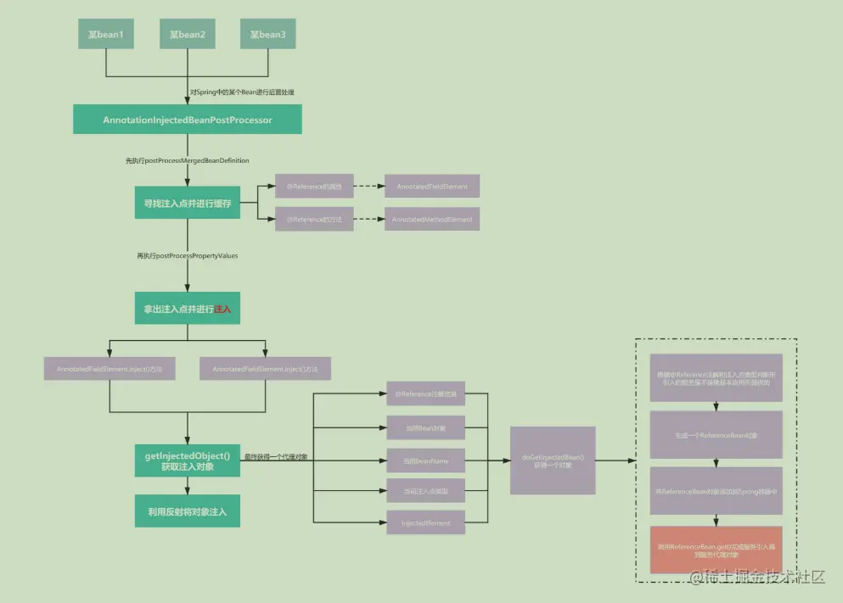
至此已经分析完毕，Spring通过激活@EnableDubbo下的@DubboComponentScan注解，由注解@DubboComponentScan中存在@Import DubboComponentScanRegistrar类，该类被@Import修饰，将会被自动注册到IOC中完成Bean的注入，在类DubboComponentScanRegistrar中扫描@Service和@Reference，并他们对应的Bean注入到IOC中。

总结

@Import用来导入@Configuration注解的配置类、声明@Bean的bean方法、导入ImortSelector的实现类或导入ImportBeanDefinitionRegistrar的实现类。

