(1) Given 1-d Gaussian function, draw it.

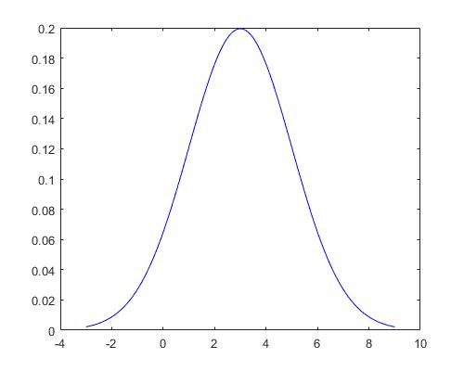

(2) Given 2-d Gaussian function, draw it.

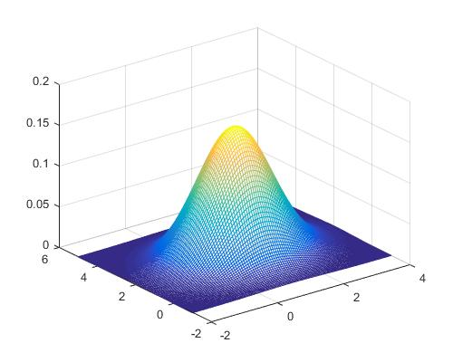

(3) Call 1-d Gaussian random data and plot 1-d histogram.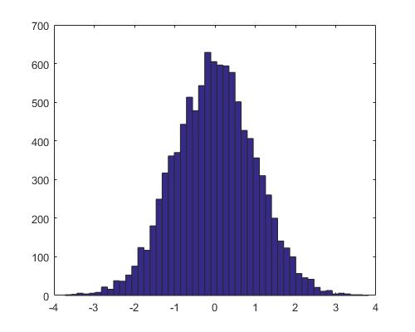

(4) Call 2-d Gaussian random data. 點在 2-d space 上。 Plot 2-d histogram.

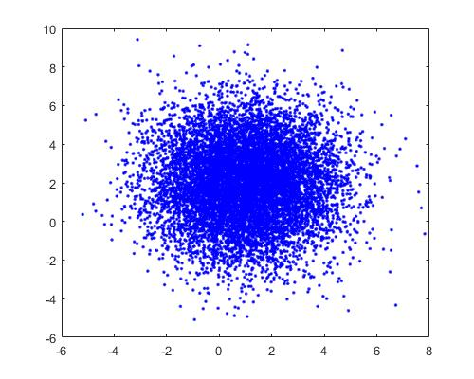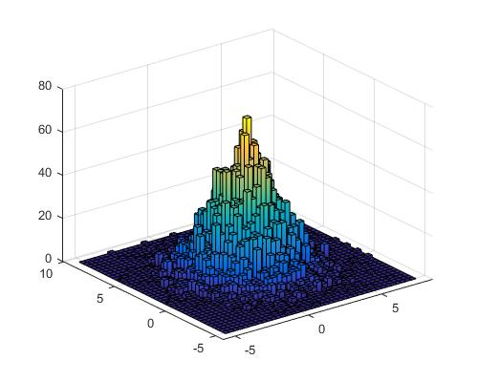

(5) 承(4)，在 2-d histogram 上畫等高線圖。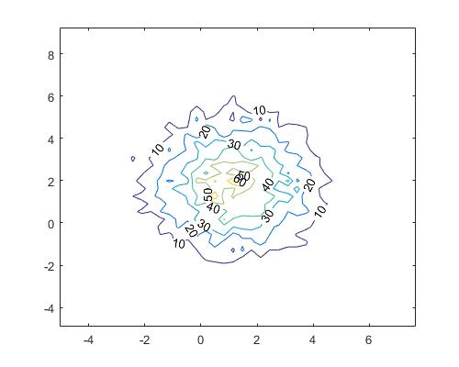

(6) Plot line x-y=1.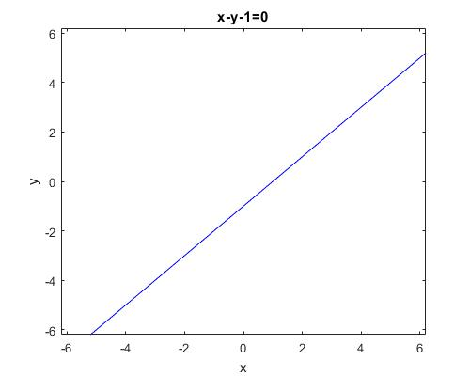

(7) Plot circle x^2+y^2=1.

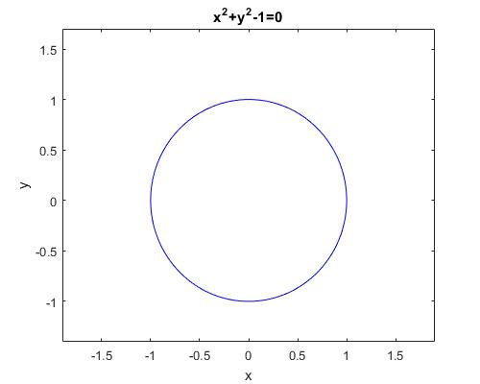

(8) Plot ellipse x^2+y^2/4 =1.

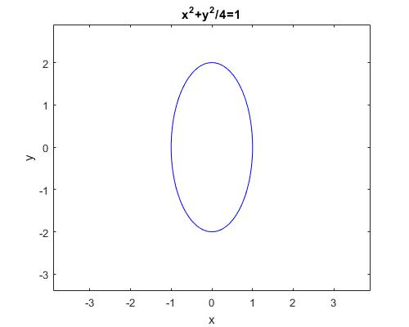

(9) Plot hyperbola x^2-y^2/4 =1.

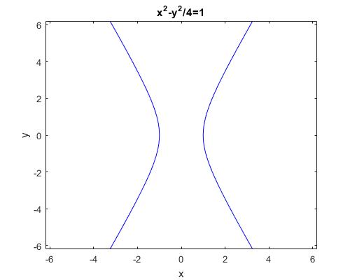

(10) Generate data of line 2x-y=0 and plot.

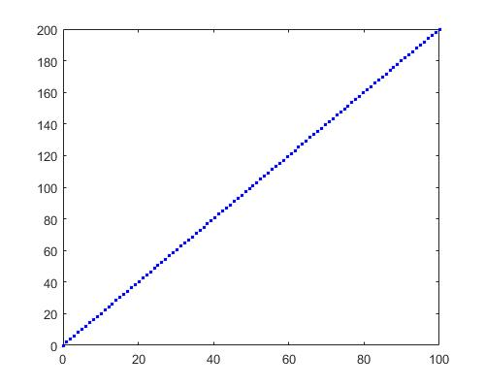

%(11) Generate data of circle x^2+y^2=4 and plot.

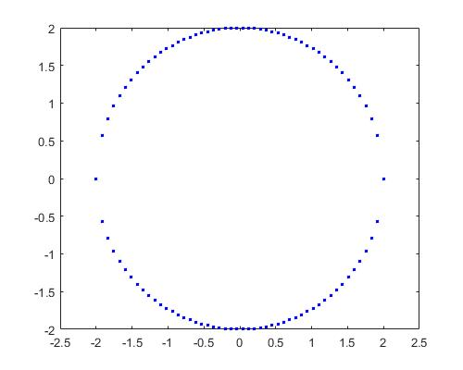

%(12) Generate data of ellipse x^2/4+y^2=1 and plot.

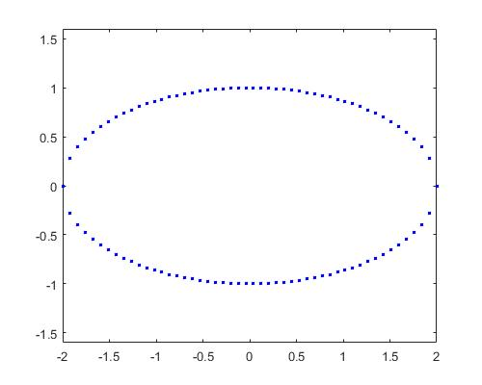

%(13) Generate data of hyperbola xy=1 and plot.

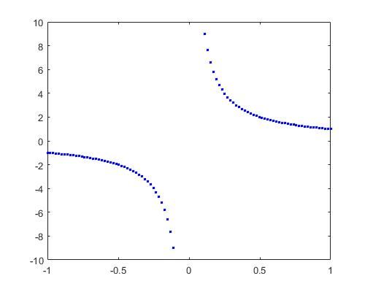

(14) Plot two spirals.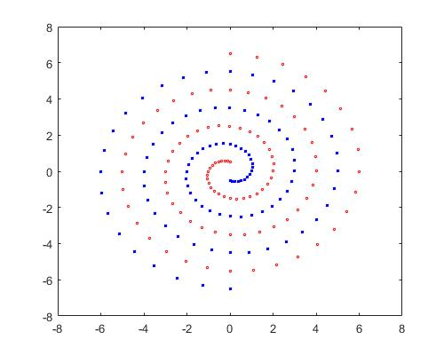

(15) Plot 8 points in the three dimensional space, and the plane z = x – y + 0.5 that can separate these two classes.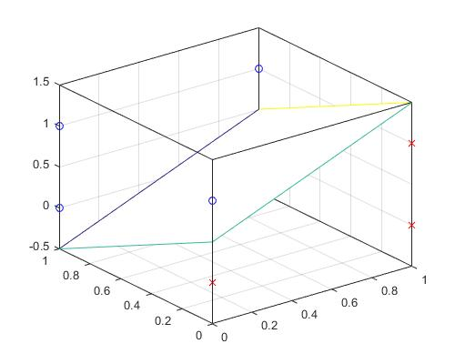

(16) Plot double moon problem:

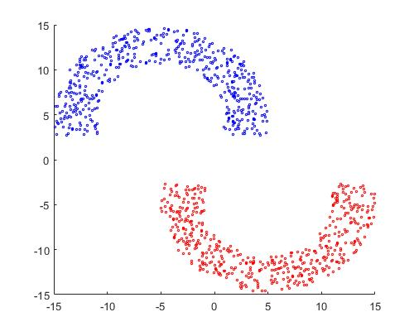

17. Given 5 sine function with different periods (different frequencies)

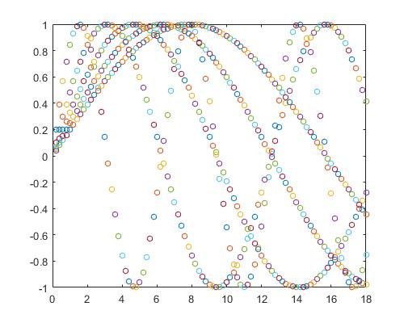

18.Design a uniform random number generator

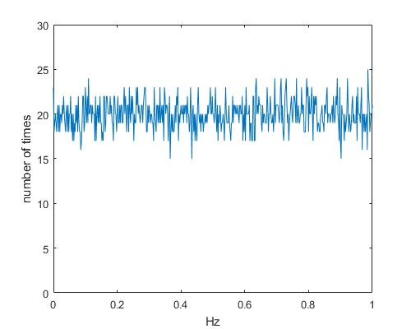

參考

Digital Quasi-Random Modulated SFAVM PWM in an AC-Drive System

此篇論文提出一種公式可以產生隨機數字，從上圖可以看出，0到1之間，每個數字出現的次數都在15-25次之間，此圖總共產生10000個data。

以下為公式



%(1) Given 1-d Gaussian function, draw it.

hFig = figure(1);

set(hFig,'name','(1) Given 1-d Gaussian function, draw it.','Position', [0 0 500 400]);

Mean=3;

Variance=4;

MySigma=sqrt(Variance);

x=linspace(Mean-3\*MySigma,Mean+3\*MySigma);

y=normpdf(x,Mean,MySigma);

L=plot(x,y);

set(L,'Color','blue');

%(2) Given 2-d Gaussian function, draw it.

hFig = figure(2);

set(hFig,'name','(2) Given 2-d Gaussian function, draw it.','Position', [100 0 500 400]);

Mean = [1 2];

Covariance = [1 0;0 1];

[X,Y] = meshgrid(linspace(Mean(1)-3\*Covariance(1,1),Mean(1)+3\*Covariance(1,1)),linspace(Mean(2)-3\*Covariance(2,2),Mean(2)+3\*Covariance(2,2)));

Z = mvnpdf([X(:) Y(:)],Mean,Covariance);

Z = reshape(Z,size(X));

mesh(X,Y,Z);

%(3) Call 1-d Gaussian random data and plot 1-d histogram.

hFig = figure(3);

set(hFig,'name','(3) Call 1-d Gaussian random data and plot 1-d histogram.','Position', [200 0 500 400]);

Mean = 0;

MySigma = 1;

NormalHist = randn(1 , 10000)\*MySigma + Mean;

hist(NormalHist, 50);

%(4) Call 2-d Gaussian random data. ÂI¦b 2-d space ¤W

hFig = figure(4);

set(hFig,'name','(4) Call 2-d Gaussian random data. ÂI¦b 2-d space ¤W','Position', [300 0 500 400]);

Mean = [1;2];

MySigma = [3 0; 0 4];

NormalPoint = mvnrnd(Mean, MySigma, 10000);

L=plot(NormalPoint(:,1),NormalPoint(:,2),'.');

set(L,'Color','blue');

%(4) Call 2-d Gaussian random data. Plot 2-d histogram.

hFig = figure(5);

set(hFig,'name','(4) Call 2-d Gaussian random data. Plot 2-d histogram.','Position', [400 0 500 400]);

hist3(NormalPoint,[40 40]);

set(get(gca,'child'),'FaceColor','interp','CDataMode','auto');

%(5) ©Ó(4)¡A¦b 2-d histogram ¤Wµeµ¥°ª½u¹Ï¡C

hFig = figure(6);

set(hFig,'name','(5) ©Ó(4)¡A¦b 2-d histogram ¤Wµeµ¥°ª½u¹Ï¡C','Position', [500 0 500 400]);

[n,c]=hist3(NormalPoint,[40 40]);

[e,h] = contour(c{1}, c{2}, n);

clabel(e,h);

%(6) Plot line x-y=1.

hFig = figure(7);

set(hFig,'name','(6) Plot line x-y=1.','Position', [600 0 500 400]);

L=ezplot('x-y-1=0',[-6.2 6.2],[-6.2 6.2]);

set(L,'Color','blue');

%(7) Plot circle x^2+y^2=1.

hFig = figure(8);

set(hFig,'name','(7) Plot circle x^2+y^2=1.','Position', [700 0 500 400]);

L=ezplot('x.^2+y.^2-1=0',[-1.9 1.9],[-1.4 1.7]);

set(L,'Color','blue');

%(8) Plot ellipse x^2+y^2/4 =1.

hFig = figure(9);

set(hFig,'name','(8) Plot ellipse x^2+y^2/4 =1.','Position', [800 0 500 400]);

L=ezplot('x.^2+y.^2./4=1',[-3.9 3.9],[-3.4 2.9]);

set(L,'Color','blue');

%(8) Plot ellipse x^2-y^2/4 =1.

hFig = figure(10);

set(hFig,'name','(8) Plot ellipse x^2-y^2/4 =1.','Position', [900 0 500 400]);

L=ezplot('x.^2-y.^2./4=1',[-6.2 6.2],[-6.2 6.2]);

set(L,'Color','blue');

%(10) Generate data of line 2x-y=0 and plot.

hFig = figure(11);

set(hFig,'name','(10) Generate data of line 2x-y=0 and plot.','Position', [1000 0 500 400]);

x = linspace(0,100,100);

y = 2\*x;

L=plot(x,y,'\*','MarkerSize',2);

set(L,'Color','blue');

%(11) Generate data of circle x^2+y^2=4 and plot.

hFig = figure(12);

set(hFig,'name','(11) Generate data of circle x^2+y^2=4 and plot.','Position', [1100 0 500 400]);

x = linspace(-2,2,50);

y1 = sqrt(4-x.^2);

y2 = -sqrt(4-x.^2);

L=plot(x,y1,'\*','MarkerSize',2);

set(L,'Color','blue');

hold on;

L=plot(x,y2,'\*','MarkerSize',2);

set(L,'Color','blue');

hold off;

axis([-2.5 2.5 -2 2]);

%(12) Generate data of ellipse x^2/4+y^2=1 and plot.

hFig = figure(13);

set(hFig,'name','(12) Generate data of ellipse x^2/4+y^2=1 and plot. ','Position', [0 500 500 400]);

x = linspace(-2,2,50);

y1 = sqrt(1-x.^2/4);

y2 = -sqrt(1-x.^2/4);

L=plot(x,y1,'\*','MarkerSize',2);

set(L,'Color','blue');

hold on;

L=plot(x,y2,'\*','MarkerSize',2);

set(L,'Color','blue');

hold off;

axis([-2 2 -1.6 1.6])

%(13) Generate data of hyperbola xy=1 and plot.

hFig = figure(14);

set(hFig,'name','(13) Generate data of hyperbola xy=1 and plot.','Position', [100 500 500 400]);

x = linspace(-1,1,100);

y = 1./x;

L=plot(x,y,'\*','MarkerSize',2);

set(L,'Color','blue');

axis([-1 1 -10 10]);

%(14) Plot two spirals.

hFig = figure(15);

set(hFig,'name','(14) Plot two spirals.','Position', [200 500 500 400]);

for i = 0:96

thetai = pi.\*i/16;

ri = 6.5.\*(104-i)./104;

xi = ri.\*sin(thetai);

yi = ri.\*cos(thetai);

plot(xi,yi,'o','MarkerSize',2,'MarkerEdgeColor','r');

axis([-8 8 -8 8]);

hold on;

end

for j = 0:96

thetaj = pi.\*j/16;

rj = 6.5.\*(104-j)./104;

xj = -rj.\*sin(thetaj);

yj = -rj.\*cos(thetaj);

plot(xj,yj,'\*','MarkerSize',2,'MarkerEdgeColor','b');

axis([-8 8 -8 8]);

hold on;

end

%(15) Plot 8 points in the three dimensional space, and the plane z = x ¡V y + 0.5 that can separate these two classes.

hFig = figure(16);

set(hFig,'name','(15) Plot 8 points in the three dimensional space, and the plane z = x ¡V y + 0.5 that can separate these two classes.','Position', [300 500 500 400]);

point=[0 1 1;0 0 0;1 0 0; 1 0 1;0 0 1;1 1 0;1 1 1;0 1 0]

for i=1:8

x = point(i,1);

y = point(i,2);

z = point(i,3);

if x - y + 0.5 < z

scatter3(x,y,z,'b','o');

else

scatter3(x,y,z,'r','x');

end

hold on;

end

set(gca,'xtick',0:0.2:1);

set(gca,'ytick',0:0.2:1);

set(gca,'ztick',-0.5:0.5:1.5);

axis([0 1 0 1 -0.5 1.5])

x = 0:1;

y = 0:1;

[X,Y] = meshgrid(x,y);

Z = X-Y+0.5;

mesh(X,Y,Z);

box on;

ax = gca;

ax.BoxStyle = 'full';

%(16) Plot double moon problem:

hFig = figure(17);

set(hFig,'name','(16) Plot double moon problem:','Position', [400 500 500 400]);

i=1

while i<501

x = -15+20\*rand;

y = -2+14\*rand;

d = ((x+5)^2)+(y^2);

if d>36 && d<100

bx(i)=x;

by(i)=y;

i=i+1;

end

hold on;

end

i=1;

while i <501;

x =-5+20\*rand;

y =-12+14\*rand;

d = ((x-5)^2)+(y^2);

if d>36&& d<100

rx(i)=x;

ry(i)=y;

i=i+1;

end

hold on;

end

b = plot(bx,by,'o','MarkerEdgeColor','b','MarkerSize',2);

r = plot(rx,ry,'o','MarkerEdgeColor','r','MarkerSize',2);

axis([-15 15 -15 15]);

for count=1:3

for i = 1:50

tempy = by+i/10;

set(b, 'ydata', tempy);

tempy = ry-i/10;

set(r, 'ydata', tempy);

drawnow;

end

for i = 1:60

tempy = by-i/10+5;

set(b, 'ydata', tempy);

tempy = ry+i/10-5;

set(r, 'ydata', tempy);

drawnow;

end

end

%17. Given 5 sine function with different periods (different frequencies)

hFig = figure(18);

set(hFig,'name','17. Given 5 sine function with different periods (different frequencies)','Position', [500 500 500 400]);

for j=1:5

for i=1:90

plot(i/5,sin(i/(5\*j)),'o','MarkerSize',5);

hold on;

axis([0 18 -1 1]);

M(i) = getframe;

end

end

%18.Design a uniform random number generator

hFig = figure(19);

set(hFig,'name','18.Design a uniform random number generator','Position', [600 500 500 400]);

low = 0;

high = 500;

Ia = 106;

Ic = 1283;

Im = 6075;

fran = 250;

count(1:501) = 0;

%

count(fran+1) = count(fran+1) +1;

%

for i = 1:10000

fran = mod((fran\*Ia+Ic),Im);

fsw = low + floor(((high-low+1)\*fran)/Im);

count(fsw+1) = count(fsw+1)+1;

end;

plot(0:0.002:1, count);

axis([0 1 0 30]);

xlabel('Hz');

ylabel('number of times');