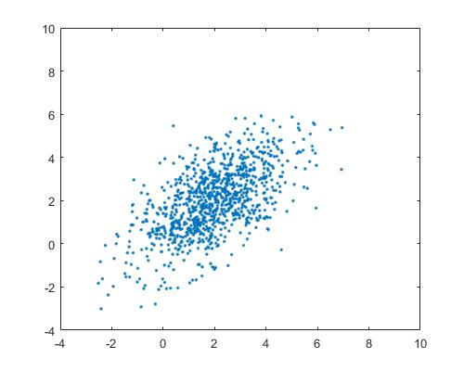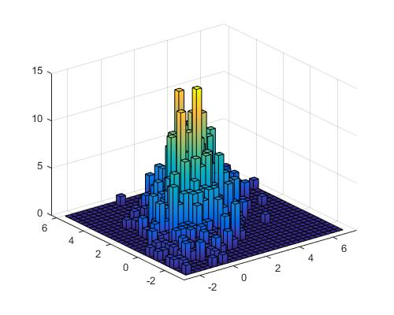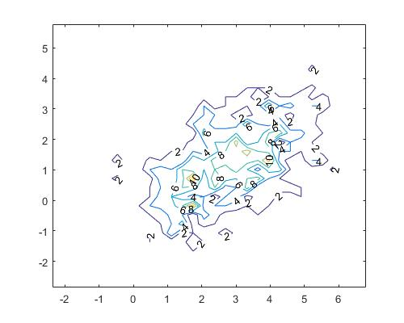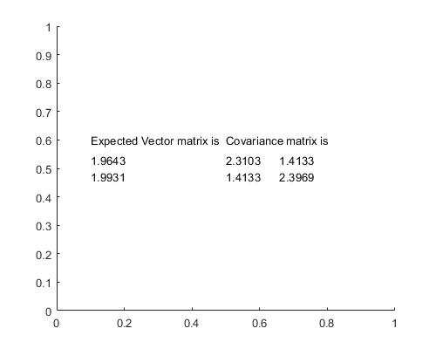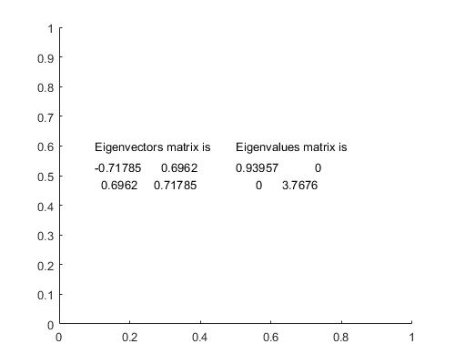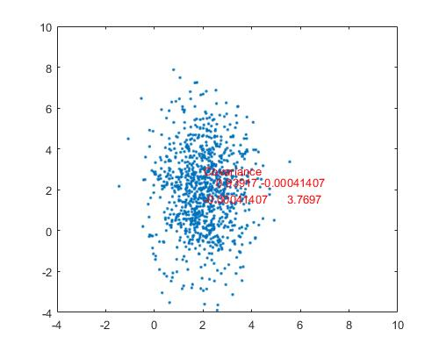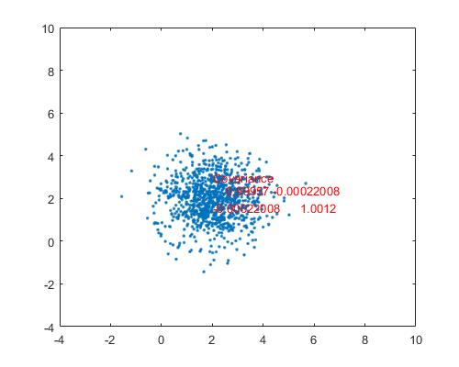

%0556638±i¬°¸Û

hFig = figure(1);

set(hFig,'name','data','Position', [0 0 500 400]);

Mean = [2 2];

MySigma=3;

Covariance = [2.5 1.5;1.5 2.5];

K=[1 0;0 2];

[V,D]=eig(Covariance);

X = randn(1000,1); %²£¥Íx¤è¦Vdata

Y = randn(1000,1); %²£¥Íy¤è¦Vdata

Point=[X Y]; %«Ø¦¨poiny²£¥Í2°ª´µdata N(0,1)

TPoint=transpose(Point);

B=ones(1000,1)\*Mean;

Plotp=V\*sqrt(D)\*TPoint+transpose(B);%­pºâ·sªº2d°ª´µ

B=ones(1000,1)\*Mean;

TPlotp=transpose(Plotp);

L=plot(TPlotp(:,1),TPlotp(:,2),'.');

axis([-4 10 -4 10])

hFig = figure(2);

set(hFig,'name','histogram','Position', [100 0 500 400]);

hist3(TPlotp,[30 30]);

set(get(gca,'child'),'FaceColor','interp','CDataMode','auto');

hFig = figure(3);

set(hFig,'name','µ¥°ª½u¹Ï¡C','Position', [200 0 500 400]);

[n,c]=hist3(TPlotp,[30 30]);

[e,h] = contour(c{1}, c{2}, n);

clabel(e,h);

%­pºâExpectedVector

sumx=0;

for i=1:1000

sumx=sumx+ Plotp(1,i);

end

sumx=sumx/1000;

sumy=0;

for i=1:1000

sumy=sumy+ Plotp(2,i);

end

sumy=sumy/1000;

%­pºâCovariance

a11=0;

for i=1:1000

a11=a11+(Plotp(1,i)-sumx)^2;

end

a11=a11/1000;

a22=0;

for i=1:1000

a22=a22+(Plotp(2,i)-sumx)^2;

end

a22=a22/1000;

a12=0;

for i=1:1000

tempx=Plotp(1,i)-sumx;

tempy=Plotp(2,i)-sumx;

a12=a12+tempx\*tempy;

end

a12=a12/1000;

NewExpectedVector=[sumx;sumy];

NewCovariance=[a11 a12;a12 a22];

[NV,ND,IINV]=eig(NewCovariance);

hFig = figure(4);

set(hFig,'name','ExpectedVector,Covarianc','Position', [300 0 500 400]);

text(0.1,0.6,'Expected Vector matrix is','HorizontalAlignment','left');

text(0.1,0.5,num2str(NewExpectedVector),'HorizontalAlignment','left');

text(0.5,0.6,'Covariance matrix is','HorizontalAlignment','left');

text(0.5,0.5,num2str(NewCovariance),'HorizontalAlignment','left');

hFig = figure(5);

set(hFig,'name','Eigenvectors,Eigenvalues','Position', [400 0 500 400]);

text(0.1,0.6,'Eigenvectors matrix is','HorizontalAlignment','left');

text(0.1,0.5,num2str(NV),'HorizontalAlignment','left');

text(0.5,0.6,'Eigenvalues matrix is','HorizontalAlignment','left');

text(0.5,0.5,num2str(ND),'HorizontalAlignment','left');

%Diagonalization

hFig = figure(6);

set(hFig,'name','Diagonalization','Position', [500 0 500 400]);

NDD=[1/sqrt(ND(1,1)) 0;0 1/sqrt(ND(2,2))];

Plotp=IINV\*(Plotp-transpose(B))+transpose(B);%´î¥h­ì¥»MEAN­È­pºâ·sªº2d°ª´µ

TPlotp=transpose(Plotp);

%­pºâExpectedVector

sumx=0;

for i=1:1000

sumx=sumx+ Plotp(1,i);

end

sumx=sumx/1000;

sumy=0;

for i=1:1000

sumy=sumy+ Plotp(2,i);

end

sumy=sumy/1000;

%­pºâCovariance

a11=0;

for i=1:1000

a11=a11+(Plotp(1,i)-sumx)^2;

end

a11=a11/1000;

a22=0;

for i=1:1000

a22=a22+(Plotp(2,i)-sumx)^2;

end

a22=a22/1000;

a12=0;

for i=1:1000

tempx=Plotp(1,i)-sumx;

tempy=Plotp(2,i)-sumx;

a12=a12+tempx\*tempy;

end

a12=a12/1000;

L=plot(TPlotp(:,1),TPlotp(:,2),'.');

NewExpectedVector=[sumx;sumy];

NewCovariance=[a11 a12;a12 a22];

text(sumx,sumy+1,'Covariance','color','r','HorizontalAlignment','left');

text(sumx,sumy,num2str(NewCovariance),'color','r','HorizontalAlignment','left');

axis([-4 10 -4 10])

%Whitening

hFig = figure(7);

set(hFig,'name','Whitening','Position', [600 0 500 400]);

Plotp=NDD\*(Plotp-transpose(B))+transpose(B);%´î¥h­ì¥»MEAN­È­pºâ·sªº2d°ª´µ

TPlotp=transpose(Plotp);

%­pºâExpectedVector

sumx=0;

for i=1:1000

sumx=sumx+ Plotp(1,i);

end

sumx=sumx/1000;

sumy=0;

for i=1:1000

sumy=sumy+ Plotp(2,i);

end

sumy=sumy/1000;

%­pºâCovariance

a11=0;

for i=1:1000

a11=a11+(Plotp(1,i)-sumx)^2;

end

a11=a11/1000;

a22=0;

for i=1:1000

a22=a22+(Plotp(2,i)-sumx)^2;

end

a22=a22/1000;

a12=0;

for i=1:1000

tempx=Plotp(1,i)-sumx;

tempy=Plotp(2,i)-sumx;

a12=a12+tempx\*tempy;

end

a12=a12/1000;

NewExpectedVector=[sumx;sumy];

NewCovariance=[a11 a12;a12 a22];

L=plot(TPlotp(:,1),TPlotp(:,2),'.');

text(sumx,sumy+1,'Covariance','color','r','HorizontalAlignment','left');

text(sumx,sumy,num2str(NewCovariance),'color','r','HorizontalAlignment','left');

axis([-4 10 -4 10])