以下為output出training data前100張圖片

Output

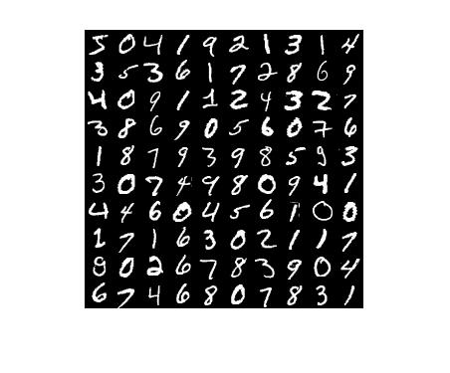

Matlab cod

outpic=zeros(280,280);

for i=1:10

for j=1:10

for k=1:28

for l=1:28

outpic(l+28\*(i-1),k+28\*(j-1))=images((k-1)\*28+l,(i-1)\*10+j);

end

end

end

end

imshow(outpic);