Prob1

(1)

12I1 + 0I2 + 6I3 + 0I4 + 0I5 = 15

-12I1 + 18I2 + 0I3 + 0I4 -24I5 = 0

0I1 + 0I2 - 6I3 + 6I4 + 24I5 = 0

I1 + 0I2 - I3 + 0I4 - I5 = 0

0I1 + I2 + 0I3 - I4 + I5 = 0

(2)

Use Gauss elimination

I5 = 0.0385 A

Prob2

(1)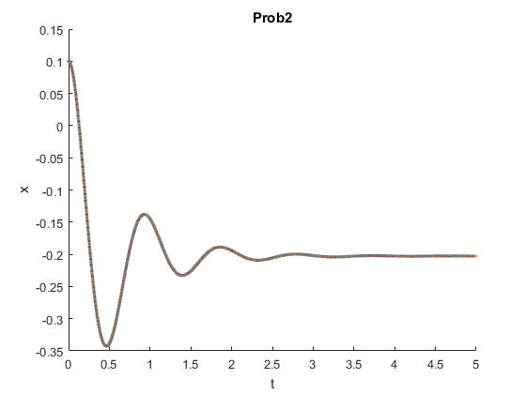

(2)

oscillation frequency = 1.073 Hz

Prob3

(1)

ε(t) - RCdv(t)/dt - Vc(t) = 0

(2)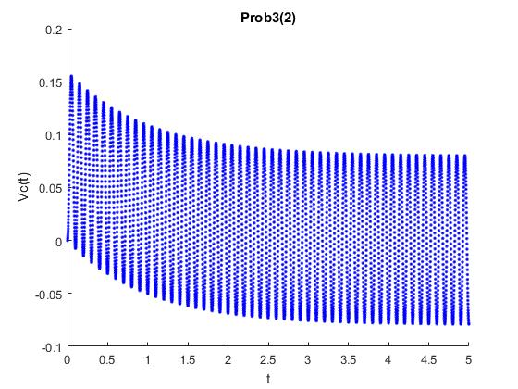

(3)

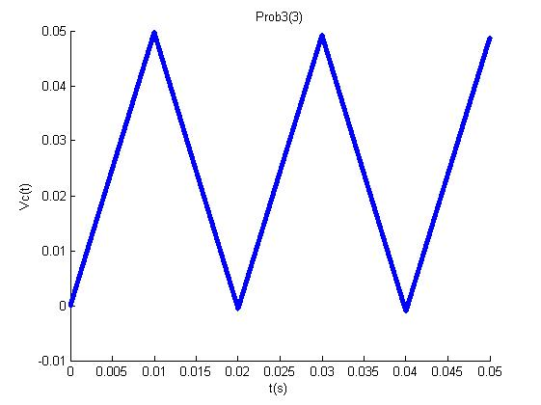

(4)

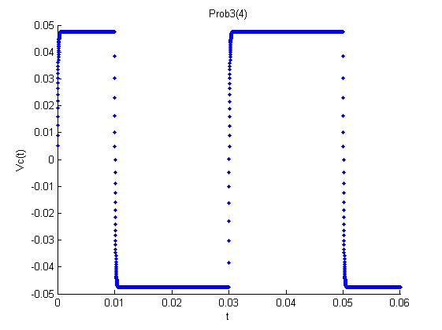

Prob4

(1)

原式左右積分-> Vs(t) = LdI(t)/dt + RI(t) + Vc(t)

= Vi(t) + Vr(t) + Vc(t)

(2)

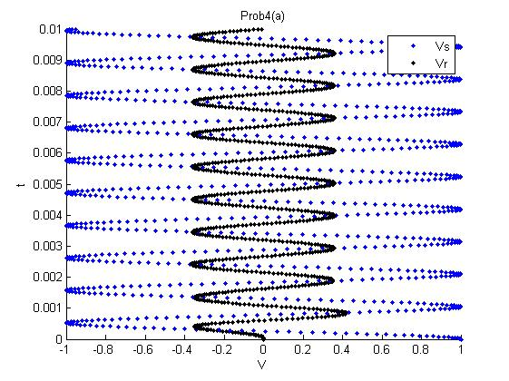

(3)

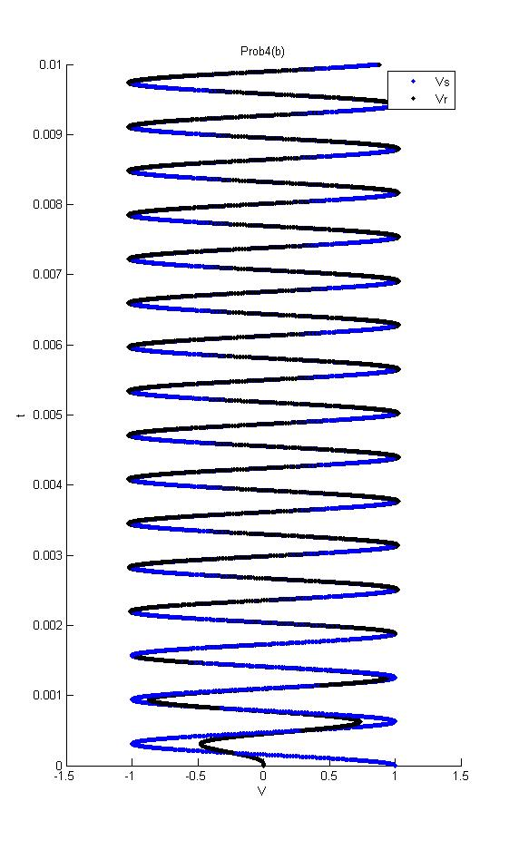

(4)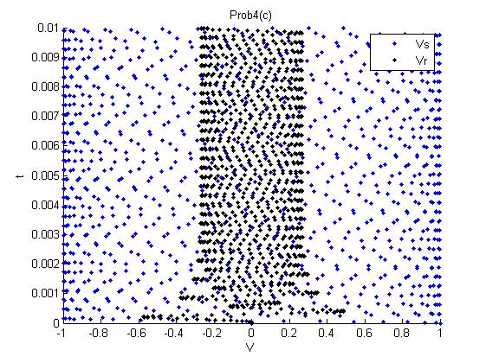

Prob5

(a)

d2x/dt2 = -GMx(t)/(x2+y2)3/2

d2y/dt2 = -GMy(t)/(x2+y2)3/2

(b)Vc = 2.9822e+15

(c)T = 3.1603e+07

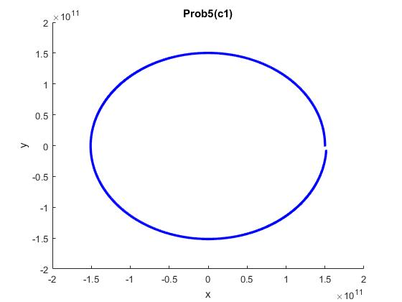

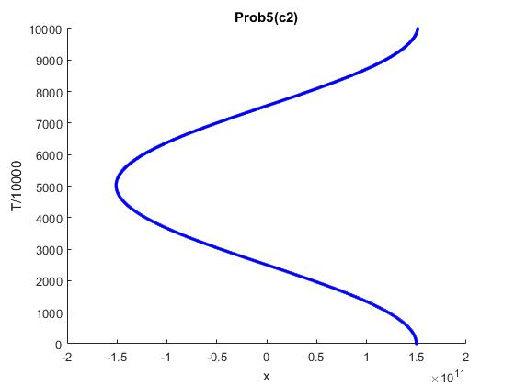

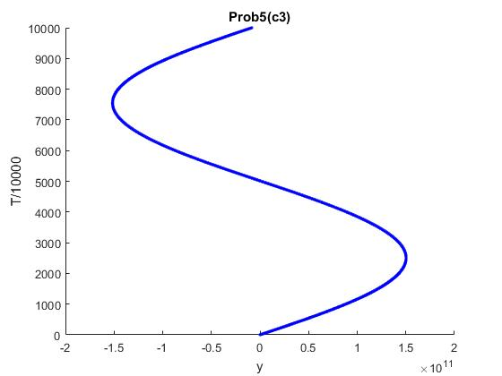

(d)

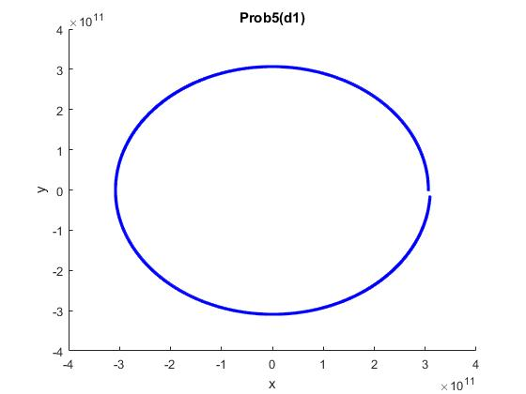

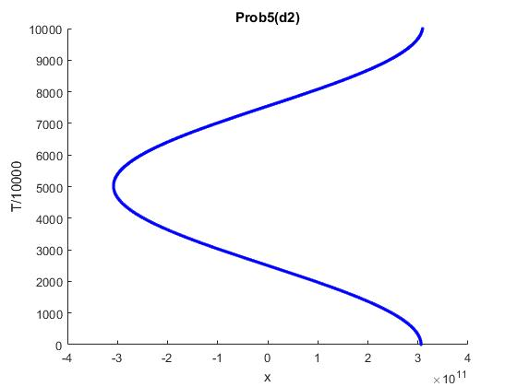

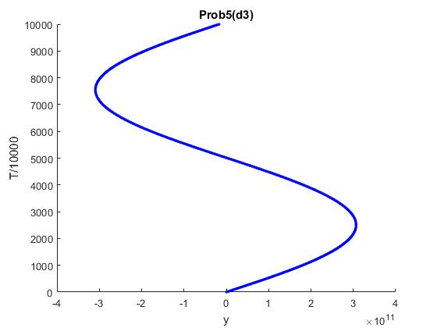

(e) T = 9.2136e+07

length of the semi-major axis : a = 3.0702e+11

b = 3.066376372566005e+11

c = 1.5318e+10

焦點(1.5318e+10,0) (-1.5318e+10,0)

在橢圓上的的點P

P到兩焦點的距離和約 = 6.122333602792158e+11

約 = 兩倍長軸

-> 圖型為橢圓

(f)