F74056166 方嘉祥

Prob1

(a)

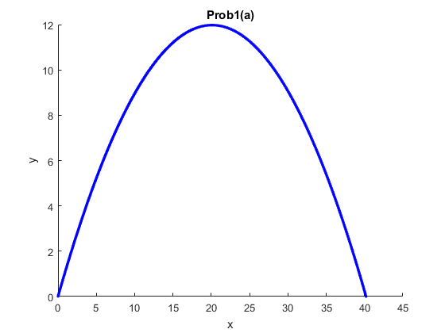

(b)

x = 42.44948m

(c)

v = 19.37227m

(d)

mass of center: 59.99946 j

Jim: 22.77097 j

Jake 18.76424 j

Jay: 18.76424 j

Prob2

(a)

h = 10^8

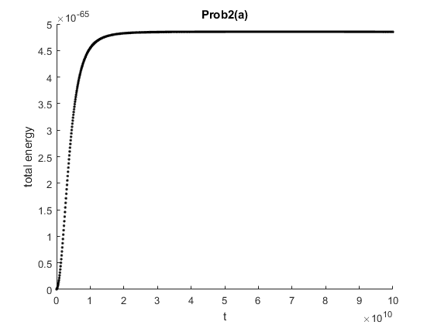

solid

(b)

h = 10^6

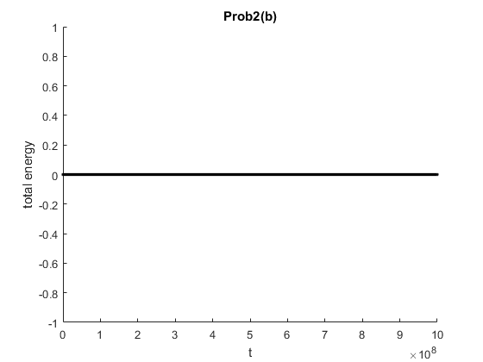

(c)

h = 10^-11

