Prob1

(1)I use Euler Method

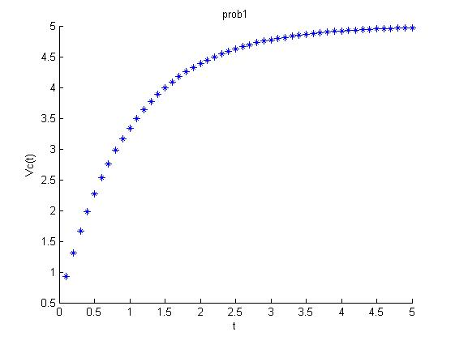

(2) Vc = 2.271

h = 0.001s

(3) it take 1.099s to reach 3.5V

Prob2

y(3) = 17.371 m

y`(3) = -9.400 m/s

h = 0.001s

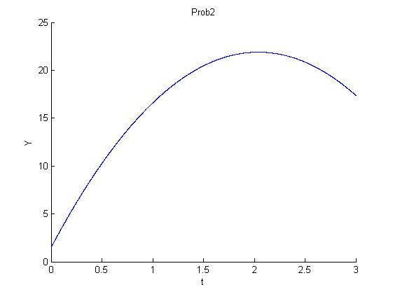

Prob3

