Analysis of Security Flaws

1: In this task, the experiment downloaded and used a jar package called Driver: SQLite JDBC (ver. 3.39.2.0, JDBC2.1) to connect the db.sqlite3, then forming a UI model.

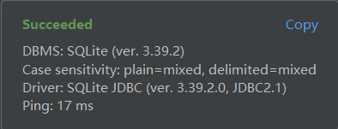 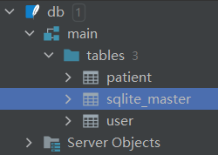

2:After adding compilation to the dependencies of the build.gradle file, this task is successfully executed. compile("org.slf4j:slf4j-simple:1.7.9").

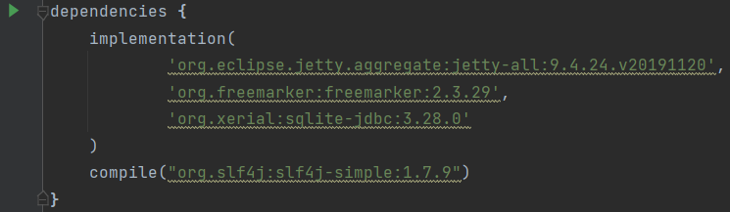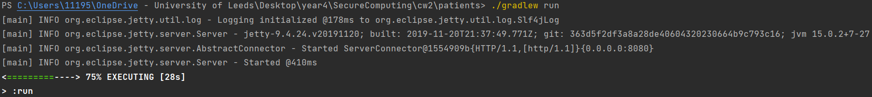

3: There are three pages in total, login,invalid ,details. And an warning page with a link to jetty.

4:Through the test on the login interface, userId actually refers to the user name, and the experiment found that when entering the user name and patient name, you can illegally query or modify the patient information, or even modify the user information, by replacing them with sql codes and injecting sql statement.

Illegal login: input ' or 1==1 or ' into password and Patient Surname frame

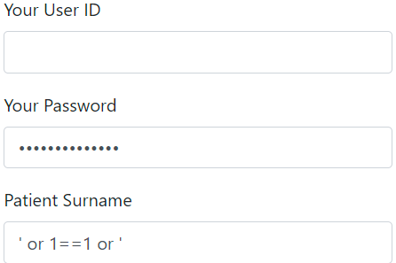

Obtain all patient information: ' or 1==1 or '

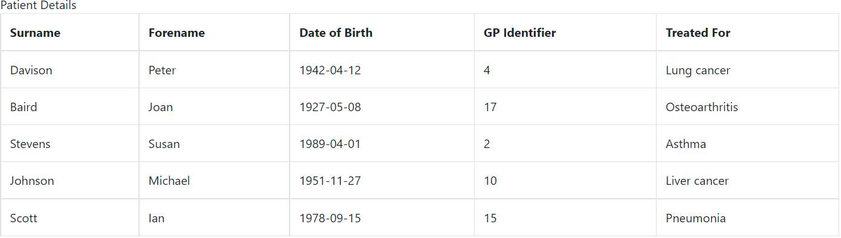

5:

Tampering patient information:

Tamper user information:

Implementation of Security Fixes

1: The experiment selects the sql injection described in task4

2: After testing, SQL injection is well prevented and the whole program works well

3:The experiment uses prepareStatement to process SQL statements.

In the scenario of using JDBC directly, if there are spliced SQL statements in the code, injection is likely to occur, but the original code uses the same method as splicing.

The safe writing method is to use parameterized queries, that is, parameter binding (? Placeholder) and PreparedStatement are used in SQL statements.

PreparedStatement is the sub interface of Statement, which can pass in SQL statements with placeholders, and provides a method to supplement placeholder variables.

It should be noted here that the use of PreparedStatement does not mean that injection will not occur. If there are spliced SQL statements before the use of PreparedStatement, injection will still occur.

So the experiment uses Connection, PreparedStatement, ResultSet and SQLException to jointly process SQL statements.

Core modification:

Modification of sql query:

private static final String AUTH_QUERY = "select * from user where username=? and password=?";

private static final String SEARCH_QUERY = "select * from patient where surname like ?";

Part of core code:

Connection connection = null;

PreparedStatement statement = null;

ResultSet resultSet = null;

Object ret = null;

try {

connection = database;

statement = connection.prepareStatement(AUTH_QUERY);

//set param

/*

process the statement and obtain the return value

*/

} catch (SQLException e) {

e.printStackTrace();

} finally {

if (statement != null)

statement.close();

}