Shabani_Muller
Frank Agyemang
2025-03-30

Reading In the data sets
In this chunk of code, we read in the data set and show a table containing the proportion of missing values for each of the chemicals even before they are put into group. The goal of this table is to understand how the proportion of missing values affects our estimates and what statistic would be more effecient for inference. For example, using a mean for this data set is not an efficient the data may be skewed and there are also lot of confounding variables.
# Read a specific sheet
tadpole_pest <- read.csv("AltEn_tadpoles_2025_pesticide_summary_030425.csv")
tadpole_det <- read.csv("AltEn_tadpole_detections_with_headers_deidentified.csv")
tadpole_fin <- read.csv("Tadpole_2021_2024_final.csv")
library(dplyr)
##
## Attaching package: 'dplyr'
## The following objects are masked from 'package:stats':
##
## filter, lag
## The following objects are masked from 'package:base':
##
## intersect, setdiff, setequal, union
tadpole_fin <- tadpole_fin %>%
mutate(ID = c(1:175))
tadpole_fin <- tadpole_fin %>% select(ID,Specices,Site, everything())
#Converting NDs to 0s
tadpole_fin[tadpole_fin == "ND"] <- 0
#converting columns back to numeric
cols_fin <- c(7:37)
tadpole_fin[cols_fin] <- lapply(tadpole_fin[cols_fin], as.numeric)
# Proportion of missing values in each column
missing_proportion <- sapply(tadpole_fin, function(x) mean(is.na(x)))
# Store it in a data frame
missing_table <- data.frame(
Variable = names(missing_proportion),
Missing_Proportion = missing_proportion
)
# View the table
print(missing_table)
## Variable Missing_Proportion
## ID ID 0.0000000
## Specices Specices 0.0000000
## Site Site 0.0000000
## Temperature Temperature 0.0000000
## Collection_date Collection_date 0.0000000
## Dev_stage Dev_stage 0.0000000
## Mass..g...dry.weight. Mass..g...dry.weight. 0.0000000
## X..Moisture X..Moisture 0.0000000
## X..Lipid X..Lipid 0.3257143
## Acetochlor Acetochlor 0.9085714
## Atrazine Atrazine 0.7657143
## Azoxystrobin Azoxystrobin 0.9942857
## Clothianidin Clothianidin 0.9200000
## Carbendazim Carbendazim 0.9600000
## Cyfluthrin..all.isomers. Cyfluthrin..all.isomers. 0.8228571
## Cyproconazole Cyproconazole 0.9771429
## Bifenthrin Bifenthrin 0.9028571
## Desthiopro Desthiopro 0.4400000
## Dithiopyr Dithiopyr 0.9771429
## Flufenacet Flufenacet 0.9428571
## Fluoxastrobin Fluoxastrobin 0.9828571
## Fluxapyroxad Fluxapyroxad 0.9714286
## Ipconazole Ipconazole 0.5085714
## Metolachlor..R.and.S. Metolachlor..R.and.S. 0.7028571
## Metconazole Metconazole 0.9828571
## Pendimethalin Pendimethalin 0.9542857
## Pentachloroanisole Pentachloroanisole 0.9428571
## Propiconazole Propiconazole 0.7542857
## Pyraclostrobin Pyraclostrobin 0.9828571
## Tebuconazole Tebuconazole 0.6057143
## Penoxsulam Penoxsulam 0.9657143
## ppDDD ppDDD 0.8628571
## ppDDE ppDDE 0.6971429
## ppDDT ppDDT 0.8971429
## Tetraconazole Tetraconazole 0.9542857
## Thiabendazole Thiabendazole 0.8285714
## ThiamethoxamD ThiamethoxamD 0.9542857

Data Cleaning and Exploratory Data Analysis
#tadpole_fin
#Converting Non-Detect to Not Available (NAs)
library(dplyr)
# Convert ND to NA
conc_data <- tadpole_fin %>%
mutate(
across(c(Mass..g...dry.weight., Dev_stage, X..Moisture),
~ case_when(.x == "ND" ~ NA_character_,
TRUE ~ as.character(.x)))
)
#Treating categorical variables as factors
conc_data[, c("Site","Specices","Collection_date","Dev_stage", "ID")] <- lapply(conc_data[, c("Site","Specices","Collection_date","Dev_stage","ID")], as.factor)

Transforming Data from wide to long
library(tidyr)
conc_data <- conc_data %>%
pivot_longer(
cols = `Acetochlor`:`ThiamethoxamD`,
names_to = "Chemical",
values_to = "Concentration"
)
conc_data[, c("Chemical")] <- lapply(conc_data[, c("Chemical")], as.factor)
conc_data <- conc_data[order(conc_data$Chemical),]
conc_data$Chemical <- gsub("\\..*", "", conc_data$Chemical)
# Create a new variable with assigned categories
conc_data <- conc_data %>%
mutate(Category = case_when(
Chemical %in% c("Clothianidin", "Thiamethoxam") ~ "Neonico",
Chemical %in% c("Azoxystrobin", "Carbendazim", "Cyproconazole", "Fluoxastrobin",
"Fluxapyroxad", "Ipconazole", "Metconazole", "Propiconazole",
"Pyraclostrobin", "Tebuconazole", "Tetraconazole", "Thiabendazole") ~ "Fungi",
Chemical %in% c("Acetochlor", "Atrazine", "Dithiopyr", "Flufenacet",
"Metolachlor", "Pendimethalin", "Penoxsulam") ~ "Herbi",
Chemical %in% c("Cyfluthrin", "Bifenthrin", "Desthiopro") ~ "Other",
Chemical %in% c("ppDDD", "ppDDE", "ppDDT", "Pentachloroanisole") ~ "Legacy_Agro",
TRUE ~ NA_character_ # Optional: Assign NA to unmatched values
))
conc_data[, c("Category")] <- lapply(conc_data[, c("Category")], as.factor)
levels(conc_data$Chemical)
## NULL
# Suppose your data frame is called df, and the column is named "your_column"
# Calculate missing proportion in a specific column
missing <- mean(is.na(conc_data$Concentration))
# Print the result
print(missing)
## [1] 0.8628571
head(conc_data)
## # A tibble: 6 × 12
## ID Specices Site Temperature Collection_date Dev_stage
## <fct> <fct> <fct> <dbl> <fct> <fct>
## 1 1 BullFrogTadpole Kpond 21.0 11/7/2021 0
## 2 2 BullFrogTadpole Kpond 21.0 11/7/2021 0
## 3 3 BullFrogTadpole Kpond 21.0 11/7/2021 0
## 4 4 BullFrogTadpole Kpond 21.0 11/7/2021 0
## 5 5 BullFrogTadpole Kpond 21.0 11/7/2021 0
## 6 6 BullFrogTadpole Kpond 21.0 11/7/2021 0
## # ℹ 6 more variables: Mass..g...dry.weight. <chr>, X..Moisture <chr>,
## # X..Lipid <dbl>, Chemical <chr>, Concentration <dbl>, Category <fct>

Exploratory Data Analysis: Proportion of Neonicotinoids, Fungicides, Herbicides
For this data set, we can mainly perform several exploratory data analysis to learn about the data but we cannot make any inference about the population due to several issues, some of which I will mention. First, it will be inaccurate to look just look at the proportions of Neonicotinoid and Fungicides across the years 2021 to 2024 since we do not have all species present in all the years. For example in 2021, we do not have any measure on Native Tadpoles and in 2022, we do not have any measurements on Bullfrog Tadpole. Nevertheless, a relative frequency of the proportions of the various categories of the chemicals is shown in the plot below.
We see that overall, fungicide make about 45 percent of the total proportion of concentration followed by Herbicides, Legacy Agrochemicals, and Others with Neonicotinoids making up the least proportion.
library(ggplot2)
library(dplyr)
# Calculate relative frequencies
data_plot <- conc_data %>%
count(Category) %>%
mutate(Relative_Freq = n / sum(n))
data_plot <- data_plot[-6,]
# There were 525 missing response values
#Table to show results
library(knitr)
kable(data_plot)
Category | n | Relative_Freq
Fungi | 2100 | 0.4285714
Herbi | 1225 | 0.2500000
Legacy_Agro | 700 | 0.1428571
Neonico | 175 | 0.0357143
Other | 525 | 0.1071429
# Plot relative frequencies
ggplot(data_plot, aes(x = Category, y = Relative_Freq, fill = Category)) +
geom_bar(stat = "identity", color = "black") + # Color for border
scale_fill_manual(values = c("Herbi" = "blue", "Fungi" = "red", "Neonico" = "green", "Legacy_Agro" = "orange", "Other" = "brown" )) + # Custom colors
labs(y = "Relative Frequency", x = "Category", title = "Relative Frequency Plot Showing Proportions of the Various Chemicals") +
theme_minimal()
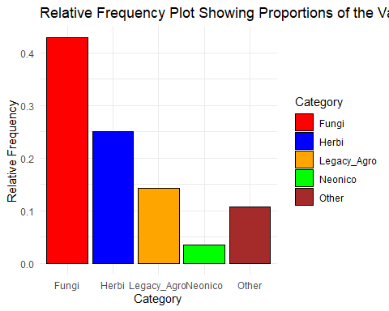

Proportion of concentration comprised by each specices in each category
Next, we also consider the proportion of concentration for each specices in each category across the years 2021 to 2024. For all Bullfrog tadpoles measured from 2021 to 2024, the proportion of fungicides were about 25 percent where as in Native tadpoles, fungicides were about 17 percent of the total proportion of concentration across the years. Nevertheless, we still see that Neonicotinoids make up the least proportion in both specices across the years.
## Proportion of chemicals for each species
# Calculate relative frequency for each species
data_plot_1 <- conc_data %>%
count(Specices, Category) %>%
mutate(Relative_Freq = n / sum(n))
## Removing missing observations
data_plot_1 <- data_plot_1[-c(6,12),]
#Table to show results
library(knitr)
kable(data_plot_1)
Specices | Category | n | Relative_Freq
BullFrogTadpole | Fungi | 1308 | 0.2669388
BullFrogTadpole | Herbi | 763 | 0.1557143
BullFrogTadpole | Legacy_Agro | 436 | 0.0889796
BullFrogTadpole | Neonico | 109 | 0.0222449
BullFrogTadpole | Other | 327 | 0.0667347
Native Tadpole | Fungi | 792 | 0.1616327
Native Tadpole | Herbi | 462 | 0.0942857
Native Tadpole | Legacy_Agro | 264 | 0.0538776
Native Tadpole | Neonico | 66 | 0.0134694
Native Tadpole | Other | 198 | 0.0404082
# Plot relative frequencies by species
ggplot(data_plot_1, aes(x = Category , y = Relative_Freq, fill = Category)) +
geom_bar(stat = "identity", color = "black") + # Color for border
scale_fill_manual(values = c("Herbi" = "blue", "Fungi" = "red", "Neonico" = "green", "Legacy_Agro" = "orange", "Other" = "brown")) + # Custom colors
facet_wrap(~ Specices) + # Facet by species
labs(y = "Relative Frequency", x = "Category", title = "Relative Frequency Plot Showing Proportions of the Various Chemicals by Specices") +
theme_minimal()
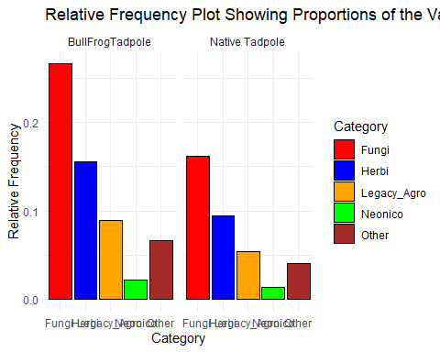
# Calculate relative frequency for each species, year, and chemical category
data_plot_2 <- conc_data
library(lubridate)
##
## Attaching package: 'lubridate'
## The following objects are masked from 'package:base':
##
## date, intersect, setdiff, union
# Convert Date to Date format and extract year
data_plot_2$Collection_date <- year(mdy(data_plot_2$Collection_date))
data_plot_2$Collection_date <- as.factor(data_plot_2$Collection_date)
data_plot_2 <- data_plot_2 %>%
count(Specices, Collection_date, Category) %>%
group_by(Specices, Collection_date) %>%
mutate(Relative_Freq = n / sum(n))
## Removing missing observations
data_plot_2 <- data_plot_2[-c(6,12,18,24,30,36),]
#Table to show results
library(knitr)
kable(data_plot_2)
Specices | Collection_date | Category | n | Relative_Freq
BullFrogTadpole | 2021 | Fungi | 516 | 0.4285714
BullFrogTadpole | 2021 | Herbi | 301 | 0.2500000
BullFrogTadpole | 2021 | Legacy_Agro | 172 | 0.1428571
BullFrogTadpole | 2021 | Neonico | 43 | 0.0357143
BullFrogTadpole | 2021 | Other | 129 | 0.1071429
BullFrogTadpole | 2023 | Fungi | 408 | 0.4285714
BullFrogTadpole | 2023 | Herbi | 238 | 0.2500000
BullFrogTadpole | 2023 | Legacy_Agro | 136 | 0.1428571
BullFrogTadpole | 2023 | Neonico | 34 | 0.0357143
BullFrogTadpole | 2023 | Other | 102 | 0.1071429
BullFrogTadpole | 2024 | Fungi | 384 | 0.4285714
BullFrogTadpole | 2024 | Herbi | 224 | 0.2500000
BullFrogTadpole | 2024 | Legacy_Agro | 128 | 0.1428571
BullFrogTadpole | 2024 | Neonico | 32 | 0.0357143
BullFrogTadpole | 2024 | Other | 96 | 0.1071429
Native Tadpole | 2022 | Fungi | 204 | 0.4285714
Native Tadpole | 2022 | Herbi | 119 | 0.2500000
Native Tadpole | 2022 | Legacy_Agro | 68 | 0.1428571
Native Tadpole | 2022 | Neonico | 17 | 0.0357143
Native Tadpole | 2022 | Other | 51 | 0.1071429
Native Tadpole | 2023 | Fungi | 168 | 0.4285714
Native Tadpole | 2023 | Herbi | 98 | 0.2500000
Native Tadpole | 2023 | Legacy_Agro | 56 | 0.1428571
Native Tadpole | 2023 | Neonico | 14 | 0.0357143
Native Tadpole | 2023 | Other | 42 | 0.1071429
Native Tadpole | 2024 | Fungi | 420 | 0.4285714
Native Tadpole | 2024 | Herbi | 245 | 0.2500000
Native Tadpole | 2024 | Legacy_Agro | 140 | 0.1428571
Native Tadpole | 2024 | Neonico | 35 | 0.0357143
Native Tadpole | 2024 | Other | 105 | 0.1071429
# Plot relative frequencies
ggplot(data_plot_2, aes(x = Category, y = Relative_Freq, fill = Category)) +
geom_bar(stat = "identity", color = "black") + # Color for border
scale_fill_manual(values = c("Herbi" = "blue", "Fungi" = "red", "Neonico" = "green", "Legacy_Agro" = "orange", "Other" = "brown")) + # Custom colors
facet_grid(Collection_date ~ Specices ) + # Create facets for species and year
labs(y = "Relative Frequency", x = "Chemical Category",
title = "Relative Frequency Plot of Chemicals by Species and Year") +
theme_minimal()
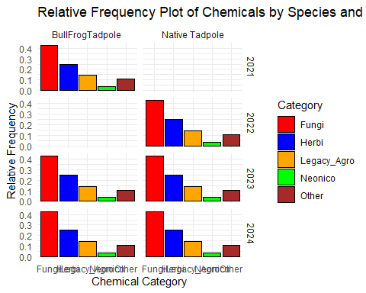
#summary(conc_data)
#is.na(conc_data$Category)

R Code to rearrange the columns and subset a clean data
library(dplyr)
# conc_data
conc_data_clean <- conc_data %>%
select(ID,Specices, Site, Category,Temperature,Collection_date,Dev_stage,Mass..g...dry.weight.,X..Moisture,X..Lipid,Concentration)
#is.na(conc_data_clean$Category)
#levels(conc_data_clean$Category)
# Suppose your response variable is named 'response'
clean_data_sub <- conc_data_clean %>%
filter(!is.na(Concentration))
## sort by date
# Extract year into a new column
library(dplyr)
clean_data_sub$Collection_date <- as.Date(clean_data_sub$Collection_date, format = "%m/%d/%Y")
clean_data_sub <- clean_data_sub %>%
mutate(Year = as.numeric(format(Collection_date, "%Y")))
clean_data_sub <- clean_data_sub %>%
arrange(Year)
clean_data_sub <- clean_data_sub %>%
select(ID,Specices, Site, Category,Temperature,Year,Collection_date,Dev_stage,Mass..g...dry.weight.,X..Moisture,X..Lipid,Concentration)
clean_data_sub$Collection_date <- NULL
clean_data_sub <- clean_data_sub %>%
mutate(Year = factor(Year))
#levels(clean_data_sub$Dev_stage)

Categorizing Dev_Stage
library(dplyr)
# Define which levels belong to each category
undeveloped_countries <- c("P25","pre-25","p27","P27","26","27-30","28","30")
developing_countries <- c("p31","33","34","35","36","37","38","39")
developed_countries <- c("41")
# Create new category variable
clean_data_sub <- clean_data_sub %>%
mutate(dev_category = case_when(
Dev_stage %in% undeveloped_countries ~ "Undeveloped",
Dev_stage %in% developing_countries ~ "Developing",
Dev_stage %in% developed_countries ~ "Developed",
TRUE ~ NA_character_ # or "Other"
))
clean_data_sub$Dev_stage <- NULL

Descriptive Statistics
For an observational study, one way to also understand the data set is through boxplots. A boxplot basically provides important summaries like the distribution, mean, minimum and maximum values. For this data set, there were a lot of observations recorded as ND (Not Detected) and NAs (missing values). In a situation where it is usually unclear whether observations that are below a certain threshold are recorded as Not Detected and how they differ from NAs which are considered as missing values, we can not make any statements as to the concentrations of the Categories of interest.
This is because if NDs were actual values that simply did not meet a threshold, then we will be losing information by considering them as missing values and we will be overestimating the means for the concentration in each of the tadpole specices.
#Boxplots
ggplot(clean_data_sub, aes(x = Specices, y = Concentration, fill = Category)) +
geom_boxplot(color = "black", alpha = 0.7) +
facet_wrap(~ Year, scales = "free_y") + # Facet by Year
labs(title = "Boxplot of Chemical Concentration by Category and Year",
x = "Category",
y = "Concentration") +
theme_minimal() +
theme(axis.text.x = element_text(angle = 45, hjust = 1)) # Rotate x-axis labels
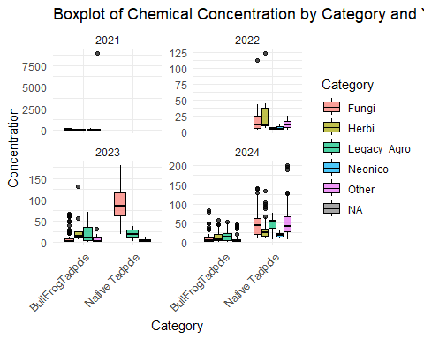

Subsetting data into the various Years

Subsetting the 2021,2022,2023 and 2024 data respectively
With this data, there are a lot of onservations that were recorded as “Not Detected” and other confounding variables. As a result, care should be taken when making inference such as concentration levels across years and locations. As a first step, the data was subsetted into four groups based on year. This is because for the year 2021, Specices “Native tadpole” was not present. Also, in 2022, Specices “Bullfrog tadpole” was not present and thus it not efficient to make inference across years due to this confounding variable. Nevertheless, data set from 2023 and 2024 were combined as one data set and analyzed as such.
selected <- c("2021")
selected_1 <- c("2022")
selected_2 <- c("2023")
selected_3 <- c("2024")
selected_4 <- c("2023","2024")
tadfin_2021 <- clean_data_sub[clean_data_sub$Year %in% selected,]
tadfin_2022 <- clean_data_sub[clean_data_sub$Year %in% selected_1,]
tadfin_2023 <- clean_data_sub[clean_data_sub$Year %in% selected_2,]
tadfin_2024 <- clean_data_sub[clean_data_sub$Year %in% selected_3,]
tadfin_23_24 <- clean_data_sub[clean_data_sub$Year %in% selected_4,]

Exploratory Data Analysis for the 2021 Data
#Proportion of the concentration by Site For data on the year 2021, there were 41 unique tadpoles after removing all observations with missing concentration values. We also removed variables “Dev_stage” also the same as “dev_category” and “X..Lipid” because all observations were missing.Data was collected only on the Bullfrog tadpole and thus “Specices” was not included in the regression models.
We then show a relative frequency plot with the preprocessed 2021 data. From the plot, we see that in the year 2021, Neonicotinoid, less than 0.10, is only present at Kpond site. Nevertheless, Fungicides seems to be present in high proportions, 0.75 and 0.50, in two sites Jcpond and Kpond. We do not see these two groups of chemicals in the other sites. We proceed with linear regression to determine how these variables affect concentration level. Before we implement the various regression model, we will look at the distribution of the concentration levels.
library(ggplot2)
tadfin_2021$ID <- sort(tadfin_2021$ID)
tadfin_2021$dev_category <- NULL
tadfin_2021$X..Lipid <- NULL
tadfin_2021$Mass..g...dry.weight. <- as.numeric(tadfin_2021$Mass..g...dry.weight.)
data_plot_3 <- tadfin_2021
library(lubridate)
data_plot_3 <- data_plot_3 %>%
count(Site, Category) %>%
group_by(Site) %>%
mutate(Relative_Freq = n / sum(n))
#Table to show results
library(knitr)
kable(data_plot_3)
Site | Category | n | Relative_Freq
Gpond | Legacy_Agro | 10 | 0.7142857
Gpond | Other | 4 | 0.2857143
Jcpond | Fungi | 9 | 0.7500000
Jcpond | Other | 3 | 0.2500000
Kpond | Fungi | 23 | 0.4893617
Kpond | Neonico | 3 | 0.0638298
Kpond | Other | 13 | 0.2765957
Kpond | NA | 8 | 0.1702128
Npond | Legacy_Agro | 21 | 0.6774194
Npond | Other | 10 | 0.3225806
Zpond | Other | 1 | 1.0000000
## Removing missing observations
data_plot_3 <- data_plot_3[-c(8),]
# Plot relative frequencies by species
ggplot(data_plot_3, aes(x = Site , y = Relative_Freq, fill = Category)) +
geom_bar(stat = "identity", color = "black") + # Color for border
scale_fill_manual(values = c("Herbi" = "blue", "Fungi" = "red", "Neonico" = "green", "Legacy_Agro" = "orange", "Other" = "brown")) + # Custom colors
facet_wrap(~ Category) + # Facet by species
labs(y = "Relative Frequency", x = "Site", title = "2021 Relative Frequency Plot Showing Proportion of Concentration for Bullfrog in Each Site") +
theme_minimal()
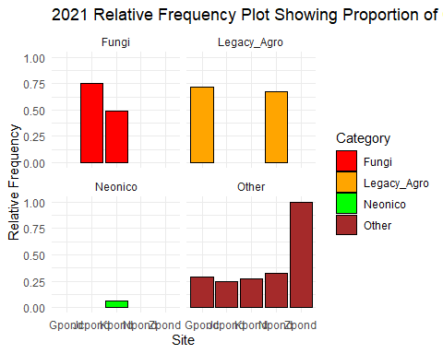

Histogram of concentration for 2021 data
Looking at the histogram for concentration, we see a strong right skewness. We a log transformation to see if we will get an approximately normal distribution. We that the distribution can be approximated by the normal distribution after applying a log transformation. Nevertheless, we still see some right skewness. Note that results will be on the log scale and needs to be back-transformed.
We used two regression models on the 2021 data. In each of the anova tables for the models, Site, Mass..g…dry.weight. and Category are statistically significant with p-values less than 0.05. Note that the estimates given for each of the model is on the log scale and needs to be back-transformed using the exponential function. Also, the R-squared for model 1 is 0.4453 and that for model 2 is 0.4779. The R-squared values tell the percentage of variation explained by the model. From the two models, we see that the second model explains more variation than model 1.
hist(tadfin_2021$Concentration)
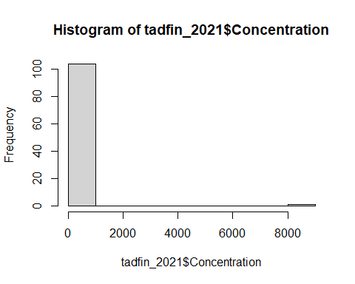
hist(log(tadfin_2021$Concentration))
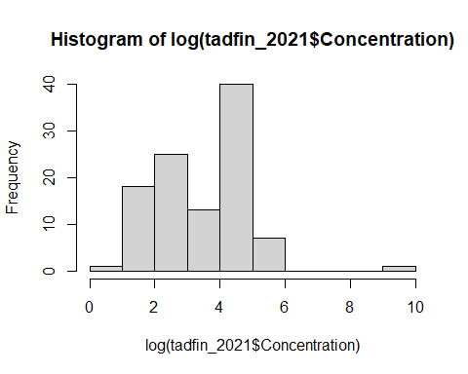
##Regression Models
mod_21_1 <- lm(log(Concentration) ~ Site + Category + Temperature , data = tadfin_2021)
anova(mod_21_1)
## Analysis of Variance Table
##
## Response: log(Concentration)
## Df Sum Sq Mean Sq F value Pr(>F)
## Site 4 58.946 14.7364 14.8660 2.429e-09 ***
## Category 3 11.874 3.9581 3.9929 0.01021 *
## Residuals 89 88.224 0.9913
## ---
## Signif. codes: 0 '***' 0.001 '**' 0.01 '*' 0.05 '.' 0.1 ' ' 1
summary(mod_21_1)
##
## Call:
## lm(formula = log(Concentration) ~ Site + Category + Temperature,
## data = tadfin_2021)
##
## Residuals:
## Min 1Q Median 3Q Max
## -2.9202 -0.2178 0.2679 0.5823 1.6175
##
## Coefficients: (1 not defined because of singularities)
## Estimate Std. Error t value Pr(>|t|)
## (Intercept) 1.8615 0.4661 3.994 0.000133 ***
## SiteJcpond 0.2584 0.5087 0.508 0.612676
## SiteKpond 2.0143 0.4350 4.631 1.24e-05 ***
## SiteNpond 1.5869 0.3208 4.946 3.54e-06 ***
## SiteZpond 0.5823 1.0557 0.552 0.582629
## CategoryLegacy_Agro -0.1079 0.4437 -0.243 0.808381
## CategoryNeonico -1.0318 0.6084 -1.696 0.093435 .
## CategoryOther 0.5619 0.3064 1.833 0.070077 .
## Temperature NA NA NA NA
## ---
## Signif. codes: 0 '***' 0.001 '**' 0.01 '*' 0.05 '.' 0.1 ' ' 1
##
## Residual standard error: 0.9956 on 89 degrees of freedom
## (8 observations deleted due to missingness)
## Multiple R-squared: 0.4453, Adjusted R-squared: 0.4017
## F-statistic: 10.21 on 7 and 89 DF, p-value: 2.533e-09
mod_21_2 <- lm(log(Concentration) ~ Site + Category + Temperature + Mass..g...dry.weight. , data = tadfin_2021)
anova(mod_21_2)
## Analysis of Variance Table
##
## Response: log(Concentration)
## Df Sum Sq Mean Sq F value Pr(>F)
## Site 4 58.946 14.7364 15.6175 1.082e-09 ***
## Category 3 11.874 3.9581 4.1947 0.007997 **
## Mass..g...dry.weight. 1 5.189 5.1888 5.4991 0.021276 *
## Residuals 88 83.035 0.9436
## ---
## Signif. codes: 0 '***' 0.001 '**' 0.01 '*' 0.05 '.' 0.1 ' ' 1
summary(mod_21_2)
##
## Call:
## lm(formula = log(Concentration) ~ Site + Category + Temperature +
## Mass..g...dry.weight., data = tadfin_2021)
##
## Residuals:
## Min 1Q Median 3Q Max
## -3.3062 -0.3365 0.2148 0.5604 1.5337
##
## Coefficients: (1 not defined because of singularities)
## Estimate Std. Error t value Pr(>|t|)
## (Intercept) 3.48791 0.82934 4.206 6.24e-05 ***
## SiteJcpond 0.30984 0.49677 0.624 0.5344
## SiteKpond 1.02013 0.59983 1.701 0.0925 .
## SiteNpond 0.62486 0.51601 1.211 0.2292
## SiteZpond -0.57933 1.14296 -0.507 0.6135
## CategoryLegacy_Agro -0.03397 0.43400 -0.078 0.9378
## CategoryNeonico -0.78051 0.60322 -1.294 0.1991
## CategoryOther 0.59737 0.29937 1.995 0.0491 *
## Temperature NA NA NA NA
## Mass..g...dry.weight. -8.20108 3.49725 -2.345 0.0213 *
## ---
## Signif. codes: 0 '***' 0.001 '**' 0.01 '*' 0.05 '.' 0.1 ' ' 1
##
## Residual standard error: 0.9714 on 88 degrees of freedom
## (8 observations deleted due to missingness)
## Multiple R-squared: 0.4779, Adjusted R-squared: 0.4304
## F-statistic: 10.07 on 8 and 88 DF, p-value: 7.256e-10

Exploratory Data Analysis for the 2022 Data
#Proportion of the concentration by Site In the 2022 data, there were only 17 unique tadpoles and measurements were taken only on Native tadpoles. Therefore, “Specices” was not added to the model for this data set too. Also, “Dev_stage” also named as “dev_category” had missing values for all entries and thus was removed from the regression models.
From the relative frequency plot below, Neonicotinoid makes about 0.20 and Fungicide makes up about 0.40 at the ENREC 2 site. Nevertheless, we do not see both groups of chemicals in the other locations.
library(ggplot2)
tadfin_2022$ID <- sort(tadfin_2022$ID)
tadfin_2022$dev_category <- NULL
tadfin_2022$Mass..g...dry.weight. <- as.numeric(tadfin_2022$Mass..g...dry.weight.)
tadfin_2022$X..Moisture <- as.numeric(tadfin_2022$X..Moisture)
data_plot_4 <- tadfin_2022
library(lubridate)
data_plot_4 <- data_plot_4 %>%
count(Site, Category) %>%
group_by(Site) %>%
mutate(Relative_Freq = n / sum(n))
#Table to show results
library(knitr)
kable(data_plot_4)
Site | Category | n | Relative_Freq
ENREC 2 | Fungi | 15 | 0.4411765
ENREC 2 | Herbi | 13 | 0.3823529
ENREC 2 | Legacy_Agro | 1 | 0.0294118
ENREC 2 | Neonico | 3 | 0.0882353
ENREC 2 | Other | 2 | 0.0588235
Npond | Legacy_Agro | 7 | 0.4375000
Npond | Other | 9 | 0.5625000
# Plot relative frequencies by species
ggplot(data_plot_4, aes(x = Site , y = Relative_Freq, fill = Category)) +
geom_bar(stat = "identity", color = "black") + # Color for border
scale_fill_manual(values = c("Herbi" = "blue", "Fungi" = "red", "Neonico" = "green", "Legacy_Agro" = "orange", "Other" = "brown")) + # Custom colors
facet_wrap(~ Category) + # Facet by species
labs(y = "Relative Frequency", x = "Site", title = "2022 Relative Frequency Plot Showing Proportion of Concentration for Bullfrog in Each Site") +
theme_minimal()
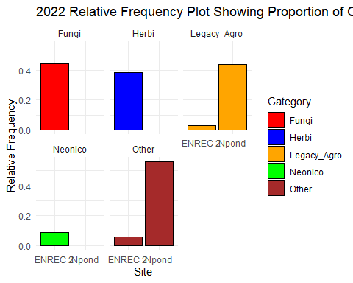
##Histogram of concentration from the year 2022 Again, looking at the histogram, we see that concentration is right-skewed and thus we apply a log transformation to the response variable. For the 2022 data, the anova table using model 1 shows that site is not statistically significant, p-value > 0.05.
hist(tadfin_2022$Concentration)
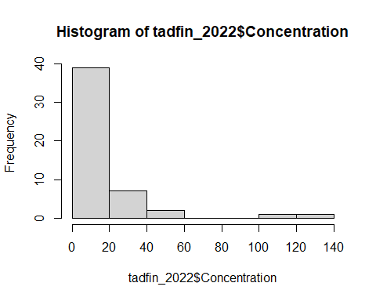
hist(log(tadfin_2022$Concentration))
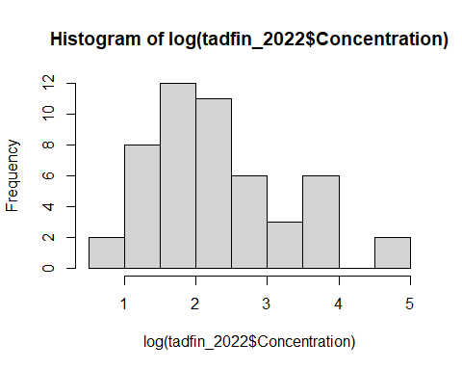
##Regression Models
mod_22_1 <- lm(log(Concentration) ~ Site + Category + Temperature + Mass..g...dry.weight., data = tadfin_2022)
anova(mod_22_1)
## Analysis of Variance Table
##
## Response: log(Concentration)
## Df Sum Sq Mean Sq F value Pr(>F)
## Site 1 1.0337 1.0337 2.1589 0.149021
## Category 4 7.9647 1.9912 4.1585 0.006186 **
## Mass..g...dry.weight. 1 12.4459 12.4459 25.9928 7.331e-06 ***
## Residuals 43 20.5892 0.4788
## ---
## Signif. codes: 0 '***' 0.001 '**' 0.01 '*' 0.05 '.' 0.1 ' ' 1
summary(mod_22_1)
##
## Call:
## lm(formula = log(Concentration) ~ Site + Category + Temperature +
## Mass..g...dry.weight., data = tadfin_2022)
##
## Residuals:
## Min 1Q Median 3Q Max
## -1.24755 -0.38260 -0.02836 0.34702 1.67944
##
## Coefficients: (1 not defined because of singularities)
## Estimate Std. Error t value Pr(>|t|)
## (Intercept) 4.6623 0.4723 9.871 1.28e-12 ***
## SiteNpond 0.1159 0.4481 0.259 0.79718
## CategoryHerbi 0.2975 0.2626 1.133 0.26350
## CategoryLegacy_Agro -1.4051 0.4880 -2.880 0.00618 **
## CategoryNeonico -1.0660 0.4404 -2.420 0.01980 *
## CategoryOther -0.8568 0.4522 -1.895 0.06486 .
## Temperature NA NA NA NA
## Mass..g...dry.weight. -35.1264 6.8898 -5.098 7.33e-06 ***
## ---
## Signif. codes: 0 '***' 0.001 '**' 0.01 '*' 0.05 '.' 0.1 ' ' 1
##
## Residual standard error: 0.692 on 43 degrees of freedom
## Multiple R-squared: 0.5102, Adjusted R-squared: 0.4418
## F-statistic: 7.464 on 6 and 43 DF, p-value: 1.624e-05
mod_22_2 <- lm(log(Concentration) ~ Site + Category + Temperature + Mass..g...dry.weight. + X..Moisture + X..Lipid,
data = tadfin_2022)
anova(mod_22_2)
## Analysis of Variance Table
##
## Response: log(Concentration)
## Df Sum Sq Mean Sq F value Pr(>F)
## Site 1 0.0098 0.0098 0.0177 0.8951172
## Category 4 7.9721 1.9930 3.5948 0.0178678 *
## Mass..g...dry.weight. 1 7.7965 7.7965 14.0623 0.0008542 ***
## X..Moisture 1 3.3904 3.3904 6.1151 0.0199902 *
## X..Lipid 1 0.0898 0.0898 0.1620 0.6904568
## Residuals 27 14.9694 0.5544
## ---
## Signif. codes: 0 '***' 0.001 '**' 0.01 '*' 0.05 '.' 0.1 ' ' 1
summary(mod_22_2)
##
## Call:
## lm(formula = log(Concentration) ~ Site + Category + Temperature +
## Mass..g...dry.weight. + X..Moisture + X..Lipid, data = tadfin_2022)
##
## Residuals:
## Min 1Q Median 3Q Max
## -1.06150 -0.45892 -0.07051 0.46206 1.39100
##
## Coefficients: (1 not defined because of singularities)
## Estimate Std. Error t value Pr(>|t|)
## (Intercept) 2.38671 1.04712 2.279 0.0308 *
## SiteNpond -13.15026 5.48958 -2.395 0.0238 *
## CategoryHerbi 0.25275 0.29846 0.847 0.4045
## CategoryLegacy_Agro -1.49777 0.59980 -2.497 0.0189 *
## CategoryNeonico -1.23886 0.48263 -2.567 0.0161 *
## CategoryOther -0.83734 0.51369 -1.630 0.1147
## Temperature NA NA NA NA
## Mass..g...dry.weight. -19.37084 10.19694 -1.900 0.0682 .
## X..Moisture 0.18527 0.07507 2.468 0.0202 *
## X..Lipid 0.04826 0.11989 0.403 0.6905
## ---
## Signif. codes: 0 '***' 0.001 '**' 0.01 '*' 0.05 '.' 0.1 ' ' 1
##
## Residual standard error: 0.7446 on 27 degrees of freedom
## (14 observations deleted due to missingness)
## Multiple R-squared: 0.5627, Adjusted R-squared: 0.4331
## F-statistic: 4.342 on 8 and 27 DF, p-value: 0.001836

Exploratory Data Analysis for the 2023 and 2024 Data
#Proportion of the concentration by Site, by Site and Specices In the combined 2023 and 2024 data, there were 126 unique tadpoles and both specices were present in both years. Thus, as part of the researcher’s objective to see the concentration levels over time, we can estimate the concentration means for each specices over the two years.
Again, we made a histogram for concentration and perform a regression on the data.
library(ggplot2)
tadfin_23_24$ID <- sort(tadfin_23_24$ID)
tadfin_2022$dev_category <- NULL
tadfin_2022$Mass..g...dry.weight. <- as.numeric(tadfin_2022$Mass..g...dry.weight.)
tadfin_2022$X..Moisture <- as.numeric(tadfin_2022$X..Moisture)
data_plot_5 <- tadfin_23_24
library(lubridate)
data_plot_5 <- data_plot_5 %>%
count(Site, Category) %>%
group_by(Site) %>%
mutate(Relative_Freq = n / sum(n))
#Table to show results
library(knitr)
kable(data_plot_5)
Site | Category | n | Relative_Freq
ENREC 2 | Fungi | 39 | 0.5342466
ENREC 2 | Herbi | 22 | 0.3013699
ENREC 2 | Legacy_Agro | 3 | 0.0410959
ENREC 2 | Other | 9 | 0.1232877
Kpond | Fungi | 92 | 0.5027322
Kpond | Herbi | 48 | 0.2622951
Kpond | Neonico | 8 | 0.0437158
Kpond | Other | 35 | 0.1912568
NGpond | Fungi | 18 | 0.4186047
NGpond | Herbi | 8 | 0.1860465
NGpond | Other | 17 | 0.3953488
NGpond_p1 | Fungi | 23 | 0.7187500
NGpond_p1 | Legacy_Agro | 3 | 0.0937500
NGpond_p1 | Other | 6 | 0.1875000
NGpond_p2 | Fungi | 16 | 0.8000000
NGpond_p2 | Other | 4 | 0.2000000
Npond | Fungi | 17 | 0.1140940
Npond | Herbi | 46 | 0.3087248
Npond | Legacy_Agro | 60 | 0.4026846
Npond | Other | 26 | 0.1744966
Zpond | Fungi | 10 | 0.5882353
Zpond | Other | 7 | 0.4117647
# Plot relative frequencies by species
ggplot(data_plot_5, aes(x = Site , y = Relative_Freq, fill = Category)) +
geom_bar(stat = "identity", color = "black") + # Color for border
scale_fill_manual(values = c("Herbi" = "blue", "Fungi" = "red", "Neonico" = "green", "Legacy_Agro" = "orange", "Other" = "brown")) + # Custom colors
facet_wrap(~ Category) + # Facet by species
labs(y = "Relative Frequency", x = "Site", title = "2023 Relative Frequency Plot Showing Proportion of Concentration for Bullfrog and Native Tadpoles in Each Site") +
theme_minimal()
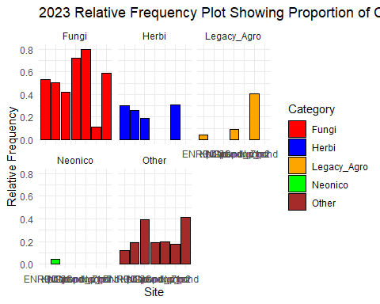
## By Site and Specices
data_plot_6 <- tadfin_2023
library(lubridate)
data_plot_6 <- data_plot_6 %>%
count(Site, Specices, Category) %>%
group_by(Site,Specices) %>%
mutate(Relative_Freq = n / sum(n))
#Table to show results
library(knitr)
kable(data_plot_6)
Site | Specices | Category | n | Relative_Freq
ENREC 2 | Native Tadpole | Fungi | 21 | 0.9545455
ENREC 2 | Native Tadpole | Legacy_Agro | 1 | 0.0454545
Kpond | BullFrogTadpole | Fungi | 37 | 0.6981132
Kpond | BullFrogTadpole | Herbi | 8 | 0.1509434
Kpond | BullFrogTadpole | Other | 8 | 0.1509434
NGpond_p1 | BullFrogTadpole | Fungi | 23 | 0.7187500
NGpond_p1 | BullFrogTadpole | Legacy_Agro | 3 | 0.0937500
NGpond_p1 | BullFrogTadpole | Other | 6 | 0.1875000
NGpond_p2 | BullFrogTadpole | Fungi | 16 | 0.8000000
NGpond_p2 | BullFrogTadpole | Other | 4 | 0.2000000
Npond | BullFrogTadpole | Fungi | 4 | 0.1250000
Npond | BullFrogTadpole | Legacy_Agro | 22 | 0.6875000
Npond | BullFrogTadpole | Other | 6 | 0.1875000
Npond | Native Tadpole | Legacy_Agro | 1 | 0.2500000
Npond | Native Tadpole | Other | 3 | 0.7500000
# Plot relative frequencies by species
ggplot(data_plot_6, aes(x = Site , y = Relative_Freq, fill = Category)) +
geom_bar(stat = "identity", color = "black") + # Color for border
scale_fill_manual(values = c("Herbi" = "blue", "Fungi" = "red", "Neonico" = "green", "Legacy_Agro" = "orange", "Other" = "brown")) + # Custom colors
facet_wrap(Category ~ Specices) + # Facet by species
labs(y = "Relative Frequency", x = "Site", title = "2023 Relative Frequency Plot Showing Proportion of Concentration for Bullfrog and Native Tadpoles in Each Site") +
theme_minimal()
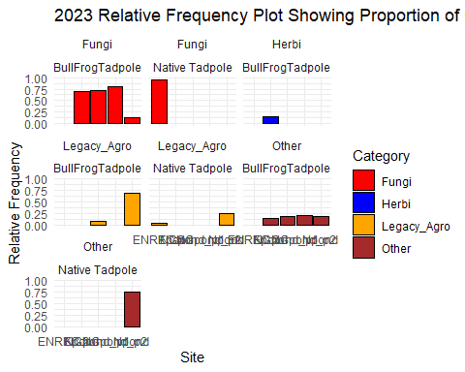
##Histogram and Regression Models for 2023-2024 data Again, as seen in previous histograms, we see a strong right-skewness in the data. We thus use a log transformation on the response variable.We can see that the distribution is normally distributed. In this data, we include the variable “Year”, which has 2 levels. The value “3” represents the year 2023 and 4 represents the year 2024. This was done to obtain the two levels for the regression models.
hist(tadfin_23_24$Concentration)
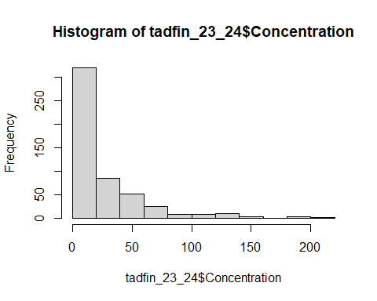
hist(log(tadfin_23_24$Concentration))
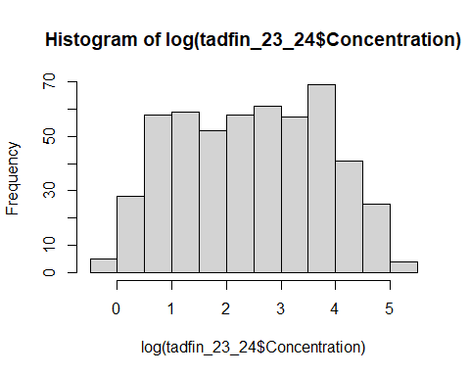
tadfin_23_24$Mass..g...dry.weight. <- as.numeric(tadfin_23_24$Mass..g...dry.weight.)
tadfin_23_24$X..Moisture <- as.numeric(tadfin_23_24$X..Moisture)
tadfin_23_24$Year <- as.factor(tadfin_23_24$Year)
##Regression Models
mod_23_24_1 <- lm(log(Concentration) ~ Specices + Site + Category + Temperature + Year ,
data = tadfin_23_24)
anova(mod_23_24_1)
## Analysis of Variance Table
##
## Response: log(Concentration)
## Df Sum Sq Mean Sq F value Pr(>F)
## Specices 1 314.07 314.075 384.0468 < 2.2e-16 ***
## Site 6 142.48 23.747 29.0370 < 2.2e-16 ***
## Category 4 11.89 2.972 3.6341 0.0062343 **
## Temperature 1 9.14 9.138 11.1737 0.0008914 ***
## Year 1 13.51 13.506 16.5151 5.599e-05 ***
## Residuals 503 411.36 0.818
## ---
## Signif. codes: 0 '***' 0.001 '**' 0.01 '*' 0.05 '.' 0.1 ' ' 1
summary(mod_23_24_1)
##
## Call:
## lm(formula = log(Concentration) ~ Specices + Site + Category +
## Temperature + Year, data = tadfin_23_24)
##
## Residuals:
## Min 1Q Median 3Q Max
## -3.1581 -0.4960 -0.0189 0.5460 2.7024
##
## Coefficients:
## Estimate Std. Error t value Pr(>|t|)
## (Intercept) 1.090819 0.234247 4.657 4.12e-06 ***
## SpecicesNative Tadpole 1.240902 0.133155 9.319 < 2e-16 ***
## SiteKpond 0.816554 0.168388 4.849 1.65e-06 ***
## SiteNGpond -0.846643 0.234428 -3.612 0.000335 ***
## SiteNGpond_p1 -0.882188 0.233191 -3.783 0.000174 ***
## SiteNGpond_p2 -0.626625 0.264516 -2.369 0.018216 *
## SiteNpond 0.441572 0.190409 2.319 0.020791 *
## SiteZpond -0.158487 0.284157 -0.558 0.577266
## CategoryHerbi 0.094244 0.114567 0.823 0.411121
## CategoryLegacy_Agro 0.385761 0.156961 2.458 0.014320 *
## CategoryNeonico -0.946254 0.341370 -2.772 0.005779 **
## CategoryOther -0.009822 0.115105 -0.085 0.932035
## Temperature 0.068839 0.013086 5.260 2.13e-07 ***
## Year2024 -0.735638 0.181019 -4.064 5.60e-05 ***
## ---
## Signif. codes: 0 '***' 0.001 '**' 0.01 '*' 0.05 '.' 0.1 ' ' 1
##
## Residual standard error: 0.9043 on 503 degrees of freedom
## Multiple R-squared: 0.5442, Adjusted R-squared: 0.5324
## F-statistic: 46.19 on 13 and 503 DF, p-value: < 2.2e-16
mod_23_24_2 <- lm(log(Concentration) ~ Specices + Site + Category + Temperature + Year + Mass..g...dry.weight. + X..Moisture + X..Lipid,
data = tadfin_23_24)
anova(mod_23_24_2)
## Analysis of Variance Table
##
## Response: log(Concentration)
## Df Sum Sq Mean Sq F value Pr(>F)
## Specices 1 306.32 306.324 405.3293 < 2.2e-16 ***
## Site 6 140.26 23.377 30.9324 < 2.2e-16 ***
## Category 4 12.25 3.064 4.0539 0.0030504 **
## Temperature 1 6.15 6.153 8.1421 0.0045149 **
## Year 1 8.35 8.346 11.0431 0.0009594 ***
## Mass..g...dry.weight. 1 19.24 19.238 25.4563 6.468e-07 ***
## X..Moisture 1 5.63 5.631 7.4514 0.0065758 **
## X..Lipid 1 9.22 9.219 12.1980 0.0005234 ***
## Residuals 472 356.71 0.756
## ---
## Signif. codes: 0 '***' 0.001 '**' 0.01 '*' 0.05 '.' 0.1 ' ' 1
summary(mod_23_24_2)
##
## Call:
## lm(formula = log(Concentration) ~ Specices + Site + Category +
## Temperature + Year + Mass..g...dry.weight. + X..Moisture +
## X..Lipid, data = tadfin_23_24)
##
## Residuals:
## Min 1Q Median 3Q Max
## -2.46718 -0.50415 -0.01344 0.49037 2.49625
##
## Coefficients:
## Estimate Std. Error t value Pr(>|t|)
## (Intercept) 0.073557 1.280033 0.057 0.954199
## SpecicesNative Tadpole 0.334550 0.272134 1.229 0.219550
## SiteKpond 0.452480 0.202731 2.232 0.026088 *
## SiteNGpond -1.052958 0.263643 -3.994 7.54e-05 ***
## SiteNGpond_p1 -1.207356 0.255033 -4.734 2.91e-06 ***
## SiteNGpond_p2 -0.953762 0.271950 -3.507 0.000496 ***
## SiteNpond 0.087680 0.232560 0.377 0.706326
## SiteZpond -0.555381 0.302369 -1.837 0.066873 .
## CategoryHerbi 0.197608 0.115284 1.714 0.087168 .
## CategoryLegacy_Agro 0.391784 0.154699 2.533 0.011646 *
## CategoryNeonico -0.851168 0.331491 -2.568 0.010545 *
## CategoryOther 0.083441 0.113496 0.735 0.462591
## Temperature 0.042262 0.014256 2.964 0.003186 **
## Year2024 -0.604047 0.230528 -2.620 0.009069 **
## Mass..g...dry.weight. -3.765662 1.743170 -2.160 0.031257 *
## X..Moisture 0.027607 0.013221 2.088 0.037327 *
## X..Lipid 0.012929 0.003702 3.493 0.000523 ***
## ---
## Signif. codes: 0 '***' 0.001 '**' 0.01 '*' 0.05 '.' 0.1 ' ' 1
##
## Residual standard error: 0.8693 on 472 degrees of freedom
## (28 observations deleted due to missingness)
## Multiple R-squared: 0.5872, Adjusted R-squared: 0.5732
## F-statistic: 41.96 on 16 and 472 DF, p-value: < 2.2e-16

Exploratory Data Analysis for the 2024 Data
#Proportion of the concentration by Site, by Site and Specices
## By Site and Specices
data_plot_7 <- tadfin_2024
library(lubridate)
data_plot_7 <- data_plot_7 %>%
count(Site, Specices, Category) %>%
group_by(Site,Specices) %>%
mutate(Relative_Freq = n / sum(n))
#Table to show results
library(knitr)
kable(data_plot_7)
Site | Specices | Category | n | Relative_Freq
ENREC 2 | Native Tadpole | Fungi | 18 | 0.3529412
ENREC 2 | Native Tadpole | Herbi | 22 | 0.4313725
ENREC 2 | Native Tadpole | Legacy_Agro | 2 | 0.0392157
ENREC 2 | Native Tadpole | Other | 9 | 0.1764706
Kpond | BullFrogTadpole | Fungi | 35 | 0.5645161
Kpond | BullFrogTadpole | Herbi | 20 | 0.3225806
Kpond | BullFrogTadpole | Other | 7 | 0.1129032
Kpond | Native Tadpole | Fungi | 20 | 0.2941176
Kpond | Native Tadpole | Herbi | 20 | 0.2941176
Kpond | Native Tadpole | Neonico | 8 | 0.1176471
Kpond | Native Tadpole | Other | 20 | 0.2941176
NGpond | BullFrogTadpole | Fungi | 18 | 0.4186047
NGpond | BullFrogTadpole | Herbi | 8 | 0.1860465
NGpond | BullFrogTadpole | Other | 17 | 0.3953488
Npond | BullFrogTadpole | Fungi | 10 | 0.1041667
Npond | BullFrogTadpole | Herbi | 46 | 0.4791667
Npond | BullFrogTadpole | Legacy_Agro | 30 | 0.3125000
Npond | BullFrogTadpole | Other | 10 | 0.1041667
Npond | Native Tadpole | Fungi | 3 | 0.1764706
Npond | Native Tadpole | Legacy_Agro | 7 | 0.4117647
Npond | Native Tadpole | Other | 7 | 0.4117647
Zpond | BullFrogTadpole | Fungi | 10 | 0.6666667
Zpond | BullFrogTadpole | Other | 5 | 0.3333333
Zpond | Native Tadpole | Other | 2 | 1.0000000
# Plot relative frequencies by species
ggplot(data_plot_7, aes(x = Site , y = Relative_Freq, fill = Category)) +
geom_bar(stat = "identity", color = "black") + # Color for border
scale_fill_manual(values = c("Herbi" = "blue", "Fungi" = "red", "Neonico" = "green", "Legacy_Agro" = "orange", "Other" = "brown")) + # Custom colors
facet_wrap(Category ~ Specices) + # Facet by species
labs(y = "Relative Frequency", x = "Site", title = "2024 Relative Frequency Plot Showing Proportion of Concentration for Bullfrog and Native Tadpoles in Each Site") +
theme_minimal()
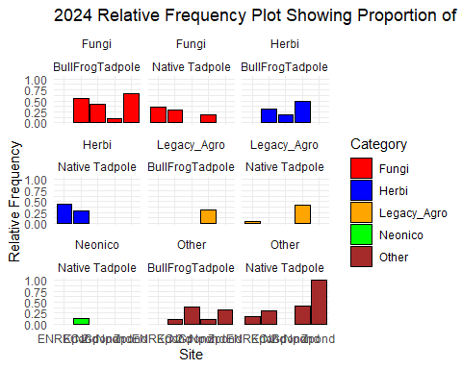
##Histograms and Interactive Plots
# hist(clean_data_sub$Concentration)
# #Using Log Transformation
# hist(log(clean_data_sub$Concentration))
#
# #Interaction plot
# with(clean_data_sub,
# interaction.plot(x.factor = Specices,
# trace.factor = Category,
# response = Concentration,
# col = c("red", "blue", "green", "purple","black"), # add more if needed
# lty = 1, # line type
# lwd = 2, # line width
# xlab = "Specices",
# ylab = "Mean Concentration",
# trace.label = "Category"))

# Regression Models when original data is considered
# # Trend line for concentration of Neonecotinoid and fungicide for each specices across 2021 to 2024
# est <- lm(log(Concentration) ~ Category + Specices, data = clean_data_sub)
# anova(est)
# summary(est)
#
# est_1 <- lm(log(Concentration) ~ Category + Specices + Temperature, data = clean_data_sub)
# anova(est_1)
# summary(est_1)
#
# est_2 <- lm(log(Concentration) ~ Category + Specices + Temperature + Year, data = clean_data_sub)
# anova(est_2)
# summary(est_2)
#
# est_3 <- lm(log(Concentration) ~ Category + Specices + Temperature + Year + Dev_stage, data = clean_data_sub)
# anova(est_3)
# summary(est_3)

Subsetting data set based on category
# # Subset based on two levels
# conc_sub <- conc_data_clean[conc_data_clean$Category %in% c("Fungi", "Neonico"), ]
# ## sort by date
# # Extract year into a new column
# library(dplyr)
#
# conc_sub$Collection_date <- as.Date(conc_sub$Collection_date, format = "%m/%d/%Y")
# conc_sub <- conc_sub %>%
# mutate(Year = as.numeric(format(Collection_date, "%Y")))
# conc_sub <- conc_sub %>%
# arrange(Year)
# conc_sub <- conc_sub %>%
# select(ID,Specices, Site, Category,Temperature,Year,Collection_date,Dev_stage,Mass..g...dry.weight.,X..Moisture,X..Lipid,Concentration)
# conc_sub$Collection_date <- NULL
#
#
#
# conc_sub <- conc_sub %>%
# mutate(Year = factor(Year))

2023 and 2024
# conc_sub_23_24 <- conc_sub[conc_sub$Year %in% c("2023", "2024"), ]
# conc_sub_23_24 <- na.omit(conc_sub_23_24)
# library(tidyr)
# mod_1 <- lm(Concentration ~ Year + Specices + Category , data = conc_sub_23_24)
# summary(mod_1)
# library(emmeans)
# em1 <- emmeans(mod_1, specs = ~ Year|Specices | Category)
# em1 <- as.data.frame(em1)
#
# library(ggplot2)
# ggplot(em1, aes(x = Specices, y = emmean, color = Year, group = Year)) +
# geom_point(position = position_dodge(0.3), size = 3) +
# geom_line(position = position_dodge(0.3)) +
# facet_wrap(~ Category) +
# labs(title = "Estimated Means of Concentration",
# y = "Estimated Mean Concentration",
# x = "Specices") +
# theme_minimal()
# library(tidyr)
# mod_2 <- lm(Concentration ~ Year + Category + Specices + Site , data = conc_sub_23_24)
# summary(mod_2)
# library(emmeans)
# em2 <- emmeans(mod_2, specs = ~ Year|Category|Specices|Site)
# em2 <- as.data.frame(em2)
#
# library(ggplot2)
# ggplot(em2, aes(x = Site, y = emmean, color = Year, group = Year)) +
# geom_point(position = position_dodge(0.3), size = 3) +
# geom_line(position = position_dodge(0.3)) +
# facet_wrap(Specices~ Category) +
# labs(title = "Estimated Means of Concentration",
# y = "Estimated Mean Concentration",
# x = "Specices") +
# theme_minimal()
##Model ##Objective: To quantify concentration of Neonicotinoids and fungicides in tadpoles over the years 2021 to 2024
# library(lme4)
# #Fitting the linear model_1
# model_1 <- lmer(Concentration ~ Category + (1|Year) + (1|Year:Category), data = clean_data_sub)
# summary(model_1)
# anova(model_1) #for anova table
# library(emmeans)
# em_1 <- emmeans(model_1, specs = ~ Category)
# em_1
table(clean_data_sub$Category)
##
## Fungi Herbi Legacy_Agro Neonico Other
## 262 137 105 14 146

Tadpole Final Data
summary(tadpole_fin)
## ID Specices Site Temperature
## Min. : 1.0 Length:175 Length:175 Min. : 2.52
## 1st Qu.: 44.5 Class :character Class :character 1st Qu.:18.86
## Median : 88.0 Mode :character Mode :character Median :20.85
## Mean : 88.0 Mean :18.92
## 3rd Qu.:131.5 3rd Qu.:23.13
## Max. :175.0 Max. :29.35
##
## Collection_date Dev_stage Mass..g...dry.weight. X..Moisture
## Length:175 Length:175 Min. :0.00200 Min. : 0.00
## Class :character Class :character 1st Qu.:0.03955 1st Qu.: 4.11
## Mode :character Mode :character Median :0.08880 Median :79.93
## Mean :0.11825 Mean :58.80
## 3rd Qu.:0.20405 3rd Qu.:85.58
## Max. :0.47240 Max. :96.20
##
## X..Lipid Acetochlor Atrazine Azoxystrobin
## Min. : 0.420 Min. : 3.200 Min. : 2.3 Min. :7.4
## 1st Qu.: 6.138 1st Qu.: 6.075 1st Qu.: 9.0 1st Qu.:7.4
## Median : 9.785 Median : 8.350 Median :13.5 Median :7.4
## Mean :15.673 Mean : 19.069 Mean :16.4 Mean :7.4
## 3rd Qu.:14.217 3rd Qu.: 14.275 3rd Qu.:22.3 3rd Qu.:7.4
## Max. :97.560 Max. :131.300 Max. :38.5 Max. :7.4
## NA's :57 NA's :159 NA's :134 NA's :174
## Clothianidin Carbendazim Cyfluthrin..all.isomers. Cyproconazole
## Min. : 3.00 Min. :13.20 Min. : 1.40 Min. :0.900
## 1st Qu.:12.68 1st Qu.:16.10 1st Qu.: 14.35 1st Qu.:1.275
## Median :16.85 Median :18.10 Median : 40.60 Median :1.400
## Mean :16.39 Mean :26.73 Mean : 60.20 Mean :1.500
## 3rd Qu.:20.00 3rd Qu.:19.80 3rd Qu.: 92.70 3rd Qu.:1.625
## Max. :32.20 Max. :84.00 Max. :200.80 Max. :2.300
## NA's :161 NA's :168 NA's :144 NA's :171
## Bifenthrin Desthiopro Dithiopyr Flufenacet
## Min. :1.800 Min. : 1.00 Min. :15.80 Min. :16.80
## 1st Qu.:2.300 1st Qu.: 4.50 1st Qu.:20.90 1st Qu.:22.98
## Median :2.800 Median : 18.00 Median :24.30 Median :30.55
## Mean :3.424 Mean : 35.74 Mean :26.68 Mean :31.20
## 3rd Qu.:3.600 3rd Qu.: 44.20 3rd Qu.:30.07 3rd Qu.:34.58
## Max. :7.600 Max. :206.20 Max. :42.30 Max. :58.90
## NA's :158 NA's :77 NA's :171 NA's :165
## Fluoxastrobin Fluxapyroxad Ipconazole Metolachlor..R.and.S.
## Min. :2.600 Min. :3.70 Min. : 1.500 Min. : 0.90
## 1st Qu.:2.700 1st Qu.:4.10 1st Qu.: 9.575 1st Qu.: 8.65
## Median :2.800 Median :4.10 Median : 48.150 Median : 22.80
## Mean :2.733 Mean :4.36 Mean : 55.417 Mean : 32.64
## 3rd Qu.:2.800 3rd Qu.:4.70 3rd Qu.: 89.675 3rd Qu.: 44.75
## Max. :2.800 Max. :5.20 Max. :180.400 Max. :134.20
## NA's :172 NA's :170 NA's :89 NA's :123
## Metconazole Pendimethalin Pentachloroanisole Propiconazole
## Min. : 5.20 Min. :3.000 Min. : 2.90 Min. : 1.300
## 1st Qu.: 6.55 1st Qu.:3.525 1st Qu.: 4.90 1st Qu.: 2.000
## Median : 7.90 Median :4.750 Median : 7.25 Median : 2.700
## Mean : 7.70 Mean :4.875 Mean : 7.30 Mean : 3.107
## 3rd Qu.: 8.95 3rd Qu.:5.725 3rd Qu.: 9.50 3rd Qu.: 3.250
## Max. :10.00 Max. :8.100 Max. :12.80 Max. :19.900
## NA's :172 NA's :167 NA's :165 NA's :132
## Pyraclostrobin Tebuconazole Penoxsulam ppDDD
## Min. :4.4 Min. : 2.70 Min. : 3.100 Min. : 4.100
## 1st Qu.:5.9 1st Qu.:10.70 1st Qu.: 5.250 1st Qu.: 6.375
## Median :7.4 Median :21.60 Median : 5.850 Median : 8.750
## Mean :6.4 Mean :33.35 Mean : 6.817 Mean :10.738
## 3rd Qu.:7.4 3rd Qu.:59.70 3rd Qu.: 8.400 3rd Qu.:13.200
## Max. :7.4 Max. :90.20 Max. :11.800 Max. :24.500
## NA's :172 NA's :106 NA's :169 NA's :151
## ppDDE ppDDT Tetraconazole Thiabendazole
## Min. : 1.30 Min. : 1.400 Min. :1.000 Min. : 0.800
## 1st Qu.: 10.30 1st Qu.: 4.325 1st Qu.:1.175 1st Qu.: 1.700
## Median : 37.10 Median : 6.000 Median :1.450 Median : 3.400
## Mean : 41.62 Mean : 7.133 Mean :1.637 Mean : 5.443
## 3rd Qu.: 62.10 3rd Qu.: 9.225 3rd Qu.:1.725 3rd Qu.: 7.550
## Max. :142.30 Max. :21.900 Max. :3.200 Max. :21.600
## NA's :122 NA's :157 NA's :167 NA's :145
## ThiamethoxamD
## Min. : 18.60
## 1st Qu.: 31.27
## Median : 33.95
## Mean :1142.00
## 3rd Qu.: 40.70
## Max. :8908.80
## NA's :167
conc_data <- tadpole_fin[,c(1:8,12,36)]
conc_data <- conc_data[order(conc_data$Temperature),]
conc_data[, c("Site","Specices","Collection_date")] <- lapply(conc_data[, c("Site","Specices","Collection_date")], as.factor)
library(dplyr)
# Convert ND to NA
conc_data <- conc_data %>%
mutate(Mass..g...dry.weight. = ifelse(Mass..g...dry.weight. == "ND", NA, as.numeric(Mass..g...dry.weight.)))
conc_data <- conc_data %>%
mutate(Dev_stage = ifelse(Dev_stage == "ND", NA, as.numeric(Dev_stage)))
## Warning: There was 1 warning in `mutate()`.
## ℹ In argument: `Dev_stage = ifelse(Dev_stage == "ND", NA,
## as.numeric(Dev_stage))`.
## Caused by warning in `ifelse()`:
## ! NAs introduced by coercion
conc_data <- conc_data %>%
mutate(X..Moisture = ifelse(X..Moisture == "ND", NA, as.numeric(X..Moisture)))
# Load libraries
library(ggplot2)
library(reshape2)
##
## Attaching package: 'reshape2'
## The following object is masked from 'package:tidyr':
##
## smiths
quant_vars <- conc_data[sapply(conc_data, is.numeric)]
# Compute the correlation matrix
cor_matrix <- cor(quant_vars, use = "pairwise.complete.obs")
# Convert the correlation matrix into a long format
cor_melted <- melt(cor_matrix)
# Create the ggplot correlation heatmap
ggplot(cor_melted, aes(x = Var1, y = Var2, fill = value)) +
geom_tile() +
scale_fill_gradient2(low = "orange", high = "green", mid = "white",
midpoint = 0, limit = c(-1, 1), space = "Lab") +
theme_minimal() +
ggtitle("Correlation Plot") +
theme(axis.text.x = element_text(angle = 45, hjust = 1)) +
labs(fill = "Correlation")
