Shabani_Muller
Frank Agyemang
2025-06-02

Data Description
In the data set named “tadpole_fin.csv”, there were 175 tadpoles from the year 2021 to 2024. Two species of tadpoles were recorded in this data set, namely Bullfrog Tadpole and Native Tadpole. Out of the 175 tadpoles, 109 were Bullfrog and 66 were Native tadpoles respectively. For data set collected in 2021 and 2022, there were information on only Bullfrog Tadpole and Native Tadpole respectively. This is an important information because there may be confounding effect and thus care must be taken in the conclusion we make. There were eight predictor variables:Temperature, Collection Date, Site, Species, Dry Weight, Moisture and Lipid. The rest of the variables measured the concentration of chemicals that were detected in tadpoles over the four year period. Overall, twenty-eight of such chemicals were detected which would later be placed in five categories : Neonicotinoid, Fungicide, Herbicide, Legacy Agrochemical and Other.
tadpole_fin <- read.csv("Tadpole_2021_2024_WetWeight_clean.csv")
tadpole_fin$ThiamethoxamD <- as.numeric(tadpole_fin$ThiamethoxamD)
## Warning: NAs introduced by coercion
tadpole_fin$ThiamethoxamD[is.na(tadpole_fin$ThiamethoxamD)] <- 1897.6
# Changing all concentration values of 0.1 to 0.05
vars_to_change <- c("Clothianidin", "ThiamethoxamD","Azoxystrobin", "Carbendazim", "Cyproconazole", "Fluoxastrobin",
"Fluxapyroxad", "Ipconazole", "Metconazole", "Propiconazole", "Pyraclostrobin", "Tebuconazole",
"Tetraconazole", "Thiabendazole","Acetochlor", "Atrazine", "Dithiopyr", "Flufenacet",
"Metolachlor..R.and.S.", "Pendimethalin", "Penoxsulam","Cyfluthrin..all.isomers.", "Bifenthrin",
"Desthiopro","ppDDD", "ppDDE", "ppDDT", "Pentachloroanisole" )
# Replace 0.1 with 0.05 in the specified columns
tadpole_fin[vars_to_change] <- lapply(tadpole_fin[vars_to_change], function(x) ifelse(x == 0.1, 0.05, x))
#summary(tadpole_fin)

Descriptive Statistics for Chemicals
Next, we show a table that provides a summary statistic for the various chemicals detected. As stated before, there were twenty eight chemicals that were detected. For each of the chemical, the mean, minimum, maximum and the category they fall in, (Neonicotinoid, Fungicide, Herbicide, Legacy Agro, Other), has been provided. Overall, the chemical,ThiamethoxamD, had the highest mean concentration, followed by Ipconazole,Desthiopro,Tebuconazole,ppDDE and Metolachlor..R.and.S. respectively. There were 12 chemicals classified as Fungicide, 7 as Herbicide, 4 as Legacy Agro, 2 as Neonicotinoid and 3 as Other. Using these compositions, we showed the proportion of chemicals in each of the five categories through a bar chart. From the bar chart, Fungicides and Herbicides constituted about 42.9 and 25 percent respectively while Neonicotinoids, Legacy Agro and Other constituted 7.1, 14.3, and 10.7 percent resepectively.
chemicals <- tadpole_fin[,c(9:36)]
# Summary statistics for numeric variables
summary_table <- data.frame(
Chemical = names(chemicals),
Mean = sapply(chemicals, mean, na.rm = TRUE),
Median = sapply(chemicals, median, na.rm = TRUE),
Min = sapply(chemicals, min, na.rm = TRUE),
Max = sapply(chemicals, max, na.rm = TRUE),
SD = sapply(chemicals, sd, na.rm = TRUE)
)
library(dplyr)
##
## Attaching package: 'dplyr'
## The following objects are masked from 'package:stats':
##
## filter, lag
## The following objects are masked from 'package:base':
##
## intersect, setdiff, setequal, union
summary_table <- summary_table %>%
mutate(Category = case_when(
Chemical %in% c("Clothianidin", "ThiamethoxamD") ~ "Neonico",
Chemical %in% c("Azoxystrobin", "Carbendazim", "Cyproconazole", "Fluoxastrobin",
"Fluxapyroxad", "Ipconazole", "Metconazole", "Propiconazole",
"Pyraclostrobin", "Tebuconazole", "Tetraconazole", "Thiabendazole") ~ "Fungi",
Chemical %in% c("Acetochlor", "Atrazine", "Dithiopyr", "Flufenacet",
"Metolachlor..R.and.S.", "Pendimethalin", "Penoxsulam") ~ "Herbi",
Chemical %in% c("Cyfluthrin..all.isomers.", "Bifenthrin", "Desthiopro") ~ "Other",
Chemical %in% c("ppDDD", "ppDDE", "ppDDT", "Pentachloroanisole") ~ "Legacy_Agro",
TRUE ~ NA_character_ # Optional: Assign NA to unmatched values
))
sort(summary_table$Mean)
## [1] 0.05628571 0.05771429 0.05942857 0.06314286 0.06685714 0.07257143
## [7] 0.07714286 0.08714286 0.08828571 0.11142857 0.11400000 0.13457143
## [13] 0.17028571 0.19228571 0.20171429 0.21485714 0.25171429 0.33228571
## [19] 0.37171429 0.41000000 0.77942857 0.98114286 2.24800000 2.38971429
## [25] 2.53257143 3.75857143 4.87742857 11.16771429
###########################################################################################################
library(ggplot2)
library(dplyr)
# Find global x-axis range
x_max <- max(summary_table$Mean, na.rm = TRUE)
# Plot
# Plot with grid lines removed
ggplot(summary_table, aes(x = Mean, y = reorder(Chemical, Mean), fill = Category)) +
geom_col() +
facet_wrap(~ Category, scales = "free_y") +
scale_x_continuous(limits = c(0, x_max)) +
labs(x = "Mean Concentration", y = "Chemical", title = "Mean Concentration of Chemicals by Category") +
theme_minimal() +
theme(
legend.position = "none",
panel.grid = element_blank(),
panel.grid.major = element_blank(),
panel.grid.minor = element_blank()
)
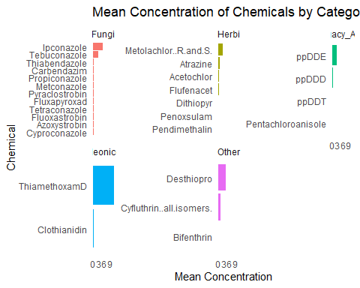
#############################################################################################################
# Proportion of chemicals in each Category - Pie Chart
library(ggplot2)
chem_summary <- summary_table %>%
count(Category) %>%
mutate(Proportion = n / sum(n),
Label = paste0(Category, " (", round(Proportion * 100, 1), "%)"))
# Create the pie chart
ggplot(chem_summary, aes(x = "", y = Proportion, fill = Category)) +
geom_col(width = 1) +
coord_polar(theta = "y") +
labs(title = "Proportion of Chemicals by Category") +
theme_void() +
geom_text(aes(label = Label),
position = position_stack(vjust = 0.5), size = 4)
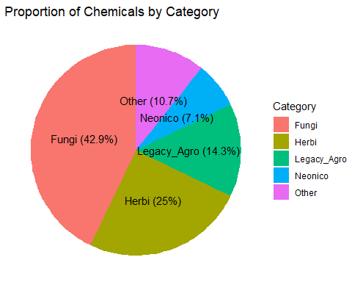
# Convert from wide to long format
# long_df <- wide_df %>%
# pivot_longer(
# cols = starts_with("Time"), # columns to pivot
# names_to = "Time_Point", # new column name for former column names
# values_to = "Value" # new column name for values
# )
#
# print(long_df)
library(tidyr)
library(dplyr)
## Coverting data from wide to long format
conc_data <- tadpole_fin %>%
pivot_longer(
cols = `Acetochlor`:`ThiamethoxamD`,
names_to = "Chemical",
values_to = "Concentration"
)
conc_data[, c("Chemical")] <- lapply(conc_data[, c("Chemical")], as.factor)
conc_data <- conc_data[order(conc_data$Chemical),]
#conc_data$Chemical <- gsub("\\..*", "", conc_data$Chemical)
############################################################################################################
# Create a new variable with assigned categories
conc_data <- conc_data %>%
mutate(Category = case_when(
Chemical %in% c("Clothianidin", "Thiamethoxam") ~ "Neonico",
Chemical %in% c("Azoxystrobin", "Carbendazim", "Cyproconazole", "Fluoxastrobin",
"Fluxapyroxad", "Ipconazole", "Metconazole", "Propiconazole",
"Pyraclostrobin", "Tebuconazole", "Tetraconazole", "Thiabendazole") ~ "Fungi",
Chemical %in% c("Acetochlor", "Atrazine", "Dithiopyr", "Flufenacet",
"Metolachlor", "Pendimethalin", "Penoxsulam") ~ "Herbi",
Chemical %in% c("Cyfluthrin", "Bifenthrin", "Desthiopro") ~ "Other",
Chemical %in% c("ppDDD", "ppDDE", "ppDDT", "Pentachloroanisole") ~ "Legacy_Agro",
TRUE ~ NA_character_ # Optional: Assign NA to unmatched values
))
conc_data[, c("Category", "Site")] <- lapply(conc_data[, c("Category","Site")], as.factor)
levels(conc_data$Site)
## [1] "ENREC 2" "Gpond" "Jcpond" "Kpond" "NGpond" "NGpond_p1"
## [7] "NGpond_p2" "Npond" "Zpond"
############################################################################################################
library(lubridate)
##
## Attaching package: 'lubridate'
## The following objects are masked from 'package:base':
##
## date, intersect, setdiff, union
# Convert Date to Date format and extract year
conc_data$Collection_date <- year(mdy(conc_data$Collection_date))
conc_data$Collection_date <- as.factor(conc_data$Collection_date)
library(dplyr)
library(ggplot2)
library(purrr)
# Filter chemicals by mean > 0.05 per year-category-chemical
chem_threshold <- conc_data %>%
group_by(Collection_date, Category, Chemical) %>%
summarise(mean_conc = mean(Concentration, na.rm = TRUE), .groups = "drop") %>%
filter(mean_conc > 0.05)
# Join back to the original data to keep only those chemicals
summary_table_2 <- conc_data %>%
inner_join(chem_threshold, by = c("Collection_date", "Category", "Chemical"))
# Step 3: Create boxplots per year-category
plots <- summary_table_2 %>%
split(list(.$Collection_date, .$Category)) %>%
map(~ ggplot(.x, aes(x = Chemical, y = Concentration)) +
geom_boxplot(fill = "#56B4E9", outlier.size = 0.5) +
labs(title = paste("Year:", unique(.x$Collection_date), "| Category:", unique(.x$Category)),
x = "Chemical", y = "Concentration") +
theme_minimal() +
theme(axis.text.x = element_text(angle = 90, vjust = 0.5, hjust = 1),
panel.grid.major.x = element_blank())
)
# View first plot
# Change number to get various plots
print(plots[[8]])
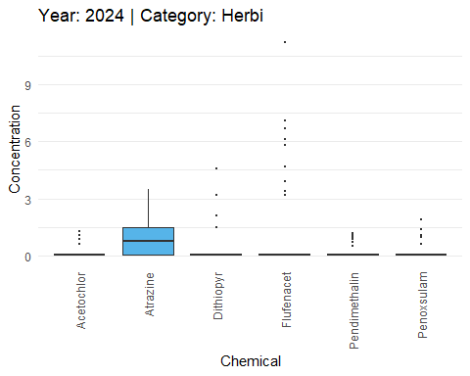

Persistence of concentration of the various chemicals in each species across the years 2021 to 2024
The researcher was interested in determining whether the concentration of the various chemicals for each species persisted over time. We used a mean plot to demonstrate whether average concentration levels for the different chemicals and species increased or decreased over time. We can see that concentration levels for Acetochlor,Azoxystrobin,Cyproconazole,ppDDD,Propiconazole,Tetraconazole,Thiabendazole for Bullfrog species was higher from the years 2021 to 2023 and declined in 2024. Nevertheless, the concentration levels in Native tadpoles for the same chemicals remained almost the same for all years except for Propiconazole. The plots also enable the researcher to make several comparisons.
# Convert to Date class (assumes mm/dd/yyyy format)
tadpole_fin$Collection_date <- as.Date(tadpole_fin$Collection_date, format = "%m/%d/%Y")
# Extract the year only
tadpole_fin$Collection_date <- format(tadpole_fin$Collection_date, "%Y")
# Now you can order by year
tadpole_fin <- tadpole_fin[order(tadpole_fin$Collection_date), ]
library(dplyr)
# Compute means grouped by species and year
tadpole_fin_means <- tadpole_fin %>%
group_by(Specices, Collection_date) %>%
summarise(across(where(is.numeric), mean, na.rm = TRUE), .groups = "drop")
## Warning: There was 1 warning in `summarise()`.
## ℹ In argument: `across(where(is.numeric), mean, na.rm = TRUE)`.
## ℹ In group 1: `Specices = "BullFrogTadpole"`, `Collection_date = "2021"`.
## Caused by warning:
## ! The `...` argument of `across()` is deprecated as of dplyr 1.1.0.
## Supply arguments directly to `.fns` through an anonymous function instead.
##
## # Previously
## across(a:b, mean, na.rm = TRUE)
##
## # Now
## across(a:b, \(x) mean(x, na.rm = TRUE))
# Removing some variables in the data frame
tadpole_fin_means <- tadpole_fin_means[, -c(3, 4, 5,6)]

Mean Plot showing the persistence of concentration for the various chemicals and Species over the years 2021 to 2024
# Mean plot showing the concentration for each chemical over time
library(ggplot2)
library(dplyr)
library(tidyr)
# Assuming your data frame is called 'df'
# First reshape the data to long format
tadpole_fin_means_long <- tadpole_fin_means %>%
pivot_longer(
cols = -c(Specices, Collection_date),
names_to = "Chemical",
values_to = "Concentration"
)
# Calculate means (optional if you want pre-aggregated values)
tadpole_fin_means_summary <- tadpole_fin_means_long %>%
group_by(Specices, Collection_date, Chemical) %>%
summarise(Mean_Concentration = mean(Concentration, na.rm = TRUE), .groups = "drop")
# Plot
ggplot(tadpole_fin_means_summary, aes(x = as.factor(Collection_date), y = Mean_Concentration, color = Specices, group = Specices)) +
geom_line() +
geom_point() +
facet_wrap(~ Chemical, scales = "free_y") +
labs(
x = "Year",
y = "Mean Concentration",
title = "Mean Chemical Concentration by Year and Species"
) +
theme_minimal()
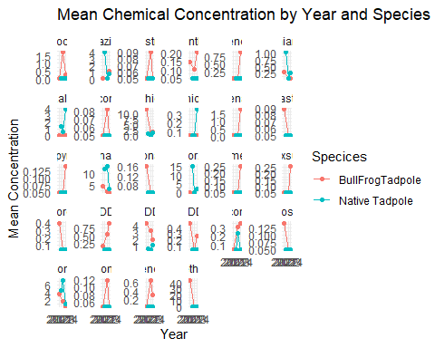
tadpole_fin[] <- lapply(tadpole_fin, function(x) if (is.character(x)) as.factor(x) else x)
library(dplyr)
library(ggplot2)
tadpole_fin_prop <- tadpole_fin %>%
group_by(Site, Specices) %>%
summarise(Count = n(), .groups = "drop") %>%
group_by(Site) %>%
mutate(Proportion = Count / sum(Count))
ggplot(tadpole_fin_prop, aes(x = "", y = Proportion, fill = Specices)) +
geom_bar(stat = "identity", width = 1) +
coord_polar("y") +
facet_wrap(~ Site) +
labs(title = "Specices Proportion in Each Site", fill = "Specices") +
theme_void() +
theme(strip.text = element_text(size = 12, face = "bold"))
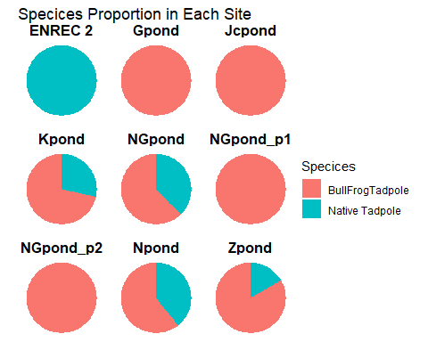
library(dplyr)
library(ggplot2)
# Step 1: Summarize proportions by Year, Site, and Species
species_by_year_site <- tadpole_fin %>%
group_by(Collection_date, Site, Specices) %>%
summarise(Count = n(), .groups = "drop") %>%
group_by(Collection_date, Site) %>%
mutate(Proportion = Count / sum(Count))
# Step 2: Create pie charts with facets
ggplot(species_by_year_site, aes(x = "", y = Proportion, fill = Specices)) +
geom_bar(stat = "identity", width = 1) +
coord_polar("y") +
facet_grid(Collection_date ~ Site) +
labs(title = "Specices Proportion by Year and Site", fill = "Specices") +
theme_void() +
theme(
strip.text = element_text(size = 10, face = "bold"),
plot.title = element_text(hjust = 0.5, face = "bold")
)
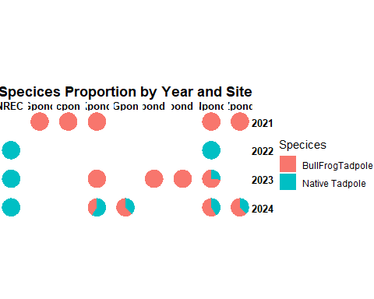
library(dplyr)
tadpole_final <- tadpole_fin %>%
mutate(
Neonico = rowSums(tadpole_fin[, c("Clothianidin", "ThiamethoxamD")]),
Fungi = rowSums(tadpole_fin[, c("Azoxystrobin", "Carbendazim", "Cyproconazole", "Fluoxastrobin",
"Fluxapyroxad", "Ipconazole", "Metconazole", "Propiconazole",
"Pyraclostrobin", "Tebuconazole", "Tetraconazole", "Thiabendazole")]),
Herbi = rowSums(tadpole_fin[, c("Acetochlor", "Atrazine", "Dithiopyr", "Flufenacet",
"Metolachlor..R.and.S.", "Pendimethalin", "Penoxsulam")]),
Other = rowSums(tadpole_fin[, c("Cyfluthrin..all.isomers.", "Bifenthrin", "Desthiopro")]),
Legacy_Agro = rowSums(tadpole_fin[, c("ppDDD", "ppDDE", "ppDDT", "Pentachloroanisole")])
)
## Removing variables
tadpole_final <- tadpole_final[, -c(9:36)]
tadpole_final_freq <- tadpole_final %>%
count(Specices, Collection_date) %>%
group_by(Specices, Collection_date) %>%
mutate(Relative_Freq = n / sum(n))
library(dplyr)
# Define which levels belong to each category
undeveloped_countries <- c("P25","pre-25","p27","P27","26","27-30","28","30")
developing_countries <- c("p31","33","34","35","36","37","38","39")
developed_countries <- c("41")
# Create new category variable
tadpole_final <- tadpole_final %>%
mutate(Dev_stage = case_when(
Dev_stage %in% undeveloped_countries ~ "Undeveloped",
Dev_stage %in% developing_countries ~ "Developing",
Dev_stage %in% developed_countries ~ "Developed",
TRUE ~ NA_character_ # or "Other"
))
tadpole_final$Dev_stage <- as.factor(tadpole_final$Dev_stage)
tadpole_final <- tadpole_final %>%
rename(
Mass = Mass..g...dry.weight.,
Moisture = X..Moisture,
Lipid = X..Lipid
)
library(dplyr)
tadpole_final <- tadpole_final %>%
mutate(ID = c(1:175))
tadpole_final <- tadpole_final %>% select(ID, Collection_date,Site,Specices, everything())
# Proportion of missing values in each column
missing_proportion <- sapply(tadpole_final, function(x) mean(is.na(x)))
# Store it in a data frame
missing_table <- data.frame(
Variable = names(missing_proportion),
Missing_Proportion = missing_proportion
)
# View the table
print(missing_table)
## Variable Missing_Proportion
## ID ID 0.0000000
## Collection_date Collection_date 0.0000000
## Site Site 0.0000000
## Specices Specices 0.0000000
## Temperature Temperature 0.0000000
## Dev_stage Dev_stage 0.4400000
## Mass Mass 0.0000000
## Moisture Moisture 0.0000000
## Lipid Lipid 0.2457143
## Neonico Neonico 0.0000000
## Fungi Fungi 0.0000000
## Herbi Herbi 0.0000000
## Other Other 0.0000000
## Legacy_Agro Legacy_Agro 0.0000000

Plot showing the frequency of chemicals detected
library(dplyr)
library(ggplot2)
# Filter for concentrations above the detection limit
above_detection <- conc_data %>%
filter(Concentration > 0.05)
# Count frequency of each chemical
chemical_counts <- above_detection %>%
group_by(Chemical) %>%
summarise(Frequency = n()) %>%
arrange(desc(Frequency))
# Step 3: Plot the frequencies
ggplot(chemical_counts, aes(x = reorder(Chemical, Frequency), y = Frequency)) +
geom_bar(stat = "identity", fill = "#0072B2") +
coord_flip() +
labs(title = "Frequency of Chemical Detections Above 0.05",
x = "Chemical",
y = "Frequency") +
theme_minimal() +
theme(panel.grid.major.x = element_blank())
