heifer
Frank Agyemang
2024-11-17

Exploratory data analysis on Heifer data set
# heifer <- read.csv("heifer.csv")
# names(heifer)
# # Remove rows with missing values
# heifer <- na.omit(heifer)
# # Replace dots with NA
# heifer[heifer == "."] <- NA
#
#
#
# # Remove rows with missing values
# heifer <- na.omit(heifer)
## Reading in Ovini's cleaned Data
heifer2 <- read.csv("Missing_Removed_Data.csv")
# Specify the variables you want to treat as factors
factor_vars <- c("Development_Treatment","Calan_Treatment","Pen","Calving_Ease","Calf_Vigor","Sire","SEX")
# Convert specified variables to factors
heifer2[factor_vars] <- lapply(heifer2[factor_vars], as.factor)
# #Rearranging the variables in the data frame
# heifer <- heifer[c("ID","Birth.date","Pen..","Initial.BW","Final.BW","Calan.Treatment","Development.Treatment","DMI","ADG","Sire","Gest.Length","Calved.First.21.Days","Birth.date.1","X1st.Calf.BW","SEX","Calving.Ease","Calf.Vigor","Final.Calf.BW","HCW","REA","YG","BF")]
#
#
# # Specify the variables you want to treat as factors
# factor_vars <- c("Pen..", "Sire","Calan.Treatment","Development.Treatment","Calved.First.21.Days","SEX","Calving.Ease","Calf.Vigor","Gest.Length")
# num_vars <- c("Initial.BW","Final.BW","X1st.Calf.BW","Final.Calf.BW")
# # Convert specified variables to factors
# heifer[factor_vars] <- lapply(heifer[factor_vars], as.factor)
# heifer[num_vars] <- lapply(heifer[num_vars], as.numeric)
# library(dplyr)

Exploratory Data Analysis
To begin with our exploratory data analysis, there are some variables which were not described. Moreover, the names of those variables are difficult to interpret. We will remove those variables and focus on those that were described to answer the researcher’s questions. We create a subset data in which variables HCW,REA,YG and BF are eliminated.
We do our exploratory analysis in two folds. First, we will try to understand the relations of variables with the heifers. That is, how the Calan treatment, Pen, etc affects first time heifers. We then move on to understand variables that affect calves.
# heifer_sub <- heifer[,-c(19:22)]
# heifer_sub$DMI <- NULL
# heifer_sub$ADG <- NULL
# Create a new column with the difference between Column2 and Column1
heifer2$Growth_BW <- heifer2$Final_BW - heifer2$Initial_BW
Since the initial and final weights were taken on the heifers, an efficient way to understand how Calan treatment and Development treatment relate to their weight is to take into account the paired nature of the measurements. Therefore, we create a new variable, Growth, which shows by how much heifers increased in weight after their initial weight and being given the treatments.
The boxplot of Pen.. by Initial weight gives an idea of the various weights of heifers that were in each pen. This is interesting to look at since the researcher described this in the study and moreover, we may want to know if that may have any effect on the calan treatment. From the boxplot, heifers in pens 1 and 3 had on average about the same initial weight whiles pens 2 and 4 had on average about the same initial weights as well. Nevertheless, the size of the boxplots in these pens show that initial weights varied largely in pens 2 and 4 than in pens 1 and 3.
Next, we look at the boxplot showing heifer growth by Calan treatment. Two treatments and a control were used for the Calan treatment. Comparing the effect of the two treatments DDG and MET to the CON (Control), we can say both treatment resulted in a higher growth than CON (Control) with MET having on average the highest growth. An important feature about these boxplot is the negative skewness in growth when the Calan treatment was applied. This means some heifers gained tremendous weight whiles others lost weight due to the Calan treatment but we will need to investigate further.
We also show a boxplot of heifer growth when development treatment was given. There were 5 levels for Development treatment and from the plots, we see that stalk and range resulted in the highest average growth weight of heifers.
## Boxplot showing groupings of heifers based on initial weight
library(dplyr)
##
## Attaching package: 'dplyr'
## The following objects are masked from 'package:stats':
##
## filter, lag
## The following objects are masked from 'package:base':
##
## intersect, setdiff, setequal, union
library(ggplot2)
ggplot(heifer2, aes(x = Pen, y = Initial_BW, fill = Pen)) +
geom_boxplot() +
labs(title = "Boxplot showing initial weights of heifers in various pens",
x = "Pen",
y = "Initial_BW") +
theme_minimal()
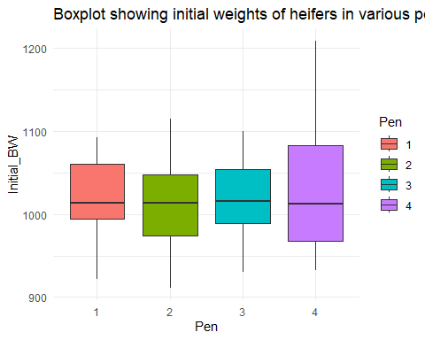
ggplot(heifer2, aes(x = Calan_Treatment, y = Growth_BW, fill = Calan_Treatment)) +
geom_boxplot() +
labs(title = "Boxplot showing heifer growth by Calan Treatment",
x = "Calan Treatment",
y = "Growth_BW") +
theme_minimal()
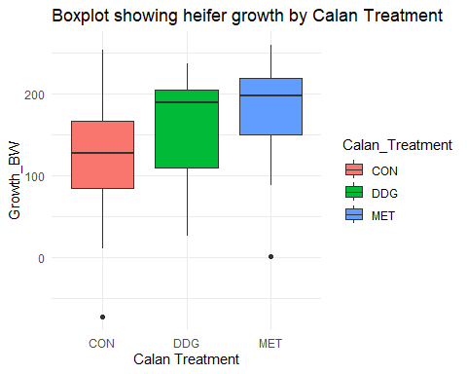
ggplot(heifer2, aes(x = Development_Treatment, y = Growth_BW, fill = Development_Treatment)) +
geom_boxplot() +
labs(title = "Boxplot showing heifer growth by Development Treatment",
x = "Development Treatment",
y = "Growth_BW") +
theme_minimal()
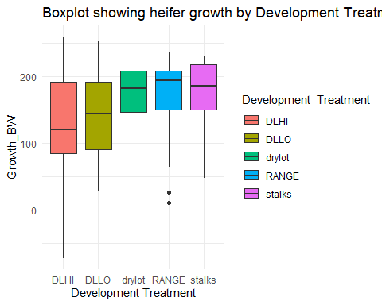
# ggplot(heifer2, aes(x = ID, y = Growth_BW)) +
# geom_point(color = "black", size = 2) + # Add points with specific color and size
# labs(
# title = "Scatter Plot",
# x = "ID",
# y = "growth"
# ) +
# theme_minimal()
## Histogram of the growth of heifers
library(ggplot2)
ggplot(heifer2, aes(x = Growth_BW)) +
geom_histogram(binwidth = 20, fill = "blue", color = "black") +
labs(title = "Histogram of heifer growth",
x = "Growth_BW",
y = "Frequency") +
theme_minimal()
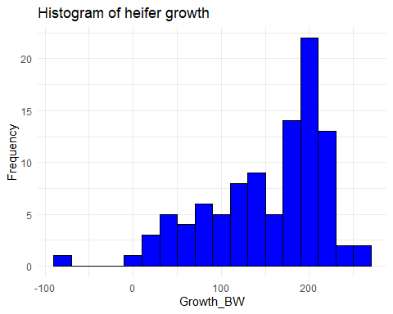

Interaction plots
We now try to determine if there were any interaction between Calan and Development treatment on the growth of heifers. From the plot, there might be some interaction between Calan and Development treatment. For example, growth in heifers using MET was high with all Development treatment except for stalks where DDG had a higher average growth. We will explore further to determine if there is any significant interaction.
# Three-way interaction plot
ggplot(heifer2, aes(x = Development_Treatment , y = Growth_BW, fill = Calan_Treatment )) +
stat_summary(fun = mean, geom = "bar", position = position_dodge(width = 2)) +
facet_grid(. ~ Development_Treatment) +
labs(title = "Two-Way Interaction Plot",
x = "Development Treatment",
y = "Mean Response") +
theme_minimal()
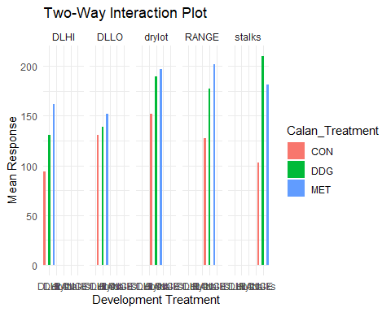

Exploratory Data Analysis on Calf
We now conduct an exploratory analysis on calf’s initial weight. We begin with a boxplot showing the initial weight for Calf by Sire. From the plot, we see that there were six different Sire (male cows). The plot shows that the Calfs from Sires 1104, 2213, 4705 and 4708 had on average a higher initial weight whiles those from Sires 1616,and 261 had a lower initial weight.
The boxplot showing initial weights of Calf by Gestation length also shows that gestation periods that were longer than 282 days led to lower initial weight of the calf with the exception of those that lasted 296 and 307. There seem to be some interaction effect and we would look further into that before making any statement about the effect of gestation length.
The researcher also wanted to know the effect of Sex on the weight of calfs. We attempt to determine the effect of sex on calf at birth and would later take into consideration how Sex affects the growth of the Calfs. From the plot, we see that STR had on average a higher initial weight than Calfs HFR.
# ## Initial Weight of Calf due to Sire
# ggplot(heifer2, aes(x = Sire, y = X1st.Calf.BW, fill = Sire)) +
# geom_boxplot() +
# labs(title = "Boxplot showing initial weights of Calf by different Sire",
# x = "Sire",
# y = "X1st.Calf.BW") +
# theme_minimal()
#
#
# ggplot(heifer_sub, aes(x = Gest.Length, y = X1st.Calf.BW, fill = Gest.Length)) +
# geom_boxplot() +
# labs(title = "Boxplot showing initial weights of Calf by Gest.Length",
# x = "Gest.Length",
# y = "X1st.Calf.BW") +
# theme_minimal()
#
# ggplot(heifer_sub, aes(x = SEX, y = X1st.Calf.BW, fill = SEX)) +
# geom_boxplot() +
# labs(title = "Boxplot showing heifer X1st.Calf.BW by Sex",
# x = "Sex",
# y = "X1st.Calf.BW") +
# theme_minimal()

