Lab 3 – Prelab

Describe in a brief paragraph the role of the Instruction Fetch stage in a MIPS processor.

Instruction fetch is simply retrieving the next program instruction from memory and moving it into the processor. This stage also technically includes managing the Program Counter (PC) by incrementing it by a word in preparation for even the next instruction.

Describe in a brief paragraph the role of the Instruction Decode stage in a MIPS processor.

Instruction decode breaks down the instruction retrieved in the instruction fetch stage into control signals for the control unit and register file. This instruction could also include immediates that would then be sign-extended. The decode stage would also test the branch conditions as well as compute the branch address

Instruction Memory Wrapper:

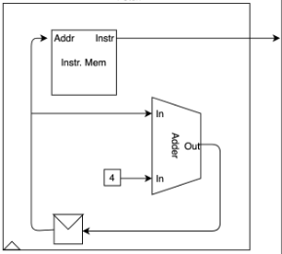

Instruction Decode:

