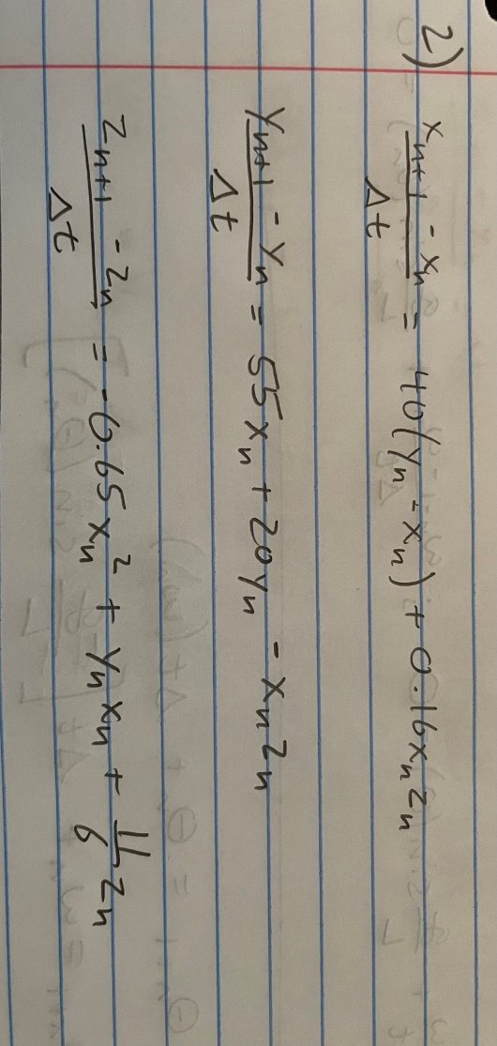**Problem 1**

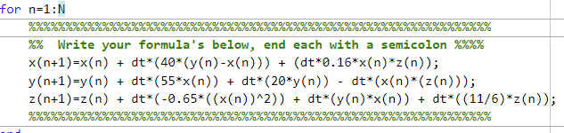

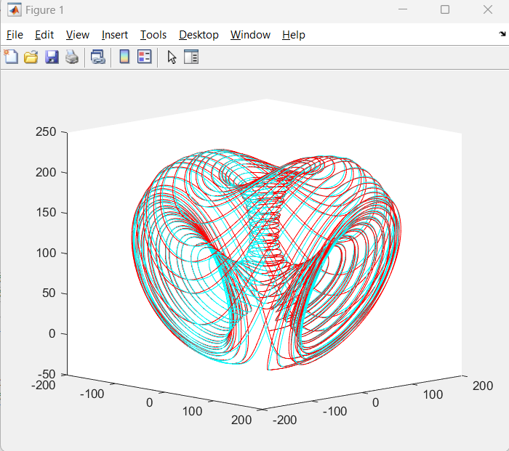

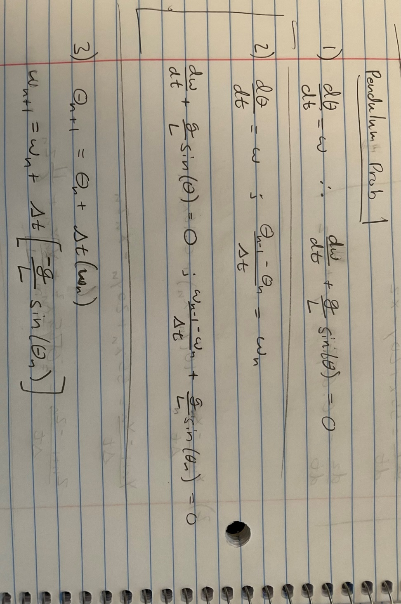**Problem 2**

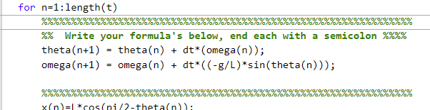

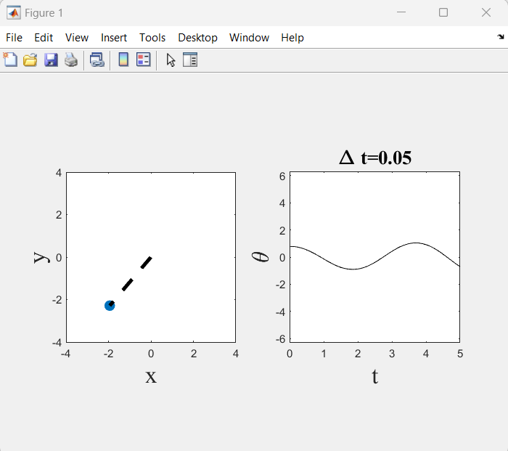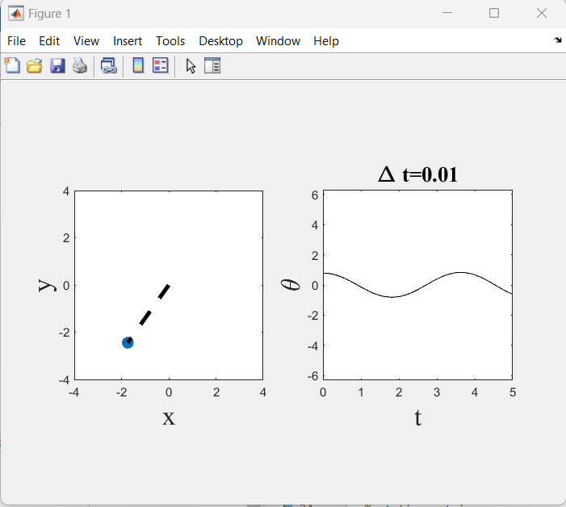

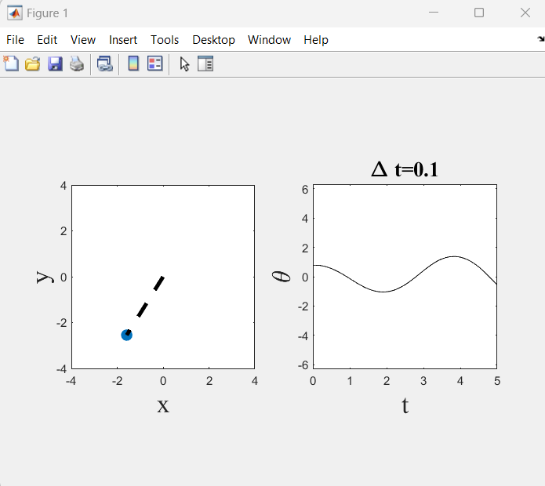

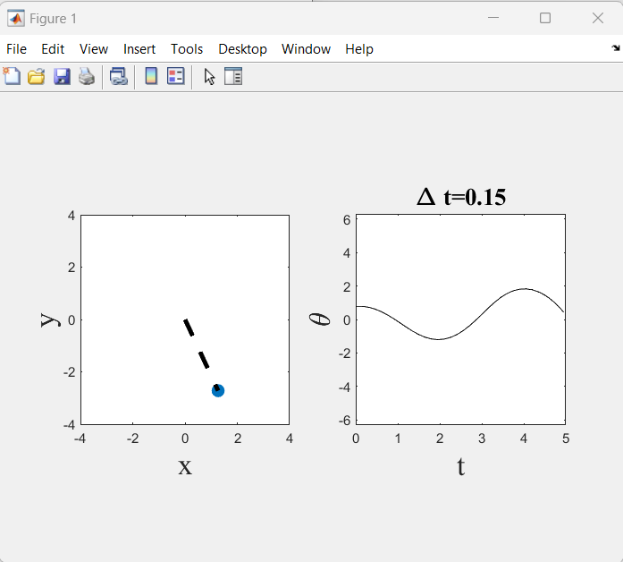

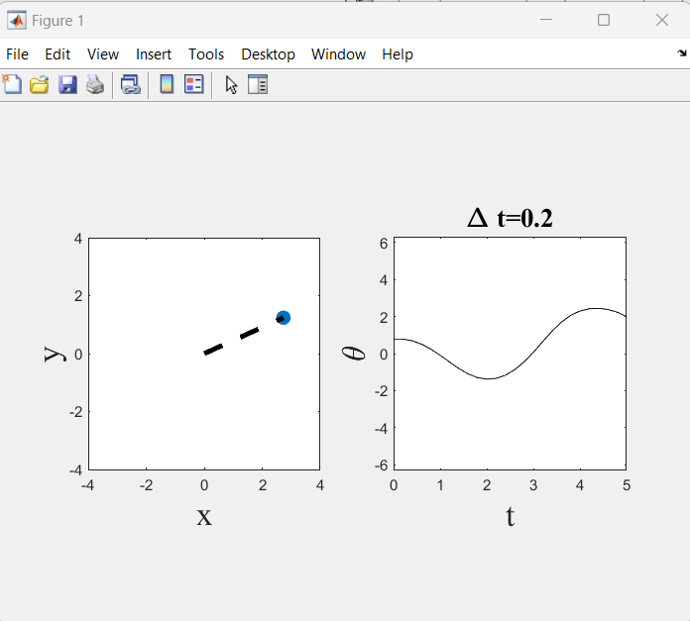

5) as dt decreases between 0.2 and 0.01, the observed output on the theta vs. time graph develops a more consistent amplitude on the second “hump.” The lower the number the closer the output seems to represent a regular cosine function.

6) A way to determine weather the solutions are accurate is by comparing the graphical results between the different values for delta t. In the pendulum results, the graph consistently trends towards a regular cosine function as the value decreases. This consistency in how it changes suggests accurate results.

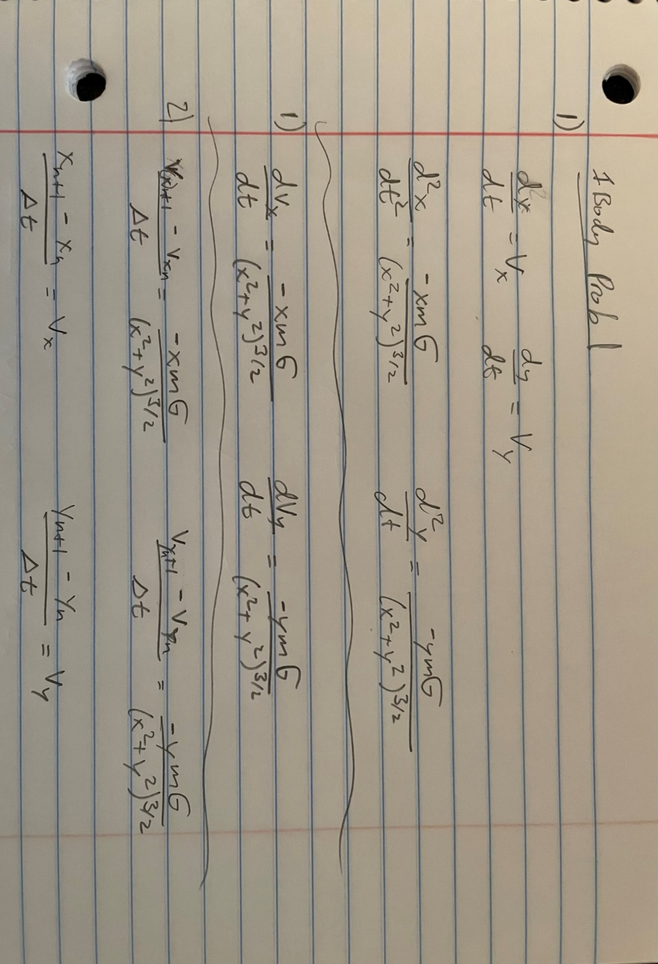

**Problem 3**

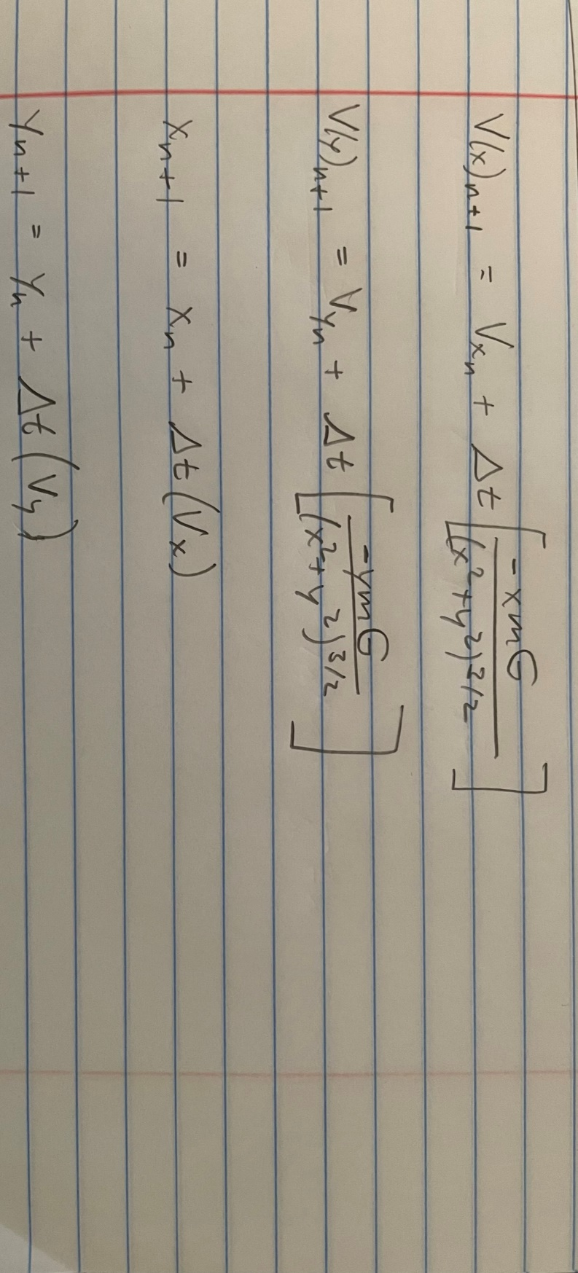

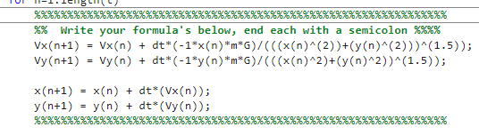

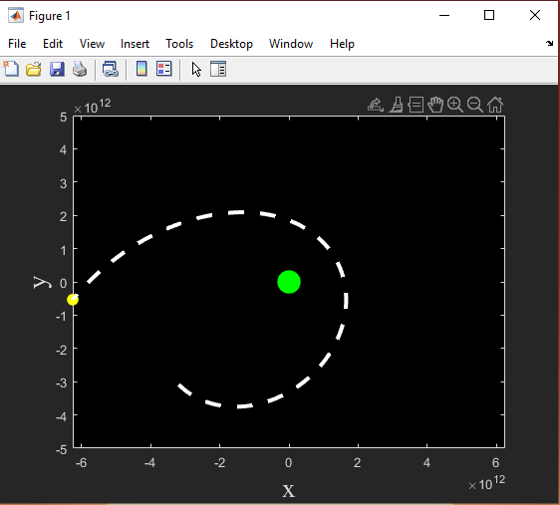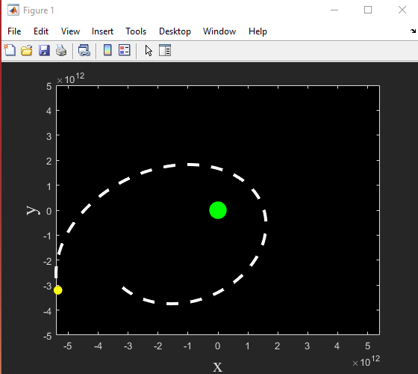

dt = 50

dt = 100

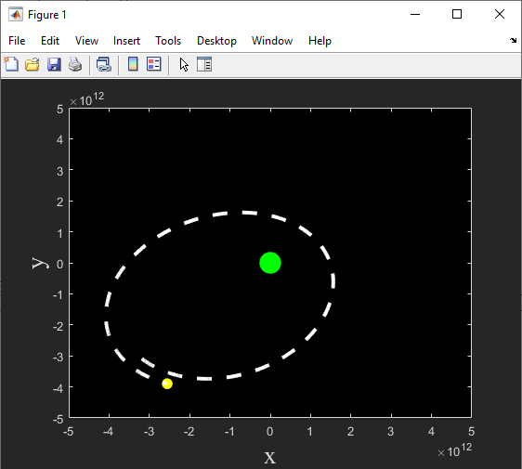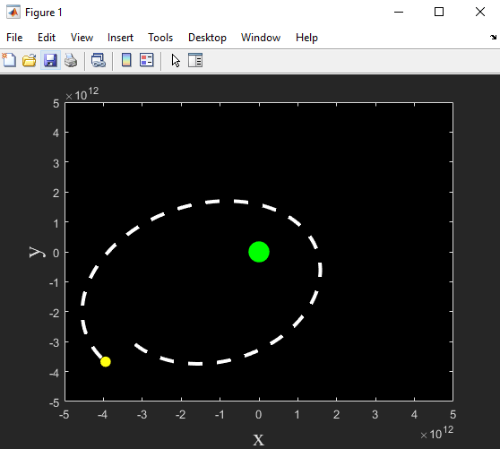

dt = 10

dt = 25

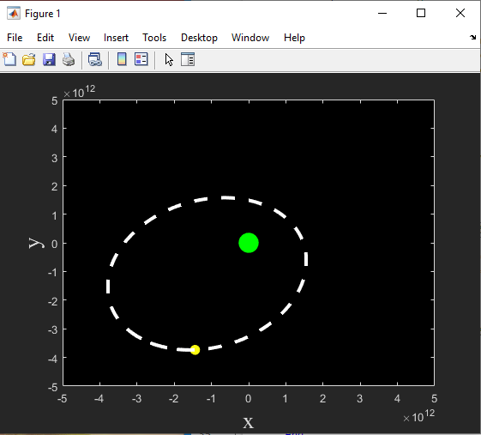

dt = 0.1

5) The larger the value of dt, the less “perfect” (if that’s the right word) the orbit seems to be. Very large values for dt begin to barely represent any orbit (at least in the time frame that the simulation is running).

6) As with the pendulum problem, checking if the results are accurate is a matter of comparing the results of the orbit simulation and how the results change with respect to delta t. In this problem, the obit consistently becomes more and more “perfect” the smaller the value gets. This consistency of change and how it seems to approach a certain results suggests that the results are accurate.