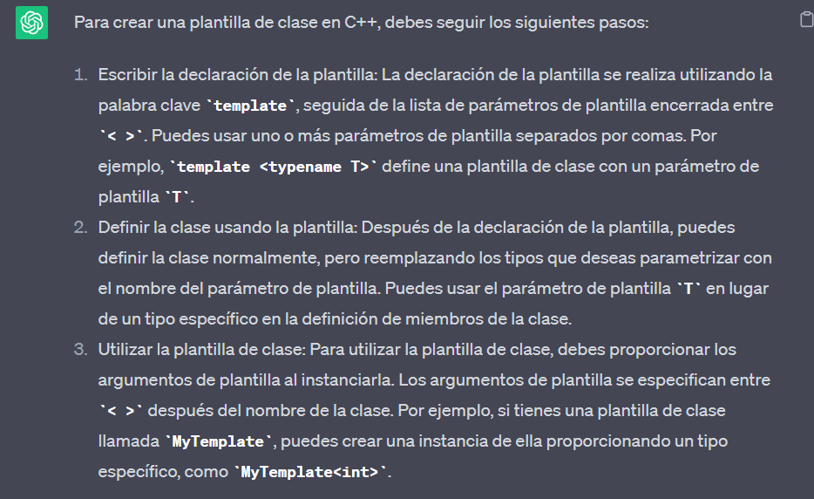

Implementación grafica:

.h:

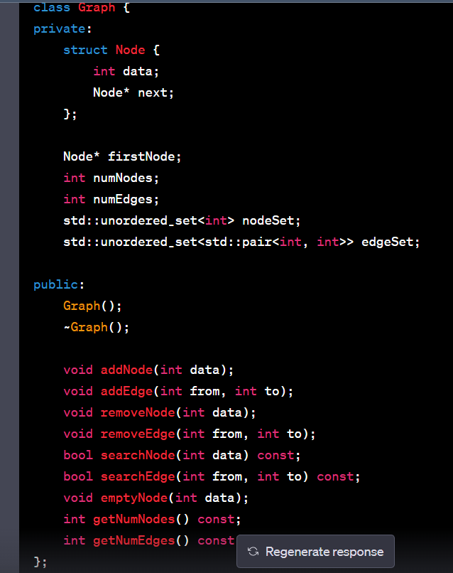

Código:

#ifndef GRAPH_H

#define GRAPH_H

#include <unordered_set>

class Graph {

private:

struct Node {

int data;

Node* next;

};

Node* firstNode;

int numNodes;

int numEdges;

std::unordered_set<int> nodeSet;

std::unordered_set<std::pair<int, int>> edgeSet;

public:

Graph();

~Graph();

void addNode(int data);

void addEdge(int from, int to);

void removeNode(int data);

void removeEdge(int from, int to);

bool searchNode(int data) const;

bool searchEdge(int from, int to) const;

void emptyNode(int data);

int getNumNodes() const;

int getNumEdges() const;

};

#endif // GRAPH_H

Cpp:

#include "graph.h"

#include <iostream>

Graph::Graph() : firstNode(nullptr), numNodes(0), numEdges(0) {}

Graph::~Graph() {

Node* currentNode = firstNode;

while (currentNode != nullptr) {

Node* nextNode = currentNode->next;

delete currentNode;

currentNode = nextNode;

}

}

void Graph::addNode(int data) {

if (nodeSet.count(data) == 0) {

Node* newNode = new Node;

newNode->data = data;

newNode->next = nullptr;

if (firstNode == nullptr) {

firstNode = newNode;

} else {

Node* currentNode = firstNode;

while (currentNode->next != nullptr) {

currentNode = currentNode->next;

}

currentNode->next = newNode;

}

nodeSet.insert(data);

numNodes++;

} else {

std::cout << "Node " << data << " already exists in the graph." << std::endl;

}

}

void Graph::addEdge(int from, int to) {

if (nodeSet.count(from) != 0 && nodeSet.count(to) != 0) {

std::pair<int, int> edge = std::make_pair(from, to);

if (edgeSet.count(edge) == 0) {

edgeSet.insert(edge);

numEdges++;

} else {

std::cout << "Edge from " << from << " to " << to << " already exists in the graph." << std::endl;

}

} else {

std::cout << "One or both of the nodes (" << from << ", " << to << ") do not exist in the graph." << std::endl;

}

}

void Graph::removeNode(int data) {

if (nodeSet.count(data) != 0) {

for (auto it = edgeSet.begin(); it != edgeSet.end(); ) {

if (it->first == data || it->second == data) {

it = edgeSet.erase(it);

numEdges--;

} else {

++it;

}

}

Node* currentNode = firstNode;

Node* prevNode = nullptr;

while (currentNode != nullptr) {

if (currentNode->data == data) {

if (prevNode == nullptr) {

firstNode = currentNode->next;

} else {

prevNode->next = currentNode->next;

}

delete currentNode;

numNodes--;

nodeSet.erase(data);

break;

}

prevNode = currentNode;

currentNode = currentNode->next;

}

} else {

std::cout << "Node " << data << " does not exist in the graph." << std::endl;

}

}

void Graph::removeEdge(int from, int to) {

std::pair<int, int> edge = std::make_pair(from, to);

if (edgeSet.count(edge) != 0) {

edgeSet.erase(edge);

numEdges--;

} else {

std::cout << "Edge from " << from << " to " << to << " does not exist in the graph." << std::endl;

}

}

bool Graph::searchNode(int data) const {

return nodeSet.count(data) != 0;

}

bool Graph::searchEdge(int from, int to) const {

std::pair<int, int> edge = std::make_pair(from, to);

return edgeSet.count(edge) != 0;

}

void Graph::emptyNode(int data) {

if (nodeSet.count(data) != 0) {

for (auto it = edgeSet.begin(); it != edgeSet.end(); ) {

if (it->first == data || it->second == data) {

it = edgeSet.erase(it);

numEdges--;

} else {

++it;

}

}

} else {

std::cout << "Node " << data << " does not exist in the graph." << std::endl;

}

}

int Graph::getNumNodes() const {

return numNodes;

}

int Graph::getNumEdges() const {

return numEdges;

}

Main:

#include <iostream>

#include "graph.h"

int main() {

Graph myGraph;

myGraph.addNode(1);

myGraph.addNode(2);

myGraph.addNode(3);

myGraph.addEdge(1, 2);

myGraph.addEdge(2, 3);

std::cout << "Number of nodes: " << myGraph.getNumNodes() << std::endl;

std::cout << "Number of edges: " << myGraph.getNumEdges() << std::endl;

myGraph.emptyNode(2);

std::cout << "Number of nodes after emptying: " << myGraph.getNumNodes() << std::endl;

std::cout << "Number of edges after emptying: " << myGraph.getNumEdges() << std::endl;

return 0;

}